UNITED STATES

SECURITIES AND EXCHANGE COMMISSION

Washington, D.C. 20549

FORM 10-Q

(Mark one)

- QUARTERLY REPORT PURSUANT TO SECTION 13 OR 15(d) OF THE SECURITIES EXCHANGE ACT OF 1934 For the quarterly period ended June 30, 2025.
☐ TRANSITION REPORT PURSUANT TO SECTION 13 OR 15(d) OF THE SECURITIES EXCHANGE ACT OF 1934 For the transition period from ________ to ________.

 |  |  |  |  | Commission File Number 001-37468
 |  |  |  |  | AppFolio, Inc.
 |  |  |  |  | (Exact name of registrant as specified in its charter)
 |  | Delaware |  |  |  |  |  | 26-0359894
 | (State of incorporation or organization) |  |  |  |  |  |  |  | (I.R.S. Employer Identification No.)
 | 70 Castilian Drive |  |  |  |  |  |  | 93117
 | Santa Barbara, California
 | (Address of principal executive offices) |  |  |  |  |  |  |  | (Zip Code)
 |  |  |  | (805) 364-6093
 |  |  |  |  | (Registrant’s telephone number, including area code)
 |  |  |  |  |  |  | N/A
 |  | (Former name, former address and former fiscal year, if changed since last report)
Securities registered pursuant to Section 12(b) of the Act:
 | Title of each class |  |  | Trading Symbol |  |  |  | Name of each exchange on which registered
Class A common stock, $0.0001 par value |  |  |  |  | APPF |  |  |  | NASDAQ Global Market

Indicate by check mark whether the registrant (1) has filed all reports required to be filed by Section 13 or 15(d) of the Securities Exchange Act of 1934 during the preceding 12 months (or for such shorter period that the registrant was required to file such reports), and (2) has been subject to such filing requirements for the past 90 days. Yes ☒ No ☐

Indicate by check mark whether the registrant has submitted electronically every Interactive Data File required to be submitted pursuant to Rule 405 of Regulation S-T (§232.405 of this chapter) during the preceding 12 months (or for such shorter period that the registrant was required to submit such files). Yes ☒ No ☐

Indicate by check mark whether the registrant is a large accelerated filer, an accelerated filer, a non-accelerated filer, a smaller reporting company or an emerging growth company. See the definitions of “large accelerated filer,” “accelerated filer,” “smaller reporting company” and "emerging growth company" in Rule 12b-2 of the Exchange Act.

Large accelerated filer | ☒ | Accelerated filer | ☐
Non-accelerated filer | ☐ | Smaller reporting company | ☐
 |  | Emerging growth company | ☐

If an emerging growth company, indicate by check mark if the registrant has elected not to use the extended transition period for complying with any new or revised financial accounting standards provided pursuant to Section 13(a) of the Exchange Act. ☐

Indicate by check mark whether the registrant is a shell company (as defined in Rule 12b-2 of the Exchange Act). Yes ☐ No ☒

As of July 24, 2025, the number of shares of the registrant’s Class A common stock outstanding was 22,871,704 and the number of shares of the registrant’s Class B common stock outstanding was 12,981,324.

 |  |  |  |  |  |  |  |  |  |  | TABLE OF CONTENTS
 |  |  |  |  |  |  |  |  |  |  |  |  |  |  |  |  | Page No.
 | Forward-Looking Statements |  |  |  |  |  |  |  |  |  |  |  |  |  |  |  | 1
 | Part I. Financial Information |  |  |  |  |  |  |  |  |  |  |  |  |  |  |  | 2
 |  | Item 1. Condensed Consolidated Financial Statements (Unaudited) |  |  |  |  |  |  |  |  |  |  |  |  |  |  | 2
 |  |  |  | Condensed Consolidated Balance Sheets as of June 30, 2025 and December 31, 2024 |  |  |  |  |  |  |  |  |  |  |  |  | 3
 |  |  |  | Condensed Consolidated Statements of Operations for the Three and Six Months Ended June 30, 2025 and 2024 |  |  |  |  |  |  |  |  |  |  |  |  | 4
 |  |  |  | Condensed Consolidated Statements of Comprehensive Income (Loss) for the Three and Six Months Ended June 30, 2025 and 2024 |  |  |  |  |  |  |  |  |  |  |  |  | 5
 |  |  |  | Condensed Consolidated Statements of Stockholders' Equity for the Six Months Ended June 30, 2025 and 2024 |  |  |  |  |  |  |  |  |  |  |  |  | 6
 |  |  |  | Condensed Consolidated Statements of Cash Flows for the Six Months Ended June 30, 2025 and 2024 |  |  |  |  |  |  |  |  |  |  |  |  | 8
 |  |  |  | Notes to Condensed Consolidated Unaudited Financial Statements |  |  |  |  |  |  |  |  |  |  |  |  | 9
 |  | Item 2. Management’s Discussion and Analysis of Financial Condition and Results of Operations |  |  |  |  |  |  |  |  |  |  |  |  |  |  | 17
 |  | Item 3. Quantitative and Qualitative Disclosures about Market Risk |  |  |  |  |  |  |  |  |  |  |  |  |  |  | 23
 |  | Item 4. Controls and Procedures |  |  |  |  |  |  |  |  |  |  |  |  |  |  | 23
 | Part II. Other Information |  |  |  |  |  |  |  |  |  |  |  |  |  |  |  | 24
 |  | Item 1. Legal Proceedings |  |  |  |  |  |  |  |  |  |  |  |  |  |  | 24
 |  | Item 1A. Risk Factors |  |  |  |  |  |  |  |  |  |  |  |  |  |  | 24
 |  | Item 2. Unregistered Sales of Equity Securities and Use of Proceeds |  |  |  |  |  |  |  |  |  |  |  |  |  |  | 25
 |  | Item 5. Other Information |  |  |  |  |  |  |  |  |  |  |  |  |  |  | 25
 |  | Item 6. Exhibits |  |  |  |  |  |  |  |  |  |  |  |  |  |  | 27
 | Signatures

FORWARD-LOOKING STATEMENTS

This Quarterly Report on Form 10-Q for the fiscal quarter ended June 30, 2025 (this "Quarterly Report"), contains forward-looking statements within the meaning of the federal securities laws, including the Private Securities Litigation Reform Act of 1995 (the “PSLRA”), which statements involve substantial risks and uncertainties. The forward-looking statements made in this Quarterly Report are intended to qualify for the protection of the safe harbor provided by the PSLRA and are based primarily on our current expectations and projections about future events and trends that we believe may affect our business, financial condition, operating results, cash flows and/or prospects. Forward-looking statements include all statements that are not statements of historical fact. Forward-looking statements can also be identified by words such as “may,” “will,” “should,” “might,” “expects,” “plans,” “anticipates,” “could,” “intends,” “target,” “projects,” “contemplates,” “believes,” “estimates,” “predicts,” “potential,” “future,” or “continue,” or the negative of these words or other similar terms or expressions. Examples of forward-looking statements include, among others, statements regarding changes in the competitive environment, responding to customer needs, research and product development plans, future products and services, growth in the size of our business and number of customers, strategic plans and objectives, the benefits or performance of our strategic investments, business forecasts and plans, our future or assumed financial condition, results of operations and liquidity, trends affecting our business and industry, capital needs and financing plans, capital resource allocation plans, share repurchase plans, and commitments and contingencies, including with respect to the outcome of legal proceedings or regulatory matters. We cannot assure you that the results, events, and circumstances reflected in the forward-looking statements will be achieved or occur, and actual results, events, or circumstances could differ materially from those described in the forward-looking statements. The outcome of the events described in these forward-looking statements is subject to risks, uncertainties, and other factors, including those risks, uncertainties and other factors described in the section entitled "Management's Discussion and Analysis of Financial Condition and Results of Operations" and "Risk Factors" in this Quarterly Report and "Risk Factors" in our Annual Report on Form 10-K for the fiscal year ended December 31, 2024 (our "Annual Report"), as well as in the other reports we file with the Securities and Exchange Commission (the "SEC"). You should read this Quarterly Report, and the other documents we file with the SEC, with the understanding that our actual future results may be materially different from the results expressed or implied by these forward-looking statements. As such, you should not rely upon forward-looking statements as predictions of future events. Any forward-looking statement made by us in this Quarterly Report is based only on information currently available to us and speaks only as of the date on which it is made. We undertake no obligation to update any forward-looking statements made in this Quarterly Report to reflect events or circumstances after the date of this Quarterly Report or to reflect new information or the occurrence of unanticipated events, except as required by law.

1

PART I. FINANCIAL INFORMATION

Item 1. Condensed Consolidated Financial Statements

2

APPFOLIO, INC.

CONDENSED CONSOLIDATED BALANCE SHEETS

(UNAUDITED)

(in thousands)

 |  | June 30, |  |  | December 31,
 |  | 2025 |  |  | 2024
Assets
Current assets
Cash and cash equivalents | $ | 73,478 |  | $ | 42,504
Investment securities—current |  | 54,088 |  |  | 235,745
Accounts receivable, net |  | 32,543 |  |  | 24,346
Prepaid expenses and other current assets |  | 37,026 |  |  | 32,807
Total current assets |  | 197,135 |  |  | 335,402
Property and equipment, net |  | 22,641 |  |  | 24,483
Operating lease right-of-use assets |  | 16,464 |  |  | 17,472
Capitalized software development costs, net |  | 12,414 |  |  | 15,429
Goodwill |  | 96,410 |  |  | 96,410
Intangible assets, net |  | 43,942 |  |  | 49,057
Deferred income taxes |  | 90,095 |  |  | 76,910
Long-term investments |  | 77,033 |  |  | 2,033
Other long-term assets |  | 11,269 |  |  | 9,482
Total assets | $ | 567,403 |  | $ | 626,678
Liabilities and Stockholders’ Equity
Current liabilities
Accounts payable | $ | 3,254 |  | $ | 2,378
Accrued employee expenses |  | 25,784 |  |  | 30,157
Accrued expenses |  | 18,103 |  |  | 14,658
Other current liabilities |  | 20,448 |  |  | 16,087
Total current liabilities |  | 67,589 |  |  | 63,280
Operating lease liabilities |  | 35,180 |  |  | 37,476
Other liabilities |  | 8,988 |  |  | 6,632
Total liabilities |  | 111,757 |  |  | 107,388
Commitments and contingencies (Note 6)
Stockholders’ equity:
Class A common stock |  | 2 |  |  | 2
Class B common stock |  | 2 |  |  | 2
Additional paid-in capital |  | 270,782 |  |  | 254,821
Accumulated other comprehensive (loss) Income |  | (71) |  |  | 173
Treasury stock |  | (172,480) |  |  | (25,756)
Retained earnings |  | 357,411 |  |  | 290,048
Total stockholders’ equity |  | 455,646 |  |  | 519,290
Total liabilities and stockholders’ equity | $ | 567,403 |  | $ | 626,678

The accompanying Notes to Condensed Consolidated Financial Statements are an integral part of these statements.

3

APPFOLIO, INC.

CONDENSED CONSOLIDATED STATEMENTS OF OPERATIONS

(UNAUDITED)

(in thousands, except per share amounts)

 |  |  | Three Months Ended |  |  |  |  |  |  |  |  | Six Months Ended
 |  |  | June 30, |  |  |  |  |  |  |  |  | June 30,
 |  | 2025 |  |  |  |  |  | 2024 |  |  |  | 2025 |  |  |  | 2024
Revenue |  | $ | 235,575 |  |  |  | $ | 197,375 |  |  | $ | 453,277 |  |  | $ | 384,805
Costs and operating expenses:
Cost of revenue (exclusive of depreciation and amortization)⁽¹⁾ |  |  | 83,827 |  |  |  |  | 69,601 |  |  |  | 163,325 |  |  |  | 134,247
Sales and marketing⁽¹⁾ |  |  | 36,776 |  |  |  |  | 27,300 |  |  |  | 67,833 |  |  |  | 51,755
Research and product development⁽¹⁾ |  |  | 46,674 |  |  |  |  | 39,522 |  |  |  | 90,432 |  |  |  | 77,417
General and administrative⁽¹⁾ |  |  | 21,936 |  |  |  |  | 20,254 |  |  |  | 45,287 |  |  |  | 41,386
Depreciation and amortization |  |  | 5,850 |  |  |  |  | 4,670 |  |  |  | 12,105 |  |  |  | 9,882
Total costs and operating expenses |  |  | 195,063 |  |  |  |  | 161,347 |  |  |  | 378,982 |  |  |  | 314,687
Income from operations |  |  | 40,512 |  |  |  |  | 36,028 |  |  |  | 74,295 |  |  |  | 70,118
Other (loss) income, net |  |  | (11) |  |  |  |  | — |  |  |  | 45 |  |  |  | —
Interest income, net |  |  | 1,466 |  |  |  |  | 3,476 |  |  |  | 4,419 |  |  |  | 6,468
Income before provision for income taxes |  |  | 41,967 |  |  |  |  | 39,504 |  |  |  | 78,759 |  |  |  | 76,586
Provision for income taxes |  |  | 5,987 |  |  |  |  | 9,839 |  |  |  | 11,396 |  |  |  | 8,258
Net income |  | $ | 35,980 |  |  |  | $ | 29,665 |  |  | $ | 67,363 |  |  | $ | 68,328
Net income per common share:
Basic |  | $ | 1.00 |  |  |  | $ | 0.82 |  |  | $ | 1.87 |  |  | $ | 1.89
Diluted
 |  | $ | 0.99 |  |  |  | $ | 0.81 |  |  | $ | 1.85 |  |  | $ | 1.86
Weighted average common shares outstanding:
Basic |  |  | 35,922 |  |  |  |  | 36,241 |  |  |  | 36,111 |  |  |  | 36,164
Diluted |  |  | 36,204 |  |  |  |  | 36,742 |  |  |  | 36,425 |  |  |  | 36,720
⁽¹⁾ Includes stock-based compensation expense as follows:
 |  |  | Three Months Ended |  |  |  |  |  |  |  |  | Six Months Ended
 |  |  | June 30, |  |  |  |  |  |  |  |  | June 30,
 |  | 2025 |  |  |  |  |  | 2024 |  |  |  | 2025 |  |  |  | 2024
Stock-based compensation expense included in costs and operating expenses:
Cost of revenue (exclusive of depreciation and amortization) |  | $ | 1,419 |  |  |  | $ | 1,175 |  |  | $ | 2,706 |  |  | $ | 2,135
Sales and marketing |  |  | 3,045 |  |  |  |  | 1,703 |  |  |  | 5,893 |  |  |  | 3,213
Research and product development |  |  | 8,176 |  |  |  |  | 6,472 |  |  |  | 15,107 |  |  |  | 12,154
General and administrative |  |  | 5,659 |  |  |  |  | 5,444 |  |  |  | 10,964 |  |  |  | 10,766
Total stock-based compensation expense |  | $ | 18,299 |  |  |  | $ | 14,794 |  |  | $ | 34,670 |  |  | $ | 28,268

The accompanying Notes to Condensed Consolidated Financial Statements are an integral part of these statements.

4

APPFOLIO, INC.

CONDENSED CONSOLIDATED STATEMENTS OF COMPREHENSIVE INCOME (LOSS)

(UNAUDITED)

(in thousands)

 |  | Three Months Ended |  |  |  |  |  | Six Months Ended
 |  | June 30, |  |  |  |  |  | June 30,
 | 2025 |  |  |  | 2024 |  |  | 2025 |  |  | 2024
Net income | $ | 35,980 |  | $ | 29,665 |  | $ | 67,363 |  | $ | 68,328
Other comprehensive loss:
Changes in unrealized losses on investment securities, net of tax |  | (37) |  |  | (69) |  |  | (244) |  |  | (283)
Comprehensive income | $ | 35,943 |  | $ | 29,596 |  | $ | 67,119 |  | $ | 68,045

The accompanying Notes to Condensed Consolidated Financial Statements are an integral part of these statements.

5

APPFOLIO, INC.

CONDENSED CONSOLIDATED STATEMENTS OF STOCKHOLDERS' EQUITY

(UNAUDITED)

(in thousands)

 |  |  |  |  |  |  |  |  |  |  |  |  |  |  | Accumulated
 |  |  |  |  |  |  |  |  |  |  |  | Additional |  |  | Other
 | Common Stock |  |  |  |  | Common Stock |  |  |  |  |  | Paid-in |  |  | Comprehensive |  |  | Treasury |  |  | Retained
 | Class A |  |  |  |  | Class B |  |  |  |  |  | Capital |  |  | Income (Loss) |  |  | Stock |  |  | Earnings |  |  | Total
 | Shares |  |  | Amount |  | Shares |  |  | Amount
Balance at December 31, 2024 | 23,241 |  | $ | 2 |  | 13,163 |  | $ | 2 |  | $ | 254,821 |  | $ | 173 |  | $ | (25,756) |  | $ | 290,048 |  | $ | 519,290
Exercise of stock options | 1 |  |  | — |  | — |  |  | — |  |  | 11 |  |  | — |  |  | — |  |  | — |  |  | 11
Stock-based compensation | — |  |  | — |  | — |  |  | — |  |  | 16,483 |  |  | — |  |  | — |  |  | — |  |  | 16,483
Vesting of restricted stock units, net of shares | 60 |  |  | — |  | — |  |  | — |  |  | (9,078) |  |  | — |  |  | — |  |  | — |  |  | (9,078)
withheld for taxes | 60 |  |  |  |  |  |  |  |  |  |  | (9,078) |  |  |  |  |  |  |  |  |  |  |  | (9,078)
Conversion of Class B common stock to Class A | 182 |  |  | — |  | (182) |  |  | — |  |  | — |  |  | — |  |  | — |  |  | — |  |  | —
common stock | 182 |  |  |  |  | (182) |  |  |  |  |  |  |  |  |  |  |  |  |  |  |  |  |  | —
Repurchase on common stock | (445) |  |  | — |  | — |  |  | — |  |  | — |  |  | — |  |  | (95,763) |  |  | — |  |  | (95,763)
Other comprehensive loss | — |  |  | — |  | — |  |  | — |  |  | — |  |  | (207) |  |  | — |  |  | — |  |  | (207)
Net Income | — |  |  | — |  | — |  |  | — |  |  | — |  |  | — |  |  | — |  |  | 31,383 |  |  | 31,383
Balance at March 31, 2025 | 23,039 |  | $ | 2 |  | 12,981 |  | $ | 2 |  | $ | 262,237 |  | $ | (34) |  | $ | (121,519) |  | $ | 321,431 |  | $ | 462,119
Exercise of stock options | 8 |  |  | — |  | — |  |  | — |  |  | 117 |  |  | — |  |  | — |  |  | — |  |  | 117
Stock based compensation | — |  |  | — |  | — |  |  | — |  |  | 18,448 |  |  | — |  |  | — |  |  | — |  |  | 18,448
Vesting of restricted stock units, net of shares | 68 |  |  | — |  | — |  |  | — |  |  | (10,020) |  |  | — |  |  | — |  |  | — |  |  | (10,020)
withheld for taxes | 68 |  |  |  |  |  |  |  |  |  |  | (10,020) |  |  |  |  |  |  |  |  |  |  |  | (10,020)
Conversion of Class B common stock to Class A | — |  |  | — |  | — |  |  | — |  |  | — |  |  | — |  |  | — |  |  | — |  |  | —
common stock |  |  |  |  |  |  |  |  |  |  |  |  |  |  |  |  |  |  |  |  |  |  |  | —
Repurchase of common stock | (244) |  |  | — |  | — |  |  | — |  |  | — |  |  | — |  |  | (50,961) |  |  | — |  |  | (50,961)
Other comprehensive loss | — |  |  | — |  | — |  |  | — |  |  | — |  |  | (37) |  |  | — |  |  | — |  |  | (37)
Net Income | — |  |  | — |  | — |  |  | — |  |  | — |  |  | — |  |  | — |  |  | 35,980 |  |  | 35,980
Balance at June 30, 2025 | 22,871 |  | $ | 2 |  | 12,981 |  | $ | 2 |  | $ | 270,782 |  | $ | (71) |  | $ | (172,480) |  | $ | 357,411 |  | $ | 455,646

The accompanying Notes to Condensed Consolidated Financial Statements are an integral part of these statements.

6

 |  |  |  |  |  |  |  |  |  |  |  |  |  |  | Accumulated
 |  |  |  |  |  |  |  |  |  |  |  | Additional |  |  | Other
 | Common Stock |  |  |  |  | Common Stock |  |  |  |  |  | Paid-in |  |  | Comprehensive |  |  | Treasury |  |  | Retained
 | Class A |  |  |  |  | Class B |  |  |  |  |  | Capital |  |  | Income (Loss) |  |  | Stock |  |  | Earnings |  |  | Total
 | Shares |  |  | Amount |  | Shares |  |  | Amount
Balance at December 31, 2023 | 21,749 |  | $ | 2 |  | 14,116 |  | $ | 2 |  | $ | 236,985 |  | $ | 99 |  | $ | (25,756) |  | $ | 85,980 |  | $ | 297,312
Exercise of stock options | 244 |  |  | — |  | — |  |  | — |  |  | 3,874 |  |  | — |  |  | — |  |  | — |  |  | 3,874
Stock-based compensation | — |  |  | — |  | — |  |  | — |  |  | 13,646 |  |  | — |  |  | — |  |  | — |  |  | 13,646
Vesting of restricted stock units, net of shares | 89 |  |  | — |  | — |  |  | — |  |  | (14,086) |  |  | — |  |  | — |  |  | — |  |  | (14,086)
withheld for taxes | 89 |  |  |  |  |  |  |  |  |  |  | (14,086) |  |  |  |  |  |  |  |  |  |  |  | (14,086)
Conversion of Class B common stock to Class A | 199 |  |  | — |  | (199) |  |  | — |  |  | — |  |  | — |  |  | — |  |  | — |  |  | —
common stock | 199 |  |  |  |  | (199) |  |  |  |  |  |  |  |  |  |  |  |  |  |  |  |  |  | —
Other comprehensive loss | — |  |  | — |  | — |  |  | — |  |  | — |  |  | (214) |  |  | — |  |  | — |  |  | (214)
Net Income | — |  |  | — |  | — |  |  | — |  |  | — |  |  | — |  |  | — |  |  | 38,663 |  |  | 38,663
Balance at March 31, 2024 | 22,281 |  | $ | 2 |  | 13,917 |  | $ | 2 |  | $ | 240,419 |  | $ | (115) |  | $ | (25,756) |  | $ | 124,643 |  | $ | 339,195
Exercise of stock options | 3 |  |  | — |  | — |  |  | — |  |  | 25 |  |  | — |  |  | — |  |  | — |  |  | 25
Stock based compensation | — |  |  | — |  | — |  |  | — |  |  | 15,032 |  |  | — |  |  | — |  |  | — |  |  | 15,032
Vesting of restricted stock units, net of shares | 71 |  |  | — |  | — |  |  | — |  |  | (12,436) |  |  | — |  |  | — |  |  | — |  |  | (12,436)
withheld for taxes | 71 |  |  |  |  |  |  |  |  |  |  | (12,436) |  |  |  |  |  |  |  |  |  |  |  | (12,436)
Conversion of Class B common stock to Class A | 644 |  |  | — |  | (644) |  |  | — |  |  | — |  |  | — |  |  | — |  |  | — |  |  | —
common stock | 644 |  |  |  |  | (644) |  |  |  |  |  |  |  |  |  |  |  |  |  |  |  |  |  | —
Other comprehensive loss | — |  |  | — |  | — |  |  | — |  |  | — |  |  | (69) |  |  | — |  |  | — |  |  | (69)
Net Income | — |  |  | — |  | — |  |  | — |  |  | — |  |  | — |  |  | — |  |  | 29,665 |  |  | 29,665
Balance at June 30, 2024 | 22,999 |  | $ | 2 |  | 13,273 |  | $ | 2 |  | $ | 243,040 |  | $ | (184) |  | $ | (25,756) |  | $ | 154,308 |  | $ | 371,412

The accompanying Notes to Condensed Consolidated Financial Statements are an integral part of these statements.

7

APPFOLIO, INC.

CONDENSED CONSOLIDATED STATEMENTS OF CASH FLOWS

(UNAUDITED)

(in thousands)

Six Months Ended

June 30,

 | 2025 |  |  |  | 2024
Cash from operating activities
Net income | $ | 67,363 |  | $ | 68,328
Adjustments to reconcile net income to net cash provided by operating activities:
Depreciation and amortization |  | 12,105 |  |  | 9,881
Amortization of operating lease right-of-use assets |  | 1,008 |  |  | 1,053
Amortization of costs capitalized to obtain revenue contracts |  | 5,419 |  |  | 4,985
Deferred income taxes |  | (13,185) |  |  | —
Stock-based compensation, including as amortized |  | 34,670 |  |  | 28,269
Other |  | (1,048) |  |  | (4,005)
Changes in operating assets and liabilities:
Accounts receivable |  | (8,197) |  |  | (4,982)
Prepaid expenses and other assets |  | (11,426) |  |  | 172
Accounts payable |  | 852 |  |  | 437
Operating lease liabilities |  | (2,102) |  |  | (1,418)
Accrued expenses and other liabilities |  | 5,649 |  |  | (8,897)
Net cash provided by operating activities |  | 91,108 |  |  | 93,823
Cash from investing activities
Purchases of available-for-sale investments |  | (64,034) |  |  | (151,539)
Proceeds from sales of available-for-sale investments |  | 202,662 |  |  | —
Proceeds from maturities of available-for-sale investments |  | 43,820 |  |  | 94,455
Purchases of property and equipment |  | (505) |  |  | (1,458)
Capitalization of software development costs |  | (1,478) |  |  | (2,529)
Purchases of long-term investments |  | (75,000) |  |  | —
Cash paid in business acquisition, net of cash acquired |  | (906) |  |  | —
Net cash provided by (used in) investing activities |  | 104,559 |  |  | (61,071)
Cash from financing activities
Proceeds from stock option exercises |  | 128 |  |  | 3,898
Tax withholding for net share settlement |  | (19,098) |  |  | (26,520)
Purchase of common stock |  | (145,723) |  |  | —
Net cash used in financing activities |  | (164,693) |  |  | (22,622)
Net increase in cash, cash equivalents and restricted cash |  | 30,974 |  |  | 10,130
Cash, cash equivalents and restricted cash
Beginning of period |  | 42,754 |  |  | 49,759
End of period | $ | 73,728 |  | $ | 59,889
Cash, cash equivalents and restricted cash at end of period:
Cash and cash equivalents | $ | 73,478 |  | $ | 59,639
Restricted cash included in prepaid expenses and other current assets |  | 250 |  |  | 250
Total cash, cash equivalents and restricted cash shown in the consolidated statements of cash flows | $ | 73,728 |  | $ | 59,889

The accompanying Notes to Condensed Consolidated Financial Statements are an integral part of these statements.

8

APPFOLIO, INC.

NOTES TO CONDENSED CONSOLIDATED UNAUDITED FINANCIAL STATEMENTS

1. Nature of Business

AppFolio, Inc. ("we," "us" or "our") is a technology leader powering the future of the real estate industry. We provide a cloud-based platform on which our customers operate their businesses. Our services enable our customers to connect communities, increase operational efficiency, deliver exceptional customer experiences, and improve financial and operational performance.

2. Summary of Significant Accounting Policies

Basis of Presentation and Significant Accounting Policies

The accompanying unaudited Condensed Consolidated Financial Statements were prepared in accordance with accounting principles generally accepted in the United States (“GAAP”) for interim financial information. Certain information and disclosures normally included in consolidated financial statements prepared in accordance with GAAP have been condensed or omitted. Accordingly, these Condensed Consolidated Financial Statements should be read in conjunction with our audited consolidated financial statements and the related notes included in our Annual Report, which was filed with the SEC on February 6, 2025. The year-end condensed balance sheet was derived from our audited consolidated financial statements. Our unaudited interim Condensed Consolidated Financial Statements include, in the opinion of management, all adjustments, consisting of normal and recurring items, necessary for the fair statement of our Condensed Consolidated Financial Statements. The operating results for the six months ended June 30, 2025 are not necessarily indicative of the results expected for the full year ending December 31, 2025.

Reclassification

We reclassified certain amounts in our Condensed Consolidated Statements of Cash Flows within the cash flows from operating activities section in the prior year to conform to the current year's presentation. We also reclassified long-term investments from other long-term assets in our Condensed Consolidated Balance Sheets in the prior year to conform to the current year's presentation,

Use of Estimates

The preparation of financial statements in conformity with GAAP requires management to make estimates and assumptions that affect the reported amounts of assets and liabilities and the disclosure of contingent assets and liabilities at the dates of the financial statements, and the reported amounts of revenue, expenses, other income, and provision for income taxes during the reporting period. Assets and liabilities which are subject to judgment and use of estimates include the fair value of assets and liabilities assumed in business combinations, the fair value of financial instruments, the fair value of privately-held strategic investments, useful lives of property and equipment and intangible assets, capitalized software development costs, incremental borrowing rate applied in lease accounting, impairment of goodwill and long-lived assets, the period of benefit associated with deferred costs, stock-based compensation, income taxes, and contingencies. Actual results could differ from those estimates and any such differences may have a material impact on our Consolidated Financial Statements.

Strategic Investments

Our strategic investments consist of non-marketable equity investments in privately-held companies in which we do not have a controlling interest or significant influence. We record these strategic investments as long-term investments in our Condensed Consolidated Balance Sheets. We have elected to apply the measurement alternative for equity investments in privately-held companies that do not have readily determinable fair values, measuring them at cost, less any impairment, plus or minus adjustments resulting from observable price changes in orderly transactions for the identical or a similar investment of the same issuer. An impairment loss is recorded when an event or circumstance indicates a decline in value has occurred.

In determining the estimated fair value of our strategic investments in privately held companies, we use the most recent and available data. Valuations of privately held securities are inherently complex due to the lack of readily available market data and require the use of judgment. The determination of whether an orderly transaction is for an identical or similar investment requires use of significant judgment. In our evaluation, we consider factors such as differences in the rights and preferences of the investments and the extent to which those differences would affect the fair values of those investments. Our impairment analysis encompasses an assessment of both qualitative and quantitative factors including the investee's financial metrics, market acceptance of the investee's product or technology, general market conditions and liquidity considerations.

9

Segment Information

Our chief operating decision maker ("CODM"), the Chief Executive Officer, allocates resources and assesses financial performance based upon discrete financial information at the consolidated level. There are no segment managers who are held accountable by our CODM, or anyone else, for operations, operating results and planning for levels or components below the consolidated unit level. Accordingly, we have determined that we operate as a single operating and reportable segment.

Our CODM uses consolidated net income (loss) as the sole measure of segment profit or loss. Significant segment expenses include cost of revenue (excluding depreciation and amortization), sales and marketing, research and product development, general and administrative expenses, and depreciation and amortization. For expenses incurred during the six months ended June 30, 2025 and 2024, refer to our Condensed Consolidated Statements of Operations. Stock-based compensation expense is also recognized as a significant segment expense. Details regarding this expense for the six months ended June 30, 2025 and 2024 was included in the parenthetical note to the respective Condensed Consolidated Statements of Operations.

Deferred Costs

Deferred costs, which primarily consist of sales commissions, are considered incremental and recoverable costs of obtaining a contract with a customer. These costs are deferred and then amortized on a straight-line basis over a period of benefit that we have determined to be three years. We typically do not pay commissions for contract renewals. We determined the period of benefit by taking into consideration our customer contract term, the useful life of our internal-use software, average customer life, and other factors. Amortization expense for deferred costs is included within sales and marketing expense in the accompanying Condensed Consolidated Statements of Operations.

Deferred costs were $18.1 million and $16.8 million as of June 30, 2025 and December 31, 2024, respectively, of which $9.4 million and $9.9 million, respectively, are included in Prepaid expenses and other current assets and $8.7 million and $6.9 million, respectively, are included in Other long-term assets in the accompanying Condensed Consolidated Balance Sheets. Amortization expense for deferred costs was $2.7 million, and $2.5 million for three months ended June 30, 2025 and 2024, respectively, and $5.4 million, and $5.0 million for the six months ended June 30, 2025 and 2024, respectively. For the six months ended June 30, 2025 and 2024, no impairments were identified in relation to the costs capitalized for the periods presented.

10

Net Income per Common Share

Net income per common share was the same for shares of our Class A and Class B common stock because they are entitled to the same liquidation and dividend rights and are therefore combined in the table below. The following table sets forth the computation of basic and diluted net income per common share (in thousands):

 |  |  |  |  | Three Months Ended |  |  |  |  |  | Six Months Ended
 |  |  |  |  | June 30, |  |  |  |  |  | June 30,
 |  |  |  | 2025 |  |  |  | 2024 |  |  | 2025 |  |  | 2024
 | Basic net income per share:
 | Numerator
 | Net income |  |  | $ | 35,980 |  | $ | 29,665 |  | $ | 67,363 |  | $ | 68,328
 | Less: undistributed earnings to participating securities |  |  |  | — |  |  | 3 |  |  | — |  |  | 8
 | Net income attributable to common stockholders |  |  | $ | 35,980 |  | $ | 29,662 |  | $ | 67,363 |  | $ | 68,320
 | Denominator
 |  |  |  |  |  |  |  |  |  |  | — |  |  | —
 | Weighted average common shares outstanding |  |  |  | 35,922 |  |  | 36,244 |  |  | 36,111 |  |  | 36,168
 | Less: Weighted average unvested restricted shares subject to repurchase |  |  |  | — |  |  | 3 |  |  | — |  |  | 4
 | Weighted average common shares outstanding; basic |  |  |  | 35,922 |  |  | 36,241 |  |  | 36,111 |  |  | 36,164
 | Net income per common share; basic |  |  | $ | 1.00 |  | $ | 0.82 |  | $ | 1.87 |  | $ | 1.89
 | Diluted net income per share:
 | Numerator
 | Net income attributable to common stockholders |  |  | $ | 35,980 |  | $ | 29,662 |  | $ | 67,363 |  | $ | 68,320
 | Denominator
 | Weighted average common shares outstanding; basic |  |  |  | 35,922 |  |  | 36,241 |  |  | 36,111 |  |  | 36,164
 | Add: Weighted average dilutive options outstanding |  |  |  | 31 |  |  | 41 |  |  | 35 |  |  | 75
 | Add: Weighted average dilutive restricted stock units outstanding |  |  |  | 251 |  |  | 460 |  |  | 279 |  |  | 481
 | Weighted average common shares outstanding; diluted |  |  |  | 36,204 |  |  | 36,742 |  |  | 36,425 |  |  | 36,720
 | Net income per common share; diluted |  |  | $ | 0.99 |  | $ | 0.81 |  | $ | 1.85 |  | $ | 1.86

Potentially dilutive securities that are not included in the calculation of diluted net income per share because doing so would be antidilutive are as follows (in thousands):

 |  | Three Months Ended |  |  |  |  |  | Six Months Ended
 |  | June 30, |  |  |  |  |  | June 30,
 | 2025 | 2024 |  |  |  |  | 2025 |  |  |  | 2024
Restricted stock units |  | 149 |  |  | 2 |  |  | 149 |  |  | 163
Total potentially dilutive securities |  | 149 |  |  | 2 |  |  | 149 |  |  | 163

11

- Investment Securities and Fair Value Measurements Investment Securities
Investment securities classified as available-for-sale consisted of the following as of June 30, 2025 and December 31, 2024 (in thousands):

 |  |  |  |  | June 30, 2025
 |  | Amortized Cost |  |  | Gross Unrealized Gains |  |  | Gross Unrealized Losses |  |  | Estimated Fair Value
U.S. government and agency securities |  | 54,098 |  |  | 1 |  |  | (11) |  |  | 54,088
Total available-for-sale investment securities | $ | 54,098 |  | $ | 1 |  | $ | (11) |  | $ | 54,088
 |  |  |  |  | December 31, 2024
 |  | Amortized Cost |  |  | Gross Unrealized Gains |  |  | Gross Unrealized Losses |  |  | Estimated Fair Value
U.S. government and agency securities |  | 235,509 |  |  | 261 |  |  | (25) |  |  | 235,745
Total available-for-sale investment securities | $ | 235,509 |  | $ | 261 |  | $ | (25) |  | $ | 235,745

As of June 30, 2025, the decline in fair value below amortized cost basis was not considered other than temporary as it is more likely than not we will hold the securities until maturity or recovery of the cost basis. No allowance for credit losses for available-for-sale investment securities was recorded as of June 30, 2025 or December 31, 2024.

The fair values of available-for-sale investment securities, by remaining contractual maturity, are as follows (in thousands):

 |  | June 30, 2025 |  |  |  |  |  | December 31, 2024
 |  | Amortized Cost |  |  | Estimated Fair Value |  |  | Amortized Cost |  |  | Estimated Fair Value
Due in one year or less | $ | 54,098 |  | $ | 54,088 |  | $ | 235,509 |  | $ | 235,745
Total available-for-sale investment securities | $ | 54,098 |  | $ | 54,088 |  | $ | 235,509 |  | $ | 235,745

During the six months ended June 30, 2025 and 2024, we had sales and maturities of investment securities, as follows (in thousands):

 |  |  |  |  | Six Months Ended June 30, 2025
 | Gross Realized Gains |  |  |  | Gross Realized Losses |  |  | Gross Proceeds from Sales |  |  | Gross Proceeds from
 | Gross Realized Gains |  |  |  |  |  |  |  |  |  | Maturities
U.S. government and agency securities | $ | 94 |  | $ | (49) |  | $ | 202,662 |  | $ | 43,820
Total | $ | 94 |  | $ | (49) |  | $ | 202,662 |  | $ | 43,820
 |  |  |  |  | Six Months Ended June 30, 2024
 | Gross Realized Gains |  |  |  | Gross Realized Losses |  |  | Gross Proceeds from Sales |  |  | Gross Proceeds from
 | Gross Realized Gains |  |  |  |  |  |  |  |  |  | Maturities
U.S. government and agency securities |  | — |  |  | — |  |  | — |  |  | 94,455
Total | $ | — |  | $ | — |  | $ | — |  | $ | 94,455

The tables above do not include our strategic investments of non-marketable equity investments in privately-held companies, which are recorded in long-term investments in our Condensed Consolidated Balance Sheets. These strategic investments consist of the following as of June 30, 2025 and December 31, 2024 (in thousands):

12

 | June 30, |  |  |  | December 31,
 | 2025 |  |  |  | 2024
Second Nature | $ | 75,000 |  | $ | —
Others |  | 2,033 |  |  | 2,033
Total long-term investments | $ | 77,033 |  | $ | 2,033

In April 2025, we purchased a minority, non-controlling equity interest in Second Nature Holdings, L.P. (“Second Nature”) for $75.0 million, paid with cash on hand. We determined that we do not have significant influence over Second Nature, and our investment in Second Nature has been classified as an investment in equity securities without readily determinable fair value.

There were no realized or unrealized gains or losses from remeasurement of investments in equity securities under the measurement alternative for the six months ended June 30, 2025 and

2024.

Fair Value Measurements

Recurring Fair Value Measurements

The following tables present our financial assets and liabilities measured at fair value on a recurring basis as of June 30, 2025 and December 31, 2024 by level within the fair value hierarchy (in thousands):

 |  |  |  |  | June 30, 2025
 | Level 1 |  |  |  | Level 2 |  |  | Total Fair
 | Level 1 |  |  |  |  |  |  | Value
Cash equivalents:
Money market funds | $ | 47,917 |  | $ | — |  | $ | 47,917
Available-for-sale investment securities:
U.S. government and agency securities |  | — |  |  | 54,088 |  |  | 54,088
Total | $ | 47,917 |  | $ | 54,088 |  | $ | 102,005
 |  |  |  |  | December 31, 2024
 | Level 1 |  |  |  | Level 2 |  |  | Total Fair
 | Level 1 |  |  |  |  |  |  | Value
Cash equivalents:
Money market funds | $ | 25,167 |  | $ | — |  | $ | 25,167
Available-for-sale investment securities:
U.S. government and agency securities |  | — |  |  | 235,745 |  |  | 235,745
Total | $ | 25,167 |  | $ | 235,745 |  | $ | 260,912

The carrying amounts of cash and cash equivalents, restricted cash, accounts receivable, accounts payable and accrued liabilities approximate their fair value because of the short maturity of these items.

Fair value for our Level 1 investment securities is based on market prices for identical assets. Our Level 2 securities were priced by a pricing vendor. The pricing vendor utilizes the most recent observable market information in pricing these securities or, if specific prices are not available for these securities, other observable inputs like market transactions involving comparable securities are used.

Strategic Investments Measured and Recorded at Fair Value on a Non-Recurring Basis

Strategic investments primarily include equity investments in privately-held companies, which do not have a readily determinable fair value. Strategic investments are classified as Level 3 in the fair value hierarchy, as their nonrecurring fair value measurements may include observable and unobservable inputs. As of June 30, 2025 and December 31, 2024, the balance of strategic investments was $77.0 million and $2.0 million, respectively.

13

4. Accrued Employee Expenses

Accrued employee expenses consisted of the following (in thousands):

 | June 30, |  |  |  | December 31,
 | 2025 |  |  |  | 2024
Accrued bonuses | $ | 14,745 |  | $ | 17,092
Accrued payroll and other |  | 11,039 |  |  | 13,065
Total accrued employee expenses | $ | 25,784 |  | $ | 30,157
5. Other Current Liabilities
Other Current Liabilities consisted of the following (in thousands):
 | June 30, |  |  |  | December 31,
 | 2025 |  |  |  | 2024
Unearned premium liabilities | $ | 6,140 |  | $ | 5,455
Insurance reserves |  | 4,741 |  |  | 3,908
Operating lease liabilities-current |  | 4,466 |  |  | 4,273
Other |  | 5,101 |  |  | 2,451
Total other current liabilities | $ | 20,448 |  | $ | 16,087

Unearned premium liabilities are the refundable portion of commissions received in connection with the sale of renters insurance policies to residents through AppFolio Insurance Services, Inc., our wholly owned subsidiary. In the event a resident cancels their renters insurance policy prior to the end of such policy, we may be required to refund a pro rata portion of the commission paid on such policy.

For additional information for insurance reserves, refer to Note 6, Commitments and Contingencies.

6. Commitments and Contingencies

Legal Liability to Landlord Insurance

We have a wholly owned subsidiary, Terra Mar Insurance Company, Inc., which was established in connection with reinsuring liability to landlord insurance policies offered to our customers by our third-party service provider. We assume a 100% quota share of the liability to landlord insurance policies placed with our customers by our third-party service provider. We accrue for reported claims, and include an estimate of losses incurred but not reported by our property manager customers, in cost of revenue because we bear the risk related to all such claims. Our estimated liability for reported claims and incurred but not reported claims as of June 30, 2025 and December 31, 2024 was $4.7 million and $3.9 million, respectively, and is included in Other current liabilities on our Condensed Consolidated Balance Sheets.

Included in Prepaid expenses and other current assets as of June 30, 2025 and December 31, 2024 are $4.3 million and $6.7 million, respectively, of deposits held with a third party related to requirements to maintain collateral for this insurance service.

Legal Proceedings

From time to time, we are involved in various investigative inquiries, legal proceedings and disputes arising from or related to matters incident to the ordinary course of our business activities, including actions with respect to intellectual property, employment, labor, regulatory and contractual matters. Although the ultimate outcome of such investigative inquiries, legal proceedings and other disputes cannot be predicted with certainty, we do not believe that any such investigative inquires, legal proceedings and other disputes, if determined adversely to us, would, individually or taken together, have a material adverse effect on our business, operating results, financial condition or cash flows.

14

Indemnification

In the ordinary course of business, we may provide indemnification of varying scope and terms to customers, business partners, investors, directors, officers, and other parties with respect to certain matters, including, but not limited to, losses arising out of our breach of any applicable agreements, intellectual property infringement claims made by third parties, and other liabilities relating to or arising from our services or our acts or omissions. These indemnification provisions may survive termination of the underlying agreement and the maximum potential amount of future payments we could be required to make under these indemnification provisions may not be subject to maximum loss clauses and is indeterminable. We have not incurred any costs as a result of such indemnification obligations and have not recorded any liabilities related to such obligations in the Condensed Consolidated Financial Statements.

7. Share Repurchase Program

On February 20, 2019, our Board of Directors (our "Board") authorized a $100.0 million share repurchase program (the "2019 Stock Repurchase Program") relating to our outstanding shares of Class A common stock. Under the 2019 Stock Repurchase Program, we were authorized to repurchase shares of our Class A common stock from time to time in open market purchases or privately negotiated transactions. The 2019 Stock Repurchase Program did not obligate us to repurchase any minimum dollar amount or number of shares, did not have an expiration date, and it could have been modified, suspended or terminated at any time and for any reason.

During the first quarter of 2025, we repurchased 445,311 shares of our Class A common stock through open market repurchases under the 2019 Stock Repurchase Program at an average purchase price of $215.05 per share, inclusive of broker commissions, for an aggregate repurchase price of $95.8 million which was recorded as a reduction to stockholders' equity. As a result of the repurchases, we substantially exhausted the remaining shares available for purchase under the 2019 Stock Repurchase Program, and it has terminated. We did not repurchase any shares of our Class A common stock under the 2019 Stock Repurchase Program during the three months ended June 30, 2024.

On April 23, 2025, our Board authorized a $300.0 million share repurchase program (the "2025 Stock Repurchase Program") relating to our outstanding shares of Class A common stock. Under the 2025 Stock Repurchase Program, we are authorized to repurchase shares of our Class A common stock from time to time in open market purchases or privately negotiated transactions. The 2025 Stock Repurchase Program does not obligate us to repurchase any minimum dollar amount or number of shares, has no expiration date, and can be modified, suspended or terminated at any time and for any reason. The timing and actual number of shares repurchased will depend on a variety of factors, including price, corporate and legal requirements, market conditions and other factors. During the three months ended June 30, 2025, we repurchased 243,987 shares of our Class A common stock through open market repurchases under the 2025 Stock Repurchase Program at an average purchase price of $204.77 per share, inclusive of broker commissions, for an aggregate repurchase price of $50.0 million which was recorded as a reduction to stockholders' equity. As of June 30, 2025, the amount remaining available for repurchases under the 2025 Stock Repurchase Program was $250.0 million.

15

8. Stock-Based Compensation

Restricted Stock Units

A summary of activity in connection with our restricted stock units ("RSUs") for the six months ended June 30, 2025, is as follows (number of shares in thousands):

 | Number of Shares |  |  |  | Weighted Average Grant Date
 | Number of Shares |  |  |  | Fair Value per Share
Unvested as of December 31, 2024 |  | 785 |  | $ | 159.98
Granted |  | 358 |  |  | 224.41
Vested |  | (216) |  |  | 153.81
Forfeited |  | (47) |  |  | 158.31
Unvested as of June 30, 2025 |  | 880 | $ |  | 187.79

Unvested RSUs as of June 30, 2025 were composed of 0.8 million RSUs with only service conditions and 0.1 million performance share units ("PSUs") with both service conditions and performance conditions. RSUs granted with only service conditions generally vest over a four-year period, assuming continued employment through the applicable vesting date. The number of PSUs granted, as included in the above table, assumes achievement of the performance metrics at 100% of the performance target. The unvested PSUs as of June 30, 2025, are subject to vesting based on the achievement of pre-established performance metrics for the year ending December 31, 2025 and will vest over a three year period, assuming continued employment through each vesting date. The actual number of shares to be issued at the end of the performance period will range from 0% to 171% of the target number of shares depending on achievement relative to the performance metrics over the applicable period.

We recognized stock-based compensation expense for the RSUs and PSUs of $17.9 million and $14.5 million for the three months ended June 30, 2025 and 2024, respectively, and $33.9 million and $27.5 million for the six months ended June 30, 2025 and 2024, respectively. As of June 30, 2025, the total estimated remaining stock-based compensation expense for the aforementioned RSUs and PSUs was $130.1 million, which is expected to be recognized over a weighted average period of 2.4 years.

9. Income Taxes

We calculate our provision for income taxes on a quarterly basis by applying an estimated annual effective tax rate to income (loss) from operations and by calculating the tax effect of discrete items recognized during the quarter.

For the three and six months ended June 30, 2025, we recorded income tax expense of $6.0 million and $11.4 million, representing an effective tax rate of 14.3% and 14.5%, respectively. Our effective tax rate differs from the U.S. federal statutory rate of 21% primarily due to excess tax benefits from stock-based compensation and research and development tax credits, partially offset by state income taxes and non-deductible officers' compensation. For the three and six months ended June 30, 2024, our effective tax rate differs from the U.S. federal statutory rate of 21% primarily due to excess tax benefits from stock-based compensation and changes in valuation allowance against deferred tax assets.

We assess our ability to realize our deferred tax assets on a quarterly basis and we establish a valuation allowance if it is more-likely-than-not that some portion of deferred tax assets will not be realized. We weigh all available positive and negative evidence, including our earnings history and results of recent operations, scheduled reversals of deferred tax liabilities, projected future taxable income and tax planning strategies. During the three months ended December 31, 2024, we assessed all available evidence and determined that there was sufficient positive evidence to overcome the negative evidence, including our past and current financial results, growth demonstrated in our top-line performance, as well as projected profitability. Accordingly, we determined it is more likely than not that the deferred tax assets will be realized and we released our valuation allowance at December 31, 2024.

There were no material changes to our unrecognized tax benefits during the three and six months ended June 30, 2025, and we do not expect to have any significant changes to unrecognized tax benefits through the remainder of the year.

16

10. Revenue and Other Information

The following table presents our revenue categories for the three and six months ended June 30, 2025 and 2024 (in thousands):

 |  | Three Months Ended |  |  |  |  |  | Six Months Ended
 |  | June 30, |  |  |  |  |  | June 30,
 | 2025 |  |  | 2024 |  |  |  | 2025 |  |  | 2024
Core solutions | $ | 52,473 |  | $ | 44,024 |  | $ | 101,986 |  | $ | 86,944
Value Added Services |  | 180,145 |  |  | 151,620 |  |  | 344,851 |  |  | 293,951
Other |  | 2,957 |  |  | 1,731 |  |  | 6,440 |  |  | 3,910
Total revenue | $ | 235,575 |  | $ | 197,375 |  | $ | 453,277 |  | $ | 384,805

Our revenue is generated primarily from customers in the United States. Our property and equipment is primarily located in the United States.

11. Subsequent Event

On July 4, 2025, the One Big Beautiful Bill Act ("OBBBA") was signed into law. Included in this legislation are provisions that allow for the immediate expensing of domestic United States research and development expenses, immediate expensing of certain capital expenditures, and other changes to the U.S. taxation of profits derived from foreign operations. We believe the impact of the relevant OBBBA provisions to our income tax expense is not material and are currently in the process of evaluating the impact on our Consolidated Financial Statements.

Item 2. Management's Discussion and Analysis of Financial Condition and Results of Operations

The following discussion and analysis of our financial condition, results of operations and liquidity should be read together with our Condensed Consolidated Financial Statements and the related notes included elsewhere in this Quarterly Report and in our Annual Report.

Overview

We are a technology leader powering the future of the real estate industry. We provide a cloud-based platform on which our customers operate their businesses. We help our customers navigate an increasingly interconnected and growing network of stakeholders in their business ecosystems, including property managers, property investors, potential residents, residents, and vendors. We also provide key functionality related to critical transactions across the real estate lifecycle, including screening potential residents, sending and receiving payments, and providing insurance-related risk mitigation services. Our services enable our customers to connect communities, increase operational efficiency, deliver exceptional customer experiences, and improve financial and operational performance.

Property management units under management. We believe that our ability to increase our number of property management units under management is an indicator of our market penetration, growth, and potential future business opportunities. We define property management units under management as active or committed units under management at the period end date. We had 8.9 million and 8.4 million property management units under management as of June 30, 2025 and 2024, respectively.

Key Components of Results of Operations

Revenue

Our core solutions and certain of our Value Added Services are offered on a subscription basis. The subscription fees for our core solutions vary by property type and are designed to scale with the size of our customers’ businesses. We recognize revenue for subscription-based services on a straight-line basis over the contract term beginning on the date that our service is made available. We generally invoice monthly or, to a lesser extent, annually in advance of a subscription period.

We also offer certain Value Added Services, which are not covered by our subscription fees, on a per-use basis. Usage-based fees are charged either as a percentage of the transaction amount (e.g., for certain of our electronic payment services) or on a flat fee per transaction basis generally with no minimum usage commitments (e.g., for our tenant screening and risk mitigation services). We recognize revenue for usage-based services in the period the service is rendered. Our payments services fees are recorded gross of any interchange and payment processing related fees. We generally invoice our

17

usage-based services on a monthly basis or collect the fee at the time of service. A significant majority of our Value Added Services revenue comes from the use of our electronic payment services, tenant screening services, and risk mitigation services.

In addition, we charge our customers for assistance onboarding onto our core solutions and for certain other non-recurring services. We generally invoice for these other services in advance of the services being completed and recognize revenue in the period the service is rendered. We also generate revenue from the legacy customers of businesses we acquire that provide standalone services outside of our platform. Revenue derived from these services is recorded in Other revenue. As of June 30, 2025 and 2024, we had 21,403 and 20,167 property management customers, respectively.

Costs and Operating Expenses

Cost of Revenue (Exclusive of Depreciation and Amortization). Many of our Value Added Services are facilitated by third-party service providers. Cost of revenue paid to these third-party service providers includes, without limitation, the cost of electronic interchange and payment processing-related services to support our payments services, the cost of credit reporting services for our tenant screening services, and various costs associated with our risk mitigation service providers. These third-party costs vary both in amount and as a percentage of revenue for each Value Added Service offering. Cost of revenue also includes personnel-related costs for our employees focused on customer service and the support of our operations (including salaries, cash bonuses, benefits, and stock-based compensation), platform infrastructure costs (such as data center operations and hosting-related costs), and allocated shared and other costs. Cost of revenue excludes depreciation of property and equipment, amortization of capitalized software development costs and amortization of intangible assets.

Sales and Marketing. Sales and marketing expense consists of personnel-related costs for our employees focused on sales and marketing (including salaries, sales commissions, cash bonuses, benefits, and stock-based compensation), costs associated with sales and marketing activities, and allocated shared and other costs. Marketing activities include advertising, online lead generation, lead nurturing, customer and industry events, and the creation of industry-related content and collateral. We focus our sales and marketing efforts on generating awareness of our software solutions, creating sales leads, establishing and promoting our brands, and cultivating an educated community of successful and vocal customers.

Research and Product Development. Research and product development expense consists of personnel-related costs for our employees focused on research and product development (including salaries, cash bonuses, benefits, and stock-based compensation), fees for third-party development resources, and allocated shared and other costs. Our research and product development efforts are focused on expanding functionality and the ease of use of our existing software solutions by adding new core functionality, Value Added Services and other improvements, as well as developing new products and services. We capitalize our software development costs that meet the criteria for capitalization. Amortization of capitalized software development costs is included in depreciation and amortization expense.

General and Administrative. General and administrative expense consists of personnel-related costs for employees in our executive, finance, information technology, human resources, legal, compliance, and administrative organizations (including salaries, cash bonuses, benefits, and stock-based compensation). In addition, general and administrative expense includes fees for third-party professional services (including audit, legal, compliance, and tax services), regulatory fees, other corporate expenses, impairment of long-lived assets, gains on lease modifications, and allocated shared and other costs.

Depreciation and Amortization. Depreciation and amortization expense includes depreciation of property and equipment, amortization of capitalized software development costs, and amortization of intangible assets. We depreciate or amortize property and equipment, software development costs, and intangible assets over their expected useful lives on a straight-line basis, which approximates the pattern in which the economic benefits of the assets are consumed.

Interest Income, Net. Interest income, net includes interest earned on investment securities, amortization and accretion of the premium and discounts paid from the purchase of investment securities, and interest earned on cash deposited in our bank accounts.

Provision for income taxes. Provision for income taxes consists of federal and state income taxes in the United States.

18

Results of Operations

Revenue

 |  | Three Months Ended |  |  |  |  |  | Change |  |  |  |  | Six Months Ended |  |  |  |  |  | Change
 |  | June 30, |  |  |  |  |  |  |  |  |  |  | June 30,
 |  | 2025 |  |  | 2024 |  |  | Amount |  | % |  |  | 2025 |  |  | 2024 |  |  | Amount |  | %
 |  |  |  |  |  |  |  |  |  | (dollars in thousands)
Core solutions | $ | 52,473 |  | $ | 44,024 |  | $ | 8,449 |  | 19 % |  | $ | 101,986 |  | $ | 86,944 |  | $ | 15,042 |  | 17 %
Value Added Services |  | 180,145 |  |  | 151,620 |  |  | 28,525 |  | 19 % |  |  | 344,851 |  |  | 293,951 |  |  | 50,900 |  | 17 %
Other |  | 2,957 |  |  | 1,731 |  |  | 1,226 |  | 71 % |  |  | 6,440 |  |  | 3,910 |  |  | 2,530 |  | 65 %
Total revenue | $ | 235,575 |  | $ | 197,375 |  | $ | 38,200 |  | 19 % |  | $ | 453,277 |  | $ | 384,805 |  | $ | 68,472 |  | 18 %

The increase in revenue for the three and six months ended June 30, 2025, compared to the same periods in the prior year, was primarily attributable to an increase in the usage of our payments, tenant screening, and risk mitigation services. During the three and six month periods ended June 30, 2025, we also experienced growth of 6% in the number of property management units under management compared to the same period in the prior year, which drove growth in users of our subscription and usage-based services.

Our payment services experienced increased usage during the comparative periods as residents and property managers transacted more business online.

We expect total revenue for the year ending December 31, 2025 to increase compared to the year ended December 31, 2024 as we continue to add new customers and property management units under management, along with increased adoption and usage of our Value Added Services.

Cost of Revenue (Exclusive of Depreciation and Amortization)

 |  | Three Months Ended |  |  |  |  | Change |  |  |  | Six Months Ended |  |  |  |  | Change
 |  | June 30, |  |  |  |  | Change |  |  |  | June 30, |  |  |  |  | Change
 |  | 2025 |  | 2024 |  |  | Amount | % |  |  | 2025 |  | 2024 |  |  | Amount | %
 |  |  |  |  |  |  |  | (dollars in thousands)
Cost of revenue (exclusive of depreciation and
amortization) | $ | 83,827 | $ | 69,601 |  | $ | 14,226 | 20 % |  | $ | 163,325 | $ | 134,247 |  | $ | 29,078 | 22 %
Percentage of revenue |  | 35.6 % |  | 35.3 % |  |  |  |  |  |  | 36.0 % |  | 34.9 %
Stock-based compensation, included above | $ | 1,419 | $ | 1,175 |  | $ | 244 | 21 % |  | $ | 2,706 | $ | 2,135 |  | $ | 571 | 27 %
Percentage of revenue |  | 0.6 % |  | 0.6 % |  |  |  |  |  |  | 0.6 % |  | 0.6 %

Cost of revenue (exclusive of depreciation and amortization) increased for the three and six months ended June 30, 2025, compared to the same periods in the prior year. The increase was primarily driven by higher third-party service provider costs of $13.0 million and $25.9 million, respectively, due to increased adoption and usage of our Value Added Services.

We expect cost of revenue (exclusive of depreciation and amortization) for the year ending December 31, 2025, to stay relatively flat as a percentage of revenue compared to the year ended December 31, 2024.

19

Sales and Marketing

 |  | Three Months Ended |  |  |  |  | Change |  |  |  | Six Months Ended |  |  |  |  | Change
 |  | June 30, |  |  |  |  | Change |  |  |  | June 30, |  |  |  |  | Change
 |  | 2025 |  | 2024 |  |  | Amount | % |  |  | 2025 |  | 2024 |  |  | Amount | %
 |  |  |  |  |  |  |  | (dollars in thousands)
Sales and marketing | $ | 36,776 | $ | 27,300 |  | $ | 9,476 | 35 % |  | $ | 67,833 | $ | 51,755 |  | $ | 16,078 | 31 %
Percentage of revenue |  | 15.6 % |  | 13.8 % |  |  |  |  |  |  | 15.0 % |  | 13.4 %
Stock-based compensation, included above | $ | 3,045 | $ | 1,703 |  | $ | 1,342 | 79 % |  | $ | 5,893 | $ | 3,213 |  | $ | 2,680 | 83 %
Percentage of revenue |  | 1.3 % |  | 0.9 % |  |  |  |  |  |  | 1.3 % |  | 0.8 %

Sales and marketing expense increased for the three and six months ended June 30, 2025, compared to the same periods in the prior year. The increase was primarily due to a $5.2 million and $9.3 million increase in personnel-related costs, including stock-based and performance-based compensation, to support growth in the business, combined with a $2.0 million and $2.7 million increase in advertising and promotion expense due to increased targeted go-to-market investment, for the respective three and six-month periods.

We expect sales and marketing expense for the year ending December 31, 2025 to stay relatively flat as a percentage of revenue compared to the year ended December 31, 2024.

Research and Product Development

 |  | Three Months Ended |  |  |  |  | Change |  |  |  | Six Months Ended |  |  |  |  | Change
 |  | June 30, |  |  |  |  | Change |  |  |  | June 30, |  |  |  |  | Change
 |  | 2025 |  | 2024 |  |  | Amount | % |  |  | 2025 |  | 2024 |  |  | Amount | %
 |  |  |  |  |  |  |  | (dollars in thousands)
Research and product development | $ | 46,674 | $ | 39,522 |  | $ | 7,152 | 18 % |  | $ | 90,432 | $ | 77,417 |  | $ | 13,015 | 17 %
Percentage of revenue |  | 19.8 % |  | 20.0 % |  |  |  |  |  |  | 20.0 % |  | 20.1 %
Stock-based compensation, included above | $ | 8,176 | $ | 6,472 |  | $ | 1,704 | 26 % |  | $ | 15,107 | $ | 12,154 |  | $ | 2,953 | 24 %
Percentage of revenue |  | 3.5 % |  | 3.3 % |  |  |  |  |  |  | 3.3 % |  | 3.2 %

Research and product development expense increased for the three and six months ended June 30, 2025, compared to the same periods in the prior year. The increase was primarily due to a $5.5 million and $9.2 million increase in personnel-related costs, including stock-based and performance-based compensation, net of capitalized software development costs driven by headcount growth, combined with a $0.8 million and $1.3 million increase in software license fees, for the respective three and six-month periods.

We expect research and product development expenses for the year ending December 31, 2025 to stay relatively flat as a percentage of revenue compared to the year ended December 31,

2024.

General and Administrative

 |  | Three Months Ended |  |  |  |  | Change |  |  |  | Six Months Ended |  |  |  |  | Change
 |  | June 30, |  |  |  |  | Change |  |  |  | June 30, |  |  |  |  | Change
 |  | 2025 |  | 2024 |  |  | Amount | % |  |  | 2025 |  | 2024 |  |  | Amount | %
 |  |  |  |  |  |  |  | (dollars in thousands)
General and administrative | $ | 21,936 | $ | 20,254 |  | $ | 1,682 | 8 % |  | $ | 45,287 | $ | 41,386 |  | $ | 3,901 | 9 %
Percentage of revenue |  | 9.3 % |  | 10.3 % |  |  |  |  |  |  | 10.0 % |  | 10.8 %
Stock-based compensation, included above | $ | 5,659 | $ | 5,444 |  | $ | 215 | 4 % |  | $ | 10,964 | $ | 10,766 |  | $ | 198 | 2 %
Percentage of revenue |  | 2.4 % |  | 2.8 % |  |  |  |  |  |  | 2.4 % |  | 2.8 %

General and administrative expense increased for the three and six months ended June 30, 2025, compared to the same periods in the prior year. The increase was primarily due to a $3.2 million and $6.0 million increase in personnel-related costs, including stock-based and performance-based compensation, driven by headcount growth, for the respective three and six-month periods.

20

We expect general and administrative expenses for the year ending December 31, 2025 to stay relatively flat as a percentage of revenue compared to the year ended December 31, 2024.

Depreciation and Amortization

 |  | Three Months Ended |  |  |  |  | Change |  |  |  | Six Months Ended |  |  |  |  | Change
 |  |  | June 30, |  |  |  | Change |  |  |  |  | June 30, |  |  |  | Change
 |  | 2025 |  | 2024 |  |  | Amount | % |  |  | 2025 |  | 2024 |  |  | Amount | %
 |  |  |  |  |  |  |  | (dollars in thousands)
Depreciation and amortization | $ | 5,850 | $ | 4,670 |  | $ | 1,180 | 25 % $ |  |  | 12,105 | $ | 9,882 |  | $ | 2,223 | 22 %
Percentage of revenue |  | 2.5 % |  | 2.4 % |  |  |  |  |  |  | 2.7 % |  | 2.6 %

Depreciation and amortization expense for the three and six months ended June 30, 2025 increased, compared to the same periods in the prior year, primarily due to amortization of the intangible assets recognized from the acquisition of Move EZ, Inc. in the fourth quarter of 2024.

We expect depreciation and amortization expenses for the year ending December 31, 2025 to stay relatively flat as a percentage of revenue compared to the year ended December 31, 2024.

Interest Income, Net

 |  | Three Months Ended |  |  |  |  | Change |  |  |  | Six Months Ended |  |  |  |  | Change
 |  |  | June 30, |  |  |  | Change |  |  |  |  | June 30, |  |  |  | Change
 |  | 2025 |  | 2024 |  |  | Amount | % |  |  | 2025 |  | 2024 |  |  | Amount | %
 |  |  |  |  |  |  |  | (dollars in thousands)
Interest income, net | $ | 1,466 | $ | 3,476 |  | $ | (2,010) | (58)% |  | $ | 4,419 | $ | 6,468 |  | $ | (2,049) | (32)%
Percentage of revenue |  | 0.6 % |  | 1.8 % |  |  |  |  |  |  | 1.0 % |  | 1.7 %

Interest income for the three and six months ended June 30, 2025 decreased, compared to the same periods in the prior year, primarily due to the sale of available-for-sale investment securities and lower interest rates.

Provision for income taxes

 |  | Three Months Ended |  |  |  |  | Change |  |  |  | Six Months Ended |  |  |  |  | Change
 |  |  | June 30, |  |  |  | Change |  |  |  |  | June 30, |  |  |  | Change
 |  | 2025 |  | 2024 |  |  | Amount | % |  |  | 2025 |  | 2024 |  |  | Amount | %
 |  |  |  |  |  |  |  | (dollars in thousands)
Income before provision for income taxes | $ | 41,967 | $ | 39,504 |  | $ | 2,463 | 6 % |  | $ | 78,759 | $ | 76,586 |  | $ | 2,173 | 3%
Provision for (benefit from) income taxes | $ | 5,987 | $ | 9,839 |  | $ | (3,852) | (39)% |  | $ | 11,396 | $ | 8,258 |  | $ | 3,138 | 38%
Effective tax rate |  | 14.3 % |  | 24.9 % |  |  |  |  |  |  | 14.5 % |  | 10.8 %

For the three and six months ended June 30, 2025, we recorded income tax expense of $6.0 million and $11.4 million, representing an effective tax rate of 14.3% and 14.5%, respectively. Our effective tax rate differs from the U.S. federal statutory rate of 21% primarily due to excess tax benefits from stock-based compensation and research & development tax credits, partially offset by state income taxes and non-deductible officers' compensation. For the three and six months ended June 30, 2024, our effective tax rate differs from the U.S. federal statutory rate of 21% primarily due to excess tax benefits from stock-based compensation and changes in valuation allowance against deferred tax assets.

The decrease in our effective tax rate for the three months ended June 30, 2025, as compared to the same period in 2024, is primarily due to a valuation allowance released at December 31, 2024 and an increase in tax benefits from research & development tax credits. The increase in our effective tax rate for the six months ended June 30, 2025, as compared to the same period in 2024, is primarily attributable to a decrease in excess tax benefits from stock-based compensation and changes in valuation allowance.

On July 4, 2025, the One Big Beautiful Bill Act ("OBBBA") was signed into law. Included in this legislation are provisions that allow for the immediate expensing of domestic United States research and development expenses, immediate expensing of certain capital expenditures, and other changes to the U.S. taxation of profits derived from foreign operations. We believe the impact of the relevant OBBBA provisions to our income tax expense is not material and are currently in the process of evaluating the impact on our Condensed Consolidated Financial Statements.

21

Liquidity and Capital Resources

Our principal sources of liquidity continue to be cash, cash equivalents, and investment securities totaling $127.6 million, as well as cash flows generated from our operations. We have financed our operations primarily through cash generated from operations. We believe that our existing cash and cash equivalents, investment securities, and cash generated from operating activities will be sufficient to meet our working capital and capital expenditure requirements for at least the next twelve months.

Capital Requirements

Our future capital requirements depend on many factors, including continued market acceptance of our software solutions; changes in the number of our customers and adoption and utilization of our Value Added Services by new and existing customers; the timing and extent of the introduction of new core functionality, products and Value Added Services; and the timing and extent of our investments across our organization.

We have in the past entered into, and may in the future enter into, arrangements to acquire or invest in new technologies or markets. We may, as a result of those arrangements or the general expansion of our business, be required to seek additional equity or debt financing, which may not be available on terms favorable to us or at all, impacting our ability to compete successfully, which would harm our business, results of operations, and financial condition.

During the first quarter of 2025, we substantially exhausted the shares remaining available for purchase under the 2019 Stock Repurchase Program. On April 23, 2025, our Board authorized the repurchase of up to $300.0 million of shares of our Class A common stock from time to time pursuant to the 2025 Stock Repurchase Program. For more information regarding our repurchases under the 2019 Stock Repurchase Program and the 2025 Stock Repurchase Program, refer to Note 7, Share Repurchase Program, of our Condensed Consolidated Financial Statements and Part 2, Item 2, "Unregistered Sales of Equity Securities and Use of Proceeds" of this Quarterly Report.

Cash Flows

The following table summarizes our cash flows for the periods indicated (in thousands):

Six Months Ended
June 30,

 |  | 2025 |  |  | 2024
Net cash provided by operating activities | $ | 91,108 |  | $ | 93,823
Net cash provided by (used in) investing activities |  | 104,559 |  |  | (61,071)
Net cash used in financing activities |  | (164,693) |  |  | (22,622)
Net increase in cash, cash equivalents and restricted cash | $ | 30,974 |  | $ | 10,130

Operating Activities

Our primary source of operating cash inflows is cash collected from our customers in connection with their use of our core solutions and Value Added Services. Our primary uses of cash from operating activities are for personnel-related expenditures and third-party costs incurred to support the delivery of our software solutions.

The net decrease in cash provided by operating activities for the six months ended June 30, 2025, compared to the same period in the prior year, was primarily due to a higher increase in operating expenditures related to personnel-related costs.

Investing Activities

Cash provided by (used in) investing activities is generally composed of the cash paid in purchases of investment securities, maturities and sales of investment securities, purchases of property and equipment, business acquisition, net of cash acquired, and additions to capitalized software development.

The net increase in cash provided by (used in) investing activities for the six months ended June 30, 2025, compared to the same period in the prior year, was primarily due to higher sales and maturities of investment securities, and lower purchases of available-for-sale investment securities, which was partially offset by cash paid for purchasing our strategic investment in Second Nature. For additional information, see Note 3. Investment Securities and Fair Value Measurements, of our Condensed Consolidated Financial Statements.

Financing Activities

22

Cash used in financing activities is generally composed of net share settlements for employee tax withholdings associated with the vesting of equity awards and repurchases of our Class A common stock offset by proceeds from the exercise of stock options.

The net increase in cash used in financing activities for the six months ended June 30, 2025, compared to the same period in the prior year, was primarily due to repurchases of our Class A common stock.

Critical Accounting Policies and Estimates

Our Condensed Consolidated Financial Statements and the related notes are prepared in accordance with GAAP. The preparation of our Condensed Consolidated Financial Statements requires management to make estimates and assumptions that affect the reported amounts of assets and liabilities and the disclosure of contingent assets and liabilities at the dates of the financial statements, and the reported amounts of revenues and expenses during the reporting period.

There have been no material changes to our critical accounting policies and estimates described in our Annual Report that have had a material impact on our Condensed Consolidated Financial Statements and related notes, expect the critical accounting policies and estimates Strategic Investments, which are disclosed in Note 2, Summary of Significant Accounting Policies of our Condensed Consolidated Financial Statements.

Item 3. Quantitative and Qualitative Disclosures about Market Risk

Interest Rate Risk

Investment Securities

As of June 30, 2025, we had $54.1 million of investment securities consisting of United States government and agency securities. The primary objective of investing in securities is to support our liquidity and capital needs. We did not purchase these investments for trading or speculative purposes and have not used any derivative financial instruments to manage our interest rate risk exposure.

Our investment securities are exposed to market risk due to interest rate fluctuations. While fluctuations in interest rates do not impact our interest income from our investment securities as all of these securities have fixed interest rates, changes in interest rates may impact the fair value of the investment securities. Since our investment securities are held as available for sale, all changes in fair value impact our other comprehensive (loss) income unless an investment security is considered impaired in which case changes in fair value are reported in other expense. As of June 30, 2025, a hypothetical 100 basis point decrease in interest rates would have resulted in an increase in the fair value of our investment securities of approximately $0.1 million and a hypothetical 100 basis point increase in interest rates would have resulted in a decrease in the fair value of our investment securities of approximately $0.1 million. This estimate is based on a sensitivity model which measures an instant change in interest rates by 100 basis points at June 30, 2025.

Item 4. Controls and Procedures

Evaluation of Disclosure Controls and Procedures

Our management, with the supervision and participation of our principal executive officer and principal financial officer, evaluated the effectiveness of our disclosure controls and procedures (as defined in Rules 13a-15(e) and 15d-15(e) under the Exchange Act) as of the end of the period covered by this Quarterly Report. Based on this evaluation, our principal executive officer and principal financial officer concluded that, as of the end of the period covered by this Quarterly Report, our disclosure controls and procedures were designed at the reasonable assurance level and were effective to provide reasonable assurance that information we are required to disclose in reports that we file or submit under the Exchange Act is recorded, processed, summarized, and reported within the time periods specified in the SEC's rules and forms, and that such information is accumulated and communicated to our management, including our principal executive officer and principal financial officer, as appropriate, to allow timely decisions regarding required disclosure.

Changes in Internal Control over Financial Reporting

There were no changes in our internal control over financial reporting identified in connection with the evaluation required by Rule 13a-15(d) and 15d-15(d) of the Exchange Act that occurred during the period covered by this Quarterly Report that have materially affected, or are reasonably likely to materially affect, our internal control over financial reporting.

23

PART II. OTHER INFORMATION

Item 1. Legal Proceedings

For information regarding legal proceedings, refer to Note 6, Commitments and Contingencies of our Condensed Consolidated Financial Statements.

Item 1A. Risk Factors

An investment in our Class A common stock involves risks. Before making an investment decision, you should carefully consider all of the information in this Quarterly Report, including in the section entitled “Management’s Discussion and Analysis of Financial Condition and Results of Operations” and the Condensed Consolidated Financial Statements and related notes. In addition, you should carefully consider the risks and uncertainties described in the section entitled “Risk Factors” in our Annual Report, which was filed with the SEC on February 6, 2025, as supplemented by the additional risk factor below. If any of the identified risks are realized, our business, financial condition, operating results and prospects could be materially and adversely affected. In that case, the trading price of our Class A common stock may decline. In addition, other risks of which we are currently unaware, or which we do not currently view as material, could have a material adverse effect on our business, financial condition, and operating results. As of the date of this Quarterly Report, there have been no material changes to the risk factors previously disclosed under the section entitled "Risk Factors" in Part I, Item IA of our 2024 Annual Report, with the exception of the following:

Risks Related to Our Financial Results

We are subject to risks associated with our strategic investments, including partial or complete loss of invested capital. Changes in the fair value of our strategic investments could negatively impact our business, financial condition and results of operations.

Our strategic investments consist of non-marketable equity investments in privately-held companies in which we do not have a controlling interest or significant influence. We make these investments to further our strategic objectives and support key business initiatives. However, these investments are inherently risky, and there can be no assurance that we will achieve the anticipated benefits of these investments or realize a return on them or be able to dispose of them on favorable terms or at all. Consequently, we could lose all or part of our invested capital.

We record these strategic investments as long-term investments in our Condensed Consolidated Balance Sheets. We have elected to apply the measurement alternative for equity investments in privately-held companies that do not have readily determinable fair values, measuring them at cost, less any impairment, plus or minus adjustments resulting from observable price changes in orderly transactions for the identical or a similar investment of the same issuer. An impairment loss is recorded when an event or circumstance indicates a decline in value has occurred.

In determining the estimated fair value of these strategic investments, we use the most recent and available data. Valuations of privately held securities are inherently complex due to the lack of readily available market data and require the use of judgment. The determination of whether an orderly transaction is for an identical or similar investment requires use of significant judgment. In our evaluation, we consider factors such as differences in the rights and preferences of the investments and the extent to which those differences would affect the fair values of those investments. Our impairment analysis encompasses an assessment of both qualitative and quantitative factors, including the investee’s financial metrics, market acceptance of the investee’s product or technology, general market conditions and liquidity considerations. We record all fair value adjustments of these strategic investments through our Condensed Consolidated Statement of Operations. As a result, we may experience additional volatility to our statement of operations due to the valuation and timing of observable price changes or impairments of our strategic investments.

Changes in the fair value of these strategic investments or partial or complete loss of our invested capital could be material to our financial statements and negatively impact our business, financial condition and results of operations.

Risks Related to Our Class A Common Stock

Share repurchases could increase the volatility of the trading price of our common stock and diminish our cash reserves, and we cannot guarantee that our share repurchase program will enhance long-term stockholder value.

On April 23, 2025, our Board authorized the repurchase of up to $300.0 million of our Class A common stock pursuant to the 2025 Stock Repurchase Program. The 2025 Stock Repurchase Program does not obligate us to repurchase any minimum dollar amount or number of shares, has no expiration date, and can be modified, terminated or suspended at any time. Repurchases of shares of our Class A common stock could affect the trading price of our Class A common stock and increase volatility of such securities. Similarly, the future announcement of the modification, suspension or termination of the 2025 Stock Repurchase Program, or our decision not to utilize the full authorized repurchase amount under the 2025 Stock

24

Repurchase Program, could result in a decrease in the trading price of our Class A common stock. In addition, the 2025 Stock Repurchase Program could have the impact of reducing our cash reserves, which may impact our ability to finance our growth, fund working capital, strategic acquisitions or business opportunities, and other general corporate purposes and execute our strategic plan. Although the 2025 Stock Repurchase Program is intended to enhance long-term stockholder value, there can be no assurance that it will do so because the trading price of our Class A common stock may decline below the levels at which we repurchased our shares and short-term stock price fluctuations could reduce the effectiveness of the 2025 Stock Repurchase Program.

Item 2. Unregistered Sales of Equity Securities and Use of Proceeds

The table below summarizes our repurchases of our Class A common stock during the three months ended June 30, 2025.

Period

April 1, 2025 to April 30, 2025

May 1, 2025 to May 31, 2025

June 1, 2025 to June 30, 2025

Total

Total Number of Shares |  |  | Average Price Paid Per |  | Total Number of Shares |  |  |  | Approximate Dollar Value of
Total Number of Shares |  |  |  |  | Purchased as Part of the Publicly |  |  | Shares that May Yet Be Purchased Under the
Repurchased⁽¹⁾ |  |  | Share⁽²⁾ |  | Announced Plans or Programs |  |  |  | Plans or Programs
(in thousands) |  |  |  |  | (in thousands) |  |  |  | (in millions)
119 | $ |  | 201.23 |  |  | 119 | $ |  | 276.0
125 | $ |  | 208.15 |  |  | 125 | $ |  | 250.0
— | $ |  | — |  |  | — | $ |  | 250.0
244 | $ |  | 204.77 |  |  | 244

- On April 23, 2025, our Board authorized the repurchase of up to $300.0 million of shares of our Class A common stock pursuant to the 2025 Stock Repurchase Program. The 2025 Stock Repurchase Program has no expiration date and can be modified, suspended, or terminated at any time and for any reason. For more information regarding the 2025 Stock Repurchase Program, refer to Note 7, Share Repurchase Program, of our Condensed Consolidated Financial Statements and Part I, Item 2, "Management's Discussion and Analysis of Financial Condition and Results of Operations - Liquidity and Capital Resources" of this Quarterly Report.

- Average price paid per share includes costs associated with the repurchases.

Item 5. Other Information

(a)

Item 5.02. Departure of Directors or Certain Officers; Election of Directors; Appointment of Certain Officers; Compensatory Arrangements of Certain Officers.

Appointment of Chief Financial Officer

On July 30, 2025 (the “Effective Date”), the Board of Directors of the Company (the “Board”) appointed Tim Eaton, 37, as the Chief Financial Officer of the Company. Mr. Eaton previously served as the Company’s Interim Chief Financial Officer from October 2024 until the Effective Date, the Company’s Principle Accounting Officer from January 2025 until the Effective Date (see “Appointment of Principle Accounting Officer” below), the Company’s Chief of Staff to the CEO from 2022 until October 2024, and in various other leadership roles within the Company since 2020. Prior to joining the Company, Mr. Eaton worked in a variety of financial, strategic, and operational positions at Visa, Google, and Goldman Sachs. Mr. Eaton holds an M.B.A in finance and entrepreneurship from the Wharton School at the University of Pennsylvania and a B.S. in business management from Brigham Young University, and is a CFA charterholder.

There are no arrangements or understandings between Mr. Eaton and any other person pursuant to which he was selected to serve as the Chief Financial Officer. There are no family relationships between Mr. Eaton and any director, executive officer, or person nominated or chosen by the Company to become a director or executive officer. There are no transactions involving Mr. Eaton that are required to be reported pursuant to Item 404(a) of Regulation S-K.

In connection with his appointment as the Chief Financial Officer, Mr. Eaton entered into an employment agreement with the Company, dated as of July 30, 2025 (the “Employment Agreement”). The Employment Agreement provides for “at-will” employment and sets forth the terms and conditions of Mr. Eaton’s employment. Pursuant to the Employment Agreement, Mr. Eaton will be entitled to receive, among other things: (1) an annual base salary of $400,000; (2) an annual bonus opportunity under the Company’s corporate bonus plan equal to 60% of his annual base salary at target; (3) a one-time, cash

25

spot bonus equal to $71,250; and (4) a one-time promotional equity award under the AppFolio, Inc. 2025 Omnibus Incentive Plan (the “Incentive Plan”) with an aggregate value of approximately $2,500,000 at target on the date of grant, which award will be allocated as a mix of 50% time-based restricted stock units and 50% performance-based restricted stock units. Pursuant to the Employment Agreement, Mr. Eaton will also be eligible for annual equity awards, subject to Board approval.

The Employment Agreement also provides the following severance benefits upon certain specified termination events.

Termination Without Cause or Resignation for Good Reason. If the Company terminates Mr. Eaton’s employment without “cause” or he resigns for “good reason,” (as each term is defined in the Employment Agreement), he will be entitled to receive: (1) nine months of base salary continuation; (2) payment of any earned but unpaid annual bonus in respect of the prior completed fiscal year; (3) a pro-rated portion of the annual bonus for the fiscal year in which such termination occurs based on the number of days Mr. Eaton was employed by the Company during such fiscal year and the achievement of the applicable performance goals determined by the Board based on forecasted results (but not greater than target-level performance); and (4) up to nine months of COBRA premiums. Payment of such amounts is conditioned upon the effectiveness of a general release of claims in favor of the Company and continuing compliance with certain restrictive covenants.

Death or Disability. If Mr. Eaton’s employment is terminated due to his death or “disability” (as defined in the Employment Agreement), he (or his estate) will be entitled to receive: (1) a lump sum payment in an amount equal to six months of his then current base salary; and (2) the equity award treatment described in the following paragraph.

With respect to each outstanding time-based equity award held by Mr. Eaton as of the date of his termination, the portion of such award that would have vested had he remained with the Company for an additional 12 months will accelerate upon such termination. With respect to each outstanding performance-based equity award held by Mr. Eaton as of the date of termination, a pro-rated portion of such award will accelerate upon termination based on the number of days Mr. Eaton was employed by the Company during the applicable performance period and the achievement of the applicable performance goals determined by the Board based on forecasted results (but not greater than target-level performance).

Termination in Connection with Change in Control. If the Company terminates Mr. Eaton’s employment without “cause” or he resigns for “good reason” on or within 12 months following the consummation of a “corporate transaction” (as defined in the Incentive Plan) then, in addition to the severance benefits described above, all outstanding equity awards held by Mr. Eaton as of the date of termination will accelerate upon such termination. The Employment Agreement also provides that if the outstanding equity awards held by Mr. Eaton immediately prior to the consummation of a “corporate transaction” are not assumed or substituted for value upon such “corporate transaction,” such equity awards will accelerate immediately prior to such “corporate transaction” (with the level of performance achievement of the applicable performance goals determined by the Board based on forecasted results (but not greater than target-level performance)). Payments of such amounts is conditioned upon the effectiveness of a general release of claims in favor of the Company and continuing compliance with certain restrictive covenants.

The foregoing summary of the Employment Agreement is qualified in its entirety by reference to the full text of the Employment Agreement, which is filed as Exhibit 10.1 to this Quarterly Report and incorporated by reference.

Appointment of Principal Accounting Officer

On July 30, 2025, the Board appointed Don Rigler, 60, as the Company’s Principal Accounting Officer to succeed Mr. Eaton in that position. Mr. Rigler has served as the Company’s Vice President of Accounting since March 2025. Prior to joining the Company, Mr. Rigler held various finance leadership roles at Salesforce, Inc., including as Vice President, Automation and Cloud Enterprise Resource Planning from April 2022 to May 2024, Vice President, M&A Finance from June 2020 to April 2022, Vice President of Finance Technology Transformation from February 2018 to June 2020, and Americas Controller from November 2010 to February 2018. Mr. Rigler holds a B.B.A. from Texas Tech University and a M.B.A. from Southern Methodist University.

There are no arrangements or understandings between Mr. Rigler and any other person pursuant to which he was selected to serve as the Principal Accounting Officer. There are no family relationships between Mr. Rigler and any director, executive officer, or person nominated or chosen by the Company to become a director or executive officer. There are no transactions involving Mr. Rigler that are required to be reported pursuant to Item 404(a) of Regulation S-K.

(c)

During the three months ended June 30, 2025, no director or officer adopted or terminated a "Rule 10b5-1 trading arrangement" or "non-Rule 10b5-1 trading arrangement," as each such term is defined in Item 408(a) of Regulation S-K.

26

Item 6. Exhibits

Exhibit | Description of Document
Number
10.1 | Employment Agreement, dated July 30, 2025, between the Registrant and Tim Eaton
31.1 | Certification of Chief Executive Officer pursuant to Rule 13a-14(a) or Rule 15d-14(a) promulgated under the Securities Exchange Act of 1934, as amended
31.2 | Certification of Principal Financial Officer pursuant to Rule 13a-14(a) or Rule 15d-14(a) promulgated under the Securities Exchange Act of 1934, as amended
32.1* | Certifications of Chief Executive Officer and Principal Financial Officer, pursuant to 18 U.S.C. Section 1350, as adopted pursuant to Section 906 of the Sarbanes-Oxley Act
 | of 2002
101.INS | Inline XBRL Instance Document
101.SCH | Inline XBRL Taxonomy Extension Schema Document
101.CAL | Inline XBRL Taxonomy Extension Calculation Linkbase Document
101.DEF | Inline XBRL Taxonomy Extension Definition Linkbase Document
101.LAB | Inline XBRL Taxonomy Extension Label Linkbase Document
101.PRE | Inline XBRL Taxonomy Extension Presentation Linkbase Document
104 | Cover Page Interactive Data File (formatted as Inline XBRL and contained in Exhibit 101)

- The certifications attached as Exhibit 32.1 accompany this Quarterly Report pursuant to 18 U.S.C. Section 1350, as adopted pursuant to Section 906 of the Sarbanes-Oxley Act of 2002, and shall not be deemed “filed” by the registrant for purposes of Section 18 of the Exchange Act, and are not to be incorporated by reference into any of the registrant’s filings under the Securities Act or the Exchange Act, whether made before or after the date of this Quarterly Report, irrespective of any general incorporation language contained in any such filing.

27

Table of Contents

SIGNATURES

Pursuant to the requirements of the Securities Exchange Act of 1934, the registrant has duly caused this report to be signed on its behalf by the undersigned thereunto duly authorized.

 |  | AppFolio, Inc.
Date: | July 31, 2025 | By: | /s/ Shane Trigg
 |  |  | Shane Trigg
 |  |  | Chief Executive Officer
 |  |  | (Principal Executive Officer)
Date: | July 31, 2025 | By: | /s/ Tim Eaton
 |  |  | Tim Eaton
 |  |  | Chief Financial Officer
 |  |  | (Principal Financial Officer)

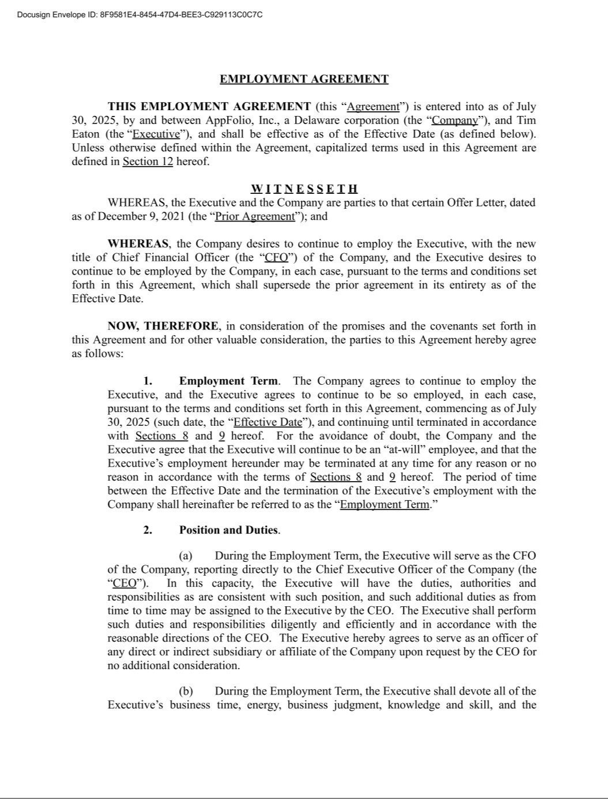

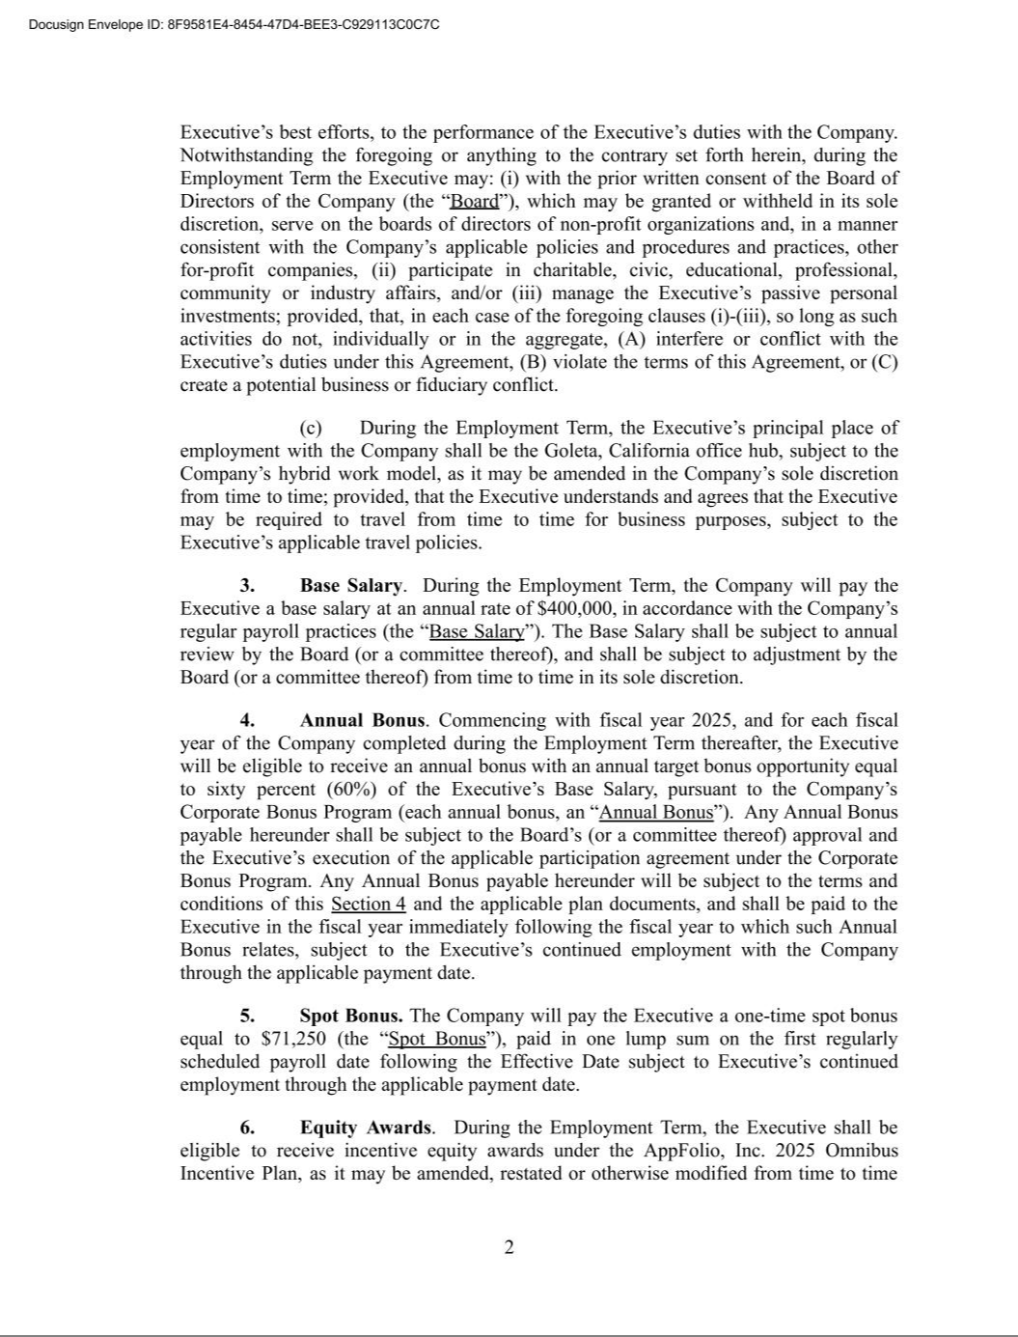

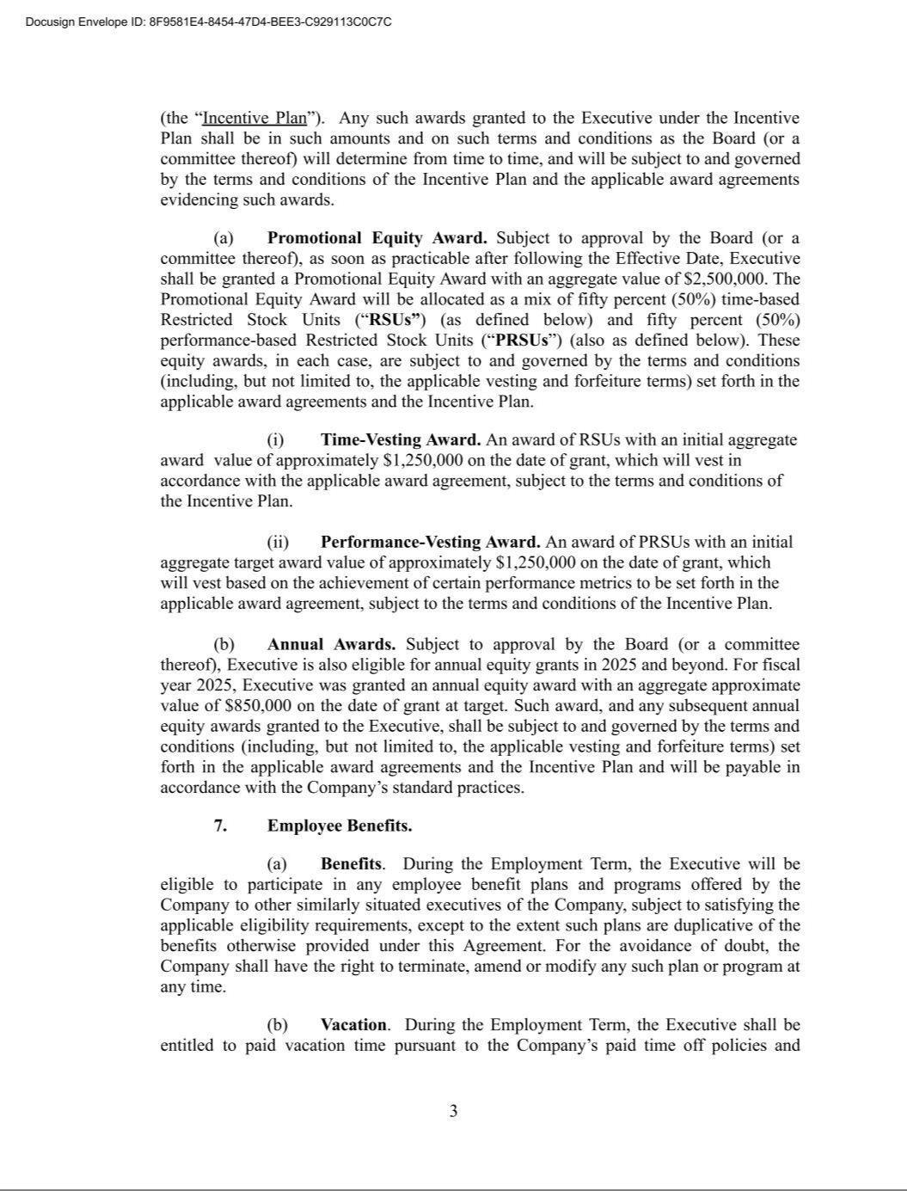

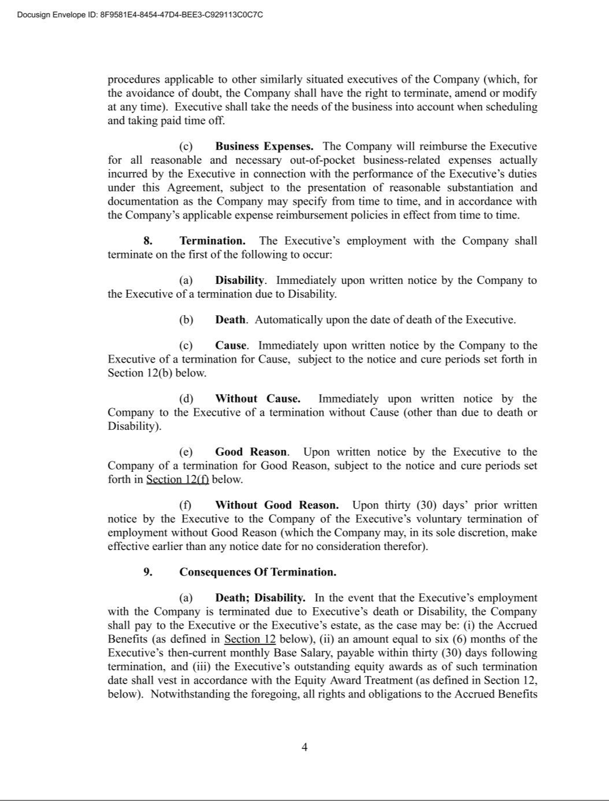

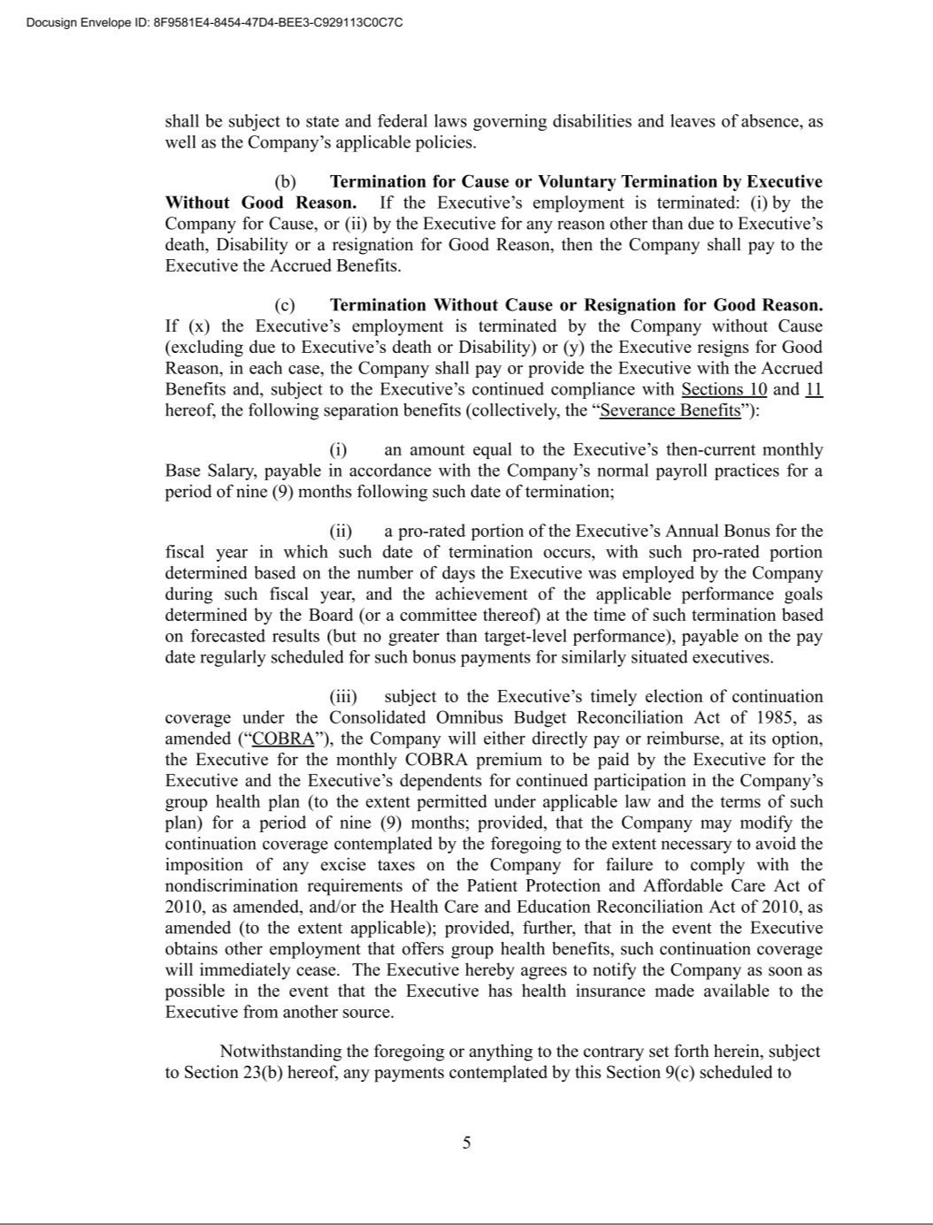

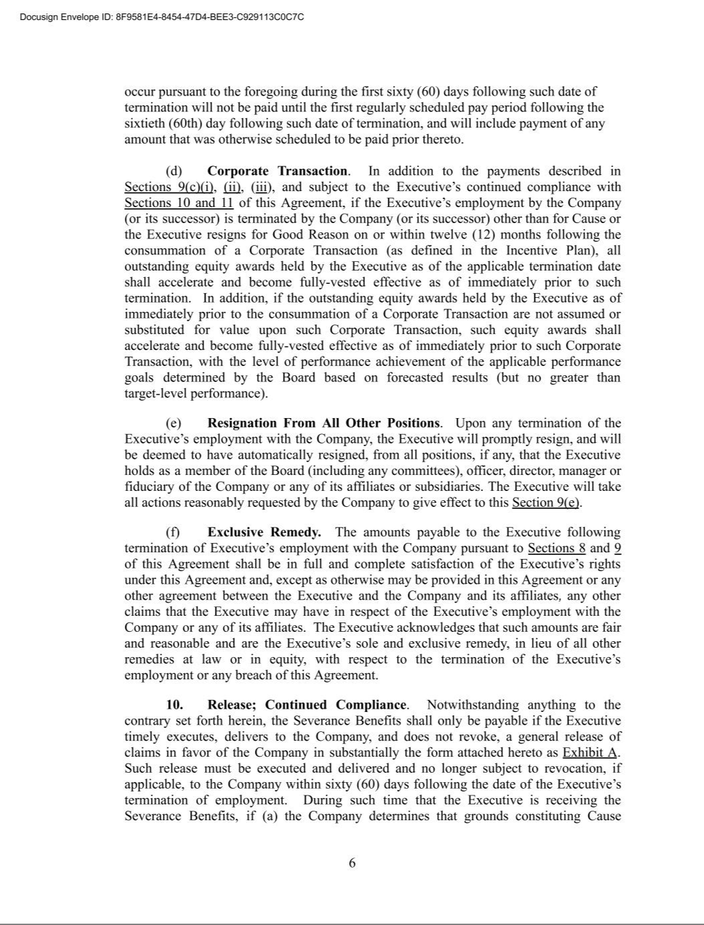

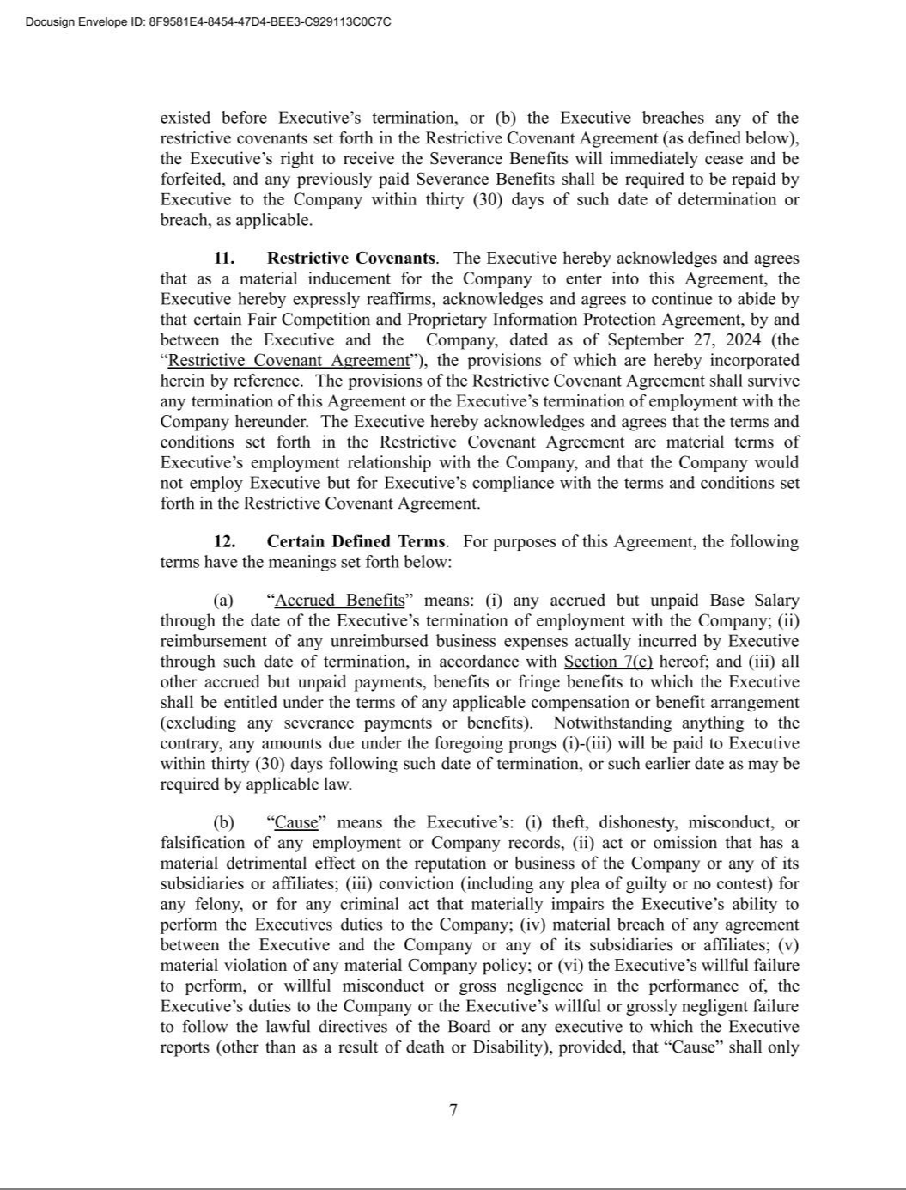

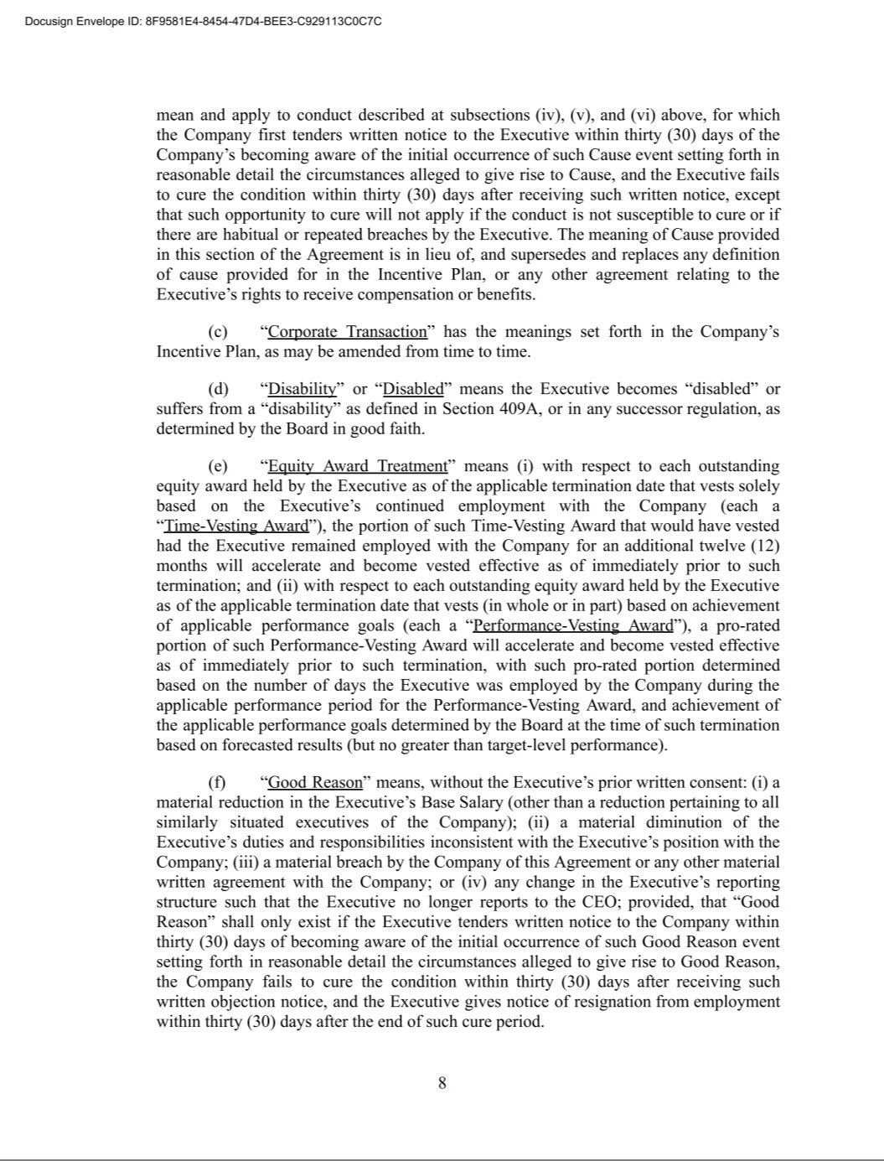

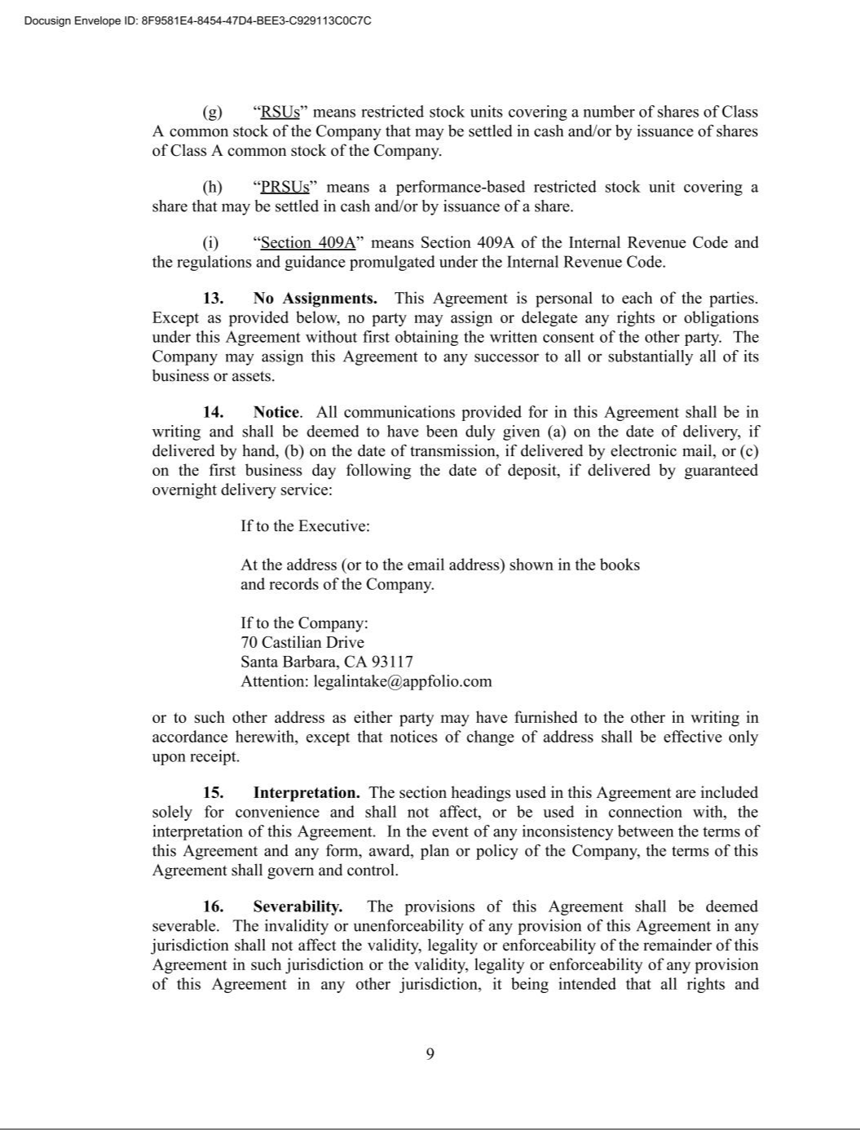

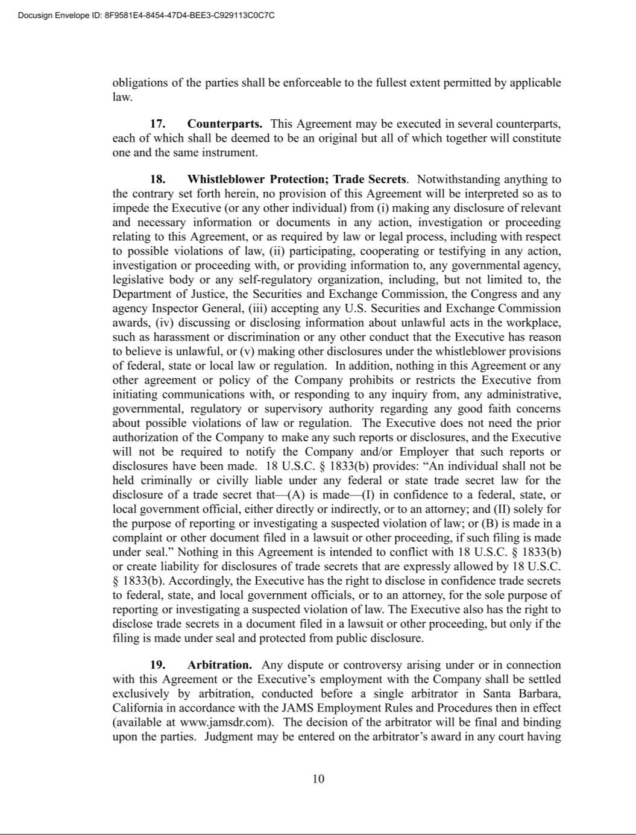

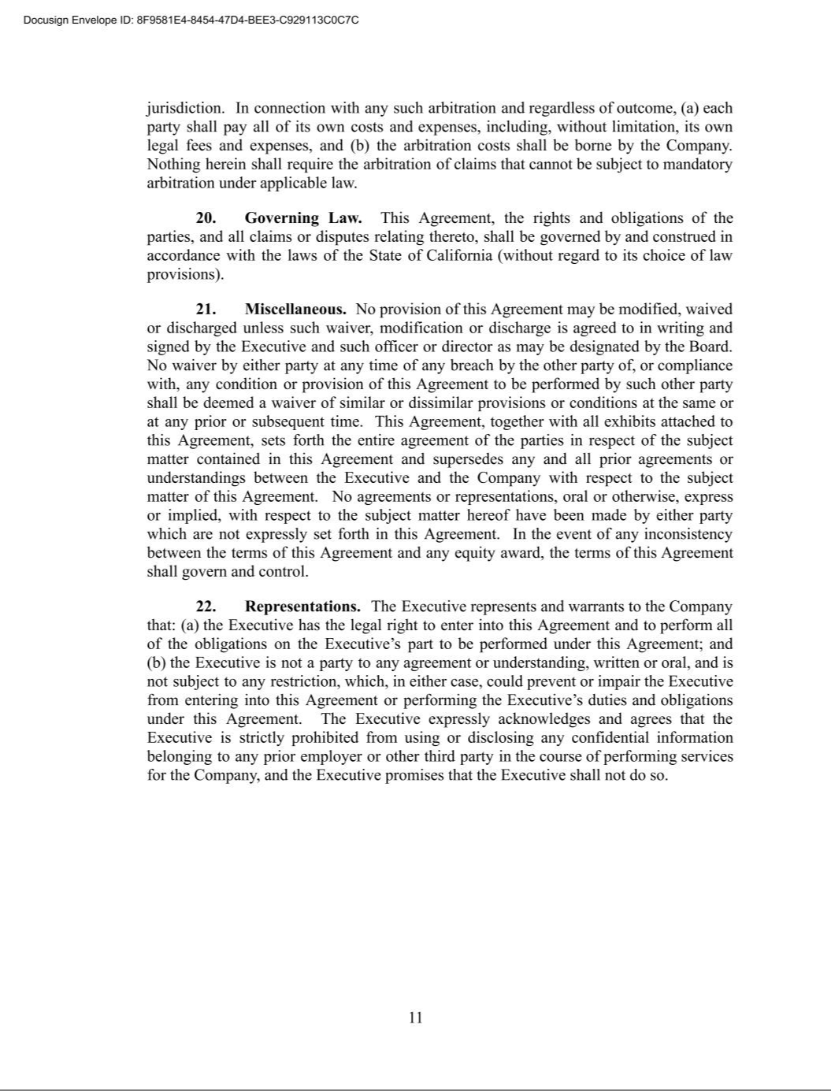

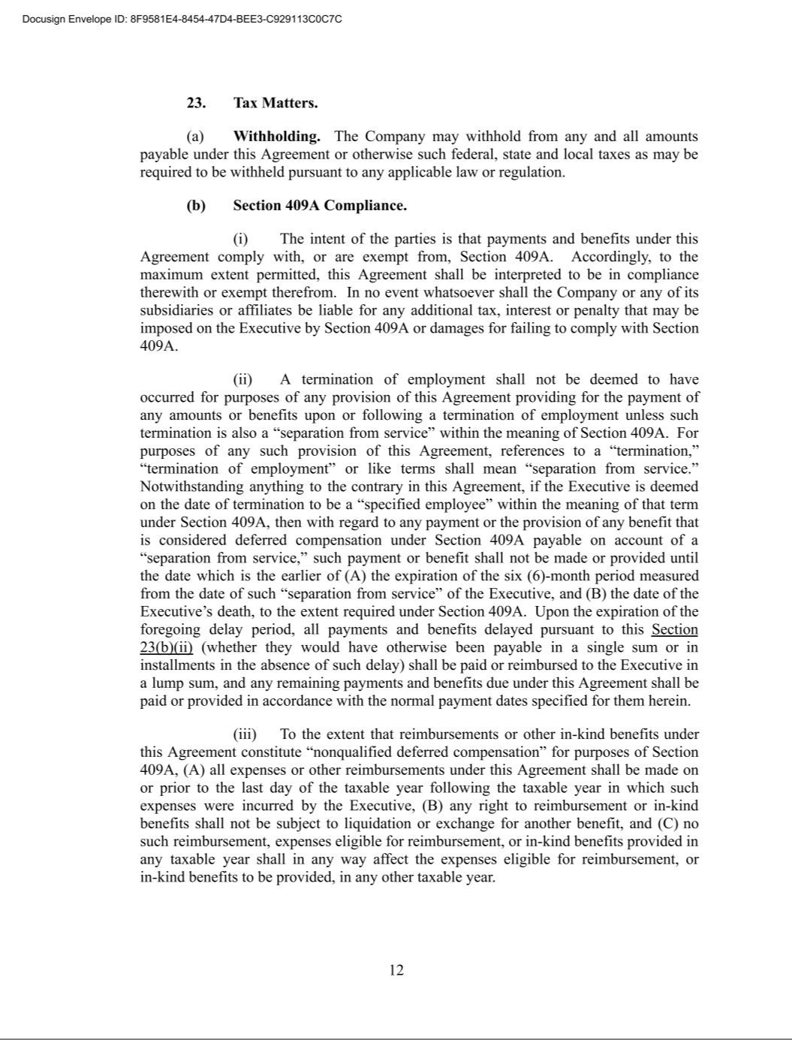

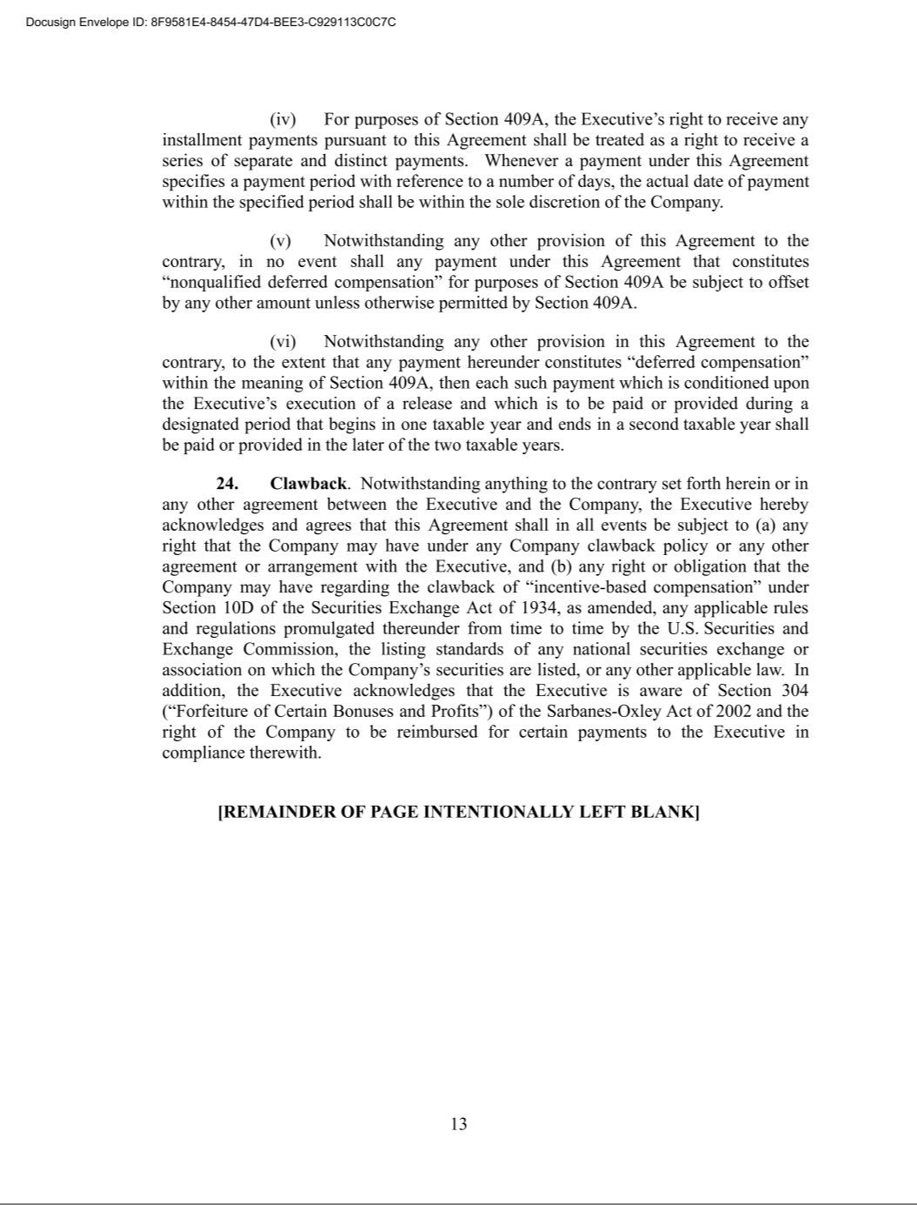

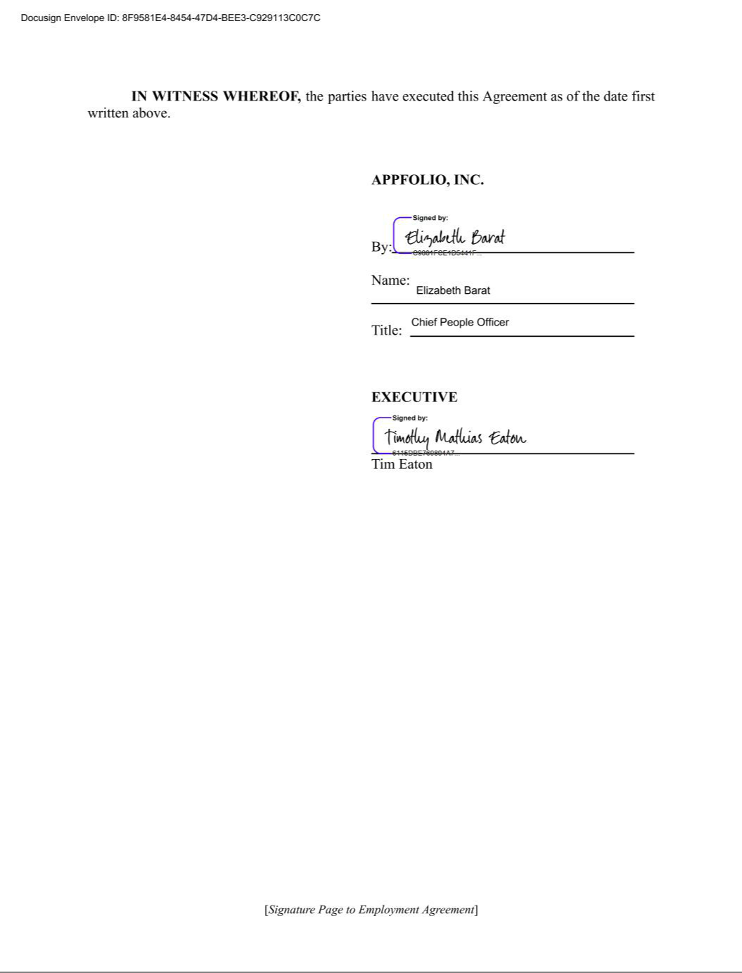

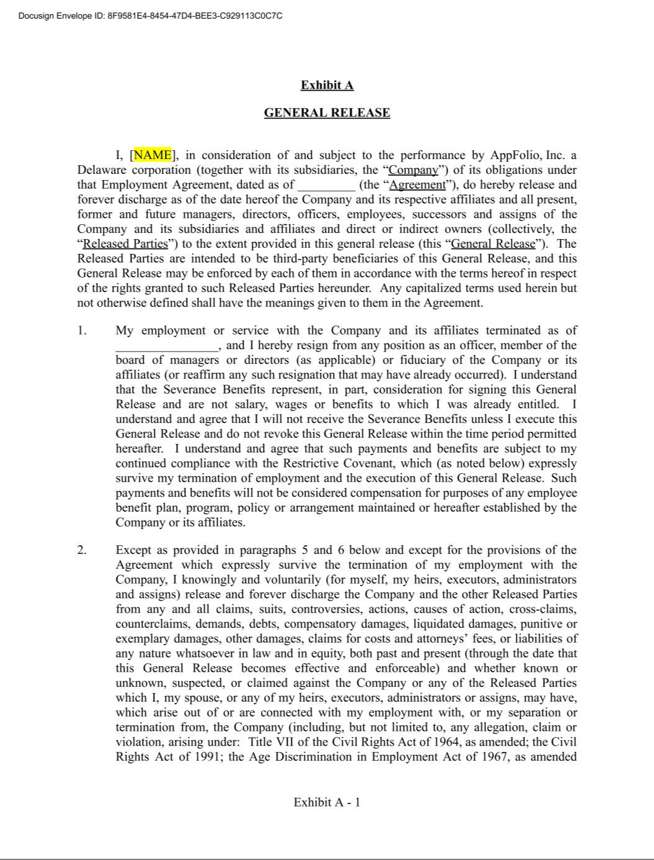

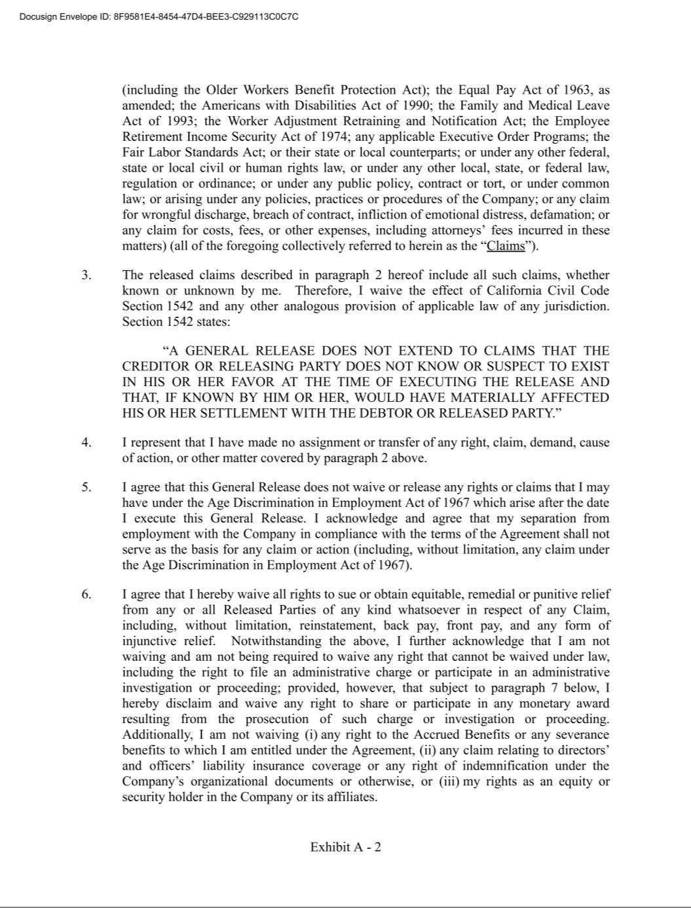

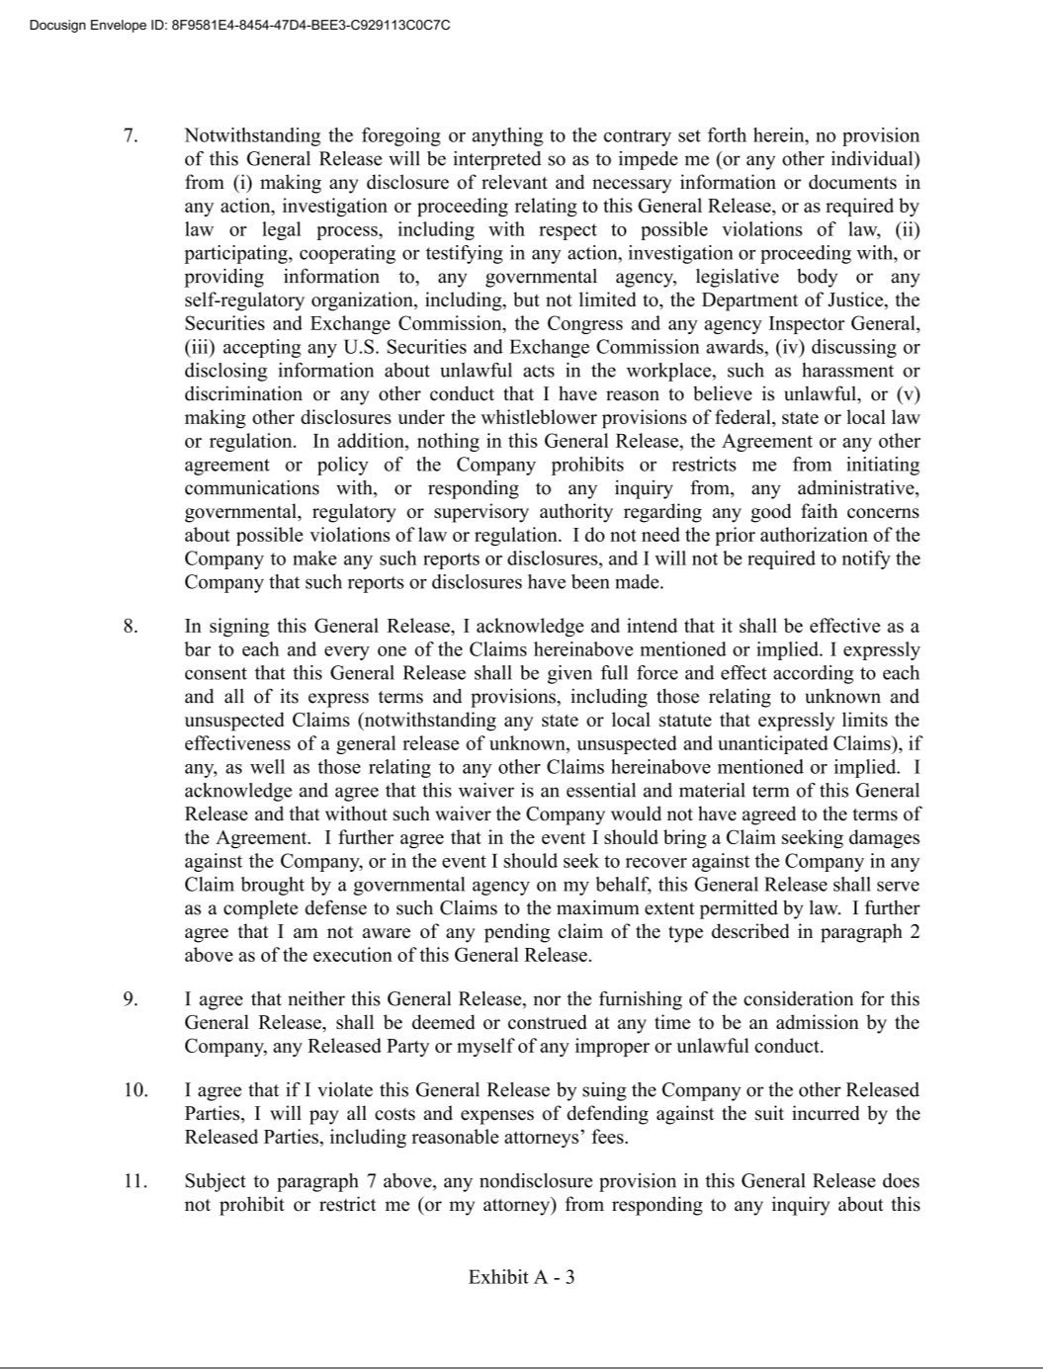

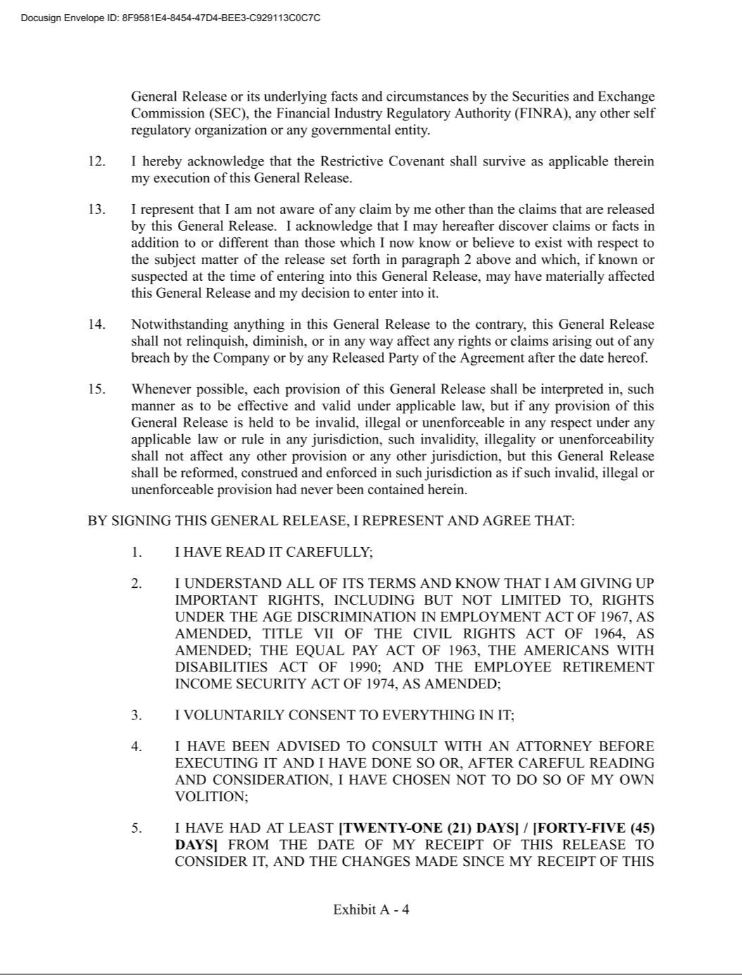



EXHIBIT 31.1

CERTIFICATION OF CHIEF EXECUTIVE OFFICER

PURSUANT TO SECTION 302 OF THE SARBANES-OXLEY ACT OF 2002

I, Shane Trigg, certify that:

- I have reviewed this Quarterly Report on Form 10-Q of AppFolio, Inc.;

- Based on my knowledge, this report does not contain any untrue statement of a material fact or omit to state a material fact necessary to make the statements made, in light of the circumstances under which such statements were made, not misleading with respect to the period covered by this report;

- Based on my knowledge, the financial statements, and other financial information included in this report, fairly present in all material respects the financial condition, results of operations and cash flows of the registrant as of, and for, the periods presented in this report;

- The registrant's other certifying officer and I are responsible for establishing and maintaining disclosure controls and procedures (as defined in Exchange Act Rules 13a-15(e) and
15d-15(e)) and internal control over financial reporting (as defined in Exchange Act Rules 13a-15(f) and 15d-15(f)) for the registrant and have:

    - Designed such disclosure controls and procedures, or caused such disclosure controls and procedures to be designed under our supervision, to ensure that material information relating to the registrant, including its consolidated subsidiaries, is made known to us by others within those entities, particularly during the period in which this report is being prepared;

    - Designed such internal control over financial reporting, or caused such internal control over financial reporting to be designed under our supervision, to provide reasonable assurance regarding the reliability of financial reporting and the preparation of financial statements for external purposes in accordance with generally accepted accounting principles;

    - Evaluated the effectiveness of the registrant’s disclosure controls and procedures and presented in this report our conclusions about the effectiveness of the disclosure controls and procedures, as of the end of the period covered by this report based on such evaluation; and

    - Disclosed in this report any change in the registrant’s internal control over financial reporting that occurred during the registrant’s most recent fiscal quarter (the registrant’s fourth fiscal quarter in the case of an annual report) that has materially affected, or is reasonably likely to materially affect, the registrant’s internal control over financial reporting; and

- The registrant's other certifying officer and I have disclosed, based on our most recent evaluation of internal control over financial reporting, to the registrant’s auditors and the audit committee of the registrant’s board of directors (or persons performing the equivalent functions):

  - All significant deficiencies and material weaknesses in the design or operation of internal control over financial reporting which are reasonably likely to adversely affect the registrant’s ability to record, process, summarize and report financial information; and

  - Any fraud, whether or not material, that involves management or other employees who have a significant role in the registrant’s internal control over financial reporting.

Date: July 31, 2025 /s/ Shane Trigg

Shane Trigg

Chief Executive Officer

EXHIBIT 31.2

CERTIFICATION OF CHIEF FINANCIAL OFFICER

PURSUANT TO SECTION 302 OF THE SARBANES-OXLEY ACT OF 2002

I, Tim Eaton, certify that:

- I have reviewed this Quarterly Report on Form 10-Q of AppFolio, Inc.;

- Based on my knowledge, this report does not contain any untrue statement of a material fact or omit to state a material fact necessary to make the statements made, in light of the circumstances under which such statements were made, not misleading with respect to the period covered by this report;

- Based on my knowledge, the financial statements, and other financial information included in this report, fairly present in all material respects the financial condition, results of operations and cash flows of the registrant as of, and for, the periods presented in this report;

- The registrant's other certifying officer and I are responsible for establishing and maintaining disclosure controls and procedures (as defined in Exchange Act Rules 13a-15(e) and
15d-15(e)) and internal control over financial reporting (as defined in Exchange Act Rules 13a-15(f) and 15d-15(f)) for the registrant and have:

    - Designed such disclosure controls and procedures, or caused such disclosure controls and procedures to be designed under our supervision, to ensure that material information relating to the registrant, including its consolidated subsidiaries, is made known to us by others within those entities, particularly during the period in which this report is being prepared;

  - Designed such internal control over financial reporting, or caused such internal control over financial reporting to be designed under our supervision, to provide reasonable assurance regarding the reliability of financial reporting and the preparation of financial statements for external purposes in accordance with generally accepted accounting principles;

    - Evaluated the effectiveness of the registrant’s disclosure controls and procedures and presented in this report our conclusions about the effectiveness of the disclosure controls and procedures, as of the end of the period covered by this report based on such evaluation; and

    - Disclosed in this report any change in the registrant’s internal control over financial reporting that occurred during the registrant’s most recent fiscal quarter (the registrant’s fourth fiscal quarter in the case of an annual report) that has materially affected, or is reasonably likely to materially affect, the registrant’s internal control over financial reporting; and

- The registrant's other certifying officer and I have disclosed, based on our most recent evaluation of internal control over financial reporting, to the registrant’s auditors and the audit committee of the registrant’s board of directors (or persons performing the equivalent functions):

      - All significant deficiencies and material weaknesses in the design or operation of internal control over financial reporting which are reasonably likely to adversely affect the registrant’s ability to record, process, summarize and report financial information; and

      - Any fraud, whether or not material, that involves management or other employees who have a significant role in the registrant’s internal control over financial reporting.

Date: July 31, 2025 /s/ Tim Eaton

Tim Eaton

Chief Financial Officer

EXHIBIT 32.1

CERTIFICATIONS OF CHIEF EXECUTIVE OFFICER AND CHIEF FINANCIAL OFFICER

PURSUANT TO 18 U.S.C. SECTION 1350,

AS ADOPTED PURSUANT TO SECTION 906 OF THE SARBANES-OXLEY ACT OF 2002

The following certifications are hereby made in connection with the Quarterly Report on Form 10-Q of AppFolio, Inc. (the “Company”) for the period ended June 30, 2025, as filed with the

Securities and Exchange Commission on the date hereof (the “Report”):

I, Shane Trigg, President and Chief Executive Officer of the Company, hereby certify, pursuant to 18 U.S.C. Section 1350, as adopted pursuant to Section 906 of the Sarbanes-Oxley Act of 2002, that, to my knowledge, (i) the Report fully complies with the requirements of Section 13(a) or 15(d) of the Securities Exchange Act of 1934, as amended, and (ii) the information contained in the Report fairly presents, in all material respects, the financial condition and results of operations of the Company as of the dates and for the periods presented.

Date: | July 31, 2025 | By: | /s/ Shane Trigg
 |  |  | Shane Trigg
 |  |  | President and Chief Executive Officer

I, Tim Eaton, Interim Chief Financial Officer of the Company, hereby certify, pursuant to 18 U.S.C. Section 1350, as adopted pursuant to Section 906 of the Sarbanes-Oxley Act of 2002, that, to my knowledge, (i) the Report fully complies with the requirements of Section 13(a) or 15(d) of the Securities Exchange Act of 1934, as amended, and (ii) the information contained in the Report fairly presents, in all material respects, the financial condition and results of operations of the Company as of the dates and for the periods presented.

Date: | July 31, 2025 | By: | /s/ Tim Eaton
 |  |  | Tim Eaton
 |  |  | Chief Financial Officer

