Table of Contents
UNITED STATES
SECURITIES AND EXCHANGE COMMISSION
Washington, D.C. 20549

FORM 10-Q
(Mark one)
☒ QUARTERLY REPORT PURSUANT TO SECTION 13 OR 15(d) OF THE SECURITIES EXCHANGE ACT OF 1934
For the quarterly period ended June 30, 2024.
☐ TRANSITION REPORT PURSUANT TO SECTION 13 OR 15(d) OF THE SECURITIES EXCHANGE ACT OF 1934
For the transition period from ________ to ________.

Commission File Number 001-37468
AppFolio, Inc.
(Exact name of registrant as specified in its charter)
Delaware |  |  |  |  |  |  |  |  |  |  |  | 26-0359894
(State of incorporation or organization) |  |  |  |  |  |  |  |  |  |  |  | (I.R.S. Employer Identification No.)
70 Castilian Drive |  |  |  |  |  |  |  |  |  |  |  | 93117
Santa Barbara, |  |  |  |  |  | California
(Address of principal executive offices) |  |  |  |  |  |  |  |  |  |  |  | (Zip Code)
(805) 364-6093
(Registrant’s telephone number, including area code)
N/A
(Former name, former address and former fiscal year, if changed since last report)
Securities registered pursuant to Section 12(b) of the Act:
Title of each class |  |  | Trading Symbol |  |  | Name of each exchange on which registered
Class A common stock, $0.0001 par value |  |  | APPF |  |  | NASDAQ Global Market
Indicate by check mark whether the registrant (1) has filed all reports required to be filed by Section 13 or 15(d) of the Securities Exchange Act of 1934 during the preceding 12 months (or for such shorter period that the registrant was required to file such reports), and (2) has been subject to such filing requirements for the past 90 days. Yes ☒ No ☐
Indicate by check mark whether the registrant has submitted electronically every Interactive Data File required to be submitted pursuant to Rule 405 of Regulation S-T (§232.405 of this chapter) during the preceding 12 months (or for such shorter period that the registrant was required to submit such files). Yes ☒ No ☐
Indicate by check mark whether the registrant is a large accelerated filer, an accelerated filer, a non-accelerated filer, a smaller reporting company or an emerging growth company. See the definitions of “large accelerated filer,” “accelerated filer,” “smaller reporting company” and "emerging growth company" in Rule 12b-2 of the Exchange Act.
Large accelerated filer |  |  |  |  |  | ☒ |  |  |  |  |  | Accelerated filer |  |  | ☐
Non-accelerated filer |  |  |  |  |  | ☐ |  |  |  |  |  | Smaller reporting company |  |  | ☐
 |  |  |  |  |  |  |  |  |  |  |  | Emerging growth company |  |  | ☐
If an emerging growth company, indicate by check mark if the registrant has elected not to use the extended transition period for complying with any new or revised financial accounting standards provided pursuant to Section 13(a) of the Exchange Act. ☐

Indicate by check mark whether the registrant is a shell company (as defined in Rule 12b-2 of the Exchange Act). Yes ☐ No ☒

As of July 19, 2024, the number of shares of the registrant’s Class A common stock outstanding was 23,008,417 and the number of shares of the registrant’s Class B common stock outstanding was 13,264,148.

Table of Contents
TABLE OF CONTENTS

 |  |  |  |  |  | Page No.
Forward-Looking Statements |  |  |  |  |  | 1
Part I. Financial Information |  |  |  |  |  | 2
Item 1. Condensed Consolidated Financial Statements (Unaudited) |  |  |  |  |  | 2
Condensed Consolidated Balance Sheets as of June 30, 2024 and December 31, 2023 |  |  |  |  |  | 3
Condensed Consolidated Statements of Operations for the Three and Six Months Ended June 30, 2024 and 2023 |  |  |  |  |  | 4
Condensed Consolidated Statements of Comprehensive Income (Loss) for the Three and Six Months Ended June 30, 2024 and 2023 |  |  |  |  |  | 5
Condensed Consolidated Statements of Stockholders' Equity for the Three and Six Months Ended June 30, 2024 and 2023 |  |  |  |  |  | 6
Condensed Consolidated Statements of Cash Flows for the Six Months Ended June 30, 2024 and 2023 |  |  |  |  |  | 8
Notes to Condensed Consolidated Unaudited Financial Statements |  |  |  |  |  | 9
Item 2. Management’s Discussion and Analysis of Financial Condition and Results of Operations |  |  |  |  |  | 16
Item 3. Quantitative and Qualitative Disclosures about Market Risk |  |  |  |  |  | 22
Item 4. Controls and Procedures |  |  |  |  |  | 23
Part II. Other Information |  |  |  |  |  | 24
Item 1. Legal Proceedings |  |  |  |  |  | 24
Item 1A. Risk Factors |  |  |  |  |  | 24
Item 5. Other Information |  |  |  |  |  | 24
Item 6. Exhibits |  |  |  |  |  | 25
Signatures

Table of Contents
FORWARD-LOOKING STATEMENTS

This Quarterly Report on Form 10-Q for the fiscal quarter ended June 30, 2024 (this "Quarterly Report"), contains forward-looking statements within the meaning of the federal securities laws, including the Private Securities Litigation Reform Act of 1995 (the “PSLRA”), which statements involve substantial risks and uncertainties. The forward-looking statements made in this Quarterly Report are intended to qualify for the protection of the safe harbor provided by the PSLRA and are based primarily on our current expectations and projections about future events and trends that we believe may affect our business, financial condition, operating results, cash flows and/or prospects. Forward-looking statements include all statements that are not statements of historical fact. Forward-looking statements can also be identified by words such as “may,” “will,” “should,” “might,” “expects,” “plans,” “anticipates,” “could,” “intends,” “target,” “projects,” “contemplates,” “believes,” “estimates,” “predicts,” “potential,” “future,” or “continue,” or the negative of these words or other similar terms or expressions. Examples of forward-looking statements include, among others, statements regarding changes in the competitive environment, responding to customer needs, research and product development plans, future products and services, growth in the size of our business and number of customers, strategic plans and objectives, business forecasts and plans, our future or assumed financial condition, results of operations and liquidity, trends affecting our business and industry, capital needs and financing plans, capital resource allocation plans, share repurchase plans, and commitments and contingencies, including with respect to the outcome of legal proceedings or regulatory matters. We cannot assure you that the results, events, and circumstances reflected in the forward-looking statements will be achieved or occur, and actual results, events, or circumstances could differ materially from those described in the forward-looking statements. The outcome of the events described in these forward-looking statements is subject to risks, uncertainties, and other factors, including those risks, uncertainties and other factors described in the section entitled "Management's Discussion and Analysis of Financial Condition and Results of Operations" in this Quarterly Report and "Risk Factors" in our Annual Report on Form 10-K for the fiscal year ended December 31, 2023 (our "Annual Report"), as well as in the other reports we file with the Securities and Exchange Commission (the "SEC"). You should read this Quarterly Report, and the other documents we file with the SEC, with the understanding that our actual future results may be materially different from the results expressed or implied by these forward-looking statements. As such, you should not rely upon forward-looking statements as predictions of future events. Any forward-looking statement made by us in this Quarterly Report is based only on information currently available to us and speaks only as of the date on which it is made. We undertake no obligation to update any forward-looking statements made in this Quarterly Report to reflect events or circumstances after the date of this Quarterly Report or to reflect new information or the occurrence of unanticipated events, except as required by law.

1
Table of Contents
PART I. FINANCIAL INFORMATION
Item 1. Condensed Consolidated Financial Statements

2
Table of Contents
APPFOLIO, INC.
CONDENSED CONSOLIDATED BALANCE SHEETS
(UNAUDITED)
(in thousands)
 |  |  |  |  |  | June 30,  2024 |  |  |  |  |  | December 31,  2023
Assets
Current assets
Cash and cash equivalents |  |  |  |  |  | $ | 59,639 |  |  |  |  | $ | 49,509
Investment securities—current |  |  |  |  |  | 221,693 |  |  |  |  |  | 162,196
Accounts receivable, net |  |  |  |  |  | 25,691 |  |  |  |  |  | 20,709
Prepaid expenses and other current assets |  |  |  |  |  | 41,774 |  |  |  |  |  | 39,943
Total current assets |  |  |  |  |  | 348,797 |  |  |  |  |  | 272,357
Property and equipment, net |  |  |  |  |  | 26,700 |  |  |  |  |  | 28,362
Operating lease right-of-use assets |  |  |  |  |  | 18,232 |  |  |  |  |  | 19,285
Capitalized software development costs, net |  |  |  |  |  | 17,345 |  |  |  |  |  | 21,562
Goodwill |  |  |  |  |  | 56,060 |  |  |  |  |  | 56,060
Other long-term assets |  |  |  |  |  | 12,183 |  |  |  |  |  | 11,263
Total assets |  |  |  |  |  | $ | 479,317 |  |  |  |  | $ | 408,889
Liabilities and Stockholders’ Equity
Current liabilities
Accounts payable |  |  |  |  |  | $ | 1,256 |  |  |  |  | $ | 1,141
Accrued employee expenses |  |  |  |  |  | 31,962 |  |  |  |  |  | 35,567
Accrued expenses |  |  |  |  |  | 16,423 |  |  |  |  |  | 21,723
Other current liabilities |  |  |  |  |  | 13,708 |  |  |  |  |  | 11,335
Total current liabilities |  |  |  |  |  | 63,349 |  |  |  |  |  | 69,766
Operating lease liabilities |  |  |  |  |  | 39,447 |  |  |  |  |  | 41,114
Other liabilities |  |  |  |  |  | 5,109 |  |  |  |  |  | 697
Total liabilities |  |  |  |  |  | 107,905 |  |  |  |  |  | 111,577
Commitments and contingencies (Note 8)
Stockholders’ equity:
Class A common stock |  |  |  |  |  | 2 |  |  |  |  |  | 2
Class B common stock |  |  |  |  |  | 2 |  |  |  |  |  | 2
Additional paid-in capital |  |  |  |  |  | 243,040 |  |  |  |  |  | 236,985
Accumulated other comprehensive Income (loss) |  |  |  |  |  | (184) |  |  |  |  |  | 99
Treasury stock |  |  |  |  |  | (25,756) |  |  |  |  |  | (25,756)
Retained earnings |  |  |  |  |  | 154,308 |  |  |  |  |  | 85,980
Total stockholders’ equity |  |  |  |  |  | 371,412 |  |  |  |  |  | 297,312
Total liabilities and stockholders’ equity |  |  |  |  |  | $ | 479,317 |  |  |  |  | $ | 408,889
The accompanying Notes to Condensed Consolidated Financial Statements are an integral part of these statements.

3
Table of Contents
APPFOLIO, INC.
CONDENSED CONSOLIDATED STATEMENTS OF OPERATIONS
(UNAUDITED)
(in thousands, except per share amounts)

 |  |  | Three Months Ended  June 30, |  |  |  |  |  |  |  |  |  |  |  | Six Months Ended  June 30,
 |  |  | 2024 |  |  |  |  |  | 2023 |  |  |  |  |  | 2024 |  |  |  |  |  | 2023
Revenue |  |  | $ | 197,375 |  |  |  |  | $ | 147,075 |  |  |  |  | $ | 384,805 |  |  |  |  | $ | 283,175
Costs and operating expenses:
Cost of revenue (exclusive of depreciation and amortization)(1) |  |  | 69,601 |  |  |  |  |  | 57,854 |  |  |  |  |  | 134,247 |  |  |  |  |  | 114,062
Sales and marketing(1) |  |  | 27,300 |  |  |  |  |  | 27,002 |  |  |  |  |  | 51,755 |  |  |  |  |  | 56,400
Research and product development(1) |  |  | 39,522 |  |  |  |  |  | 37,263 |  |  |  |  |  | 77,417 |  |  |  |  |  | 74,925
General and administrative(1) |  |  | 20,254 |  |  |  |  |  | 18,819 |  |  |  |  |  | 41,386 |  |  |  |  |  | 50,510
Depreciation and amortization |  |  | 4,670 |  |  |  |  |  | 6,816 |  |  |  |  |  | 9,882 |  |  |  |  |  | 14,487
Total costs and operating expenses |  |  | 161,347 |  |  |  |  |  | 147,754 |  |  |  |  |  | 314,687 |  |  |  |  |  | 310,384
Income (loss) from operations |  |  | 36,028 |  |  |  |  |  | (679) |  |  |  |  |  | 70,118 |  |  |  |  |  | (27,209)
Other income (loss), net |  |  | — |  |  |  |  |  | (54) |  |  |  |  |  | — |  |  |  |  |  | (34)
Interest income, net |  |  | 3,476 |  |  |  |  |  | 1,478 |  |  |  |  |  | 6,468 |  |  |  |  |  | 2,839
Income (loss) before provision for income taxes |  |  | 39,504 |  |  |  |  |  | 745 |  |  |  |  |  | 76,586 |  |  |  |  |  | (24,404)
Provision for income taxes |  |  | 9,839 |  |  |  |  |  | 19,646 |  |  |  |  |  | 8,258 |  |  |  |  |  | 29,607
Net income (loss) |  |  | $ | 29,665 |  |  |  |  | $ | (18,901) |  |  |  |  | $ | 68,328 |  |  |  |  | $ | (54,011)
Net income (loss) per common share:
Basic |  |  | $ | 0.82 |  |  |  |  | $ | (0.53) |  |  |  |  | $ | 1.89 |  |  |  |  | $ | (1.52)
Diluted |  |  | $ | 0.81 |  |  |  |  | $ | (0.53) |  |  |  |  | $ | 1.86 |  |  |  |  | $ | (1.52)
Weighted average common shares outstanding:
Basic |  |  | 36,241 |  |  |  |  |  | 35,565 |  |  |  |  |  | 36,164 |  |  |  |  |  | 35,505
Diluted |  |  | 36,742 |  |  |  |  |  | 35,565 |  |  |  |  |  | 36,720 |  |  |  |  |  | 35,505
(1) Includes stock-based compensation expense as follows:
 |  |  | Three Months Ended  June 30, |  |  |  |  |  |  |  |  |  |  |  | Six Months Ended  June 30,
 |  |  | 2024 |  |  |  |  |  | 2023 |  |  |  |  |  | 2024 |  |  |  |  |  | 2023
Stock-based compensation expense included in costs and operating expenses:
Cost of revenue (exclusive of depreciation and amortization) |  |  | $ | 1,175 |  |  |  |  | $ | 988 |  |  |  |  | $ | 2,135 |  |  |  |  | $ | 1,756
Sales and marketing |  |  | 1,703 |  |  |  |  |  | 444 |  |  |  |  |  | 3,213 |  |  |  |  |  | 2,861
Research and product development |  |  | 6,472 |  |  |  |  |  | 4,348 |  |  |  |  |  | 12,154 |  |  |  |  |  | 9,787
General and administrative |  |  | 5,444 |  |  |  |  |  | 4,992 |  |  |  |  |  | 10,766 |  |  |  |  |  | 10,271
Total stock-based compensation expense |  |  | $ | 14,794 |  |  |  |  | $ | 10,772 |  |  |  |  | $ | 28,268 |  |  |  |  | $ | 24,675

The accompanying Notes to Condensed Consolidated Financial Statements are an integral part of these statements.

4
Table of Contents

APPFOLIO, INC.
CONDENSED CONSOLIDATED STATEMENTS OF COMPREHENSIVE INCOME (LOSS)
(UNAUDITED)
(in thousands)

 |  |  | Three Months Ended  June 30, |  |  |  |  |  |  |  |  |  |  |  | Six Months Ended  June 30,
 |  |  | 2024 |  |  |  |  |  | 2023 |  |  |  |  |  | 2024 |  |  |  |  |  | 2023
Net income (loss) |  |  | $ | 29,665 |  |  |  |  | $ | (18,901) |  |  |  |  | $ | 68,328 |  |  |  |  | $ | (54,011)
Other comprehensive income (loss):
Changes in unrealized (losses) gains on investment securities, net of tax |  |  | (69) |  |  |  |  |  | 334 |  |  |  |  |  | (283) |  |  |  |  |  | 1,097
Comprehensive income (loss) |  |  | $ | 29,596 |  |  |  |  | $ | (18,567) |  |  |  |  | $ | 68,045 |  |  |  |  | $ | (52,914)
The accompanying Notes to Condensed Consolidated Financial Statements are an integral part of these statements.

5
Table of Contents

APPFOLIO, INC.
CONDENSED CONSOLIDATED STATEMENTS OF STOCKHOLDERS' EQUITY
(UNAUDITED)
(in thousands)
 |  |  |  |  |  |  |  |  |  |  |  |  |  |  |  |  |  |  |  |  |  |  |  |  |  |  |  |  |  |  |  |  | Accumulated
 |  |  |  |  |  |  |  |  |  |  |  |  |  |  |  |  |  |  |  |  |  |  |  |  |  |  | Additional |  |  |  |  |  | Other
 |  |  | Common Stock |  |  |  |  |  |  |  |  |  |  |  | Common Stock |  |  |  |  |  |  |  |  |  |  |  | Paid-in |  |  |  |  |  | Comprehensive |  |  |  |  |  | Treasury |  |  |  |  |  | Retained
 |  |  | Class A |  |  |  |  |  |  |  |  |  |  |  | Class B |  |  |  |  |  |  |  |  |  |  |  | Capital |  |  |  |  |  | Income (Loss) |  |  |  |  |  | Stock |  |  |  |  |  | Earnings |  |  |  |  |  | Total
 |  |  | Shares |  |  |  |  |  | Amount |  |  |  |  |  | Shares |  |  |  |  |  | Amount
Balance at December 31, 2023 |  |  | 21,749 |  |  |  |  |  | $ | 2 |  |  |  |  | 14,116 |  |  |  |  |  | $ | 2 |  |  |  |  | $ | 236,985 |  |  |  |  | $ | 99 |  |  |  |  | $ | (25,756) |  |  |  |  | $ | 85,980 |  |  |  |  | $ | 297,312
Exercise of stock options |  |  | 244 |  |  |  |  |  | — |  |  |  |  |  | — |  |  |  |  |  | — |  |  |  |  |  | 3,874 |  |  |  |  |  | — |  |  |  |  |  | — |  |  |  |  |  | — |  |  |  |  |  | 3,874
Stock-based compensation |  |  | — |  |  |  |  |  | — |  |  |  |  |  | — |  |  |  |  |  | — |  |  |  |  |  | 13,646 |  |  |  |  |  | — |  |  |  |  |  | — |  |  |  |  |  | — |  |  |  |  |  | 13,646
Vesting of restricted stock units, net of shares withheld for taxes |  |  | 89 |  |  |  |  |  | — |  |  |  |  |  | — |  |  |  |  |  | — |  |  |  |  |  | (14,086) |  |  |  |  |  | — |  |  |  |  |  | — |  |  |  |  |  | — |  |  |  |  |  | (14,086)
Conversion of Class B common stock to Class A common stock |  |  | 199 |  |  |  |  |  | — |  |  |  |  |  | (199) |  |  |  |  |  | — |  |  |  |  |  | — |  |  |  |  |  | — |  |  |  |  |  | — |  |  |  |  |  | — |  |  |  |  |  | —
Other comprehensive loss |  |  | — |  |  |  |  |  | — |  |  |  |  |  | — |  |  |  |  |  | — |  |  |  |  |  | — |  |  |  |  |  | (214) |  |  |  |  |  | — |  |  |  |  |  | — |  |  |  |  |  | (214)
Net Income |  |  | — |  |  |  |  |  | — |  |  |  |  |  | — |  |  |  |  |  | — |  |  |  |  |  | — |  |  |  |  |  | — |  |  |  |  |  | — |  |  |  |  |  | 38,663 |  |  |  |  |  | 38,663
Balance at March 31, 2024 |  |  | 22,281 |  |  |  |  |  | $ | 2 |  |  |  |  | 13,917 |  |  |  |  |  | $ | 2 |  |  |  |  | $ | 240,419 |  |  |  |  | $ | (115) |  |  |  |  | $ | (25,756) |  |  |  |  | $ | 124,643 |  |  |  |  | $ | 339,195
Exercise of stock options |  |  | 3 |  |  |  |  |  | — |  |  |  |  |  | — |  |  |  |  |  | — |  |  |  |  |  | 25 |  |  |  |  |  | — |  |  |  |  |  | — |  |  |  |  |  | — |  |  |  |  |  | 25
Stock based compensation |  |  | — |  |  |  |  |  | — |  |  |  |  |  | — |  |  |  |  |  | — |  |  |  |  |  | 15,032 |  |  |  |  |  | — |  |  |  |  |  | — |  |  |  |  |  | — |  |  |  |  |  | 15,032
Vesting of restricted stock units, net of shares withheld for taxes |  |  | 71 |  |  |  |  |  | — |  |  |  |  |  | — |  |  |  |  |  | — |  |  |  |  |  | (12,436) |  |  |  |  |  | — |  |  |  |  |  | — |  |  |  |  |  | — |  |  |  |  |  | (12,436)
Conversion of Class B common stock to Class A common stock |  |  | 644 |  |  |  |  |  | — |  |  |  |  |  | (644) |  |  |  |  |  | — |  |  |  |  |  | — |  |  |  |  |  | — |  |  |  |  |  | — |  |  |  |  |  | — |  |  |  |  |  | —
Other comprehensive loss |  |  | — |  |  |  |  |  | — |  |  |  |  |  | — |  |  |  |  |  | — |  |  |  |  |  | — |  |  |  |  |  | (69) |  |  |  |  |  | — |  |  |  |  |  | — |  |  |  |  |  | (69)
Net Income |  |  | — |  |  |  |  |  | — |  |  |  |  |  | — |  |  |  |  |  | — |  |  |  |  |  | — |  |  |  |  |  | — |  |  |  |  |  | — |  |  |  |  |  | 29,665 |  |  |  |  |  | 29,665
Balance at June 30, 2024 |  |  | 22,999 |  |  |  |  |  | $ | 2 |  |  |  |  | 13,273 |  |  |  |  |  | $ | 2 |  |  |  |  | $ | 243,040 |  |  |  |  | $ | (184) |  |  |  |  | $ | (25,756) |  |  |  |  | $ | 154,308 |  |  |  |  | $ | 371,412
The accompanying Notes to Condensed Consolidated Financial Statements are an integral part of these statements.

6
Table of Contents
 |  |  |  |  |  |  |  |  |  |  |  |  |  |  |  |  |  |  |  |  |  |  |  |  |  |  |  |  |  |  |  |  | Accumulated
 |  |  |  |  |  |  |  |  |  |  |  |  |  |  |  |  |  |  |  |  |  |  |  |  |  |  | Additional |  |  |  |  |  | Other
 |  |  | Common Stock |  |  |  |  |  |  |  |  |  |  |  | Common Stock |  |  |  |  |  |  |  |  |  |  |  | Paid-in |  |  |  |  |  | Comprehensive |  |  |  |  |  | Treasury |  |  |  |  |  | Retained
 |  |  | Class A |  |  |  |  |  |  |  |  |  |  |  | Class B |  |  |  |  |  |  |  |  |  |  |  | Capital |  |  |  |  |  | Income (Loss) |  |  |  |  |  | Stock |  |  |  |  |  | Earnings |  |  |  |  |  | Total
 |  |  | Shares |  |  |  |  |  | Amount |  |  |  |  |  | Shares |  |  |  |  |  | Amount
Balance at December 31, 2022 |  |  | 20,569 |  |  |  |  |  | $ | 2 |  |  |  |  | 14,746 |  |  |  |  |  | $ | 2 |  |  |  |  | $ | 209,704 |  |  |  |  | $ | (1,684) |  |  |  |  | $ | (25,756) |  |  |  |  | $ | 83,278 |  |  |  |  | $ | 265,546
Exercise of stock options |  |  | 64 |  |  |  |  |  | — |  |  |  |  |  | — |  |  |  |  |  | — |  |  |  |  |  | 834 |  |  |  |  |  | — |  |  |  |  |  | — |  |  |  |  |  | — |  |  |  |  |  | 834
Stock-based compensation |  |  | — |  |  |  |  |  | — |  |  |  |  |  | — |  |  |  |  |  | — |  |  |  |  |  | 14,075 |  |  |  |  |  | — |  |  |  |  |  | — |  |  |  |  |  | — |  |  |  |  |  | 14,075
Vesting of restricted stock units, net of shares withheld for taxes |  |  | 79 |  |  |  |  |  | — |  |  |  |  |  | — |  |  |  |  |  | — |  |  |  |  |  | (5,539) |  |  |  |  |  | — |  |  |  |  |  | — |  |  |  |  |  | — |  |  |  |  |  | (5,539)
Conversion of Class B common stock to Class A common stock |  |  | 27 |  |  |  |  |  | — |  |  |  |  |  | (27) |  |  |  |  |  | — |  |  |  |  |  | — |  |  |  |  |  | — |  |  |  |  |  | — |  |  |  |  |  | — |  |  |  |  |  | —
Issuance of restricted stock awards |  |  | 2 |  |  |  |  |  | — |  |  |  |  |  | — |  |  |  |  |  | — |  |  |  |  |  | — |  |  |  |  |  | — |  |  |  |  |  | — |  |  |  |  |  | — |  |  |  |  |  | —
Other comprehensive income |  |  | — |  |  |  |  |  | — |  |  |  |  |  | — |  |  |  |  |  | — |  |  |  |  |  | — |  |  |  |  |  | 763 |  |  |  |  |  | — |  |  |  |  |  | — |  |  |  |  |  | 763
Net loss |  |  | — |  |  |  |  |  | — |  |  |  |  |  | — |  |  |  |  |  | — |  |  |  |  |  | — |  |  |  |  |  | — |  |  |  |  |  | — |  |  |  |  |  | (35,110) |  |  |  |  |  | (35,110)
Balance at March 31, 2023 |  |  | 20,741 |  |  |  |  |  | $ | 2 |  |  |  |  | 14,719 |  |  |  |  |  | $ | 2 |  |  |  |  | $ | 219,074 |  |  |  |  | $ | (921) |  |  |  |  | $ | (25,756) |  |  |  |  | $ | 48,168 |  |  |  |  | $ | 240,569
Exercise of stock options |  |  | 95 |  |  |  |  |  | — |  |  |  |  |  | — |  |  |  |  |  | — |  |  |  |  |  | 668 |  |  |  |  |  | — |  |  |  |  |  | — |  |  |  |  |  | — |  |  |  |  |  | 668
Stock-based compensation |  |  | — |  |  |  |  |  | — |  |  |  |  |  | — |  |  |  |  |  | — |  |  |  |  |  | 11,000 |  |  |  |  |  | — |  |  |  |  |  | — |  |  |  |  |  | — |  |  |  |  |  | 11,000
Vesting of restricted stock units, net of shares withheld for taxes |  |  | 82 |  |  |  |  |  | — |  |  |  |  |  | — |  |  |  |  |  | — |  |  |  |  |  | (7,717) |  |  |  |  |  | — |  |  |  |  |  | — |  |  |  |  |  | — |  |  |  |  |  | (7,717)
Issuance of restricted stock awards |  |  | 4 |  |  |  |  |  | — |  |  |  |  |  | — |  |  |  |  |  | — |  |  |  |  |  | — |  |  |  |  |  | — |  |  |  |  |  | — |  |  |  |  |  | — |  |  |  |  |  | —
Other comprehensive income |  |  | — |  |  |  |  |  | — |  |  |  |  |  | — |  |  |  |  |  | — |  |  |  |  |  | — |  |  |  |  |  | 334 |  |  |  |  |  | — |  |  |  |  |  | — |  |  |  |  |  | 334
Net loss |  |  | — |  |  |  |  |  | — |  |  |  |  |  | — |  |  |  |  |  | — |  |  |  |  |  | — |  |  |  |  |  | — |  |  |  |  |  | — |  |  |  |  |  | (18,901) |  |  |  |  |  | (18,901)
Balance at June 30, 2023 |  |  | 20,922 |  |  |  |  |  | $ | 2 |  |  |  |  | 14,719 |  |  |  |  |  | $ | 2 |  |  |  |  | $ | 223,025 |  |  |  |  | $ | (587) |  |  |  |  | $ | (25,756) |  |  |  |  | $ | 29,267 |  |  |  |  | $ | 225,953
The accompanying Notes to Condensed Consolidated Financial Statements are an integral part of these statements.

7
Table of Contents
APPFOLIO, INC.
CONDENSED CONSOLIDATED STATEMENTS OF CASH FLOWS
(UNAUDITED)
(in thousands)
Six Months Ended
June 30,
 |  |  | 2024 |  |  |  |  |  | 2023
Cash from operating activities
Net Income (loss) |  |  | $ | 68,328 |  |  |  |  | $ | (54,011)
Adjustments to reconcile net income (loss) to net cash provided by (used in) operating activities:
Depreciation and amortization |  |  | 8,892 |  |  |  |  |  | 13,135
Amortization of operating lease right-of-use assets |  |  | 1,053 |  |  |  |  |  | 1,109
Gain on lease modification |  |  | — |  |  |  |  |  | (4,281)
Stock-based compensation, including as amortized |  |  | 29,258 |  |  |  |  |  | 26,027
Other |  |  | (4,005) |  |  |  |  |  | (708)
Changes in operating assets and liabilities:
Accounts receivable |  |  | (4,982) |  |  |  |  |  | (3,530)
Prepaid expenses and other current assets |  |  | 5,157 |  |  |  |  |  | (2,066)
Accounts payable |  |  | 437 |  |  |  |  |  | (989)
Operating lease liabilities |  |  | (1,418) |  |  |  |  |  | (4,638)
Accrued expenses and other liabilities |  |  | (8,897) |  |  |  |  |  | 22,295
Net cash provided by (used in) operating activities |  |  | 93,823 |  |  |  |  |  | (7,657)
Cash from investing activities
Purchases of available-for-sale investments |  |  | (151,539) |  |  |  |  |  | (73,597)
Proceeds from sales of available-for-sale investments |  |  | — |  |  |  |  |  | 1,013
Proceeds from maturities of available-for-sale investments |  |  | 94,455 |  |  |  |  |  | 49,617
Purchases of property and equipment |  |  | (1,458) |  |  |  |  |  | (2,171)
Capitalization of software development costs |  |  | (2,529) |  |  |  |  |  | (2,151)
Proceeds from sale of business, net of cash divested |  |  | — |  |  |  |  |  | 629
Net cash used in investing activities |  |  | (61,071) |  |  |  |  |  | (26,660)
Cash from financing activities
Proceeds from stock option exercises |  |  | 3,898 |  |  |  |  |  | 1,502
Tax withholding for net share settlement |  |  | (26,520) |  |  |  |  |  | (13,256)
Net cash used in financing activities |  |  | (22,622) |  |  |  |  |  | (11,754)
Net increase (decrease) in cash, cash equivalents and restricted cash |  |  | 10,130 |  |  |  |  |  | (46,071)
Cash, cash equivalents and restricted cash
Beginning of period |  |  | 49,759 |  |  |  |  |  | 71,019
End of period |  |  | $ | 59,889 |  |  |  |  | $ | 24,948
Cash, cash equivalents and restricted cash at end of period:
Cash and cash equivalents |  |  | $ | 59,639 |  |  |  |  | $ | 24,698
Restricted cash included in prepaid expenses and other current assets |  |  | 250 |  |  |  |  |  | 250
Total cash, cash equivalents and restricted cash shown in the consolidated statements of cash flows |  |  | $ | 59,889 |  |  |  |  | $ | 24,948
Supplemental disclosure of cash flow information
Cash paid for amounts included in the measurement of lease liabilities included in operating cash flows |  |  | 2,966 |  |  |  |  |  | 5,805
The accompanying Notes to Condensed Consolidated Financial Statements are an integral part of these statements.

8
Table of Contents
APPFOLIO, INC.
NOTES TO CONDENSED CONSOLIDATED UNAUDITED FINANCIAL STATEMENTS

1. Nature of Business
AppFolio, Inc. ("we," "us" or "our") is a leading provider of cloud business management solutions for the real estate industry. Our solutions are designed to enable our property manager customers to digitally transform their businesses, address critical business operations and deliver a better customer experience. Digital transformation is effectively a requirement for business success in the modern world, and the way we work and live requires powerful software solutions.

2. Summary of Significant Accounting Policies
Basis of Presentation and Significant Accounting Policies
The accompanying unaudited Condensed Consolidated Financial Statements were prepared in accordance with accounting principles generally accepted in the United States (“GAAP”) for interim financial information. Certain information and disclosures normally included in consolidated financial statements prepared in accordance with GAAP have been condensed or omitted. Accordingly, these Condensed Consolidated Financial Statements should be read in conjunction with our audited consolidated financial statements and the related notes included in our Annual Report, which was filed with the SEC on February 1, 2024. The year-end condensed balance sheet was derived from our audited consolidated financial statements. Our unaudited interim Condensed Consolidated Financial Statements include, in the opinion of management, all adjustments, consisting of normal and recurring items, necessary for the fair statement of our Condensed Consolidated Financial Statements. The operating results for the three and six months ended June 30, 2024 are not necessarily indicative of the results expected for the full year ending December 31, 2024.

Reclassification
We reclassified certain amounts in our Condensed Consolidated Statements of Cash Flows within the cash flows from operating activities section in the prior year to conform to the current year's presentation.
Use of Estimates
The preparation of financial statements in conformity with GAAP requires us to make estimates and assumptions that affect the reported amounts of assets and liabilities and the disclosure of contingent assets and liabilities at the dates of the financial statements, and the reported amounts of revenue, expenses, other income, and provision for income taxes during the reporting period. Assets and liabilities which are subject to judgment and use of estimates include the fair value of financial instruments, capitalized software development costs, period of benefit associated with deferred costs, incremental borrowing rate used to measure operating lease liabilities, the recoverability of goodwill and long-lived assets, income taxes, useful lives associated with property and equipment and intangible assets, contingencies, assumptions underlying performance-based compensation (whether cash or stock-based), and assumptions underlying stock-based compensation. Actual results could differ from those estimates and any such differences may have a material impact on our Condensed Consolidated Financial Statements.
9
Table of Contents
Net Income (Loss) per Common Share
Net income (loss) per common share was the same for shares of our Class A and Class B common stock because they are entitled to the same liquidation and dividend rights and are therefore combined in the table below. The following table sets forth the computation of basic and diluted net income (loss) per common share (in thousands):
 |  |  | Three Months Ended  June 30, |  |  |  |  |  |  |  |  |  |  |  | Six Months Ended  June 30,
 |  |  | 2024 |  |  |  |  |  | 2023 |  |  |  |  |  | 2024 |  |  |  |  |  | 2023
Basic net income (loss) per share:
Numerator
Net income (loss) |  |  | $ | 29,665 |  |  |  |  | $ | (18,901) |  |  |  |  | $ | 68,328 |  |  |  |  | $ | (54,011)
Less: undistributed earnings to participating securities |  |  | 3 |  |  |  |  |  | — |  |  |  |  |  | 8 |  |  |  |  |  | —
Net income (loss) attributable to common stockholders |  |  | $ | 29,662 |  |  |  |  | $ | (18,901) |  |  |  |  | $ | 68,320 |  |  |  |  | $ | (54,011)
Denominator |  |  |  |  |  |  |  |  |  |  |  |  |  |  | — |  |  |  |  |  | —
Weighted average common shares outstanding |  |  | 36,244 |  |  |  |  |  | 35,573 |  |  |  |  |  | 36,168 |  |  |  |  |  | 35,512
Less: Weighted average unvested restricted shares subject to repurchase |  |  | 3 |  |  |  |  |  | 8 |  |  |  |  |  | 4 |  |  |  |  |  | 7
Weighted average common shares outstanding; basic |  |  | 36,241 |  |  |  |  |  | 35,565 |  |  |  |  |  | 36,164 |  |  |  |  |  | 35,505
Net income (loss) per common share; basic |  |  | $ | 0.82 |  |  |  |  | $ | (0.53) |  |  |  |  | $ | 1.89 |  |  |  |  | $ | (1.52)
Diluted net income (loss) per share:
Numerator
Net income (loss) attributable to common stockholders |  |  | $ | 29,662 |  |  |  |  | $ | (18,901) |  |  |  |  | $ | 68,320 |  |  |  |  | $ | (54,011)
Denominator
Weighted average common shares outstanding; basic |  |  | 36,241 |  |  |  |  |  | 35,565 |  |  |  |  |  | 36,164 |  |  |  |  |  | 35,505
Add: Weighted average dilutive options outstanding |  |  | 41 |  |  |  |  |  | — |  |  |  |  |  | 75 |  |  |  |  |  | —
Add: Weighted average dilutive RSUs outstanding |  |  | 460 |  |  |  |  |  | — |  |  |  |  |  | 481 |  |  |  |  |  | —
Weighted average common shares outstanding; diluted |  |  | 36,742 |  |  |  |  |  | 35,565 |  |  |  |  |  | 36,720 |  |  |  |  |  | 35,505
Net income (loss) per common share; diluted |  |  | $ | 0.81 |  |  |  |  | $ | (0.53) |  |  |  |  | $ | 1.86 |  |  |  |  | $ | (1.52)
Potentially dilutive securities that are not included in the calculation of diluted net income (loss) per share because doing so would be antidilutive are as follows (in thousands):
 |  |  | Three Months Ended  June 30, |  |  |  |  |  |  |  |  |  |  |  | Six Months Ended  June 30,
 |  |  | 2024 |  |  |  |  |  | 2023 |  |  |  |  |  | 2024 |  |  |  |  |  | 2023
Unvested Restricted Stock Awards |  |  | — |  |  |  |  |  | 6 |  |  |  |  |  | — |  |  |  |  |  | 6
Options |  |  | — |  |  |  |  |  | 477 |  |  |  |  |  | — |  |  |  |  |  | 477
Restricted Stock Units |  |  | 2 |  |  |  |  |  | 1,335 |  |  |  |  |  | 163 |  |  |  |  |  | 1,335
Total potentially dilutive securities |  |  | 2 |  |  |  |  |  | 1,818 |  |  |  |  |  | 163 |  |  |  |  |  | 1,818

10
Table of Contents
3. Investment Securities and Fair Value Measurements
Investment Securities
Investment securities classified as available-for-sale consisted of the following as of June 30, 2024 and December 31, 2023 (in thousands):
 |  |  | June 30, 2024
 |  |  | Amortized Cost |  |  |  |  |  | Gross Unrealized Gains |  |  |  |  |  | Gross Unrealized Losses |  |  |  |  |  | Estimated Fair Value
U.S. government and agency securities |  |  | 221,841 |  |  |  |  |  | 1 |  |  |  |  |  | (149) |  |  |  |  |  | 221,693
Total available-for-sale investment securities |  |  | $ | 221,841 |  |  |  |  | $ | 1 |  |  |  |  | $ | (149) |  |  |  |  | $ | 221,693
 |  |  | December 31, 2023
 |  |  | Amortized Cost |  |  |  |  |  | Gross Unrealized Gains |  |  |  |  |  | Gross Unrealized Losses |  |  |  |  |  | Estimated Fair Value
U.S. government and agency securities |  |  | 162,062 |  |  |  |  |  | 193 |  |  |  |  |  | (59) |  |  |  |  |  | 162,196
Total available-for-sale investment securities |  |  | $ | 162,062 |  |  |  |  | $ | 193 |  |  |  |  | $ | (59) |  |  |  |  | $ | 162,196
As of June 30, 2024, the decline in fair value below amortized cost basis was not considered other than temporary as it is more likely than not we will hold the securities until maturity or recovery of the cost basis. No allowance for credit losses for available-for-sale investment securities was recorded as of June 30, 2024 or December 31, 2023.
The fair values of available-for-sale investment securities, by remaining contractual maturity, are as follows (in thousands):
 |  |  | June 30, 2024 |  |  |  |  |  |  |  |  |  |  |  | December 31, 2023
 |  |  | Amortized Cost |  |  |  |  |  | Estimated Fair Value |  |  |  |  |  | Amortized Cost |  |  |  |  |  | Estimated Fair Value
Due in one year or less |  |  | $ | 221,841 |  |  |  |  | $ | 221,693 |  |  |  |  | $ | 162,062 |  |  |  |  | $ | 162,196
Total available-for-sale investment securities |  |  | $ | 221,841 |  |  |  |  | $ | 221,693 |  |  |  |  | $ | 162,062 |  |  |  |  | $ | 162,196
During the six months ended June 30, 2024 and 2023, we had sales and maturities of investment securities, as follows (in thousands):
 |  |  | Six Months Ended June 30, 2024
 |  |  | Gross Realized Gains |  |  |  |  |  | Gross Realized Losses |  |  |  |  |  | Gross Proceeds from Sales |  |  |  |  |  | Gross Proceeds from Maturities
U.S. government and agency securities |  |  | — |  |  |  |  |  | — |  |  |  |  |  | — |  |  |  |  |  | 94,455
Total |  |  | $ | — |  |  |  |  | $ | — |  |  |  |  | $ | — |  |  |  |  | $ | 94,455
 |  |  | Six Months Ended June 30, 2023
 |  |  | Gross Realized Gains |  |  |  |  |  | Gross Realized Losses |  |  |  |  |  | Gross Proceeds from Sales |  |  |  |  |  | Gross Proceeds from Maturities
Corporate bonds |  |  | $ | 3 |  |  |  |  | $ | — |  |  |  |  | $ | 1,013 |  |  |  |  | $ | 11,012
U.S. government and agency securities |  |  | — |  |  |  |  |  | — |  |  |  |  |  | — |  |  |  |  |  | 38,605
Total |  |  | $ | 3 |  |  |  |  |  |  |  |  |  |  | $ | 1,013 |  |  |  |  | $ | 49,617
The tables above do not include our non-marketable debt securities of $1.3 million, which is recorded in Other long term assets in Condensed Consolidated Balance Sheet as of June 30, 2024.
Fair Value Measurements
Recurring Fair Value Measurements
11
Table of Contents
The following tables present our financial assets and liabilities measured at fair value on a recurring basis as of June 30, 2024 and December 31, 2023 by level within the fair value hierarchy (in thousands):
 |  |  | June 30, 2024
 |  |  | Level 1 |  |  |  |  |  | Level 2 |  |  |  |  |  |  |  | Total Fair  Value
Cash equivalents:
Money market funds |  |  | $ | 42,185 |  |  |  |  | $ | — |  |  |  |  |  |  | $ | 42,185
Available-for-sale investment securities:
U.S. government and agency securities |  |  | — |  |  |  |  |  | 221,693 |  |  |  |  |  |  |  | 221,693
Total |  |  | $ | 42,185 |  |  |  |  | $ | 221,693 |  |  |  |  |  |  | $ | 263,878
 |  |  | December 31, 2023
 |  |  | Level 1 |  |  |  |  |  | Level 2 |  |  |  |  |  |  |  | Total Fair  Value
Cash equivalents:
Money market funds |  |  | $ | 37,100 |  |  |  |  | $ | — |  |  |  |  |  |  | $ | 37,100
Available-for-sale investment securities:
U.S. government and agency securities |  |  | — |  |  |  |  |  | 162,196 |  |  |  |  |  |  |  | 162,196
Total |  |  | $ | 37,100 |  |  |  |  | $ | 162,196 |  |  |  |  |  |  | $ | 199,296
The carrying amounts of cash and cash equivalents, restricted cash, accounts receivable, accounts payable and accrued liabilities approximate their fair value because of the short maturity of these items.
Fair value for our Level 1 investment securities is based on market prices for identical assets. Our Level 2 securities were priced by a pricing vendor. The pricing vendor utilizes the most recent observable market information in pricing these securities or, if specific prices are not available for these securities, other observable inputs like market transactions involving comparable securities are used.

4. Capitalized Software Development Costs, net
Capitalized software development costs were as follows (in thousands):
 |  |  |  |  |  | June 30,  2024 |  |  |  |  |  | December 31,  2023
Capitalized software development costs, gross |  |  |  |  |  | $ | 125,370 |  |  |  |  | $ | 126,606
Less: Accumulated amortization |  |  |  |  |  | (108,025) |  |  |  |  |  | (105,044)
Capitalized software development costs, net |  |  |  |  |  | $ | 17,345 |  |  |  |  | $ | 21,562
Capitalized software development costs were $1.6 million and $1.3 million for the three months ended June 30, 2024 and 2023, respectively, and $2.7 million and $2.3 million for the six months ended June 30, 2024 and 2023, respectively. Amortization expense with respect to capitalized software development costs totaled $3.2 million and $4.9 million for the three months ended June 30, 2024 and 2023, respectively, and $7.0 million and $10.8 million for the six months ended June 30, 2024 and 2023, respectively. We disposed fully amortized capitalized software development costs of $2.1 million and $1.3 million, during the three months ended June 30, 2024 and 2023, respectively, and $4.0 million and $3.5 million, during six months ended June 30, 2024 and 2023, respectively.
Future amortization expense with respect to capitalized software development costs as of June 30, 2024 is estimated as follows (in thousands):
Years Ending December 31,
2024 |  |  |  |  |  | $ | 5,583
2025 |  |  |  |  |  | 6,963
2026 |  |  |  |  |  | 3,345
2027 |  |  |  |  |  | 1,454
Total amortization expense |  |  |  |  |  | $ | 17,345

12
Table of Contents
5. Accrued Employee Expenses
Accrued employee expenses consisted of the following (in thousands):
 |  |  |  |  |  | June 30,  2024 |  |  |  |  |  | December 31,  2023
Accrued vacation |  |  |  |  |  | $ | 13,726 |  |  |  |  | $ | 12,399
Accrued bonuses |  |  |  |  |  | 11,764 |  |  |  |  |  | 14,795
Accrued payroll, severance and related personnel cost |  |  |  |  |  | 6,472 |  |  |  |  |  | 8,373
Total accrued employee expenses |  |  |  |  |  | $ | 31,962 |  |  |  |  | $ | 35,567

6. Other Current Liabilities
Other Current Liabilities consisted of the following (in thousands):
 |  |  |  |  |  | June 30,  2024 |  |  |  |  |  | December 31,  2023
Insurance reserves |  |  |  |  |  | $ | 4,389 |  |  |  |  | $ | 4,174
Operating lease liabilities-current |  |  |  |  |  | 3,875 |  |  |  |  |  | 3,626
Other |  |  |  |  |  | 5,444 |  |  |  |  |  | 3,535
Total other current liabilities |  |  |  |  |  | $ | 13,708 |  |  |  |  | $ | 11,335
For additional information, refer to Note 8, Commitments and Contingencies and Note 7, Leases.

7. Leases
Operating leases for our corporate offices have remaining lease terms ranging from one month to nine years, some of which include options to extend the leases for up to ten years. These options to extend have not been recognized as part of our operating lease right-of-use assets and lease liabilities as it is not reasonably certain that we will exercise these options. Our lease agreements do not contain any residual value guarantees or material restrictive covenants. Certain leases contain provisions for property-related costs that are variable in nature for which we are responsible, including common area maintenance, which are expensed as incurred.
The components of lease expense recognized in the Condensed Consolidated Statements of Operations were as follows (in thousands):
 |  |  | Three Months Ended  June 30, |  |  |  |  |  |  |  |  |  |  |  | Six Months Ended  June 30,
 |  |  | 2024 |  |  |  |  |  | 2023 |  |  |  |  |  | 2024 |  |  |  |  |  | 2023
Operating lease cost |  |  | $ | 1,070 |  |  |  |  | $ | 1,131 |  |  |  |  | $ | 2,143 |  |  |  |  | $ | 2,276
Variable lease cost |  |  | 289 |  |  |  |  |  | 448 |  |  |  |  |  | 654 |  |  |  |  |  | 1,021
Total lease cost |  |  | $ | 1,359 |  |  |  |  | $ | 1,579 |  |  |  |  | $ | 2,797 |  |  |  |  | $ | 3,297
13
Table of Contents

Lease-related assets and liabilities were as follows (in thousands):
 |  |  | June 30,  2024 |  |  |  |  |  | December 31,  2023
Assets
Operating lease right-of-use assets |  |  | $ | 18,232 |  |  |  |  | $ | 19,285
Liabilities
Other current liabilities |  |  | $ | 3,875 |  |  |  |  | $ | 3,626
Operating lease liabilities |  |  | 39,447 |  |  |  |  |  | 41,114
Total lease liabilities |  |  | $ | 43,323 |  |  |  |  | $ | 44,740
In January 2023, we entered into an amendment to the lease agreement for our San Diego facility. We remeasured the lease liability and recorded a reduction to the lease liability and right-of-use asset using the discount rate at the modification date, which resulted in a gain of $2.4 million in the Condensed Consolidated Statements of Operations.
In June 2023, we entered into a second amendment to reduce the rentable square footage and our future rental payment obligations under the San Diego Lease pursuant to which we made a one-time payment of $2.9 million. We again remeasured the lease liability and recorded a reduction to the lease liability using the discount rate at the modification date. As a result, we recorded a gain of $1.9 million in the Consolidated Statements of Operations.
Future minimum lease payments under non-cancellable leases as of June 30, 2024 were as follows (in thousands):
Years ending December 31,
2024 |  |  | $ | 2,840
2025 |  |  | 6,168
2026 |  |  | 6,346
2027 |  |  | 6,529
2028 |  |  | 6,717
Thereafter |  |  | 24,373
Total future minimum lease payments |  |  | 52,973
Less: imputed interest |  |  | (9,650)
Total |  |  | $ | 43,323

8. Commitments and Contingencies
Legal Liability to Landlord Insurance
We have a wholly owned subsidiary, Terra Mar Insurance Company, Inc., which was established in connection with reinsuring liability to landlord insurance policies offered to our customers by our third-party service provider. We assume a 100% quota share of the liability to landlord insurance policies placed with our customers by our third-party service provider. We accrue for reported claims, and include an estimate of losses incurred but not reported by our property manager customers, in cost of revenue because we bear the risk related to all such claims. Our estimated liability for reported claims and incurred but not reported claims as of June 30, 2024 and December 31, 2023 was $4.4 million and $4.2 million, respectively, and is included in Other current liabilities on our Condensed Consolidated Balance Sheets.
Included in Prepaid expenses and other current assets as of June 30, 2024 and December 31, 2023 are $3.6 million and $5.1 million, respectively, of deposits held with a third party related to requirements to maintain collateral for this insurance service.
Legal Proceedings
From time to time, we are involved in various other investigative inquiries, legal proceedings and disputes arising from or related to matters incident to the ordinary course of our business activities, including actions with respect to intellectual property, employment, labor, regulatory and contractual matters. Although the ultimate outcome of such investigative inquiries, legal proceedings and other disputes cannot be predicted with certainty, we do not believe that any such pending investigative inquiries, legal proceedings and other disputes, if determined adversely to us, would, individually or taken together, have a material adverse effect on our business, operating results, financial condition or cash flows.

14
Table of Contents
Indemnification
In the ordinary course of business, we may provide indemnification of varying scope and terms to customers, business partners, investors, directors, officers, and other parties with respect to certain matters, including, but not limited to, losses arising out of our breach of any applicable agreements, intellectual property infringement claims made by third parties, and other liabilities relating to or arising from our services or our acts or omissions. These indemnification provisions may survive termination of the underlying agreement and the maximum potential amount of future payments we could be required to make under these indemnification provisions may not be subject to maximum loss clauses and is indeterminable. We have not incurred any costs as a result of such indemnification obligations and have not recorded any liabilities related to such obligations in the Condensed Consolidated Financial Statements.

9. Stock-Based Compensation
Stock Options
A summary of activity in connection with our stock options for the six months ended June 30, 2024, is as follows (number of shares in thousands):
 |  |  |  |  |  | Number of  Shares |  |  |  |  |  | Weighted  Average  Exercise  Price per Share |  |  |  |  |  | Weighted  Average  Remaining  Contractual Life  in Years
Options outstanding as of December 31, 2023 |  |  |  |  |  | 381 |  |  |  |  |  | $ | 51.49 |  |  |  |  | 3.4
Options exercised |  |  |  |  |  | (247) |  |  |  |  |  | 15.77
Options cancelled/forfeited |  |  |  |  |  | (1) |  |  |  |  |  | 3.28
Options outstanding as of June 30, 2024 |  |  |  |  |  | 133 |  |  |  |  |  | $ | 118.00 |  |  |  |  | 7.9
Our stock-based compensation expense for stock options were not material for the periods presented.
As of June 30, 2024, the total estimated remaining stock-based compensation expense for the aforementioned stock options was $5.8 million, which is expected to be recognized over a weighted average period of 3.5 years.
Restricted Stock Units
A summary of activity in connection with our restricted stock units ("RSUs") for the six months ended June 30, 2024, is as follows (number of shares in thousands):
 |  |  |  |  |  | Number of Shares |  |  |  |  |  | Weighted Average Grant Date Fair Value per Share
Unvested as of December 31, 2023 |  |  |  |  |  | 943 |  |  |  |  |  | $ | 121.61
Granted |  |  |  |  |  | 283 |  |  |  |  |  | 212.29
Vested |  |  |  |  |  | (227) |  |  |  |  |  | 124.91
Forfeited |  |  |  |  |  | (28) |  |  |  |  |  | 132.12
Unvested as of June 30, 2024 |  |  |  |  |  | 971 |  |  |  |  |  | $ | 146.99
Unvested RSUs as of June 30, 2024 were composed of 0.8 million RSUs with only service conditions and 0.1 million performance share units ("PSUs") with both service conditions and performance conditions. RSUs granted with only service conditions generally vest over a four-year period, assuming continued employment through the applicable vesting date. The number of PSUs granted, as included in the above table, assumes achievement of the performance metric at 100% of the performance target. The unvested PSUs as of June 30, 2024, are subject to vesting based on the achievement of pre-established performance metrics for the year ending December 31, 2024 and will vest over a three year period, assuming continued employment through each vesting date. The actual number of shares to be issued at the end of the performance period will range from 0% to 170% of the target number of shares depending on achievement relative to the performance metric over the applicable period.
We recognized stock-based compensation expense for the RSUs and PSUs of $14.5 million and $10.4 million for the three months ended June 30, 2024 and 2023, respectively, and $27.5 million and $24.1 million for the six months ended June 30, 2024 and 2023, respectively. As of June 30, 2024, the total estimated remaining stock-based compensation expense for
15
Table of Contents
the aforementioned RSUs and PSUs was $113.8 million, which is expected to be recognized over a weighted average period of 2.3 years.

10. Income Taxes
We calculate our provision for income taxes on a quarterly basis by applying an estimated annual effective tax rate to income (loss) from operations and by calculating the tax effect of discrete items recognized during the quarter.
For the three and six months ended June 30, 2024, we recorded income tax expense of $9.8 million and $8.3 million, representing an effective tax rate of 24.9% and 10.8%, respectively. For the three months ended June 30, 2024, our effective tax rate differs from the U.S. federal statutory rate of 21% primarily due to change in valuation allowance against deferred tax assets, state income taxes and non-deductible officers' compensation partially offset by excess tax benefits from stock-based compensation. For six months ended June 30, 2024, our effective tax rates differ from the U.S. federal statutory rate of 21% primarily due to excess tax benefits from stock-based compensation.
We assess our ability to realize our deferred tax assets on a quarterly basis and we establish a valuation allowance if it is more-likely-than-not that some portion of the deferred tax assets will not be realized. We weigh all available positive and negative evidence, including our earnings history and results of recent operations, scheduled reversals of deferred tax liabilities, projected future taxable income and tax planning strategies. Due to a history of cumulative losses, including permanent adjustments, and assessing all available positive and negative evidence, we have determined that it is more likely than not that our federal and state deferred tax assets would not be realized. Accordingly, we have been maintaining full valuation allowance against our deferred tax assets. However, based on our current and projected future earnings, we believe that there is reasonable possibility that sufficient positive evidence of sustained profitability may be achieved during the current year to reach a conclusion that part or all of our deferred tax assets may become realizable, resulting in a possible release of valuation allowance. Such valuation allowance release may result in a material increase to our deferred tax assets and a corresponding decrease in income tax expense. The exact timing and amount of the valuation allowance release are subject to our projection of earnings and level of profitability that will be achieved.
There were no material changes to our unrecognized tax benefits during the three and six months ended June 30, 2024, and we do not expect to have any significant changes to unrecognized tax benefits through the remainder of the year.

11. Revenue and Other Information
The following table presents our revenue categories for the three and six months ended June 30, 2024 and 2023 (in thousands):
 |  |  |  |  |  | Three Months Ended  June 30, |  |  |  |  |  |  |  |  |  |  |  | Six Months Ended  June 30,
 |  |  |  |  |  | 2024 |  |  |  |  |  | 2023 |  |  |  |  |  | 2024 |  |  |  |  |  | 2023
Core solutions |  |  |  |  |  | $ | 44,024 |  |  |  |  | $ | 38,515 |  |  |  |  | $ | 86,944 |  |  |  |  | $ | 75,684
Value Added Services |  |  |  |  |  | 151,620 |  |  |  |  |  | 106,085 |  |  |  |  |  | 293,951 |  |  |  |  |  | 202,920
Other |  |  |  |  |  | 1,731 |  |  |  |  |  | 2,475 |  |  |  |  |  | 3,910 |  |  |  |  |  | 4,571
Total revenue |  |  |  |  |  | $ | 197,375 |  |  |  |  | $ | 147,075 |  |  |  |  | $ | 384,805 |  |  |  |  | $ | 283,175
Our revenue is generated primarily from customers in the United States. All of our property and equipment is located in the United States.

Item 2. Management's Discussion and Analysis of Financial Condition and Results of Operations

The following discussion and analysis of our financial condition and results of operations should be read together with our Condensed Consolidated Financial Statements and the related notes included elsewhere in this Quarterly Report and in our Annual Report.

Overview
We are a technology leader powering the future of the real estate industry. Our solutions are designed to enable our property manager customers to digitally transform their businesses, address critical business operations and deliver a better customer experience. Our products assist our customers with an interconnected and growing network of stakeholders in their business ecosystems, including property owners, real estate investment managers, rental prospects, residents, and service
16
Table of Contents
providers, and provide key functionality related to critical transactions across the real estate lifecycle, including screening potential tenants, sending and receiving payments and risk mitigation services. AppFolio’s intuitive interface, coupled with streamlined and automated workflows, make it easier for our customers to eliminate redundant and manual processes so they can deliver a great experience for their network of stakeholders while improving financial and operational performance.
We rely heavily on our talented team of employees to execute our growth plans and achieve our long-term strategic objectives. We believe our people are at the heart of our success and our customers' success, and we have worked hard not only to attract and retain talented individuals, but also to provide a challenging and rewarding work environment to motivate and develop our valuable human capital. As we navigate the challenges of increased competition for talent, we continue to evolve our compensation and employee reward practices.
Property management units under management. We believe that our ability to increase our number of property management units under management is an indicator of our market penetration, growth, and potential future business opportunities. We define property management units under management as active or committed units under management at the period end date. We had 8.4 million and 7.7 million property management units under management as of June 30, 2024 and 2023, respectively.

Key Components of Results of Operations
Revenue
Our core solutions and certain of our Value Added Services are offered on a subscription basis. Our core solutions subscription fees vary by property type and are designed to scale with the size of our customers’ businesses. We recognize revenue for subscription-based services on a straight-line basis over the contract term beginning on the date that our service is made available. We generally invoice monthly or, to a lesser extent, annually in advance of the subscription period.
We also offer certain Value Added Services, which are not covered by our subscription fees, on a per-use basis. Usage-based fees are charged either as a percentage of the transaction amount (e.g., for certain of our payment services) or on a flat fee per transaction basis with no minimum usage commitments (e.g., for our tenant screening and risk mitigation services). We recognize revenue for usage-based services in the period the service is rendered. Our payments services fees are recorded gross of the interchange and payment processing related fees. We generally invoice our usage-based services on a monthly basis or collect the fee at the time of service. A significant majority of our Value Added Services revenue comes from the use of our payment services, tenant screening services, and risk mitigation services.
In addition, we charge our customers for assistance onboarding onto our core solutions and for certain other non-recurring services. We generally invoice for these other services in advance of the services being completed and recognize revenue in the period the service is rendered. We generate revenue from the legacy customers of previously acquired businesses by providing services outside of our property management core solution platform. Revenue derived from these services is recorded in Other revenue. As of June 30, 2024 and 2023, we had 20,167 and 19,145 property management customers, respectively.
Costs and Operating Expenses
Cost of Revenue (Exclusive of Depreciation and Amortization). Many of our Value Added Services are facilitated by third-party service providers. Cost of revenue paid to these third-party service providers includes the cost of electronic interchange and payment processing-related services to support our payments services, the cost of credit reporting services for our tenant screening services, and various costs associated with our risk mitigation service providers. These third-party costs vary both in amount and as a percent of revenue for each Value Added Service offering. Cost of revenue also consists of personnel-related costs for our employees focused on customer service and the support of our operations (including salaries, performance-based compensation, benefits, and stock-based compensation), platform infrastructure costs (such as data center operations and hosting-related costs), and allocated shared and other costs. Cost of revenue excludes depreciation of property and equipment, amortization of capitalized software development costs and amortization of intangible assets.
Sales and Marketing. Sales and marketing expense consists of personnel-related costs for our employees focused on sales and marketing (including salaries, sales commissions, performance-based compensation, benefits, and stock-based compensation), costs associated with sales and marketing activities, and allocated shared and other costs. Marketing activities include advertising, online lead generation, lead nurturing, customer and industry events, and the creation of industry-related content and collateral. We focus our sales and marketing efforts on generating awareness of our software solutions, creating sales leads, establishing and promoting our brands, and cultivating an educated community of successful and vocal customers.
Research and Product Development. Research and product development expense consists of personnel-related costs for our employees focused on research and product development (including salaries, performance-based compensation,
17
Table of Contents
benefits, and stock-based compensation), fees for third-party development resources, and allocated shared and other costs. Our research and product development efforts are focused on expanding functionality and the ease of use of our existing software solutions by adding new core functionality, Value Added Services and other improvements, as well as developing new products and services. We capitalize our software development costs that meet the criteria for capitalization. Amortization of capitalized software development costs is included in depreciation and amortization expense.
General and Administrative. General and administrative expense consists of personnel-related costs for employees in our executive, finance, information technology, human resources, legal, compliance, and administrative organizations (including salaries, performance-based compensation, benefits, and stock-based compensation). In addition, general and administrative expense includes fees for third-party professional services (including audit, legal, compliance, and tax services), regulatory fees, other corporate expenses, impairment of long-lived assets, gains on lease modifications, and allocated shared and other costs.
Depreciation and Amortization. Depreciation and amortization expense includes depreciation of property and equipment, amortization of capitalized software development costs, and amortization of intangible assets. We depreciate or amortize property and equipment, software development costs, and intangible assets over their expected useful lives on a straight-line basis, which approximates the pattern in which the economic benefits of the assets are consumed.
Other Income (Loss), Net. Other income (loss), net includes gains and losses associated with the sale of businesses and property and equipment.
Interest Income, Net. Interest income, net includes interest earned on investment securities, amortization and accretion of the premium and discounts paid from the purchase of investment securities, and interest earned on cash deposited in our bank accounts.
Provision for income taxes. Provision for income taxes consists of federal and state income taxes in the United States.

Results of Operations

Revenue
 |  |  |  |  |  | Three Months Ended  June 30, |  |  |  |  |  |  |  |  |  |  |  | Change |  |  |  |  |  |  |  |  |  |  |  | Six Months Ended  June 30, |  |  |  |  |  |  |  |  |  |  |  | Change
 |  |  |  |  |  | 2024 |  |  |  |  |  | 2023 |  |  |  |  |  | Amount |  |  |  |  |  | % |  |  |  |  |  | 2024 |  |  |  |  |  | 2023 |  |  |  |  |  | Amount |  |  |  |  |  | %
 |  |  |  |  |  | (dollars in thousands)
Core solutions |  |  |  |  |  | $ | 44,024 |  |  |  |  | $ | 38,515 |  |  |  |  | $ | 5,509 |  |  |  |  | 14 |  | % |  |  |  | $ | 86,944 |  |  |  |  | $ | 75,684 |  |  |  |  | $ | 11,260 |  |  |  |  | 15 |  | %
Value Added Services |  |  |  |  |  | 151,620 |  |  |  |  |  | 106,085 |  |  |  |  |  | 45,535 |  |  |  |  |  | 43 |  | % |  |  |  | 293,951 |  |  |  |  |  | 202,920 |  |  |  |  |  | 91,031 |  |  |  |  |  | 45 |  | %
Other |  |  |  |  |  | 1,731 |  |  |  |  |  | 2,475 |  |  |  |  |  | (744) |  |  |  |  |  | (30) |  | % |  |  |  | 3,910 |  |  |  |  |  | 4,571 |  |  |  |  |  | (661) |  |  |  |  |  | (14) |  | %
Total revenue |  |  |  |  |  | $ | 197,375 |  |  |  |  | $ | 147,075 |  |  |  |  | $ | 50,300 |  |  |  |  | 34 |  | % |  |  |  | $ | 384,805 |  |  |  |  | $ | 283,175 |  |  |  |  | $ | 101,630 |  |  |  |  | 36 |  | %

The increase in revenue for the three and six months ended June 30, 2024, compared to the same period in the prior year, was primarily attributable to an increase in the usage of our payments, tenant screening, and risk mitigation services. During the three and six month periods ended June 30, 2024, we also experienced growth of 9% in the number of property management units under management compared to the same periods in the prior year, which drove growth in users of our subscription and usage-based services.
Our payment services experienced increased usage during the comparative periods as residents, property managers, and owners transacted more business online.
We expect total revenue for the year ending December 31, 2024 to increase compared to the year ended December 31, 2023 as we continue to add new customers and property management units under management, along with increased adoption and utilization of our Value Added Services.

18
Table of Contents
Cost of Revenue (Exclusive of Depreciation and Amortization)
 |  |  |  |  |  | Three Months Ended  June 30, |  |  |  |  |  |  |  |  |  |  |  | Change |  |  |  |  |  |  |  |  |  |  |  | Six Months Ended  June 30, |  |  |  |  |  |  |  |  |  |  |  | Change
 |  |  |  |  |  | 2024 |  |  |  |  |  | 2023 |  |  |  |  |  | Amount |  |  |  |  |  | % |  |  |  |  |  | 2024 |  |  |  |  |  | 2023 |  |  |  |  |  | Amount |  |  |  |  |  | %
 |  |  |  |  |  | (dollars in thousands)
Cost of revenue (exclusive of depreciation and amortization) |  |  |  |  |  | $ | 69,601 |  |  |  |  | $ | 57,854 |  |  |  |  | $ | 11,747 |  |  |  |  | 20 |  | % |  |  |  | $ | 134,247 |  |  |  |  | $ | 114,062 |  |  |  |  | $ | 20,185 |  |  |  |  | 18 |  | %
Percentage of revenue |  |  |  |  |  | 35.3 |  | % |  |  |  | 39.3 |  | % |  |  |  |  |  |  |  |  |  |  |  |  |  |  |  | 34.9 |  | % |  |  |  | 40.3 |  | %
Stock-based compensation, included above |  |  |  |  |  | $ | 1,175 |  |  |  |  | $ | 988 |  |  |  |  | $ | 187 |  |  |  |  | 19 |  | % |  |  |  | $ | 2,135 |  |  |  |  | $ | 1,756 |  |  |  |  | $ | 379 |  |  |  |  | 22 |  | %
Percentage of revenue |  |  |  |  |  | 0.6 |  | % |  |  |  | 0.7 |  | % |  |  |  |  |  |  |  |  |  |  |  |  |  |  |  | 0.6 |  | % |  |  |  | 0.6 |  | %

Cost of revenue (exclusive of depreciation and amortization) for the three and six months ended June 30, 2024 increased primarily due to increases in expenditures to third-party service providers related to the delivery of our Value Added Services of $11.6 million and $20.1 million, respectively, compared to the same period in the prior year. This increase was associated with increased adoption and utilization of our Value Added Services during the period and partially offset by the lower headcount resulting from improved efficiency.
We expect cost of revenue (exclusive of depreciation and amortization) for the year ending December 31, 2024, to decrease as a percentage of revenue compared to the year ended December 31, 2023, primarily due to increased revenue from eCheck transaction fees, product mix, and continued leverage from headcount efficiencies.
Sales and Marketing
 |  |  |  |  |  | Three Months Ended  June 30, |  |  |  |  |  |  |  |  |  |  |  | Change |  |  |  |  |  |  |  |  |  |  |  | Six Months Ended  June 30, |  |  |  |  |  |  |  |  |  |  |  | Change
 |  |  |  |  |  | 2024 |  |  |  |  |  | 2023 |  |  |  |  |  | Amount |  |  |  |  |  | % |  |  |  |  |  | 2024 |  |  |  |  |  | 2023 |  |  |  |  |  | Amount |  |  |  |  |  | %
 |  |  |  |  |  | (dollars in thousands)
Sales and marketing |  |  |  |  |  | $ | 27,300 |  |  |  |  | $ | 27,002 |  |  |  |  | $ | 298 |  |  |  |  | 1 |  | % |  |  |  | $ | 51,755 |  |  |  |  | $ | 56,400 |  |  |  |  | $ | (4,645) |  |  |  |  | (8) |  | %
Percentage of revenue |  |  |  |  |  | 13.8 |  | % |  |  |  | 18.4 |  | % |  |  |  |  |  |  |  |  |  |  |  |  |  |  |  | 13.4 |  | % |  |  |  | 19.9 |  | %
Stock-based compensation, included above |  |  |  |  |  | $ | 1,703 |  |  |  |  | $ | 444 |  |  |  |  | $ | 1,259 |  |  |  |  | 284 |  | % |  |  |  | $ | 3,213 |  |  |  |  | $ | 2,861 |  |  |  |  | $ | 352 |  |  |  |  | 12 |  | %
Percentage of revenue |  |  |  |  |  | 0.9 |  | % |  |  |  | 0.3 |  | % |  |  |  |  |  |  |  |  |  |  |  |  |  |  |  | 0.8 |  | % |  |  |  | 1.0 |  | %
Sales and marketing expense for the three months ended June 30, 2024 stayed flat compared to the same period in the prior year. Sales and marketing expense for the six months ended June 30, 2024 decreased primarily due to $3.5 million decrease in personnel-related costs, including stock-based and performance-based compensation, driven by the lower headcount resulting from our improved efficiency.
The increase in stock-based compensation for the three months ended June 30, 2024 was primarily due to the reversal of expense for unvested equity awards as a result of changes in our leadership team in the second quarter of 2023.
We expect sales and marketing expense for the year ending December 31, 2024 to decrease as a percentage of revenue compared to the year ended December 31, 2023, as we continue to leverage headcount efficiencies.
Research and Product Development
 |  |  |  |  |  | Three Months Ended  June 30, |  |  |  |  |  |  |  |  |  |  |  | Change |  |  |  |  |  |  |  |  |  |  |  | Six Months Ended  June 30, |  |  |  |  |  |  |  |  |  |  |  | Change
 |  |  |  |  |  | 2024 |  |  |  |  |  | 2023 |  |  |  |  |  | Amount |  |  |  |  |  | % |  |  |  |  |  | 2024 |  |  |  |  |  | 2023 |  |  |  |  |  | Amount |  |  |  |  |  | %
 |  |  |  |  |  | (dollars in thousands)
Research and product development |  |  |  |  |  | $ | 39,522 |  |  |  |  | $ | 37,263 |  |  |  |  | $ | 2,259 |  |  |  |  | 6 |  | % |  |  |  | $ | 77,417 |  |  |  |  | $ | 74,925 |  |  |  |  | $ | 2,492 |  |  |  |  | 3 |  | %
Percentage of revenue |  |  |  |  |  | 20.0 |  | % |  |  |  | 25.3 |  | % |  |  |  |  |  |  |  |  |  |  |  |  |  |  |  | 20.1 |  | % |  |  |  | 26.5 |  | %
Stock-based compensation, included above |  |  |  |  |  | $ | 6,472 |  |  |  |  | $ | 4,348 |  |  |  |  | $ | 2,124 |  |  |  |  | 49 |  | % |  |  |  | $ | 12,154 |  |  |  |  | $ | 9,787 |  |  |  |  | $ | 2,367 |  |  |  |  | 24 |  | %
Percentage of revenue |  |  |  |  |  | 3.3 |  | % |  |  |  | 3.0 |  | % |  |  |  |  |  |  |  |  |  |  |  |  |  |  |  | 3.2 |  | % |  |  |  | 3.5 |  | %
19
Table of Contents
Research and product development expense for the three and six months ended June 30, 2024 increased compared to the same period in the prior year, primarily due to an increase in allocated shared and other costs, of $1.6 million and $2.6 million, respectively, driven by expenses supporting our growth.
We expect research and product development expenses for the year ending December 31, 2024 to decrease as a percentage of revenue compared to the year ended December 31, 2023, as we continue to leverage headcount efficiencies.
General and Administrative
 |  |  |  |  |  | Three Months Ended  June 30, |  |  |  |  |  |  |  |  |  |  |  | Change |  |  |  |  |  |  |  |  |  |  |  | Six Months Ended  June 30, |  |  |  |  |  |  |  |  |  |  |  | Change
 |  |  |  |  |  | 2024 |  |  |  |  |  | 2023 |  |  |  |  |  | Amount |  |  |  |  |  | % |  |  |  |  |  | 2024 |  |  |  |  |  | 2023 |  |  |  |  |  | Amount |  |  |  |  |  | %
 |  |  |  |  |  | (dollars in thousands)
General and administrative |  |  |  |  |  | $ | 20,254 |  |  |  |  | $ | 18,819 |  |  |  |  | $ | 1,435 |  |  |  |  | 8 |  | % |  |  |  | $ | 41,386 |  |  |  |  | $ | 50,510 |  |  |  |  | $ | (9,124) |  |  |  |  | (18) |  | %
Percentage of revenue |  |  |  |  |  | 10.3 |  | % |  |  |  | 12.8 |  | % |  |  |  |  |  |  |  |  |  |  |  |  |  |  |  | 10.8 |  | % |  |  |  | 17.8 |  | %
Stock-based compensation, included above |  |  |  |  |  | $ | 5,444 |  |  |  |  | $ | 4,992 |  |  |  |  | $ | 452 |  |  |  |  | 9 |  | % |  |  |  | $ | 10,766 |  |  |  |  | $ | 10,271 |  |  |  |  | $ | 495 |  |  |  |  | 5 |  | %
Percentage of revenue |  |  |  |  |  | 2.8 |  | % |  |  |  | 3.4 |  | % |  |  |  |  |  |  |  |  |  |  |  |  |  |  |  | 2.8 |  | % |  |  |  | 3.6 |  | %
General and administrative expense for the three months ended June 30, 2024 increased compared to the same period in the prior year primarily due to a gain on lease modification of $1.9 million recognized in the three months ended June 30, 2023, that did not recur in 2024.
General and administrative expense for the six months ended June 30, 2024 decreased compared to the same period in the prior year primarily due to a $15.3 million decrease in personnel-related costs, including stock-based and performance-based compensation. The decrease in personnel-related costs was primarily due to severance costs associated with our former Chief Executive Officer's separation in the first quarter of 2023. The decrease was partially offset by $4.3 million gain on lease modifications recognized in the six months ended June 30, 2023, and an increase in allocated shared and other costs of $1.9 million, driven by expenses to support our growth.
We expect general and administrative expenses for the year ending December 31, 2024 to decrease as a percentage of revenue compared to the year ended December 31, 2023, as we continue to leverage headcount efficiencies.
Depreciation and Amortization
 |  |  |  |  |  | Three Months Ended  June 30, |  |  |  |  |  |  |  |  |  |  |  | Change |  |  |  |  |  |  |  |  |  |  |  | Six Months Ended  June 30, |  |  |  |  |  |  |  |  |  |  |  | Change
 |  |  |  |  |  | 2024 |  |  |  |  |  | 2023 |  |  |  |  |  | Amount |  |  |  |  |  | % |  |  |  |  |  | 2024 |  |  |  |  |  | 2023 |  |  |  |  |  | Amount |  |  |  |  |  | %
 |  |  |  |  |  | (dollars in thousands)
Depreciation and amortization |  |  |  |  |  | $ | 4,670 |  |  |  |  | $ | 6,816 |  |  |  |  | $ | (2,146) |  |  |  |  | (31) |  | % |  |  |  | $ | 9,882 |  |  |  |  | $ | 14,487 |  |  |  |  | $ | (4,605) |  |  |  |  | (32) |  | %
Percentage of revenue |  |  |  |  |  | 2.4 |  | % |  |  |  | 4.6 |  | % |  |  |  |  |  |  |  |  |  |  |  |  |  |  |  | 2.6 |  | % |  |  |  | 5.1 |  | %
Depreciation and amortization expense for the three and six months ended June 30, 2024 decreased, compared to the same period in the prior year, primarily due to decreased amortization expense associated with capitalized software development and intangible balances.
We expect depreciation and amortization expenses for the year ending December 31, 2024 to decrease as a percentage of revenue compared to the year ended December 31, 2023 due to a decrease in amortization of accumulated capitalized software development balances.
Interest Income, Net
 |  |  | Three Months Ended June 30, 2024 |  |  |  |  |  |  |  |  |  |  |  | Change |  |  |  |  |  |  |  |  |  |  |  | Six Months Ended June 30, 2024 |  |  |  |  |  |  |  |  |  |  |  | Change
 |  |  | 2024 |  |  |  |  |  | 2023 |  |  |  |  |  | Amount |  |  |  |  |  | % |  |  |  |  |  | 2024 |  |  |  |  |  | 2023 |  |  |  |  |  | Amount |  |  |  |  |  | %
 |  |  | (dollars in thousands)
Interest income, net |  |  | $ | 3,476 |  |  |  |  | $ | 1,478 |  |  |  |  | $ | 1,998 |  |  |  |  | 135 |  | % |  |  |  | $ | 6,468 |  |  |  |  | $ | 2,839 |  |  |  |  | $ | 3,629 |  |  |  |  | 128 |  | %
Percentage of revenue |  |  | 1.8 |  | % |  |  |  | 1.0 |  | % |  |  |  |  |  |  |  |  |  |  |  |  |  |  |  | 1.7 |  | % |  |  |  | 1.0 |  | %

Interest income for the three and six months ended June 30, 2024 increased, compared to the same period in the prior year, primarily due to higher interest rates and purchases of available-for-sale investment securities.
20
Table of Contents
Provision for Income Taxes
 |  |  |  |  |  | Three Months Ended  June 30, |  |  |  |  |  |  |  |  |  |  |  | Change |  |  |  |  |  |  |  |  |  |  |  | Six Months Ended  June 30, |  |  |  |  |  |  |  |  |  |  |  | Change
 |  |  |  |  |  | 2024 |  |  |  |  |  | 2023 |  |  |  |  |  | Amount |  |  |  |  |  | % |  |  |  |  |  | 2024 |  |  |  |  |  | 2023 |  |  |  |  |  | Amount |  |  |  |  |  | %
 |  |  |  |  |  | (dollars in thousands)
Income (loss) before provision for income taxes |  |  |  |  |  | $ | 39,504 |  |  |  |  | $ | 745 |  |  |  |  | $ | 38,759 |  |  |  |  | 5,203 |  | % |  |  |  | $ | 76,586 |  |  |  |  | $ | (24,404) |  |  |  |  | $ | 100,990 |  |  |  |  | (414)%
Provision for income taxes |  |  |  |  |  | $ | 9,839 |  |  |  |  | $ | 19,646 |  |  |  |  | $ | (9,807) |  |  |  |  | * |  |  |  |  |  | $ | 8,258 |  |  |  |  | $ | 29,607 |  |  |  |  | $ | (21,349) |  |  |  |  | *
Effective tax rate |  |  |  |  |  | 24.9 |  | % |  |  |  | 2,637.0 |  | % |  |  |  |  |  |  |  |  |  |  |  |  |  |  |  | 10.8 |  | % |  |  |  | (121.3) |  | %
*Percentage not meaningful
For the three months ended June 30, 2024, our effective tax rate differs from the U.S. federal statutory rate of 21% primarily due to a change in valuation allowance against deferred tax assets, state income taxes and non-deductible officers' compensation partially offset by excess tax benefits from stock-based compensation. For the six months ended June 30, 2024, our effective tax rate differs from the U.S. federal statutory rate of 21% primarily due to excess tax benefits from stock-based compensation. Our effective tax rate for the three and six months ended June 30, 2023 differs from the U.S. federal statutory rate of 21% primarily due to a change in valuation allowance against deferred tax assets, non-deductible officers' compensation and state income taxes, partially offset by tax benefits from research and development tax credits.
Our effective tax rate for the three and six months ended June 30, 2024, as compared to the same period in 2023, is significantly different as a result of the increase in our pre-tax income in the current year.

Liquidity and Capital Resources
Our principal sources of liquidity continue to be cash, cash equivalents, and investment securities totaling $281.3 million, as well as cash flows generated from our operations. We have financed our operations primarily through cash generated from operations. We believe that our existing cash and cash equivalents, investment securities, and cash generated from operating activities will be sufficient to meet our working capital and capital expenditure requirements for at least the next twelve months.
Capital Requirements
Our future capital requirements will depend on many factors, including continued market acceptance of our software solutions, changes in the number of our customers, adoption and utilization of our Value Added Services by new and existing customers, the timing and extent of the introduction of new core functionality, products and Value Added Services, and the timing and extent of our investments across our organization. In addition, we have in the past entered into, and may in the future enter into, arrangements to acquire or invest in new technologies or markets adjacent to those we serve today. Furthermore, our Board of Directors has authorized the repurchase of up to $100.0 million of shares of our Class A common stock from time to time. To date, we have repurchased $4.2 million of our Class A common stock under the share repurchase program.
Cash Flows
The following table summarizes our cash flows for the periods indicated (in thousands):
Six Months Ended
June 30,
 |  |  |  |  |  | 2024 |  |  |  |  |  | 2023
Net cash provided by (used in) operating activities |  |  |  |  |  | $ | 93,823 |  |  |  |  | $ | (7,657)
Net cash used in investing activities |  |  |  |  |  | (61,071) |  |  |  |  |  | (26,660)
Net cash used in financing activities |  |  |  |  |  | (22,622) |  |  |  |  |  | (11,754)
Net increase (decrease) in cash, cash equivalents and restricted cash |  |  |  |  |  | $ | 10,130 |  |  |  |  | $ | (46,071)
Operating Activities
Our primary source of operating cash inflows is cash collected from our customers in connection with their use of our core solutions and Value Added Services. Our primary uses of cash from operating activities are for personnel-related expenditures and third-party costs incurred to support the delivery of our software solutions.
The net increase in cash provided by operating activities for the six months ended June 30, 2024, compared to the same period in the prior year, was primarily due to an increase in cash collections from customers.
21
Table of Contents
Investing Activities
Cash (used in) provided by investing activities is generally composed of purchases of investment securities, maturities of investment securities, purchases of property and equipment, and additions to capitalized software development.
The net increase in cash used in investing activities for the six months ended June 30, 2024, compared to the same period in the prior year, was primarily due to higher purchases of available-for-sale investment securities.
Financing Activities
Cash used in financing activities is generally composed of net share settlements for employee tax withholdings associated with the vesting of equity awards offset by proceeds from the exercise of stock options.
The net increase in cash used in financing activities for the six months ended June 30, 2024, compared to the same period in the prior year, was primarily due to an increase in net share settlements for employee tax withholdings associated with the vesting of equity awards.

Critical Accounting Policies and Estimates
Our Condensed Consolidated Financial Statements and the related notes are prepared in accordance with GAAP. The preparation of our Condensed Consolidated Financial Statements requires management to make estimates and assumptions that affect the reported amounts of assets and liabilities and the disclosure of contingent assets and liabilities at the dates of the financial statements, and the reported amounts of revenues and expenses during the reporting period.
There have been no changes to our critical accounting policies and estimates described in our Annual Report that have had a material impact on our Condensed Consolidated Financial Statements and related notes.

Item 3. Quantitative and Qualitative Disclosures about Market Risk
Interest Rate Risk
Investment Securities
As of June 30, 2024, we had $221.7 million of investment securities consisting of United States government agency securities and treasury securities. The primary objective of investing in securities is to support our liquidity and capital needs. We did not purchase these investments for trading or speculative purposes and have not used any derivative financial instruments to manage our interest rate risk exposure.
Our investment securities are exposed to market risk due to interest rate fluctuations. While fluctuations in interest rates do not impact our interest income from our investment securities as all of these securities have fixed interest rates, changes in interest rates may impact the fair value of the investment securities. Since our investment securities are held as available for sale, all changes in fair value impact our other comprehensive (loss) income unless an investment security is considered impaired in which case changes in fair value are reported in other expense. As of June 30, 2024, a hypothetical 100 basis point decrease in interest rates would have resulted in an increase in the fair value of our investment securities of approximately $0.9 million and a hypothetical 100 basis point increase in interest rates would have resulted in a decrease in the fair value of our investment securities of approximately $0.9 million. This estimate is based on a sensitivity model which measures an instant change in interest rates by 100 basis points at June 30, 2024.

22
Table of Contents
Item 4. Controls and Procedures
Evaluation of Disclosure Controls and Procedures
Our management, with the supervision and participation of our principal executive officer and principal financial officer, evaluated the effectiveness of our disclosure controls and procedures (as defined in Rules 13a-15(e) and 15d-15(e) under the Exchange Act) as of the end of the period covered by this Quarterly Report. Based on this evaluation, our principal executive officer and principal financial officer concluded that, as of the end of the period covered by this Quarterly Report, our disclosure controls and procedures were designed at the reasonable assurance level and were effective to provide reasonable assurance that information we are required to disclose in reports that we file or submit under the Exchange Act is recorded, processed, summarized, and reported within the time periods specified in the SEC's rules and forms, and that such information is accumulated and communicated to our management, including our principal executive officer and principal financial officer, as appropriate, to allow timely decisions regarding required disclosure.
Changes in Internal Control over Financial Reporting
There were no changes in our internal control over financial reporting identified in connection with the evaluation required by Rule 13a-15(d) and 15d-15(d) of the Exchange Act that occurred during the period covered by this Quarterly Report that have materially affected, or are reasonably likely to materially affect, our internal control over financial reporting.

23
Table of Contents
PART II. OTHER INFORMATION

Item 1. Legal Proceedings
For information regarding legal proceedings, refer to Note 8, Commitments and Contingencies of our Condensed Consolidated Financial Statements.

Item 1A. Risk Factors
An investment in our Class A common stock involves risks. Before making an investment decision, you should carefully consider all of the information in this Quarterly Report, including in the section entitled “Management’s Discussion and Analysis of Financial Condition and Results of Operations” and the Condensed Consolidated Financial Statements and related notes. In addition, you should carefully consider the risks and uncertainties described in the section entitled “Risk Factors” in our Annual Report, which was filed with the SEC on February 1, 2024. If any of the identified risks are realized, our business, financial condition, operating results and prospects could be materially and adversely affected. In that case, the trading price of our Class A common stock may decline. In addition, other risks of which we are currently unaware, or which we do not currently view as material, could have a material adverse effect on our business, financial condition, operating results and prospects. As of the date of this Quarterly Report, there have been no material changes to the risk factors previously disclosed under the section "Risk Factors" in Part I, Item IA of our 2023 Annual Report.

Item 5. Other Information

(a) At our annual meeting of stockholders held on June 14, 2024 (the “2024 Annual Meeting”), our stockholders approved each of (1) the AppFolio, Inc. 2025 Omnibus Incentive Plan (the “2025 Omnibus Incentive Plan”) and (2) the AppFolio, Inc. 2025 Employee Stock Purchase Plan (the “2025 ESPP,” and together with the 2025 Omnibus Incentive Plan, the “Plans”). Our Board of Directors had previously adopted each of the Plans on January 24, 2024, subject to approval of our stockholders at the 2024 Annual Meeting. Each of the Plans became effective on the date of the 2024 Annual Meeting.

2025 Omnibus Incentive Plan

The 2025 Omnibus Incentive Plan generally provides for the grant of equity- and cash-based awards to eligible employees, directors and consultants and advisors of the Company and its affiliates in the form of: (1) stock options to purchase shares of our Class A Common Stock (in the form of either incentive stock options or non-qualified stock options), (2) stock appreciation rights, (3) restricted stock, (4) restricted stock units, (5) performance awards, (6) other stock-based awards, and (7) cash awards. A description of the material terms of the 2025 Omnibus Incentive Plan was included in the Company’s Proxy Statement for the 2024 Annual Meeting (the “2024 Proxy Statement”) under the caption “Proposal Four: Approval of the AppFolio, Inc. 2025 Omnibus Incentive Plan.” The descriptions of the 2025 Omnibus Incentive Plan contained herein and in the 2024 Proxy Statement are qualified in their entirety by reference to the full text of the 2025 Omnibus Incentive Plan, a copy of which is attached hereto as Exhibit 10.1.

2025 ESPP

The 2025 ESPP generally provides a means for eligible employees of the Company and any parent or subsidiary of the Company formed after the effective date of the 2025 ESPP to authorize payroll deductions on a voluntary basis to be used for the periodic purchase of shares of our Class A Common Stock at a purchase price equal to eighty-five percent (85%) of the fair market value of a share of Class A Common Stock on the applicable purchase date (i.e., the last trading day of the applicable offering period). A description of the material terms of the 2025 ESPP was included in the 2024 Proxy Statement under the caption “Proposal Five: Approval of the AppFolio, Inc. 2025 Employee Stock Purchase Plan.” The descriptions of the 2025 ESPP contained herein and in the 2024 Proxy Statement are qualified in their entirety by reference to the full text of the 2025 ESPP, a copy of which is attached hereto as Exhibit 10.2.

(c) On November 15, 2023, Olivia Nottebohm, a member of our Board of Directors, entered into a prearranged stock selling plan for the sale of up to 1,449 shares of the Company's Class A common stock between March 1, 2024 and December 27, 2024. Ms. Nottebohm's trading plan was entered into during an open insider trading window and was intended to satisfy the affirmative defense of Rule 10b5-1(c) under the Exchange Act. On June 27, 2024, Ms. Nottebohm's trading plan automatically terminated and expired pursuant to its terms in connection with the completed sale of all shares subject to the trading plan.

On March 13, 2024, Janet Kerr, a member of our Board of Directors, entered into a prearranged stock selling plan for the sale of up to 2,500 shares of the Company's Class A common stock between June 14, 2024 and December 31, 2024. Ms. Kerr's trading plan was entered into during an open insider trading window and was intended to satisfy the affirmative defense
24
Table of Contents
of Rule 10b5-1(c) under the Exchange Act. On June 14, 2024, Ms. Kerr's trading plan automatically terminated and expired pursuant to its terms in connection with the completed sale of all shares subject to the trading plan.

On May 10, 2024, Shane Trigg, our Chief Executive Officer and a member of our Board of Directors, adopted a Rule 10b5-1 trading arrangement providing for the sale of up to 19,414 shares of the Company's Class A common stock between August 15, 2024 and August 15, 2025. Mr. Trigg's trading plan was entered into during an open insider trading window and is intended to satisfy the affirmative defense of Rule 10b5-1(c) under the Exchange Act.
On May 16, 2024, Matt Mazza, our Chief Legal Officer, adopted a Rule 10b5-1 trading arrangement providing for the sale, between August 15, 2024 and August 31, 2025, of up to (i) 8,413 shares of the Company's Class A common stock, plus (ii) the net number of shares of the Company's Class A common stock received by Mr. Mazza in connection with the of vesting, between August 10, 2024 and August 10, 2025, of RSUs and PSUs held by Mr. Mazza. Mr. Mazza's trading plan was entered into during an open insider trading window and is intended to satisfy the affirmative defense of Rule 10b5-1(c) under the Exchange Act of 1934.

Item 6. Exhibits
 |  |  | Exhibit  Number |  |  |  |  |  | Description of Document
 |  |  | 10.1 |  |  |  |  |  | AppFolio, Inc. 2025 Omnibus Incentive Plan
 |  |  | 10.2 |  |  |  |  |  | AppFolio, Inc. 2025 Employee Stock Purchase Plan
 |  |  | 31.1 |  |  |  |  |  | Certification of Chief Executive Officer pursuant to Rule 13a-14(a) or Rule 15d-14(a) promulgated under the Securities Exchange Act of 1934, as amended
 |  |  | 31.2 |  |  |  |  |  | Certification of Principal Financial Officer pursuant to Rule 13a-14(a) or Rule 15d-14(a) promulgated under the Securities Exchange Act of 1934, as amended
 |  |  | 32.1* |  |  |  |  |  | Certifications of Chief Executive Officer and Principal Financial Officer, pursuant to 18 U.S.C. Section 1350, as adopted pursuant to Section 906 of the Sarbanes-Oxley Act of 2002
 |  |  | 101.INS |  |  |  |  |  | Inline XBRL Instance Document
 |  |  | 101.SCH |  |  |  |  |  | Inline XBRL Taxonomy Extension Schema Document
 |  |  | 101.CAL |  |  |  |  |  | Inline XBRL Taxonomy Extension Calculation Linkbase Document
 |  |  | 101.DEF |  |  |  |  |  | Inline XBRL Taxonomy Extension Definition Linkbase Document
 |  |  | 101.LAB |  |  |  |  |  | Inline XBRL Taxonomy Extension Label Linkbase Document
 |  |  | 101.PRE |  |  |  |  |  | Inline XBRL Taxonomy Extension Presentation Linkbase Document
 |  |  | 104 |  |  |  |  |  | Cover Page Interactive Data File (formatted as Inline XBRL and contained in Exhibit 101)
 |  |  | * |  |  |  |  |  | The certifications attached as Exhibit 32.1 accompany this Quarterly Report pursuant to 18 U.S.C. Section 1350, as adopted pursuant to Section 906 of the Sarbanes-Oxley Act of 2002, and shall not be deemed “filed” by the registrant for purposes of Section 18 of the Exchange Act, and are not to be incorporated by reference into any of the registrant’s filings under the Securities Act or the Exchange Act, whether made before or after the date of this Quarterly Report, irrespective of any general incorporation language contained in any such filing.

25
Table of Contents
SIGNATURES

Pursuant to the requirements of the Securities Exchange Act of 1934, as amended, the registrant has duly caused this report to be signed on its behalf by the undersigned thereunto duly authorized.
 |  |  |  |  |  | AppFolio, Inc.
Date: |  |  | July 26, 2024 |  |  | By: |  |  | /s/ Shane Trigg
 |  |  |  |  |  |  |  |  | Shane Trigg
 |  |  |  |  |  |  |  |  | Chief Executive Officer
 |  |  |  |  |  |  |  |  | (Principal Executive Officer)
Date: |  |  | July 26, 2024 |  |  | By: |  |  | /s/ Fay Sien Goon
 |  |  |  |  |  |  |  |  | Fay Sien Goon
 |  |  |  |  |  |  |  |  | Chief Financial Officer
 |  |  |  |  |  |  |  |  | (Principal Financial and Accounting Officer)

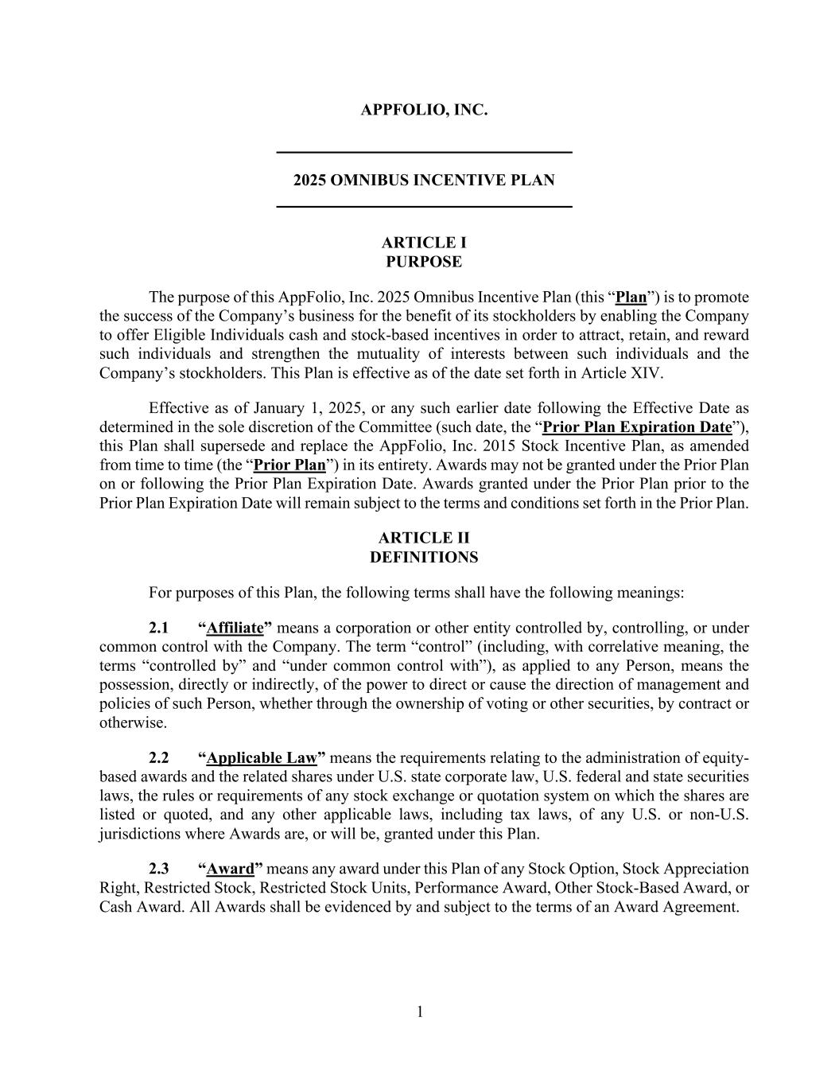

1 APPFOLIO, INC. 2025 OMNIBUS INCENTIVE PLAN ARTICLE I PURPOSE The purpose of this AppFolio, Inc. 2025 Omnibus Incentive Plan (this “Plan”) is to promote the success of the Company’s business for the benefit of its stockholders by enabling the Company to offer Eligible Individuals cash and stock-based incentives in order to attract, retain, and reward such individuals and strengthen the mutuality of interests between such individuals and the Company’s stockholders. This Plan is effective as of the date set forth in Article XIV. Effective as of January 1, 2025, or any such earlier date following the Effective Date as determined in the sole discretion of the Committee (such date, the “Prior Plan Expiration Date”), this Plan shall supersede and replace the AppFolio, Inc. 2015 Stock Incentive Plan, as amended from time to time (the “Prior Plan”) in its entirety. Awards may not be granted under the Prior Plan on or following the Prior Plan Expiration Date. Awards granted under the Prior Plan prior to the Prior Plan Expiration Date will remain subject to the terms and conditions set forth in the Prior Plan. ARTICLE II DEFINITIONS For purposes of this Plan, the following terms shall have the following meanings: 2.1 “Affiliate” means a corporation or other entity controlled by, controlling, or under common control with the Company. The term “control” (including, with correlative meaning, the terms “controlled by” and “under common control with”), as applied to any Person, means the possession, directly or indirectly, of the power to direct or cause the direction of management and policies of such Person, whether through the ownership of voting or other securities, by contract or otherwise. 2.2 “Applicable Law” means the requirements relating to the administration of equity- based awards and the related shares under U.S. state corporate law, U.S. federal and state securities laws, the rules or requirements of any stock exchange or quotation system on which the shares are listed or quoted, and any other applicable laws, including tax laws, of any U.S. or non-U.S. jurisdictions where Awards are, or will be, granted under this Plan. 2.3 “Award” means any award under this Plan of any Stock Option, Stock Appreciation Right, Restricted Stock, Restricted Stock Units, Performance Award, Other Stock-Based Award, or Cash Award. All Awards shall be evidenced by and subject to the terms of an Award Agreement.

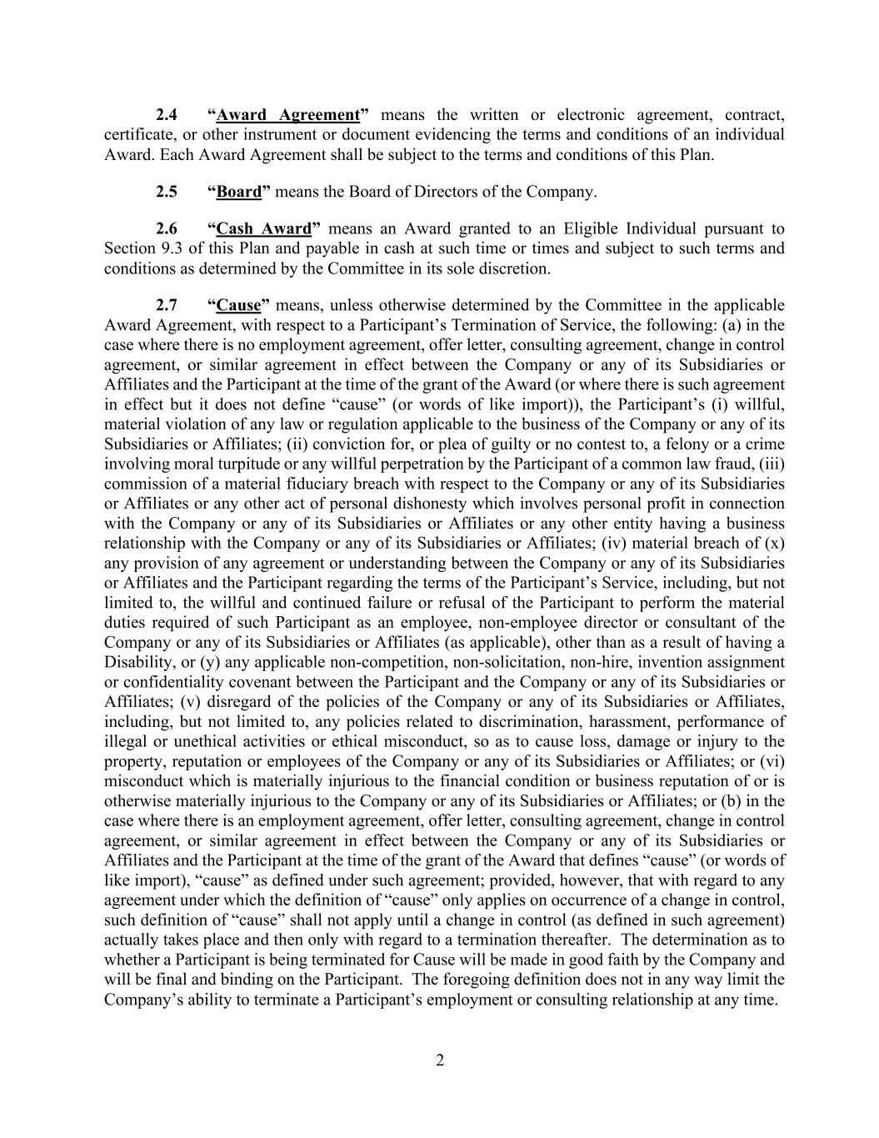
2 2.4 “Award Agreement” means the written or electronic agreement, contract, certificate, or other instrument or document evidencing the terms and conditions of an individual Award. Each Award Agreement shall be subject to the terms and conditions of this Plan. 2.5 “Board” means the Board of Directors of the Company. 2.6 “Cash Award” means an Award granted to an Eligible Individual pursuant to Section 9.3 of this Plan and payable in cash at such time or times and subject to such terms and conditions as determined by the Committee in its sole discretion. 2.7 “Cause” means, unless otherwise determined by the Committee in the applicable Award Agreement, with respect to a Participant’s Termination of Service, the following: (a) in the case where there is no employment agreement, offer letter, consulting agreement, change in control agreement, or similar agreement in effect between the Company or any of its Subsidiaries or Affiliates and the Participant at the time of the grant of the Award (or where there is such agreement in effect but it does not define “cause” (or words of like import)), the Participant’s (i) willful, material violation of any law or regulation applicable to the business of the Company or any of its Subsidiaries or Affiliates; (ii) conviction for, or plea of guilty or no contest to, a felony or a crime involving moral turpitude or any willful perpetration by the Participant of a common law fraud, (iii) commission of a material fiduciary breach with respect to the Company or any of its Subsidiaries or Affiliates or any other act of personal dishonesty which involves personal profit in connection with the Company or any of its Subsidiaries or Affiliates or any other entity having a business relationship with the Company or any of its Subsidiaries or Affiliates; (iv) material breach of (x) any provision of any agreement or understanding between the Company or any of its Subsidiaries or Affiliates and the Participant regarding the terms of the Participant’s Service, including, but not limited to, the willful and continued failure or refusal of the Participant to perform the material duties required of such Participant as an employee, non-employee director or consultant of the Company or any of its Subsidiaries or Affiliates (as applicable), other than as a result of having a Disability, or (y) any applicable non-competition, non-solicitation, non-hire, invention assignment or confidentiality covenant between the Participant and the Company or any of its Subsidiaries or Affiliates; (v) disregard of the policies of the Company or any of its Subsidiaries or Affiliates, including, but not limited to, any policies related to discrimination, harassment, performance of illegal or unethical activities or ethical misconduct, so as to cause loss, damage or injury to the property, reputation or employees of the Company or any of its Subsidiaries or Affiliates; or (vi) misconduct which is materially injurious to the financial condition or business reputation of or is otherwise materially injurious to the Company or any of its Subsidiaries or Affiliates; or (b) in the case where there is an employment agreement, offer letter, consulting agreement, change in control agreement, or similar agreement in effect between the Company or any of its Subsidiaries or Affiliates and the Participant at the time of the grant of the Award that defines “cause” (or words of like import), “cause” as defined under such agreement; provided, however, that with regard to any agreement under which the definition of “cause” only applies on occurrence of a change in control, such definition of “cause” shall not apply until a change in control (as defined in such agreement) actually takes place and then only with regard to a termination thereafter. The determination as to whether a Participant is being terminated for Cause will be made in good faith by the Company and will be final and binding on the Participant. The foregoing definition does not in any way limit the Company’s ability to terminate a Participant’s employment or consulting relationship at any time.

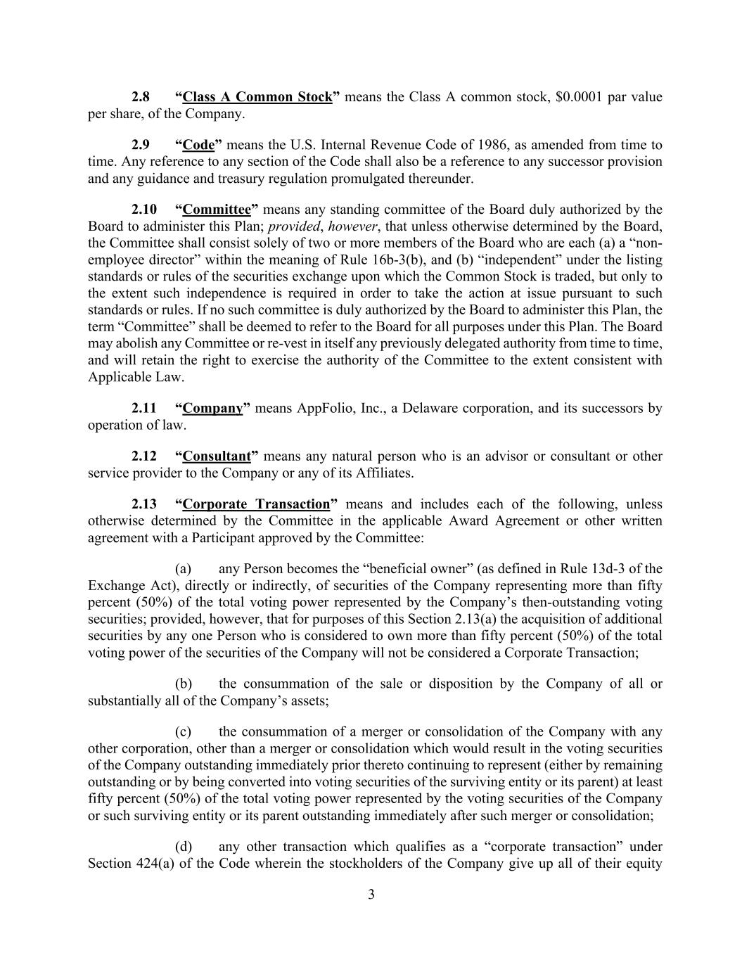
3 2.8 “Class A Common Stock” means the Class A common stock, $0.0001 par value per share, of the Company. 2.9 “Code” means the U.S. Internal Revenue Code of 1986, as amended from time to time. Any reference to any section of the Code shall also be a reference to any successor provision and any guidance and treasury regulation promulgated thereunder. 2.10 “Committee” means any standing committee of the Board duly authorized by the Board to administer this Plan; provided, however, that unless otherwise determined by the Board, the Committee shall consist solely of two or more members of the Board who are each (a) a “non- employee director” within the meaning of Rule 16b-3(b), and (b) “independent” under the listing standards or rules of the securities exchange upon which the Common Stock is traded, but only to the extent such independence is required in order to take the action at issue pursuant to such standards or rules. If no such committee is duly authorized by the Board to administer this Plan, the term “Committee” shall be deemed to refer to the Board for all purposes under this Plan. The Board may abolish any Committee or re-vest in itself any previously delegated authority from time to time, and will retain the right to exercise the authority of the Committee to the extent consistent with Applicable Law. 2.11 “Company” means AppFolio, Inc., a Delaware corporation, and its successors by operation of law. 2.12 “Consultant” means any natural person who is an advisor or consultant or other service provider to the Company or any of its Affiliates. 2.13 “Corporate Transaction” means and includes each of the following, unless otherwise determined by the Committee in the applicable Award Agreement or other written agreement with a Participant approved by the Committee: (a) any Person becomes the “beneficial owner” (as defined in Rule 13d-3 of the Exchange Act), directly or indirectly, of securities of the Company representing more than fifty percent (50%) of the total voting power represented by the Company’s then-outstanding voting securities; provided, however, that for purposes of this Section 2.13(a) the acquisition of additional securities by any one Person who is considered to own more than fifty percent (50%) of the total voting power of the securities of the Company will not be considered a Corporate Transaction; (b) the consummation of the sale or disposition by the Company of all or substantially all of the Company’s assets; (c) the consummation of a merger or consolidation of the Company with any other corporation, other than a merger or consolidation which would result in the voting securities of the Company outstanding immediately prior thereto continuing to represent (either by remaining outstanding or by being converted into voting securities of the surviving entity or its parent) at least fifty percent (50%) of the total voting power represented by the voting securities of the Company or such surviving entity or its parent outstanding immediately after such merger or consolidation; (d) any other transaction which qualifies as a “corporate transaction” under Section 424(a) of the Code wherein the stockholders of the Company give up all of their equity

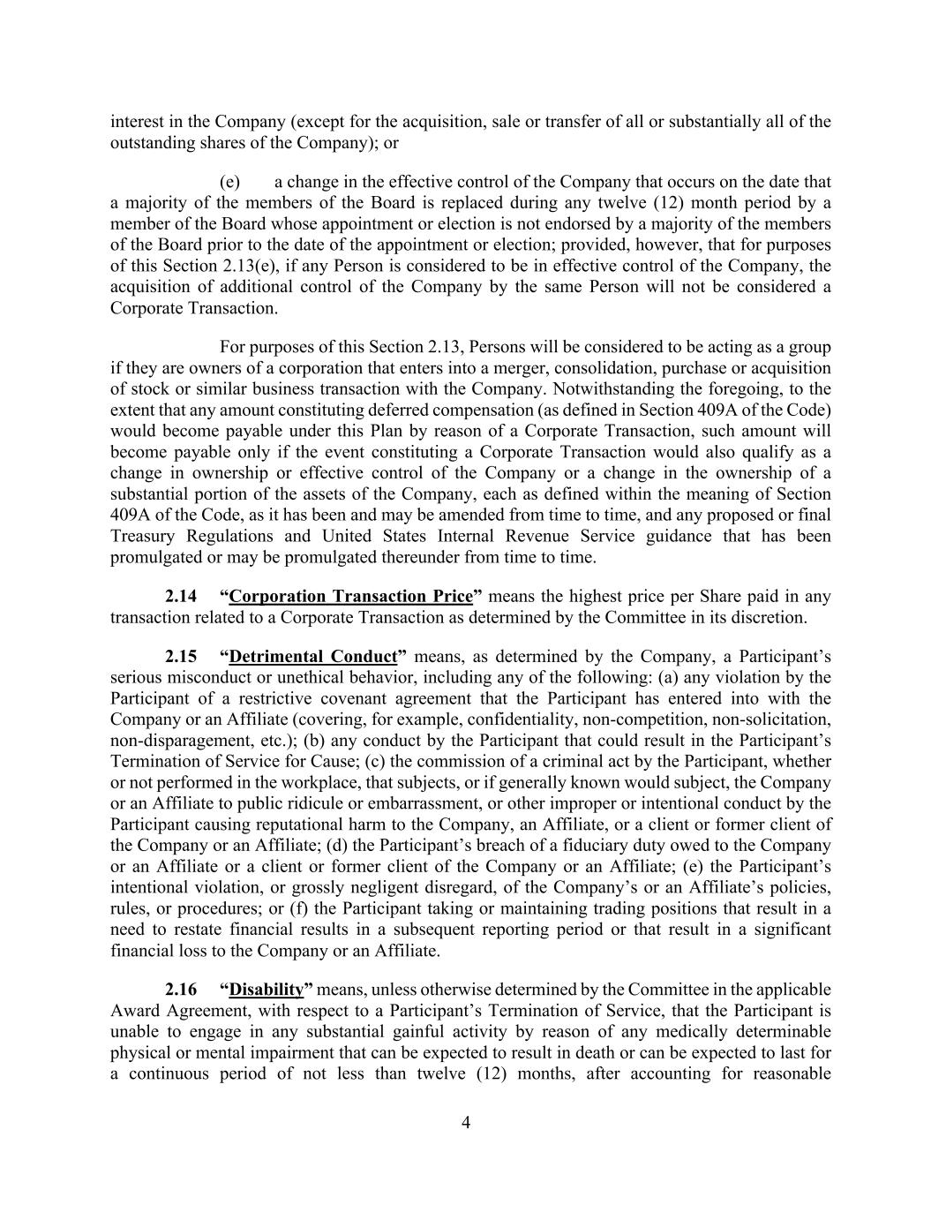
4 interest in the Company (except for the acquisition, sale or transfer of all or substantially all of the outstanding shares of the Company); or (e) a change in the effective control of the Company that occurs on the date that a majority of the members of the Board is replaced during any twelve (12) month period by a member of the Board whose appointment or election is not endorsed by a majority of the members of the Board prior to the date of the appointment or election; provided, however, that for purposes of this Section 2.13(e), if any Person is considered to be in effective control of the Company, the acquisition of additional control of the Company by the same Person will not be considered a Corporate Transaction. For purposes of this Section 2.13, Persons will be considered to be acting as a group if they are owners of a corporation that enters into a merger, consolidation, purchase or acquisition of stock or similar business transaction with the Company. Notwithstanding the foregoing, to the extent that any amount constituting deferred compensation (as defined in Section 409A of the Code) would become payable under this Plan by reason of a Corporate Transaction, such amount will become payable only if the event constituting a Corporate Transaction would also qualify as a change in ownership or effective control of the Company or a change in the ownership of a substantial portion of the assets of the Company, each as defined within the meaning of Section 409A of the Code, as it has been and may be amended from time to time, and any proposed or final Treasury Regulations and United States Internal Revenue Service guidance that has been promulgated or may be promulgated thereunder from time to time. 2.14 “Corporation Transaction Price” means the highest price per Share paid in any transaction related to a Corporate Transaction as determined by the Committee in its discretion. 2.15 “Detrimental Conduct” means, as determined by the Company, a Participant’s serious misconduct or unethical behavior, including any of the following: (a) any violation by the Participant of a restrictive covenant agreement that the Participant has entered into with the Company or an Affiliate (covering, for example, confidentiality, non-competition, non-solicitation, non-disparagement, etc.); (b) any conduct by the Participant that could result in the Participant’s Termination of Service for Cause; (c) the commission of a criminal act by the Participant, whether or not performed in the workplace, that subjects, or if generally known would subject, the Company or an Affiliate to public ridicule or embarrassment, or other improper or intentional conduct by the Participant causing reputational harm to the Company, an Affiliate, or a client or former client of the Company or an Affiliate; (d) the Participant’s breach of a fiduciary duty owed to the Company or an Affiliate or a client or former client of the Company or an Affiliate; (e) the Participant’s intentional violation, or grossly negligent disregard, of the Company’s or an Affiliate’s policies, rules, or procedures; or (f) the Participant taking or maintaining trading positions that result in a need to restate financial results in a subsequent reporting period or that result in a significant financial loss to the Company or an Affiliate. 2.16 “Disability” means, unless otherwise determined by the Committee in the applicable Award Agreement, with respect to a Participant’s Termination of Service, that the Participant is unable to engage in any substantial gainful activity by reason of any medically determinable physical or mental impairment that can be expected to result in death or can be expected to last for a continuous period of not less than twelve (12) months, after accounting for reasonable

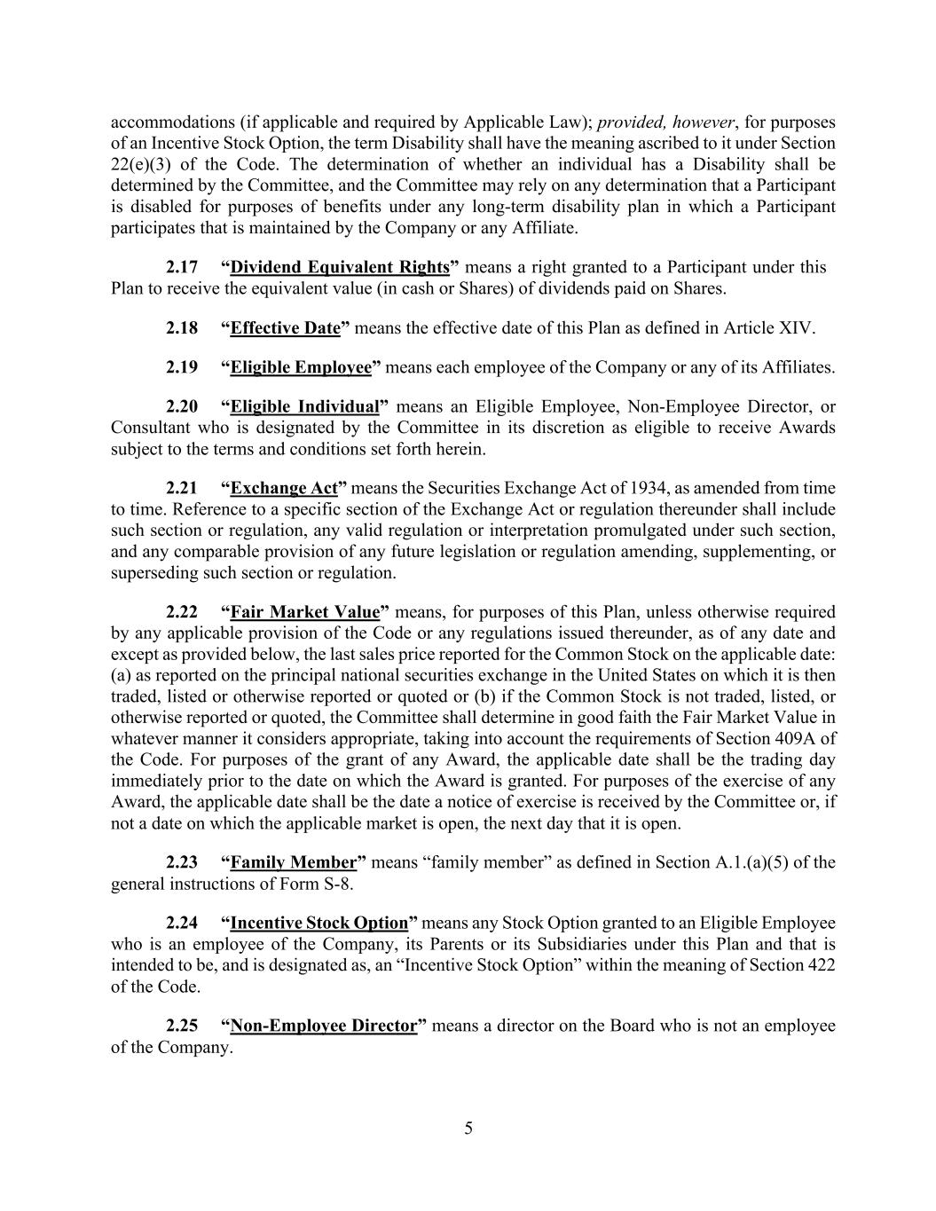
5 accommodations (if applicable and required by Applicable Law); provided, however, for purposes of an Incentive Stock Option, the term Disability shall have the meaning ascribed to it under Section 22(e)(3) of the Code. The determination of whether an individual has a Disability shall be determined by the Committee, and the Committee may rely on any determination that a Participant is disabled for purposes of benefits under any long-term disability plan in which a Participant participates that is maintained by the Company or any Affiliate. 2.17 “Dividend Equivalent Rights” means a right granted to a Participant under this Plan to receive the equivalent value (in cash or Shares) of dividends paid on Shares. 2.18 “Effective Date” means the effective date of this Plan as defined in Article XIV. 2.19 “Eligible Employee” means each employee of the Company or any of its Affiliates. 2.20 “Eligible Individual” means an Eligible Employee, Non-Employee Director, or Consultant who is designated by the Committee in its discretion as eligible to receive Awards subject to the terms and conditions set forth herein. 2.21 “Exchange Act” means the Securities Exchange Act of 1934, as amended from time to time. Reference to a specific section of the Exchange Act or regulation thereunder shall include such section or regulation, any valid regulation or interpretation promulgated under such section, and any comparable provision of any future legislation or regulation amending, supplementing, or superseding such section or regulation. 2.22 “Fair Market Value” means, for purposes of this Plan, unless otherwise required by any applicable provision of the Code or any regulations issued thereunder, as of any date and except as provided below, the last sales price reported for the Common Stock on the applicable date: (a) as reported on the principal national securities exchange in the United States on which it is then traded, listed or otherwise reported or quoted or (b) if the Common Stock is not traded, listed, or otherwise reported or quoted, the Committee shall determine in good faith the Fair Market Value in whatever manner it considers appropriate, taking into account the requirements of Section 409A of the Code. For purposes of the grant of any Award, the applicable date shall be the trading day immediately prior to the date on which the Award is granted. For purposes of the exercise of any Award, the applicable date shall be the date a notice of exercise is received by the Committee or, if not a date on which the applicable market is open, the next day that it is open. 2.23 “Family Member” means “family member” as defined in Section A.1.(a)(5) of the general instructions of Form S-8. 2.24 “Incentive Stock Option” means any Stock Option granted to an Eligible Employee who is an employee of the Company, its Parents or its Subsidiaries under this Plan and that is intended to be, and is designated as, an “Incentive Stock Option” within the meaning of Section 422 of the Code. 2.25 “Non-Employee Director” means a director on the Board who is not an employee of the Company.

6 2.26 “Non-Qualified Stock Option” means any Stock Option granted under this Plan that is not an Incentive Stock Option. 2.27 “Other Stock-Based Award” means an Award granted under Article IX of this Plan that is valued in whole or in part by reference to, or is payable in or otherwise based on, Shares, but may be settled in the form of Shares or cash. 2.28 “Parent” means any parent corporation of the Company within the meaning of Section 424(e) of the Code. 2.29 “Participant” means an Eligible Individual to whom an Award has been granted pursuant to this Plan. 2.30 “Performance Award” means an Award granted under Article VIII of this Plan. 2.31 “Performance Goals” means goals established by the Committee as contingencies for Awards to vest and/or become exercisable or distributable. 2.32 “Performance Period” means the designated period during which the Performance Goals must be satisfied with respect to the Award to which the Performance Goals relate. 2.33 “Person” means any “person” as such term is used in Sections 13(d) and 14(d) of the Exchange Act. 2.34 “Prior Plan Award” means an award outstanding under the Prior Plan as of the Prior Plan Expiration Date. 2.35 “Restricted Stock” means an Award of Shares granted under Article VII of this Plan. 2.36 “Restricted Stock Unit” means an unfunded, unsecured right to receive, on the applicable settlement date, one Share or an amount in cash or other consideration determined by the Committee to be of equal value as of such settlement date, subject to certain vesting conditions and other restrictions. 2.37 “Rule 16b-3” means Rule 16b-3 under Section 16(b) of the Exchange Act as then in effect or any successor provision. 2.38 “Section 409A of the Code” means the nonqualified deferred compensation rules under Section 409A of the Code and any applicable treasury regulations and other official guidance thereunder. 2.39 “Securities Act” means the Securities Act of 1933, as amended, and all rules and regulations promulgated thereunder. Reference to a specific section of the Securities Act or regulation thereunder shall include such section or regulation, any valid regulation or interpretation promulgated under such section, and any comparable provision of any future legislation or regulation amending, supplementing, or superseding such section or regulation.

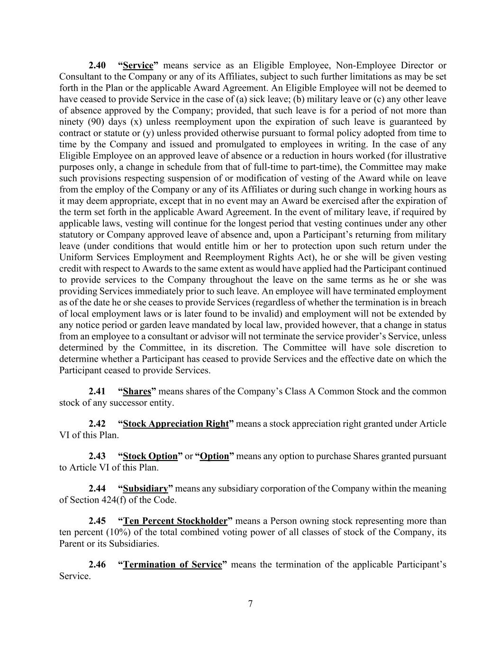
7 2.40 “Service” means service as an Eligible Employee, Non-Employee Director or Consultant to the Company or any of its Affiliates, subject to such further limitations as may be set forth in the Plan or the applicable Award Agreement. An Eligible Employee will not be deemed to have ceased to provide Service in the case of (a) sick leave; (b) military leave or (c) any other leave of absence approved by the Company; provided, that such leave is for a period of not more than ninety (90) days (x) unless reemployment upon the expiration of such leave is guaranteed by contract or statute or (y) unless provided otherwise pursuant to formal policy adopted from time to time by the Company and issued and promulgated to employees in writing. In the case of any Eligible Employee on an approved leave of absence or a reduction in hours worked (for illustrative purposes only, a change in schedule from that of full-time to part-time), the Committee may make such provisions respecting suspension of or modification of vesting of the Award while on leave from the employ of the Company or any of its Affiliates or during such change in working hours as it may deem appropriate, except that in no event may an Award be exercised after the expiration of the term set forth in the applicable Award Agreement. In the event of military leave, if required by applicable laws, vesting will continue for the longest period that vesting continues under any other statutory or Company approved leave of absence and, upon a Participant’s returning from military leave (under conditions that would entitle him or her to protection upon such return under the Uniform Services Employment and Reemployment Rights Act), he or she will be given vesting credit with respect to Awards to the same extent as would have applied had the Participant continued to provide services to the Company throughout the leave on the same terms as he or she was providing Services immediately prior to such leave. An employee will have terminated employment as of the date he or she ceases to provide Services (regardless of whether the termination is in breach of local employment laws or is later found to be invalid) and employment will not be extended by any notice period or garden leave mandated by local law, provided however, that a change in status from an employee to a consultant or advisor will not terminate the service provider’s Service, unless determined by the Committee, in its discretion. The Committee will have sole discretion to determine whether a Participant has ceased to provide Services and the effective date on which the Participant ceased to provide Services. 2.41 “Shares” means shares of the Company’s Class A Common Stock and the common stock of any successor entity. 2.42 “Stock Appreciation Right” means a stock appreciation right granted under Article VI of this Plan. 2.43 “Stock Option” or “Option” means any option to purchase Shares granted pursuant to Article VI of this Plan. 2.44 “Subsidiary” means any subsidiary corporation of the Company within the meaning of Section 424(f) of the Code. 2.45 “Ten Percent Stockholder” means a Person owning stock representing more than ten percent (10%) of the total combined voting power of all classes of stock of the Company, its Parent or its Subsidiaries. 2.46 “Termination of Service” means the termination of the applicable Participant’s Service.

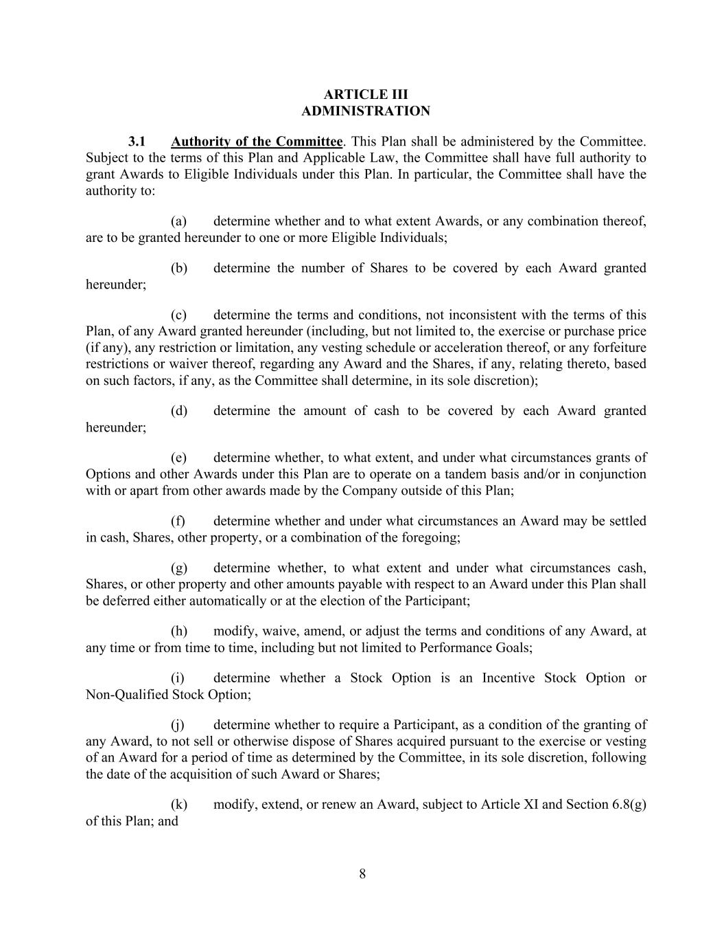
8 ARTICLE III ADMINISTRATION 3.1 Authority of the Committee. This Plan shall be administered by the Committee. Subject to the terms of this Plan and Applicable Law, the Committee shall have full authority to grant Awards to Eligible Individuals under this Plan. In particular, the Committee shall have the authority to: (a) determine whether and to what extent Awards, or any combination thereof, are to be granted hereunder to one or more Eligible Individuals; (b) determine the number of Shares to be covered by each Award granted hereunder; (c) determine the terms and conditions, not inconsistent with the terms of this Plan, of any Award granted hereunder (including, but not limited to, the exercise or purchase price (if any), any restriction or limitation, any vesting schedule or acceleration thereof, or any forfeiture restrictions or waiver thereof, regarding any Award and the Shares, if any, relating thereto, based on such factors, if any, as the Committee shall determine, in its sole discretion); (d) determine the amount of cash to be covered by each Award granted hereunder; (e) determine whether, to what extent, and under what circumstances grants of Options and other Awards under this Plan are to operate on a tandem basis and/or in conjunction with or apart from other awards made by the Company outside of this Plan; (f) determine whether and under what circumstances an Award may be settled in cash, Shares, other property, or a combination of the foregoing; (g) determine whether, to what extent and under what circumstances cash, Shares, or other property and other amounts payable with respect to an Award under this Plan shall be deferred either automatically or at the election of the Participant; (h) modify, waive, amend, or adjust the terms and conditions of any Award, at any time or from time to time, including but not limited to Performance Goals; (i) determine whether a Stock Option is an Incentive Stock Option or Non-Qualified Stock Option; (j) determine whether to require a Participant, as a condition of the granting of any Award, to not sell or otherwise dispose of Shares acquired pursuant to the exercise or vesting of an Award for a period of time as determined by the Committee, in its sole discretion, following the date of the acquisition of such Award or Shares; (k) modify, extend, or renew an Award, subject to Article XI and Section 6.8(g) of this Plan; and

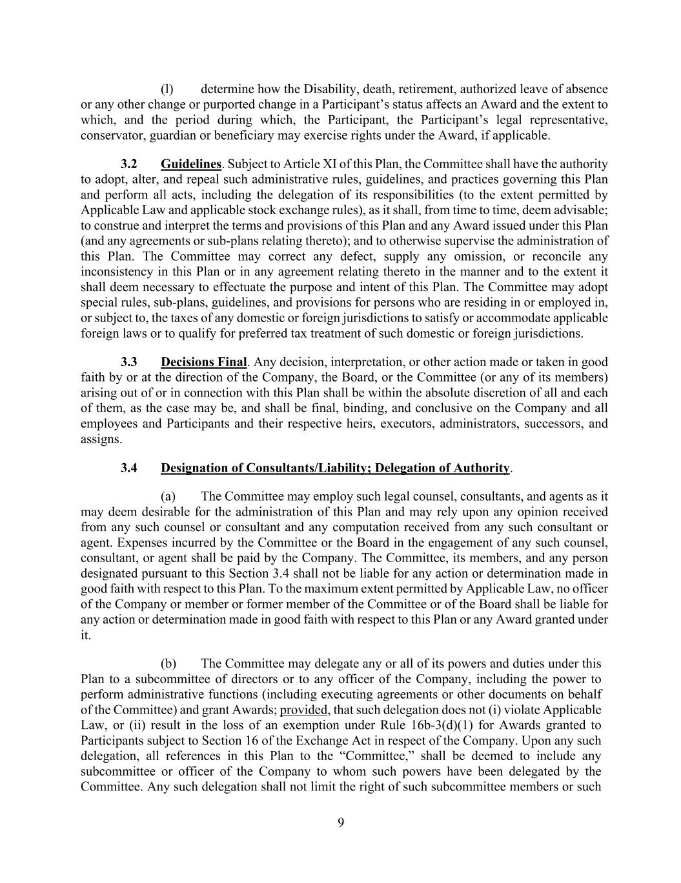
9 (l) determine how the Disability, death, retirement, authorized leave of absence or any other change or purported change in a Participant’s status affects an Award and the extent to which, and the period during which, the Participant, the Participant’s legal representative, conservator, guardian or beneficiary may exercise rights under the Award, if applicable. 3.2 Guidelines. Subject to Article XI of this Plan, the Committee shall have the authority to adopt, alter, and repeal such administrative rules, guidelines, and practices governing this Plan and perform all acts, including the delegation of its responsibilities (to the extent permitted by Applicable Law and applicable stock exchange rules), as it shall, from time to time, deem advisable; to construe and interpret the terms and provisions of this Plan and any Award issued under this Plan (and any agreements or sub-plans relating thereto); and to otherwise supervise the administration of this Plan. The Committee may correct any defect, supply any omission, or reconcile any inconsistency in this Plan or in any agreement relating thereto in the manner and to the extent it shall deem necessary to effectuate the purpose and intent of this Plan. The Committee may adopt special rules, sub-plans, guidelines, and provisions for persons who are residing in or employed in, or subject to, the taxes of any domestic or foreign jurisdictions to satisfy or accommodate applicable foreign laws or to qualify for preferred tax treatment of such domestic or foreign jurisdictions. 3.3 Decisions Final. Any decision, interpretation, or other action made or taken in good faith by or at the direction of the Company, the Board, or the Committee (or any of its members) arising out of or in connection with this Plan shall be within the absolute discretion of all and each of them, as the case may be, and shall be final, binding, and conclusive on the Company and all employees and Participants and their respective heirs, executors, administrators, successors, and assigns. 3.4 Designation of Consultants/Liability; Delegation of Authority. (a) The Committee may employ such legal counsel, consultants, and agents as it may deem desirable for the administration of this Plan and may rely upon any opinion received from any such counsel or consultant and any computation received from any such consultant or agent. Expenses incurred by the Committee or the Board in the engagement of any such counsel, consultant, or agent shall be paid by the Company. The Committee, its members, and any person designated pursuant to this Section 3.4 shall not be liable for any action or determination made in good faith with respect to this Plan. To the maximum extent permitted by Applicable Law, no officer of the Company or member or former member of the Committee or of the Board shall be liable for any action or determination made in good faith with respect to this Plan or any Award granted under it. (b) The Committee may delegate any or all of its powers and duties under this Plan to a subcommittee of directors or to any officer of the Company, including the power to perform administrative functions (including executing agreements or other documents on behalf of the Committee) and grant Awards; provided, that such delegation does not (i) violate Applicable Law, or (ii) result in the loss of an exemption under Rule 16b-3(d)(1) for Awards granted to Participants subject to Section 16 of the Exchange Act in respect of the Company. Upon any such delegation, all references in this Plan to the “Committee,” shall be deemed to include any subcommittee or officer of the Company to whom such powers have been delegated by the Committee. Any such delegation shall not limit the right of such subcommittee members or such

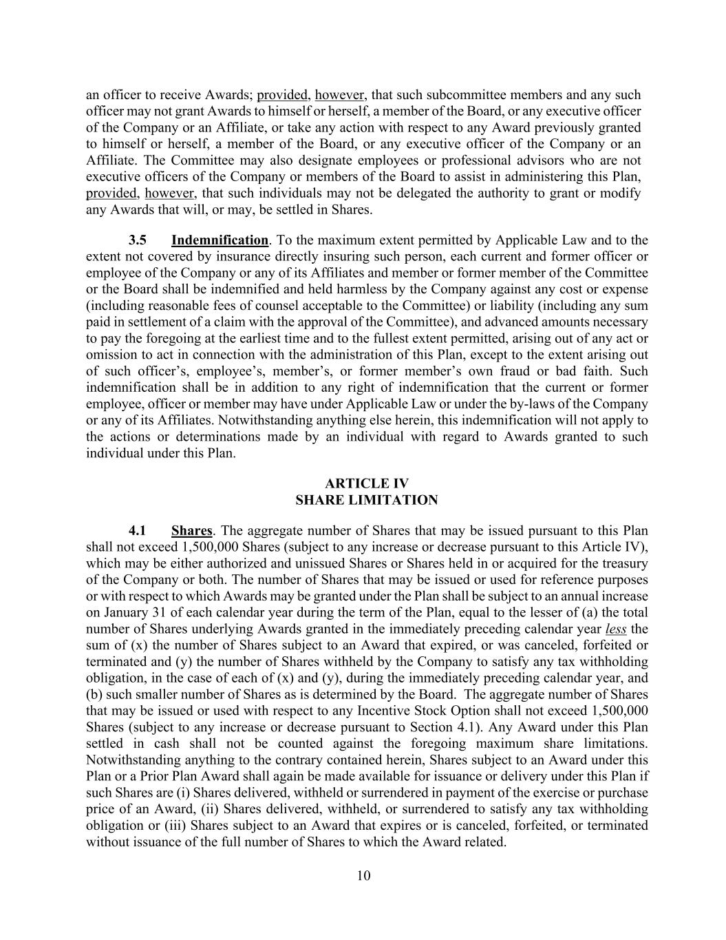
10 an officer to receive Awards; provided, however, that such subcommittee members and any such officer may not grant Awards to himself or herself, a member of the Board, or any executive officer of the Company or an Affiliate, or take any action with respect to any Award previously granted to himself or herself, a member of the Board, or any executive officer of the Company or an Affiliate. The Committee may also designate employees or professional advisors who are not executive officers of the Company or members of the Board to assist in administering this Plan, provided, however, that such individuals may not be delegated the authority to grant or modify any Awards that will, or may, be settled in Shares. 3.5 Indemnification. To the maximum extent permitted by Applicable Law and to the extent not covered by insurance directly insuring such person, each current and former officer or employee of the Company or any of its Affiliates and member or former member of the Committee or the Board shall be indemnified and held harmless by the Company against any cost or expense (including reasonable fees of counsel acceptable to the Committee) or liability (including any sum paid in settlement of a claim with the approval of the Committee), and advanced amounts necessary to pay the foregoing at the earliest time and to the fullest extent permitted, arising out of any act or omission to act in connection with the administration of this Plan, except to the extent arising out of such officer’s, employee’s, member’s, or former member’s own fraud or bad faith. Such indemnification shall be in addition to any right of indemnification that the current or former employee, officer or member may have under Applicable Law or under the by-laws of the Company or any of its Affiliates. Notwithstanding anything else herein, this indemnification will not apply to the actions or determinations made by an individual with regard to Awards granted to such individual under this Plan. ARTICLE IV SHARE LIMITATION 4.1 Shares. The aggregate number of Shares that may be issued pursuant to this Plan shall not exceed 1,500,000 Shares (subject to any increase or decrease pursuant to this Article IV), which may be either authorized and unissued Shares or Shares held in or acquired for the treasury of the Company or both. The number of Shares that may be issued or used for reference purposes or with respect to which Awards may be granted under the Plan shall be subject to an annual increase on January 31 of each calendar year during the term of the Plan, equal to the lesser of (a) the total number of Shares underlying Awards granted in the immediately preceding calendar year less the sum of (x) the number of Shares subject to an Award that expired, or was canceled, forfeited or terminated and (y) the number of Shares withheld by the Company to satisfy any tax withholding obligation, in the case of each of (x) and (y), during the immediately preceding calendar year, and (b) such smaller number of Shares as is determined by the Board. The aggregate number of Shares that may be issued or used with respect to any Incentive Stock Option shall not exceed 1,500,000 Shares (subject to any increase or decrease pursuant to Section 4.1). Any Award under this Plan settled in cash shall not be counted against the foregoing maximum share limitations. Notwithstanding anything to the contrary contained herein, Shares subject to an Award under this Plan or a Prior Plan Award shall again be made available for issuance or delivery under this Plan if such Shares are (i) Shares delivered, withheld or surrendered in payment of the exercise or purchase price of an Award, (ii) Shares delivered, withheld, or surrendered to satisfy any tax withholding obligation or (iii) Shares subject to an Award that expires or is canceled, forfeited, or terminated without issuance of the full number of Shares to which the Award related.

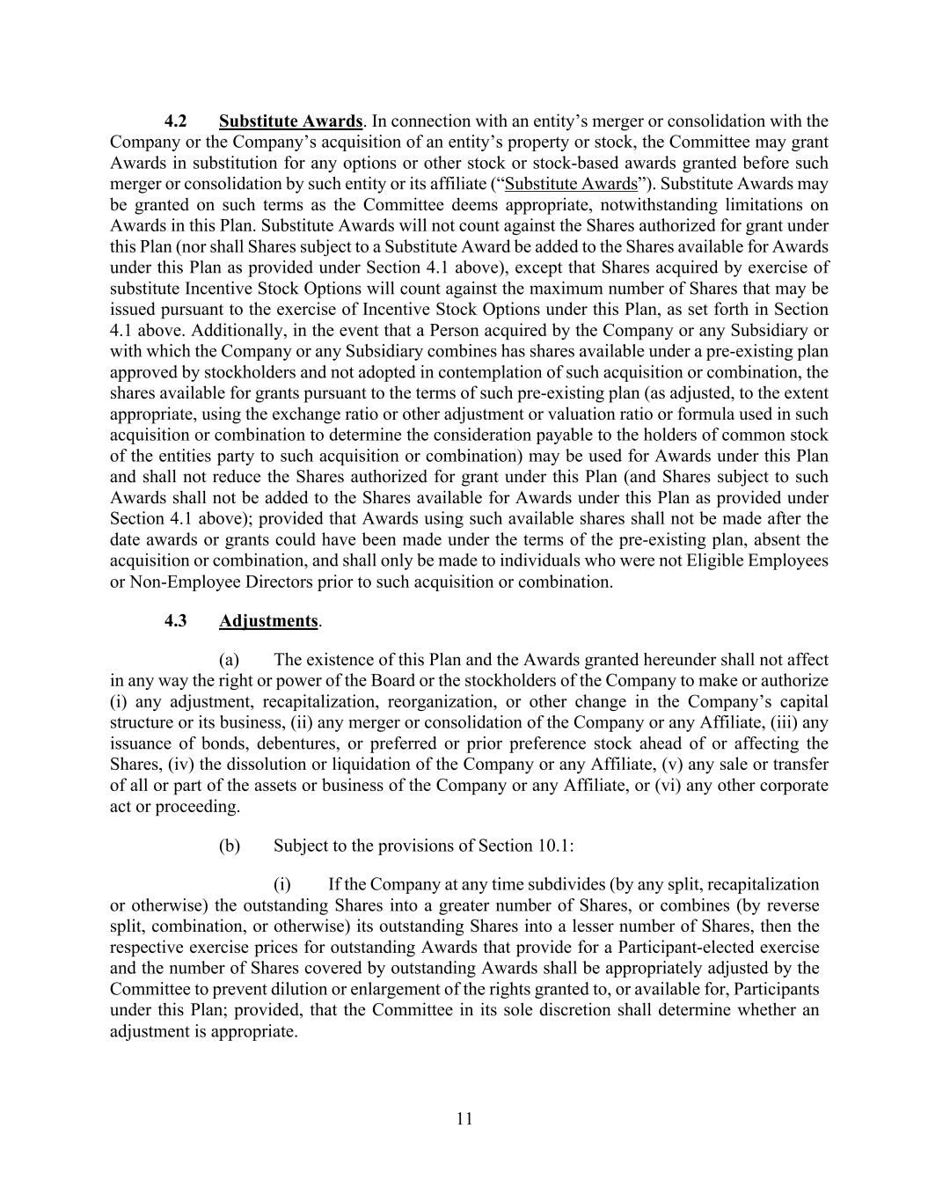
11 4.2 Substitute Awards. In connection with an entity’s merger or consolidation with the Company or the Company’s acquisition of an entity’s property or stock, the Committee may grant Awards in substitution for any options or other stock or stock-based awards granted before such merger or consolidation by such entity or its affiliate (“Substitute Awards”). Substitute Awards may be granted on such terms as the Committee deems appropriate, notwithstanding limitations on Awards in this Plan. Substitute Awards will not count against the Shares authorized for grant under this Plan (nor shall Shares subject to a Substitute Award be added to the Shares available for Awards under this Plan as provided under Section 4.1 above), except that Shares acquired by exercise of substitute Incentive Stock Options will count against the maximum number of Shares that may be issued pursuant to the exercise of Incentive Stock Options under this Plan, as set forth in Section 4.1 above. Additionally, in the event that a Person acquired by the Company or any Subsidiary or with which the Company or any Subsidiary combines has shares available under a pre-existing plan approved by stockholders and not adopted in contemplation of such acquisition or combination, the shares available for grants pursuant to the terms of such pre-existing plan (as adjusted, to the extent appropriate, using the exchange ratio or other adjustment or valuation ratio or formula used in such acquisition or combination to determine the consideration payable to the holders of common stock of the entities party to such acquisition or combination) may be used for Awards under this Plan and shall not reduce the Shares authorized for grant under this Plan (and Shares subject to such Awards shall not be added to the Shares available for Awards under this Plan as provided under Section 4.1 above); provided that Awards using such available shares shall not be made after the date awards or grants could have been made under the terms of the pre-existing plan, absent the acquisition or combination, and shall only be made to individuals who were not Eligible Employees or Non-Employee Directors prior to such acquisition or combination. 4.3 Adjustments. (a) The existence of this Plan and the Awards granted hereunder shall not affect in any way the right or power of the Board or the stockholders of the Company to make or authorize (i) any adjustment, recapitalization, reorganization, or other change in the Company’s capital structure or its business, (ii) any merger or consolidation of the Company or any Affiliate, (iii) any issuance of bonds, debentures, or preferred or prior preference stock ahead of or affecting the Shares, (iv) the dissolution or liquidation of the Company or any Affiliate, (v) any sale or transfer of all or part of the assets or business of the Company or any Affiliate, or (vi) any other corporate act or proceeding. (b) Subject to the provisions of Section 10.1: (i) If the Company at any time subdivides (by any split, recapitalization or otherwise) the outstanding Shares into a greater number of Shares, or combines (by reverse split, combination, or otherwise) its outstanding Shares into a lesser number of Shares, then the respective exercise prices for outstanding Awards that provide for a Participant-elected exercise and the number of Shares covered by outstanding Awards shall be appropriately adjusted by the Committee to prevent dilution or enlargement of the rights granted to, or available for, Participants under this Plan; provided, that the Committee in its sole discretion shall determine whether an adjustment is appropriate.

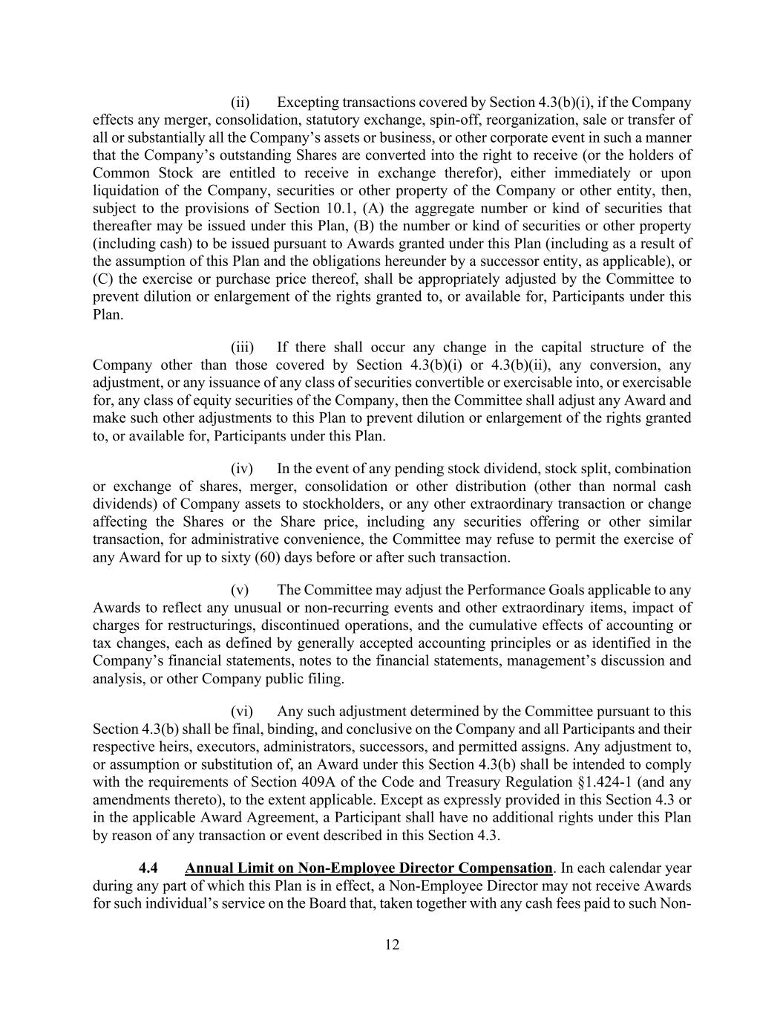
12 (ii) Excepting transactions covered by Section 4.3(b)(i), if the Company effects any merger, consolidation, statutory exchange, spin-off, reorganization, sale or transfer of all or substantially all the Company’s assets or business, or other corporate event in such a manner that the Company’s outstanding Shares are converted into the right to receive (or the holders of Common Stock are entitled to receive in exchange therefor), either immediately or upon liquidation of the Company, securities or other property of the Company or other entity, then, subject to the provisions of Section 10.1, (A) the aggregate number or kind of securities that thereafter may be issued under this Plan, (B) the number or kind of securities or other property (including cash) to be issued pursuant to Awards granted under this Plan (including as a result of the assumption of this Plan and the obligations hereunder by a successor entity, as applicable), or (C) the exercise or purchase price thereof, shall be appropriately adjusted by the Committee to prevent dilution or enlargement of the rights granted to, or available for, Participants under this Plan. (iii) If there shall occur any change in the capital structure of the Company other than those covered by Section 4.3(b)(i) or 4.3(b)(ii), any conversion, any adjustment, or any issuance of any class of securities convertible or exercisable into, or exercisable for, any class of equity securities of the Company, then the Committee shall adjust any Award and make such other adjustments to this Plan to prevent dilution or enlargement of the rights granted to, or available for, Participants under this Plan. (iv) In the event of any pending stock dividend, stock split, combination or exchange of shares, merger, consolidation or other distribution (other than normal cash dividends) of Company assets to stockholders, or any other extraordinary transaction or change affecting the Shares or the Share price, including any securities offering or other similar transaction, for administrative convenience, the Committee may refuse to permit the exercise of any Award for up to sixty (60) days before or after such transaction. (v) The Committee may adjust the Performance Goals applicable to any Awards to reflect any unusual or non-recurring events and other extraordinary items, impact of charges for restructurings, discontinued operations, and the cumulative effects of accounting or tax changes, each as defined by generally accepted accounting principles or as identified in the Company’s financial statements, notes to the financial statements, management’s discussion and analysis, or other Company public filing. (vi) Any such adjustment determined by the Committee pursuant to this Section 4.3(b) shall be final, binding, and conclusive on the Company and all Participants and their respective heirs, executors, administrators, successors, and permitted assigns. Any adjustment to, or assumption or substitution of, an Award under this Section 4.3(b) shall be intended to comply with the requirements of Section 409A of the Code and Treasury Regulation §1.424-1 (and any amendments thereto), to the extent applicable. Except as expressly provided in this Section 4.3 or in the applicable Award Agreement, a Participant shall have no additional rights under this Plan by reason of any transaction or event described in this Section 4.3. 4.4 Annual Limit on Non-Employee Director Compensation. In each calendar year during any part of which this Plan is in effect, a Non-Employee Director may not receive Awards for such individual’s service on the Board that, taken together with any cash fees paid to such Non-

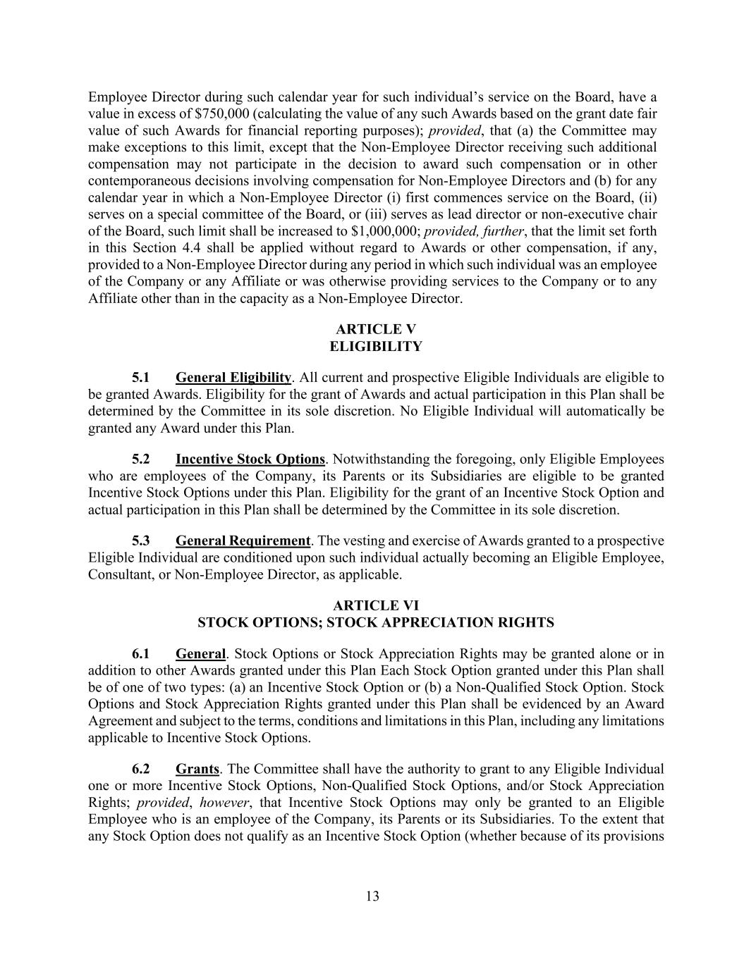
13 Employee Director during such calendar year for such individual’s service on the Board, have a value in excess of $750,000 (calculating the value of any such Awards based on the grant date fair value of such Awards for financial reporting purposes); provided, that (a) the Committee may make exceptions to this limit, except that the Non-Employee Director receiving such additional compensation may not participate in the decision to award such compensation or in other contemporaneous decisions involving compensation for Non-Employee Directors and (b) for any calendar year in which a Non-Employee Director (i) first commences service on the Board, (ii) serves on a special committee of the Board, or (iii) serves as lead director or non-executive chair of the Board, such limit shall be increased to $1,000,000; provided, further, that the limit set forth in this Section 4.4 shall be applied without regard to Awards or other compensation, if any, provided to a Non-Employee Director during any period in which such individual was an employee of the Company or any Affiliate or was otherwise providing services to the Company or to any Affiliate other than in the capacity as a Non-Employee Director. ARTICLE V ELIGIBILITY 5.1 General Eligibility. All current and prospective Eligible Individuals are eligible to be granted Awards. Eligibility for the grant of Awards and actual participation in this Plan shall be determined by the Committee in its sole discretion. No Eligible Individual will automatically be granted any Award under this Plan. 5.2 Incentive Stock Options. Notwithstanding the foregoing, only Eligible Employees who are employees of the Company, its Parents or its Subsidiaries are eligible to be granted Incentive Stock Options under this Plan. Eligibility for the grant of an Incentive Stock Option and actual participation in this Plan shall be determined by the Committee in its sole discretion. 5.3 General Requirement. The vesting and exercise of Awards granted to a prospective Eligible Individual are conditioned upon such individual actually becoming an Eligible Employee, Consultant, or Non-Employee Director, as applicable. ARTICLE VI STOCK OPTIONS; STOCK APPRECIATION RIGHTS 6.1 General. Stock Options or Stock Appreciation Rights may be granted alone or in addition to other Awards granted under this Plan Each Stock Option granted under this Plan shall be of one of two types: (a) an Incentive Stock Option or (b) a Non-Qualified Stock Option. Stock Options and Stock Appreciation Rights granted under this Plan shall be evidenced by an Award Agreement and subject to the terms, conditions and limitations in this Plan, including any limitations applicable to Incentive Stock Options. 6.2 Grants. The Committee shall have the authority to grant to any Eligible Individual one or more Incentive Stock Options, Non-Qualified Stock Options, and/or Stock Appreciation Rights; provided, however, that Incentive Stock Options may only be granted to an Eligible Employee who is an employee of the Company, its Parents or its Subsidiaries. To the extent that any Stock Option does not qualify as an Incentive Stock Option (whether because of its provisions

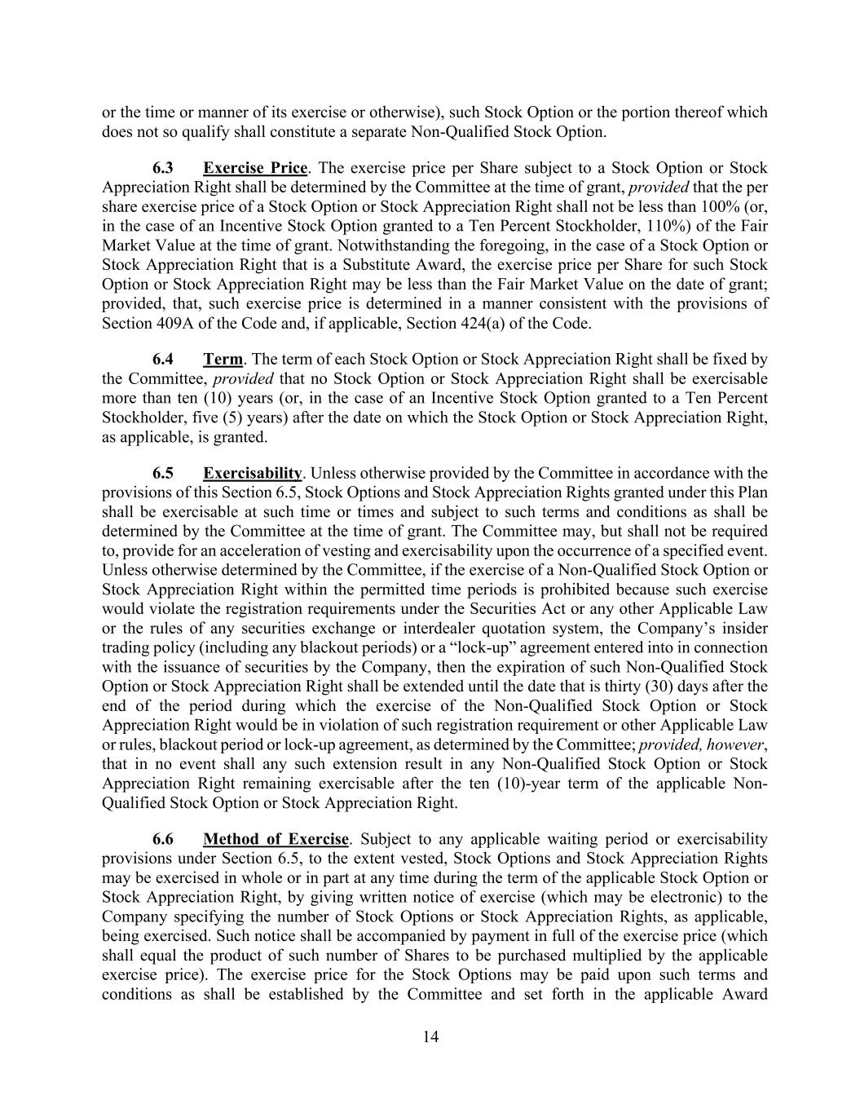
14 or the time or manner of its exercise or otherwise), such Stock Option or the portion thereof which does not so qualify shall constitute a separate Non-Qualified Stock Option. 6.3 Exercise Price. The exercise price per Share subject to a Stock Option or Stock Appreciation Right shall be determined by the Committee at the time of grant, provided that the per share exercise price of a Stock Option or Stock Appreciation Right shall not be less than 100% (or, in the case of an Incentive Stock Option granted to a Ten Percent Stockholder, 110%) of the Fair Market Value at the time of grant. Notwithstanding the foregoing, in the case of a Stock Option or Stock Appreciation Right that is a Substitute Award, the exercise price per Share for such Stock Option or Stock Appreciation Right may be less than the Fair Market Value on the date of grant; provided, that, such exercise price is determined in a manner consistent with the provisions of Section 409A of the Code and, if applicable, Section 424(a) of the Code. 6.4 Term. The term of each Stock Option or Stock Appreciation Right shall be fixed by the Committee, provided that no Stock Option or Stock Appreciation Right shall be exercisable more than ten (10) years (or, in the case of an Incentive Stock Option granted to a Ten Percent Stockholder, five (5) years) after the date on which the Stock Option or Stock Appreciation Right, as applicable, is granted. 6.5 Exercisability. Unless otherwise provided by the Committee in accordance with the provisions of this Section 6.5, Stock Options and Stock Appreciation Rights granted under this Plan shall be exercisable at such time or times and subject to such terms and conditions as shall be determined by the Committee at the time of grant. The Committee may, but shall not be required to, provide for an acceleration of vesting and exercisability upon the occurrence of a specified event. Unless otherwise determined by the Committee, if the exercise of a Non-Qualified Stock Option or Stock Appreciation Right within the permitted time periods is prohibited because such exercise would violate the registration requirements under the Securities Act or any other Applicable Law or the rules of any securities exchange or interdealer quotation system, the Company’s insider trading policy (including any blackout periods) or a “lock-up” agreement entered into in connection with the issuance of securities by the Company, then the expiration of such Non-Qualified Stock Option or Stock Appreciation Right shall be extended until the date that is thirty (30) days after the end of the period during which the exercise of the Non-Qualified Stock Option or Stock Appreciation Right would be in violation of such registration requirement or other Applicable Law or rules, blackout period or lock-up agreement, as determined by the Committee; provided, however, that in no event shall any such extension result in any Non-Qualified Stock Option or Stock Appreciation Right remaining exercisable after the ten (10)-year term of the applicable Non- Qualified Stock Option or Stock Appreciation Right. 6.6 Method of Exercise. Subject to any applicable waiting period or exercisability provisions under Section 6.5, to the extent vested, Stock Options and Stock Appreciation Rights may be exercised in whole or in part at any time during the term of the applicable Stock Option or Stock Appreciation Right, by giving written notice of exercise (which may be electronic) to the Company specifying the number of Stock Options or Stock Appreciation Rights, as applicable, being exercised. Such notice shall be accompanied by payment in full of the exercise price (which shall equal the product of such number of Shares to be purchased multiplied by the applicable exercise price). The exercise price for the Stock Options may be paid upon such terms and conditions as shall be established by the Committee and set forth in the applicable Award

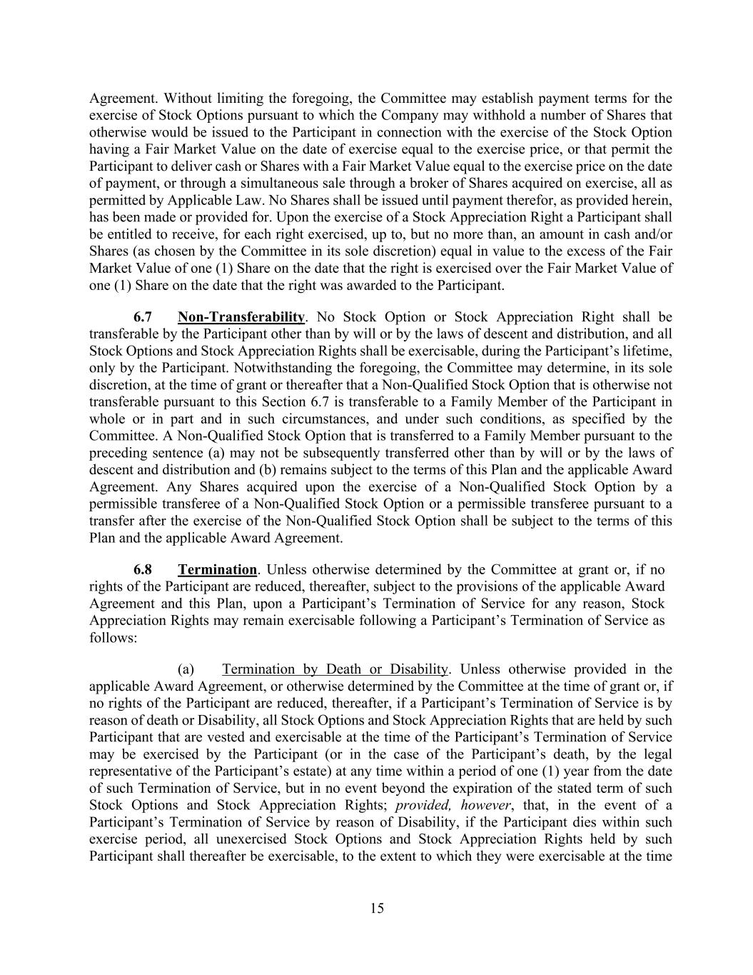
15 Agreement. Without limiting the foregoing, the Committee may establish payment terms for the exercise of Stock Options pursuant to which the Company may withhold a number of Shares that otherwise would be issued to the Participant in connection with the exercise of the Stock Option having a Fair Market Value on the date of exercise equal to the exercise price, or that permit the Participant to deliver cash or Shares with a Fair Market Value equal to the exercise price on the date of payment, or through a simultaneous sale through a broker of Shares acquired on exercise, all as permitted by Applicable Law. No Shares shall be issued until payment therefor, as provided herein, has been made or provided for. Upon the exercise of a Stock Appreciation Right a Participant shall be entitled to receive, for each right exercised, up to, but no more than, an amount in cash and/or Shares (as chosen by the Committee in its sole discretion) equal in value to the excess of the Fair Market Value of one (1) Share on the date that the right is exercised over the Fair Market Value of one (1) Share on the date that the right was awarded to the Participant. 6.7 Non-Transferability. No Stock Option or Stock Appreciation Right shall be transferable by the Participant other than by will or by the laws of descent and distribution, and all Stock Options and Stock Appreciation Rights shall be exercisable, during the Participant’s lifetime, only by the Participant. Notwithstanding the foregoing, the Committee may determine, in its sole discretion, at the time of grant or thereafter that a Non-Qualified Stock Option that is otherwise not transferable pursuant to this Section 6.7 is transferable to a Family Member of the Participant in whole or in part and in such circumstances, and under such conditions, as specified by the Committee. A Non-Qualified Stock Option that is transferred to a Family Member pursuant to the preceding sentence (a) may not be subsequently transferred other than by will or by the laws of descent and distribution and (b) remains subject to the terms of this Plan and the applicable Award Agreement. Any Shares acquired upon the exercise of a Non-Qualified Stock Option by a permissible transferee of a Non-Qualified Stock Option or a permissible transferee pursuant to a transfer after the exercise of the Non-Qualified Stock Option shall be subject to the terms of this Plan and the applicable Award Agreement. 6.8 Termination. Unless otherwise determined by the Committee at grant or, if no rights of the Participant are reduced, thereafter, subject to the provisions of the applicable Award Agreement and this Plan, upon a Participant’s Termination of Service for any reason, Stock Appreciation Rights may remain exercisable following a Participant’s Termination of Service as follows: (a) Termination by Death or Disability. Unless otherwise provided in the applicable Award Agreement, or otherwise determined by the Committee at the time of grant or, if no rights of the Participant are reduced, thereafter, if a Participant’s Termination of Service is by reason of death or Disability, all Stock Options and Stock Appreciation Rights that are held by such Participant that are vested and exercisable at the time of the Participant’s Termination of Service may be exercised by the Participant (or in the case of the Participant’s death, by the legal representative of the Participant’s estate) at any time within a period of one (1) year from the date of such Termination of Service, but in no event beyond the expiration of the stated term of such Stock Options and Stock Appreciation Rights; provided, however, that, in the event of a Participant’s Termination of Service by reason of Disability, if the Participant dies within such exercise period, all unexercised Stock Options and Stock Appreciation Rights held by such Participant shall thereafter be exercisable, to the extent to which they were exercisable at the time

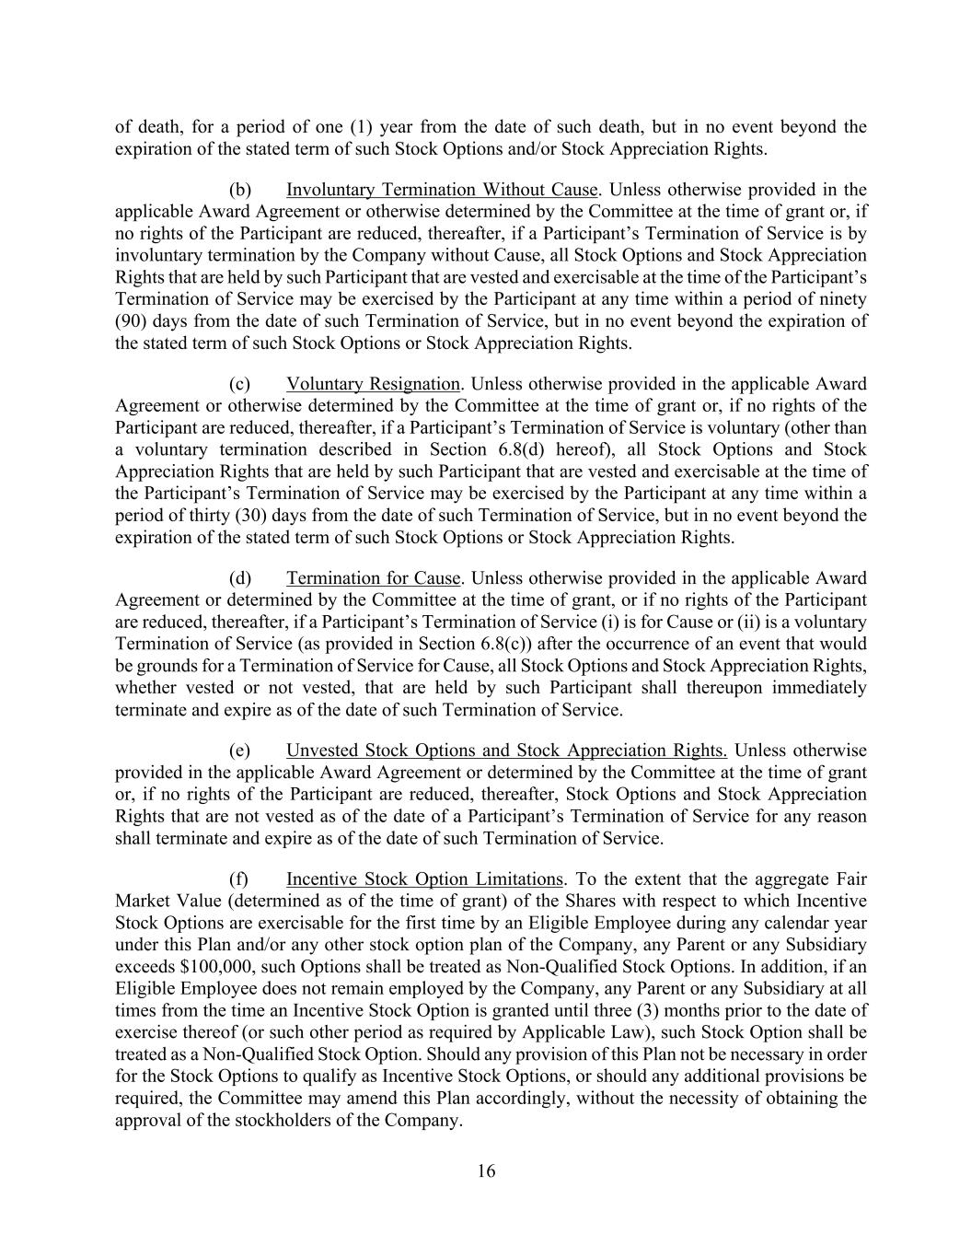
16 of death, for a period of one (1) year from the date of such death, but in no event beyond the expiration of the stated term of such Stock Options and/or Stock Appreciation Rights. (b) Involuntary Termination Without Cause. Unless otherwise provided in the applicable Award Agreement or otherwise determined by the Committee at the time of grant or, if no rights of the Participant are reduced, thereafter, if a Participant’s Termination of Service is by involuntary termination by the Company without Cause, all Stock Options and Stock Appreciation Rights that are held by such Participant that are vested and exercisable at the time of the Participant’s Termination of Service may be exercised by the Participant at any time within a period of ninety (90) days from the date of such Termination of Service, but in no event beyond the expiration of the stated term of such Stock Options or Stock Appreciation Rights. (c) Voluntary Resignation. Unless otherwise provided in the applicable Award Agreement or otherwise determined by the Committee at the time of grant or, if no rights of the Participant are reduced, thereafter, if a Participant’s Termination of Service is voluntary (other than a voluntary termination described in Section 6.8(d) hereof), all Stock Options and Stock Appreciation Rights that are held by such Participant that are vested and exercisable at the time of the Participant’s Termination of Service may be exercised by the Participant at any time within a period of thirty (30) days from the date of such Termination of Service, but in no event beyond the expiration of the stated term of such Stock Options or Stock Appreciation Rights. (d) Termination for Cause. Unless otherwise provided in the applicable Award Agreement or determined by the Committee at the time of grant, or if no rights of the Participant are reduced, thereafter, if a Participant’s Termination of Service (i) is for Cause or (ii) is a voluntary Termination of Service (as provided in Section 6.8(c)) after the occurrence of an event that would be grounds for a Termination of Service for Cause, all Stock Options and Stock Appreciation Rights, whether vested or not vested, that are held by such Participant shall thereupon immediately terminate and expire as of the date of such Termination of Service. (e) Unvested Stock Options and Stock Appreciation Rights. Unless otherwise provided in the applicable Award Agreement or determined by the Committee at the time of grant or, if no rights of the Participant are reduced, thereafter, Stock Options and Stock Appreciation Rights that are not vested as of the date of a Participant’s Termination of Service for any reason shall terminate and expire as of the date of such Termination of Service. (f) Incentive Stock Option Limitations. To the extent that the aggregate Fair Market Value (determined as of the time of grant) of the Shares with respect to which Incentive Stock Options are exercisable for the first time by an Eligible Employee during any calendar year under this Plan and/or any other stock option plan of the Company, any Parent or any Subsidiary exceeds $100,000, such Options shall be treated as Non-Qualified Stock Options. In addition, if an Eligible Employee does not remain employed by the Company, any Parent or any Subsidiary at all times from the time an Incentive Stock Option is granted until three (3) months prior to the date of exercise thereof (or such other period as required by Applicable Law), such Stock Option shall be treated as a Non-Qualified Stock Option. Should any provision of this Plan not be necessary in order for the Stock Options to qualify as Incentive Stock Options, or should any additional provisions be required, the Committee may amend this Plan accordingly, without the necessity of obtaining the approval of the stockholders of the Company.

17 (g) Modification, Extension and Renewal of Stock Options. The Committee may (i) modify, extend, or renew outstanding Stock Options granted under this Plan (provided that the rights of a Participant are not reduced without such Participant’s consent and provided, further that such action does not subject the Stock Options to Section 409A of the Code without the consent of the Participant), and (ii) accept the surrender of outstanding Stock Options (to the extent not theretofore exercised) and authorize the granting of new Stock Options in substitution therefor (to the extent not theretofore exercised). 6.9 Automatic Exercise. The Committee may include a provision in an Award Agreement providing for the automatic exercise of a Non-Qualified Stock Option or Stock Appreciation Right on a cashless basis on the last day of the term of such Option or Stock Appreciation Right if the Participant has failed to exercise the Non-Qualified Stock Option or Stock Appreciation Right as of such date, with respect to which the Fair Market Value of the Shares underlying the Non-Qualified Stock Option or Stock Appreciation Right exceeds the exercise price of such Non-Qualified Stock Option or Stock Appreciation Right on the date of expiration of such Option or Stock Appreciation Right, subject to Section 13.4. 6.10 Dividends. No dividend or Dividend Equivalent Rights shall be granted with respect to Stock Options or Stock Appreciation Rights. 6.11 Other Terms and Conditions. As the Committee shall deem appropriate, Stock Options and Stock Appreciation Rights may be subject to additional terms and conditions or other provisions, which shall not be inconsistent with any of the terms of this Plan. ARTICLE VII RESTRICTED STOCK; RESTRICTED STOCK UNITS 7.1 Awards of Restricted Stock and Restricted Stock Units. Shares of Restricted Stock and Restricted Stock Units may be granted alone or in addition to other Awards granted under this Plan. The Committee shall determine the Eligible Individuals to whom, and the time or times at which, grants of Restricted Stock and/or Restricted Stock Units shall be made, the number of shares of Restricted Stock or Restricted Stock Units to be awarded, the price (if any) to be paid by the Participant (subject to Section 7.2), the time or times within which such Awards may be subject to forfeiture, the vesting schedule and rights to acceleration thereof, and all other terms and conditions of the Awards. The Committee shall determine and set forth in the Award Agreement the terms and conditions for each Award of Restricted Stock and Restricted Stock Units, subject to the conditions and limitations contained in this Plan, including any vesting or forfeiture conditions. The Committee may condition the grant or vesting of Restricted Stock and Restricted Stock Units upon the attainment of specified Performance Goals or such other factor as the Committee may determine in its sole discretion. 7.2 Awards and Certificates. Restricted Stock and Restricted Stock Units granted under this Plan shall be evidenced by an Award Agreement and subject to the following terms and conditions and shall be in such form and contain such additional terms and conditions not inconsistent with the terms of this Plan, as the Committee shall deem desirable:

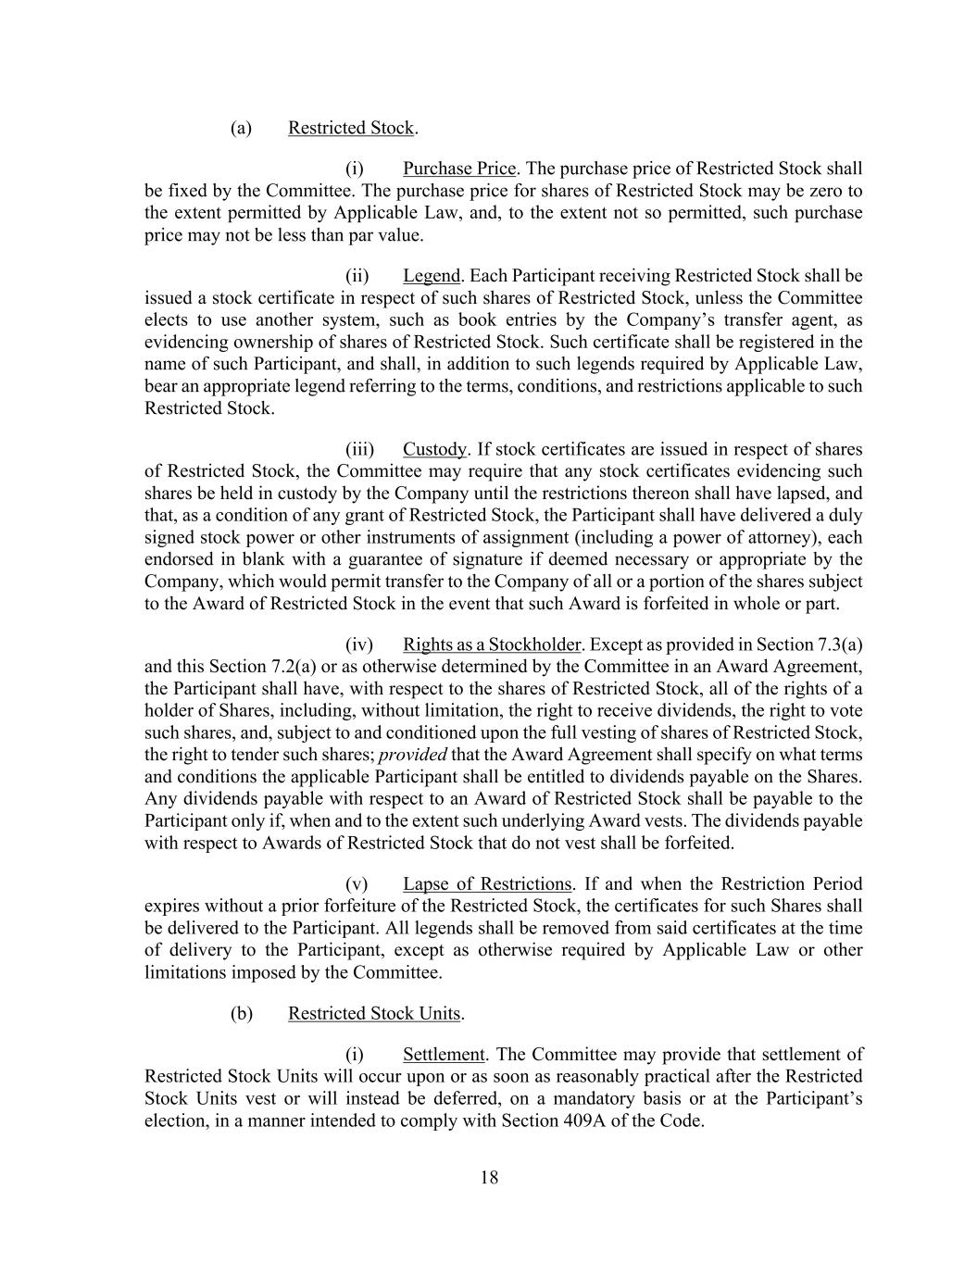
18 (a) Restricted Stock. (i) Purchase Price. The purchase price of Restricted Stock shall be fixed by the Committee. The purchase price for shares of Restricted Stock may be zero to the extent permitted by Applicable Law, and, to the extent not so permitted, such purchase price may not be less than par value. (ii) Legend. Each Participant receiving Restricted Stock shall be issued a stock certificate in respect of such shares of Restricted Stock, unless the Committee elects to use another system, such as book entries by the Company’s transfer agent, as evidencing ownership of shares of Restricted Stock. Such certificate shall be registered in the name of such Participant, and shall, in addition to such legends required by Applicable Law, bear an appropriate legend referring to the terms, conditions, and restrictions applicable to such Restricted Stock. (iii) Custody. If stock certificates are issued in respect of shares of Restricted Stock, the Committee may require that any stock certificates evidencing such shares be held in custody by the Company until the restrictions thereon shall have lapsed, and that, as a condition of any grant of Restricted Stock, the Participant shall have delivered a duly signed stock power or other instruments of assignment (including a power of attorney), each endorsed in blank with a guarantee of signature if deemed necessary or appropriate by the Company, which would permit transfer to the Company of all or a portion of the shares subject to the Award of Restricted Stock in the event that such Award is forfeited in whole or part. (iv) Rights as a Stockholder. Except as provided in Section 7.3(a) and this Section 7.2(a) or as otherwise determined by the Committee in an Award Agreement, the Participant shall have, with respect to the shares of Restricted Stock, all of the rights of a holder of Shares, including, without limitation, the right to receive dividends, the right to vote such shares, and, subject to and conditioned upon the full vesting of shares of Restricted Stock, the right to tender such shares; provided that the Award Agreement shall specify on what terms and conditions the applicable Participant shall be entitled to dividends payable on the Shares. Any dividends payable with respect to an Award of Restricted Stock shall be payable to the Participant only if, when and to the extent such underlying Award vests. The dividends payable with respect to Awards of Restricted Stock that do not vest shall be forfeited. (v) Lapse of Restrictions. If and when the Restriction Period expires without a prior forfeiture of the Restricted Stock, the certificates for such Shares shall be delivered to the Participant. All legends shall be removed from said certificates at the time of delivery to the Participant, except as otherwise required by Applicable Law or other limitations imposed by the Committee. (b) Restricted Stock Units. (i) Settlement. The Committee may provide that settlement of Restricted Stock Units will occur upon or as soon as reasonably practical after the Restricted Stock Units vest or will instead be deferred, on a mandatory basis or at the Participant’s election, in a manner intended to comply with Section 409A of the Code.

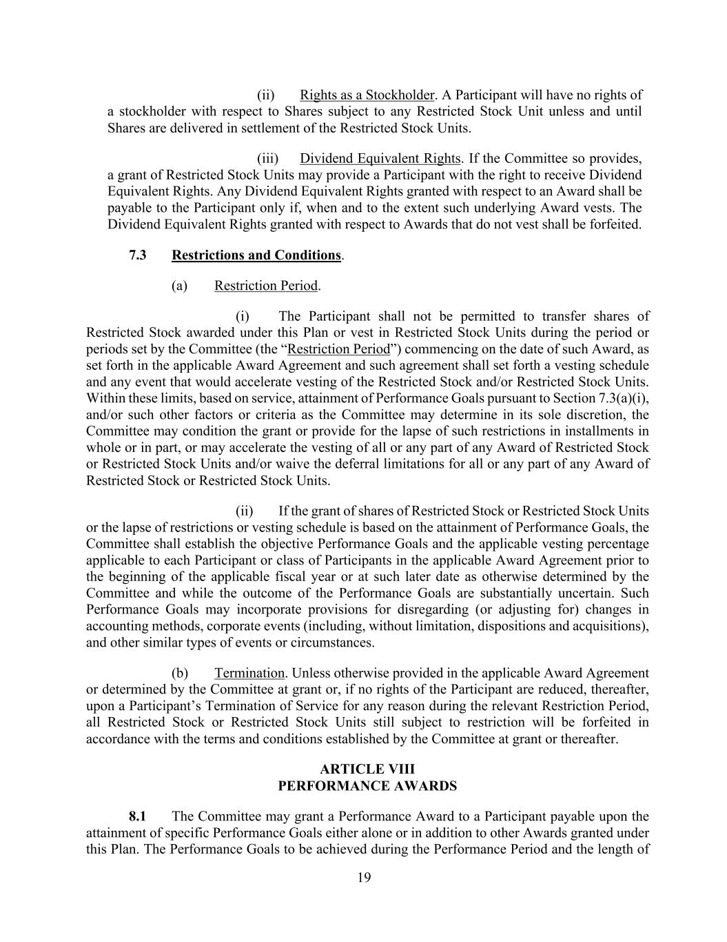
19 (ii) Rights as a Stockholder. A Participant will have no rights of a stockholder with respect to Shares subject to any Restricted Stock Unit unless and until Shares are delivered in settlement of the Restricted Stock Units. (iii) Dividend Equivalent Rights. If the Committee so provides, a grant of Restricted Stock Units may provide a Participant with the right to receive Dividend Equivalent Rights. Any Dividend Equivalent Rights granted with respect to an Award shall be payable to the Participant only if, when and to the extent such underlying Award vests. The Dividend Equivalent Rights granted with respect to Awards that do not vest shall be forfeited. 7.3 Restrictions and Conditions. (a) Restriction Period. (i) The Participant shall not be permitted to transfer shares of Restricted Stock awarded under this Plan or vest in Restricted Stock Units during the period or periods set by the Committee (the “Restriction Period”) commencing on the date of such Award, as set forth in the applicable Award Agreement and such agreement shall set forth a vesting schedule and any event that would accelerate vesting of the Restricted Stock and/or Restricted Stock Units. Within these limits, based on service, attainment of Performance Goals pursuant to Section 7.3(a)(i), and/or such other factors or criteria as the Committee may determine in its sole discretion, the Committee may condition the grant or provide for the lapse of such restrictions in installments in whole or in part, or may accelerate the vesting of all or any part of any Award of Restricted Stock or Restricted Stock Units and/or waive the deferral limitations for all or any part of any Award of Restricted Stock or Restricted Stock Units. (ii) If the grant of shares of Restricted Stock or Restricted Stock Units or the lapse of restrictions or vesting schedule is based on the attainment of Performance Goals, the Committee shall establish the objective Performance Goals and the applicable vesting percentage applicable to each Participant or class of Participants in the applicable Award Agreement prior to the beginning of the applicable fiscal year or at such later date as otherwise determined by the Committee and while the outcome of the Performance Goals are substantially uncertain. Such Performance Goals may incorporate provisions for disregarding (or adjusting for) changes in accounting methods, corporate events (including, without limitation, dispositions and acquisitions), and other similar types of events or circumstances. (b) Termination. Unless otherwise provided in the applicable Award Agreement or determined by the Committee at grant or, if no rights of the Participant are reduced, thereafter, upon a Participant’s Termination of Service for any reason during the relevant Restriction Period, all Restricted Stock or Restricted Stock Units still subject to restriction will be forfeited in accordance with the terms and conditions established by the Committee at grant or thereafter. ARTICLE VIII PERFORMANCE AWARDS 8.1 The Committee may grant a Performance Award to a Participant payable upon the attainment of specific Performance Goals either alone or in addition to other Awards granted under this Plan. The Performance Goals to be achieved during the Performance Period and the length of

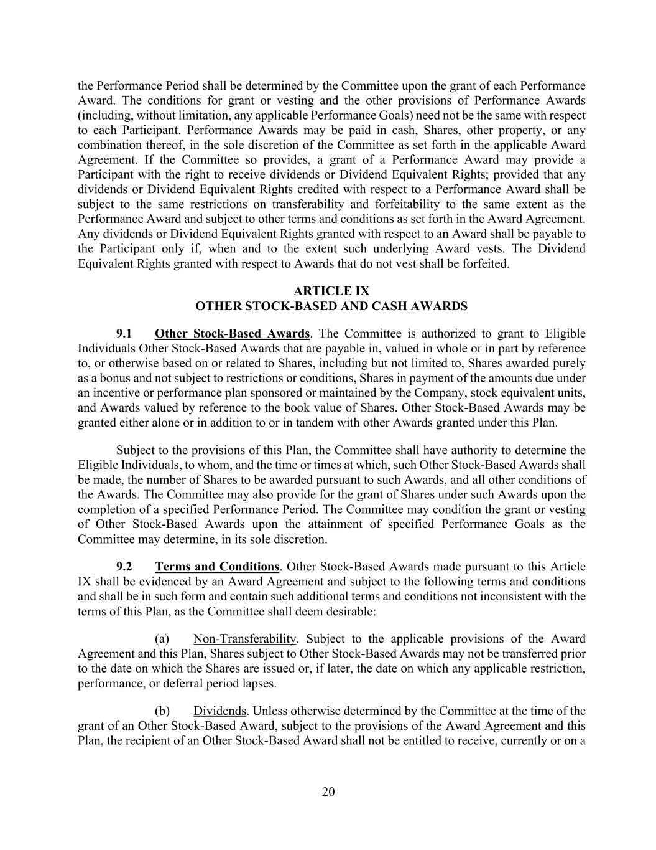
20 the Performance Period shall be determined by the Committee upon the grant of each Performance Award. The conditions for grant or vesting and the other provisions of Performance Awards (including, without limitation, any applicable Performance Goals) need not be the same with respect to each Participant. Performance Awards may be paid in cash, Shares, other property, or any combination thereof, in the sole discretion of the Committee as set forth in the applicable Award Agreement. If the Committee so provides, a grant of a Performance Award may provide a Participant with the right to receive dividends or Dividend Equivalent Rights; provided that any dividends or Dividend Equivalent Rights credited with respect to a Performance Award shall be subject to the same restrictions on transferability and forfeitability to the same extent as the Performance Award and subject to other terms and conditions as set forth in the Award Agreement. Any dividends or Dividend Equivalent Rights granted with respect to an Award shall be payable to the Participant only if, when and to the extent such underlying Award vests. The Dividend Equivalent Rights granted with respect to Awards that do not vest shall be forfeited. ARTICLE IX OTHER STOCK-BASED AND CASH AWARDS 9.1 Other Stock-Based Awards. The Committee is authorized to grant to Eligible Individuals Other Stock-Based Awards that are payable in, valued in whole or in part by reference to, or otherwise based on or related to Shares, including but not limited to, Shares awarded purely as a bonus and not subject to restrictions or conditions, Shares in payment of the amounts due under an incentive or performance plan sponsored or maintained by the Company, stock equivalent units, and Awards valued by reference to the book value of Shares. Other Stock-Based Awards may be granted either alone or in addition to or in tandem with other Awards granted under this Plan. Subject to the provisions of this Plan, the Committee shall have authority to determine the Eligible Individuals, to whom, and the time or times at which, such Other Stock-Based Awards shall be made, the number of Shares to be awarded pursuant to such Awards, and all other conditions of the Awards. The Committee may also provide for the grant of Shares under such Awards upon the completion of a specified Performance Period. The Committee may condition the grant or vesting of Other Stock-Based Awards upon the attainment of specified Performance Goals as the Committee may determine, in its sole discretion. 9.2 Terms and Conditions. Other Stock-Based Awards made pursuant to this Article IX shall be evidenced by an Award Agreement and subject to the following terms and conditions and shall be in such form and contain such additional terms and conditions not inconsistent with the terms of this Plan, as the Committee shall deem desirable: (a) Non-Transferability. Subject to the applicable provisions of the Award Agreement and this Plan, Shares subject to Other Stock-Based Awards may not be transferred prior to the date on which the Shares are issued or, if later, the date on which any applicable restriction, performance, or deferral period lapses. (b) Dividends. Unless otherwise determined by the Committee at the time of the grant of an Other Stock-Based Award, subject to the provisions of the Award Agreement and this Plan, the recipient of an Other Stock-Based Award shall not be entitled to receive, currently or on a

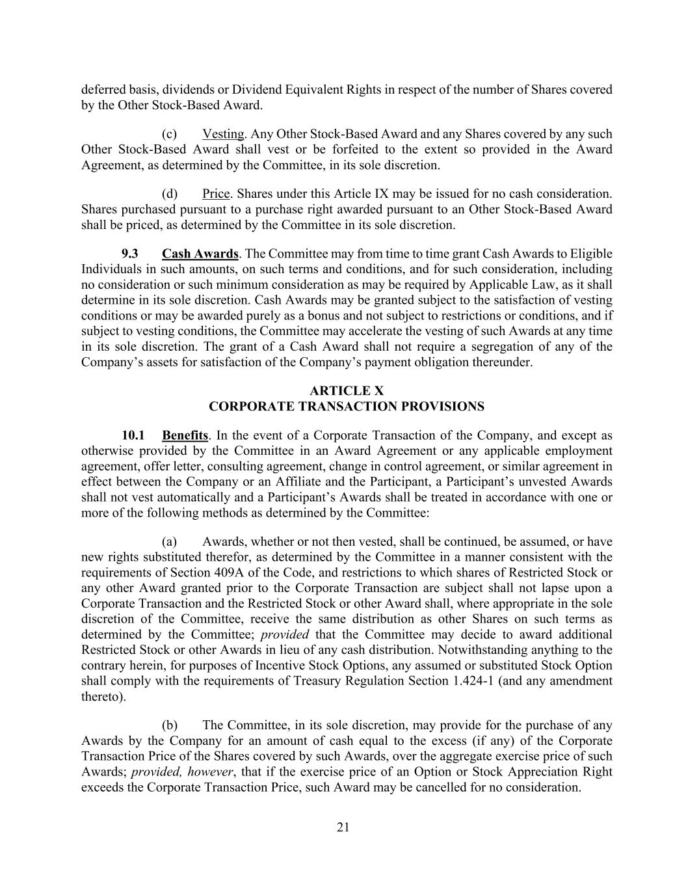
21 deferred basis, dividends or Dividend Equivalent Rights in respect of the number of Shares covered by the Other Stock-Based Award. (c) Vesting. Any Other Stock-Based Award and any Shares covered by any such Other Stock-Based Award shall vest or be forfeited to the extent so provided in the Award Agreement, as determined by the Committee, in its sole discretion. (d) Price. Shares under this Article IX may be issued for no cash consideration. Shares purchased pursuant to a purchase right awarded pursuant to an Other Stock-Based Award shall be priced, as determined by the Committee in its sole discretion. 9.3 Cash Awards. The Committee may from time to time grant Cash Awards to Eligible Individuals in such amounts, on such terms and conditions, and for such consideration, including no consideration or such minimum consideration as may be required by Applicable Law, as it shall determine in its sole discretion. Cash Awards may be granted subject to the satisfaction of vesting conditions or may be awarded purely as a bonus and not subject to restrictions or conditions, and if subject to vesting conditions, the Committee may accelerate the vesting of such Awards at any time in its sole discretion. The grant of a Cash Award shall not require a segregation of any of the Company’s assets for satisfaction of the Company’s payment obligation thereunder. ARTICLE X CORPORATE TRANSACTION PROVISIONS 10.1 Benefits. In the event of a Corporate Transaction of the Company, and except as otherwise provided by the Committee in an Award Agreement or any applicable employment agreement, offer letter, consulting agreement, change in control agreement, or similar agreement in effect between the Company or an Affiliate and the Participant, a Participant’s unvested Awards shall not vest automatically and a Participant’s Awards shall be treated in accordance with one or more of the following methods as determined by the Committee: (a) Awards, whether or not then vested, shall be continued, be assumed, or have new rights substituted therefor, as determined by the Committee in a manner consistent with the requirements of Section 409A of the Code, and restrictions to which shares of Restricted Stock or any other Award granted prior to the Corporate Transaction are subject shall not lapse upon a Corporate Transaction and the Restricted Stock or other Award shall, where appropriate in the sole discretion of the Committee, receive the same distribution as other Shares on such terms as determined by the Committee; provided that the Committee may decide to award additional Restricted Stock or other Awards in lieu of any cash distribution. Notwithstanding anything to the contrary herein, for purposes of Incentive Stock Options, any assumed or substituted Stock Option shall comply with the requirements of Treasury Regulation Section 1.424-1 (and any amendment thereto). (b) The Committee, in its sole discretion, may provide for the purchase of any Awards by the Company for an amount of cash equal to the excess (if any) of the Corporate Transaction Price of the Shares covered by such Awards, over the aggregate exercise price of such Awards; provided, however, that if the exercise price of an Option or Stock Appreciation Right exceeds the Corporate Transaction Price, such Award may be cancelled for no consideration.

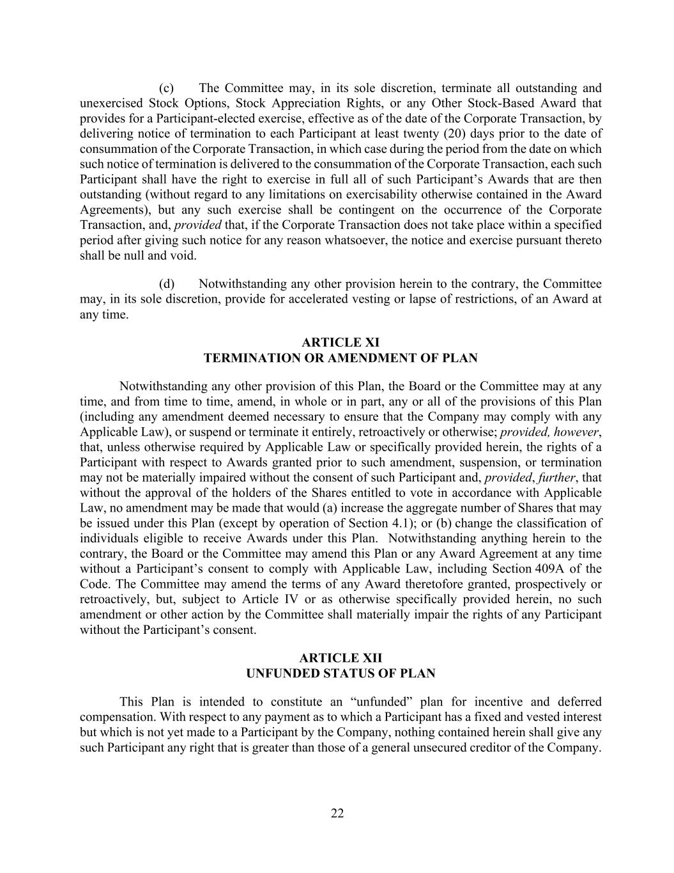
22 (c) The Committee may, in its sole discretion, terminate all outstanding and unexercised Stock Options, Stock Appreciation Rights, or any Other Stock-Based Award that provides for a Participant-elected exercise, effective as of the date of the Corporate Transaction, by delivering notice of termination to each Participant at least twenty (20) days prior to the date of consummation of the Corporate Transaction, in which case during the period from the date on which such notice of termination is delivered to the consummation of the Corporate Transaction, each such Participant shall have the right to exercise in full all of such Participant’s Awards that are then outstanding (without regard to any limitations on exercisability otherwise contained in the Award Agreements), but any such exercise shall be contingent on the occurrence of the Corporate Transaction, and, provided that, if the Corporate Transaction does not take place within a specified period after giving such notice for any reason whatsoever, the notice and exercise pursuant thereto shall be null and void. (d) Notwithstanding any other provision herein to the contrary, the Committee may, in its sole discretion, provide for accelerated vesting or lapse of restrictions, of an Award at any time. ARTICLE XI TERMINATION OR AMENDMENT OF PLAN Notwithstanding any other provision of this Plan, the Board or the Committee may at any time, and from time to time, amend, in whole or in part, any or all of the provisions of this Plan (including any amendment deemed necessary to ensure that the Company may comply with any Applicable Law), or suspend or terminate it entirely, retroactively or otherwise; provided, however, that, unless otherwise required by Applicable Law or specifically provided herein, the rights of a Participant with respect to Awards granted prior to such amendment, suspension, or termination may not be materially impaired without the consent of such Participant and, provided, further, that without the approval of the holders of the Shares entitled to vote in accordance with Applicable Law, no amendment may be made that would (a) increase the aggregate number of Shares that may be issued under this Plan (except by operation of Section 4.1); or (b) change the classification of individuals eligible to receive Awards under this Plan. Notwithstanding anything herein to the contrary, the Board or the Committee may amend this Plan or any Award Agreement at any time without a Participant’s consent to comply with Applicable Law, including Section 409A of the Code. The Committee may amend the terms of any Award theretofore granted, prospectively or retroactively, but, subject to Article IV or as otherwise specifically provided herein, no such amendment or other action by the Committee shall materially impair the rights of any Participant without the Participant’s consent. ARTICLE XII UNFUNDED STATUS OF PLAN This Plan is intended to constitute an “unfunded” plan for incentive and deferred compensation. With respect to any payment as to which a Participant has a fixed and vested interest but which is not yet made to a Participant by the Company, nothing contained herein shall give any such Participant any right that is greater than those of a general unsecured creditor of the Company.

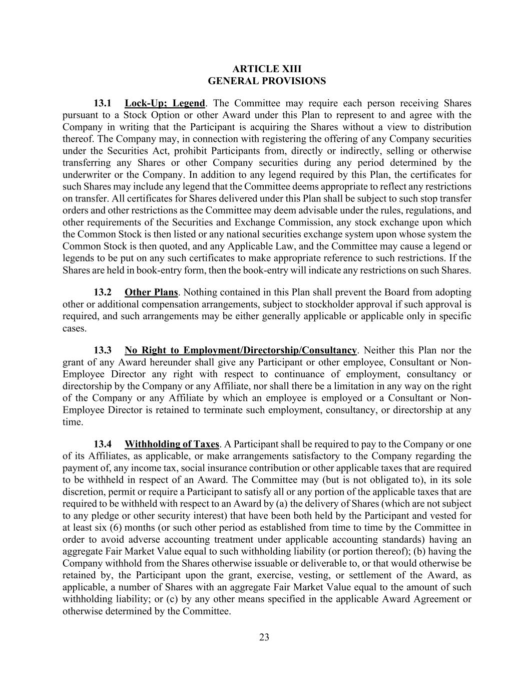
23 ARTICLE XIII GENERAL PROVISIONS 13.1 Lock-Up; Legend. The Committee may require each person receiving Shares pursuant to a Stock Option or other Award under this Plan to represent to and agree with the Company in writing that the Participant is acquiring the Shares without a view to distribution thereof. The Company may, in connection with registering the offering of any Company securities under the Securities Act, prohibit Participants from, directly or indirectly, selling or otherwise transferring any Shares or other Company securities during any period determined by the underwriter or the Company. In addition to any legend required by this Plan, the certificates for such Shares may include any legend that the Committee deems appropriate to reflect any restrictions on transfer. All certificates for Shares delivered under this Plan shall be subject to such stop transfer orders and other restrictions as the Committee may deem advisable under the rules, regulations, and other requirements of the Securities and Exchange Commission, any stock exchange upon which the Common Stock is then listed or any national securities exchange system upon whose system the Common Stock is then quoted, and any Applicable Law, and the Committee may cause a legend or legends to be put on any such certificates to make appropriate reference to such restrictions. If the Shares are held in book-entry form, then the book-entry will indicate any restrictions on such Shares. 13.2 Other Plans. Nothing contained in this Plan shall prevent the Board from adopting other or additional compensation arrangements, subject to stockholder approval if such approval is required, and such arrangements may be either generally applicable or applicable only in specific cases. 13.3 No Right to Employment/Directorship/Consultancy. Neither this Plan nor the grant of any Award hereunder shall give any Participant or other employee, Consultant or Non- Employee Director any right with respect to continuance of employment, consultancy or directorship by the Company or any Affiliate, nor shall there be a limitation in any way on the right of the Company or any Affiliate by which an employee is employed or a Consultant or Non- Employee Director is retained to terminate such employment, consultancy, or directorship at any time. 13.4 Withholding of Taxes. A Participant shall be required to pay to the Company or one of its Affiliates, as applicable, or make arrangements satisfactory to the Company regarding the payment of, any income tax, social insurance contribution or other applicable taxes that are required to be withheld in respect of an Award. The Committee may (but is not obligated to), in its sole discretion, permit or require a Participant to satisfy all or any portion of the applicable taxes that are required to be withheld with respect to an Award by (a) the delivery of Shares (which are not subject to any pledge or other security interest) that have been both held by the Participant and vested for at least six (6) months (or such other period as established from time to time by the Committee in order to avoid adverse accounting treatment under applicable accounting standards) having an aggregate Fair Market Value equal to such withholding liability (or portion thereof); (b) having the Company withhold from the Shares otherwise issuable or deliverable to, or that would otherwise be retained by, the Participant upon the grant, exercise, vesting, or settlement of the Award, as applicable, a number of Shares with an aggregate Fair Market Value equal to the amount of such withholding liability; or (c) by any other means specified in the applicable Award Agreement or otherwise determined by the Committee.

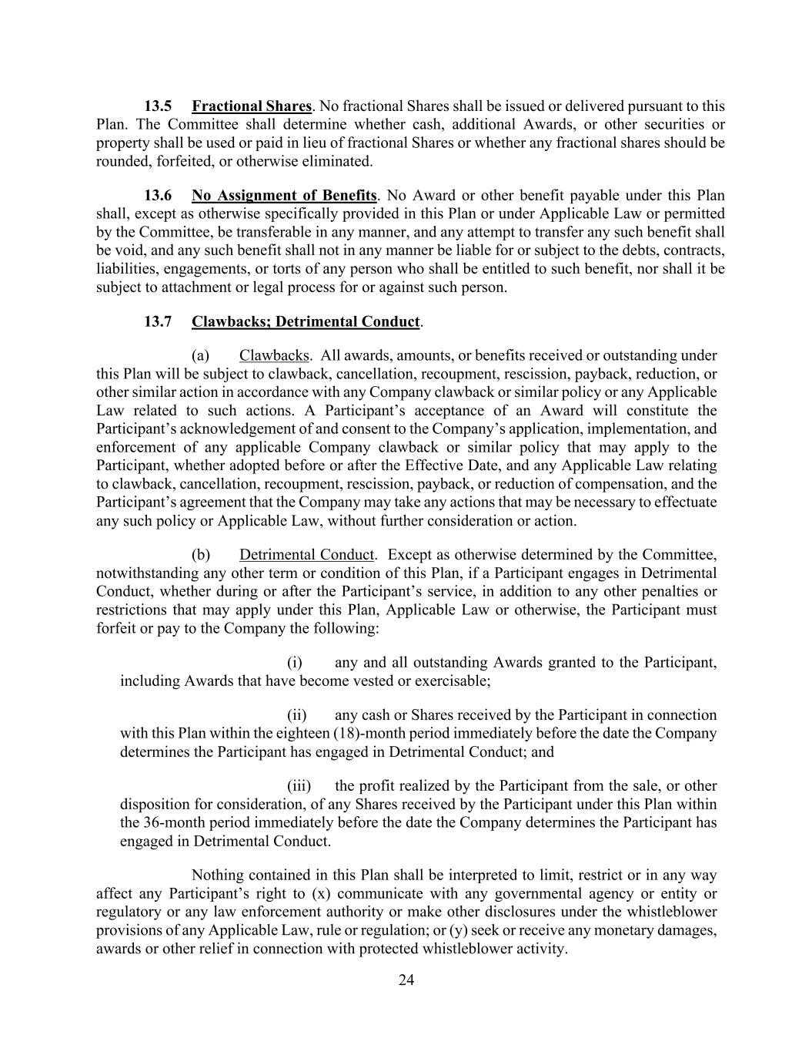
24 13.5 Fractional Shares. No fractional Shares shall be issued or delivered pursuant to this Plan. The Committee shall determine whether cash, additional Awards, or other securities or property shall be used or paid in lieu of fractional Shares or whether any fractional shares should be rounded, forfeited, or otherwise eliminated. 13.6 No Assignment of Benefits. No Award or other benefit payable under this Plan shall, except as otherwise specifically provided in this Plan or under Applicable Law or permitted by the Committee, be transferable in any manner, and any attempt to transfer any such benefit shall be void, and any such benefit shall not in any manner be liable for or subject to the debts, contracts, liabilities, engagements, or torts of any person who shall be entitled to such benefit, nor shall it be subject to attachment or legal process for or against such person. 13.7 Clawbacks; Detrimental Conduct. (a) Clawbacks. All awards, amounts, or benefits received or outstanding under this Plan will be subject to clawback, cancellation, recoupment, rescission, payback, reduction, or other similar action in accordance with any Company clawback or similar policy or any Applicable Law related to such actions. A Participant’s acceptance of an Award will constitute the Participant’s acknowledgement of and consent to the Company’s application, implementation, and enforcement of any applicable Company clawback or similar policy that may apply to the Participant, whether adopted before or after the Effective Date, and any Applicable Law relating to clawback, cancellation, recoupment, rescission, payback, or reduction of compensation, and the Participant’s agreement that the Company may take any actions that may be necessary to effectuate any such policy or Applicable Law, without further consideration or action. (b) Detrimental Conduct. Except as otherwise determined by the Committee, notwithstanding any other term or condition of this Plan, if a Participant engages in Detrimental Conduct, whether during or after the Participant’s service, in addition to any other penalties or restrictions that may apply under this Plan, Applicable Law or otherwise, the Participant must forfeit or pay to the Company the following: (i) any and all outstanding Awards granted to the Participant, including Awards that have become vested or exercisable; (ii) any cash or Shares received by the Participant in connection with this Plan within the eighteen (18)-month period immediately before the date the Company determines the Participant has engaged in Detrimental Conduct; and (iii) the profit realized by the Participant from the sale, or other disposition for consideration, of any Shares received by the Participant under this Plan within the 36-month period immediately before the date the Company determines the Participant has engaged in Detrimental Conduct. Nothing contained in this Plan shall be interpreted to limit, restrict or in any way affect any Participant’s right to (x) communicate with any governmental agency or entity or regulatory or any law enforcement authority or make other disclosures under the whistleblower provisions of any Applicable Law, rule or regulation; or (y) seek or receive any monetary damages, awards or other relief in connection with protected whistleblower activity.

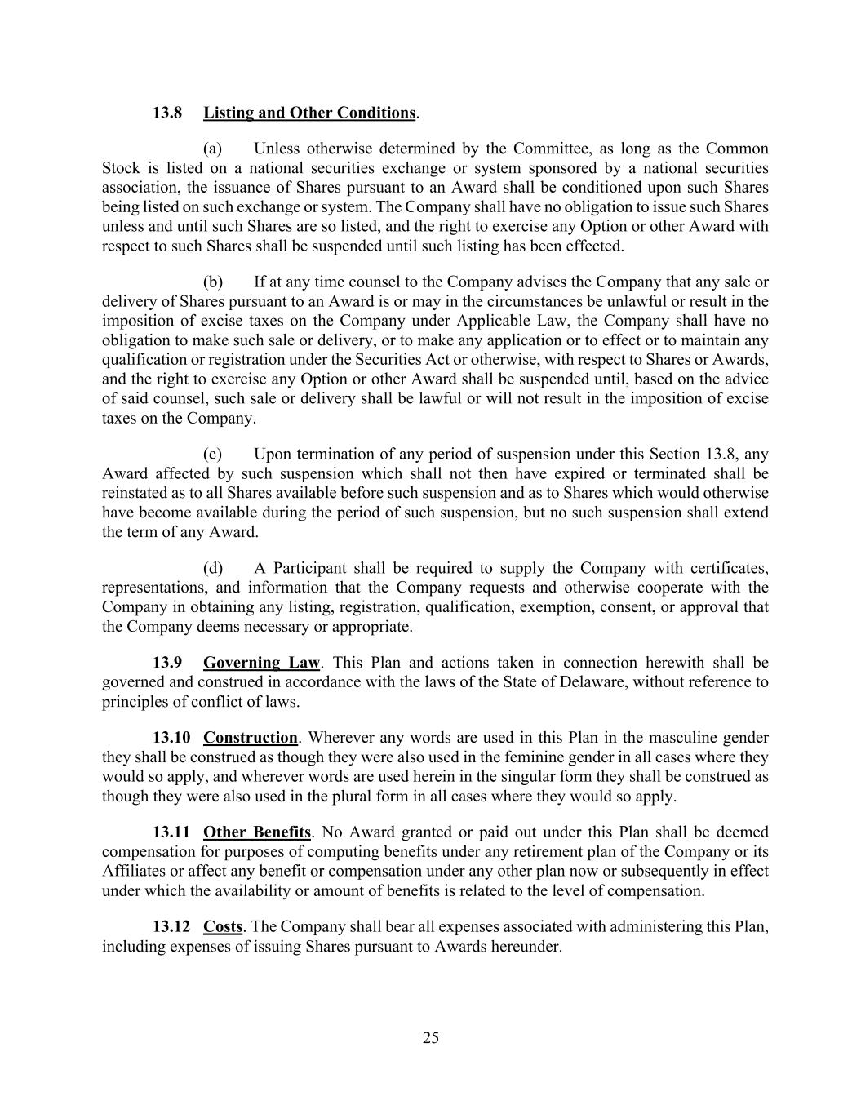
25 13.8 Listing and Other Conditions. (a) Unless otherwise determined by the Committee, as long as the Common Stock is listed on a national securities exchange or system sponsored by a national securities association, the issuance of Shares pursuant to an Award shall be conditioned upon such Shares being listed on such exchange or system. The Company shall have no obligation to issue such Shares unless and until such Shares are so listed, and the right to exercise any Option or other Award with respect to such Shares shall be suspended until such listing has been effected. (b) If at any time counsel to the Company advises the Company that any sale or delivery of Shares pursuant to an Award is or may in the circumstances be unlawful or result in the imposition of excise taxes on the Company under Applicable Law, the Company shall have no obligation to make such sale or delivery, or to make any application or to effect or to maintain any qualification or registration under the Securities Act or otherwise, with respect to Shares or Awards, and the right to exercise any Option or other Award shall be suspended until, based on the advice of said counsel, such sale or delivery shall be lawful or will not result in the imposition of excise taxes on the Company. (c) Upon termination of any period of suspension under this Section 13.8, any Award affected by such suspension which shall not then have expired or terminated shall be reinstated as to all Shares available before such suspension and as to Shares which would otherwise have become available during the period of such suspension, but no such suspension shall extend the term of any Award. (d) A Participant shall be required to supply the Company with certificates, representations, and information that the Company requests and otherwise cooperate with the Company in obtaining any listing, registration, qualification, exemption, consent, or approval that the Company deems necessary or appropriate. 13.9 Governing Law. This Plan and actions taken in connection herewith shall be governed and construed in accordance with the laws of the State of Delaware, without reference to principles of conflict of laws. 13.10 Construction. Wherever any words are used in this Plan in the masculine gender they shall be construed as though they were also used in the feminine gender in all cases where they would so apply, and wherever words are used herein in the singular form they shall be construed as though they were also used in the plural form in all cases where they would so apply. 13.11 Other Benefits. No Award granted or paid out under this Plan shall be deemed compensation for purposes of computing benefits under any retirement plan of the Company or its Affiliates or affect any benefit or compensation under any other plan now or subsequently in effect under which the availability or amount of benefits is related to the level of compensation. 13.12 Costs. The Company shall bear all expenses associated with administering this Plan, including expenses of issuing Shares pursuant to Awards hereunder.

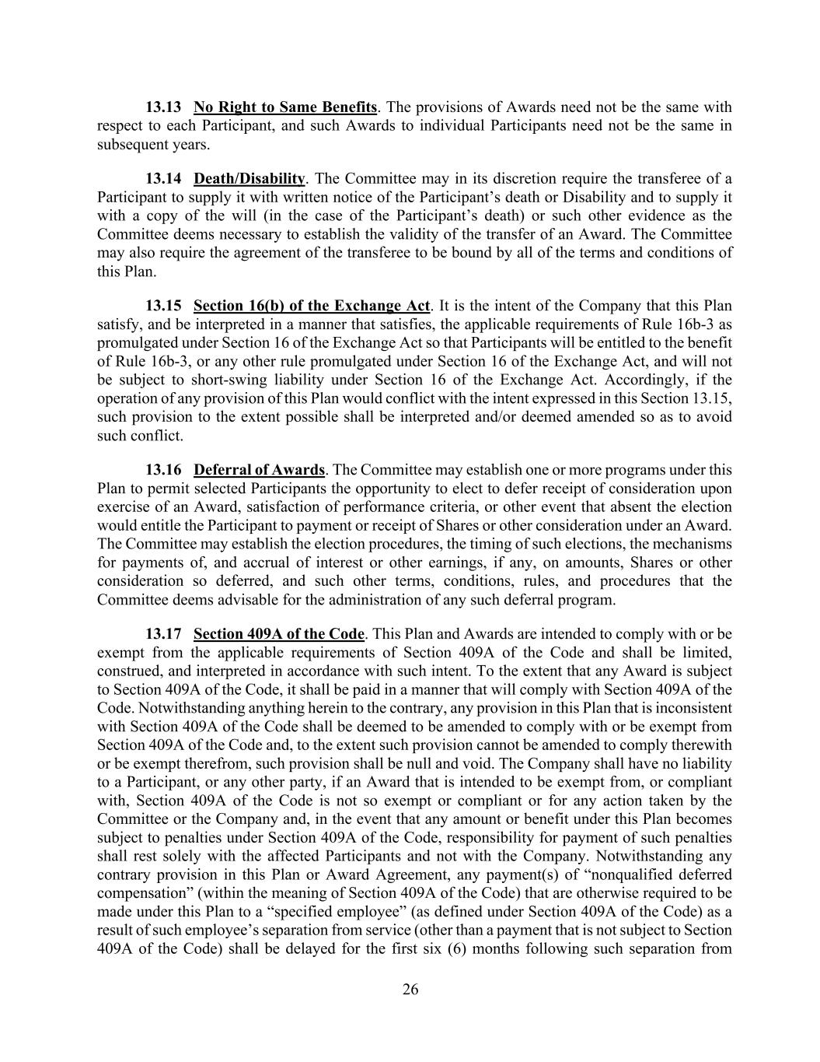
26 13.13 No Right to Same Benefits. The provisions of Awards need not be the same with respect to each Participant, and such Awards to individual Participants need not be the same in subsequent years. 13.14 Death/Disability. The Committee may in its discretion require the transferee of a Participant to supply it with written notice of the Participant’s death or Disability and to supply it with a copy of the will (in the case of the Participant’s death) or such other evidence as the Committee deems necessary to establish the validity of the transfer of an Award. The Committee may also require the agreement of the transferee to be bound by all of the terms and conditions of this Plan. 13.15 Section 16(b) of the Exchange Act. It is the intent of the Company that this Plan satisfy, and be interpreted in a manner that satisfies, the applicable requirements of Rule 16b-3 as promulgated under Section 16 of the Exchange Act so that Participants will be entitled to the benefit of Rule 16b-3, or any other rule promulgated under Section 16 of the Exchange Act, and will not be subject to short-swing liability under Section 16 of the Exchange Act. Accordingly, if the operation of any provision of this Plan would conflict with the intent expressed in this Section 13.15, such provision to the extent possible shall be interpreted and/or deemed amended so as to avoid such conflict. 13.16 Deferral of Awards. The Committee may establish one or more programs under this Plan to permit selected Participants the opportunity to elect to defer receipt of consideration upon exercise of an Award, satisfaction of performance criteria, or other event that absent the election would entitle the Participant to payment or receipt of Shares or other consideration under an Award. The Committee may establish the election procedures, the timing of such elections, the mechanisms for payments of, and accrual of interest or other earnings, if any, on amounts, Shares or other consideration so deferred, and such other terms, conditions, rules, and procedures that the Committee deems advisable for the administration of any such deferral program. 13.17 Section 409A of the Code. This Plan and Awards are intended to comply with or be exempt from the applicable requirements of Section 409A of the Code and shall be limited, construed, and interpreted in accordance with such intent. To the extent that any Award is subject to Section 409A of the Code, it shall be paid in a manner that will comply with Section 409A of the Code. Notwithstanding anything herein to the contrary, any provision in this Plan that is inconsistent with Section 409A of the Code shall be deemed to be amended to comply with or be exempt from Section 409A of the Code and, to the extent such provision cannot be amended to comply therewith or be exempt therefrom, such provision shall be null and void. The Company shall have no liability to a Participant, or any other party, if an Award that is intended to be exempt from, or compliant with, Section 409A of the Code is not so exempt or compliant or for any action taken by the Committee or the Company and, in the event that any amount or benefit under this Plan becomes subject to penalties under Section 409A of the Code, responsibility for payment of such penalties shall rest solely with the affected Participants and not with the Company. Notwithstanding any contrary provision in this Plan or Award Agreement, any payment(s) of “nonqualified deferred compensation” (within the meaning of Section 409A of the Code) that are otherwise required to be made under this Plan to a “specified employee” (as defined under Section 409A of the Code) as a result of such employee’s separation from service (other than a payment that is not subject to Section 409A of the Code) shall be delayed for the first six (6) months following such separation from

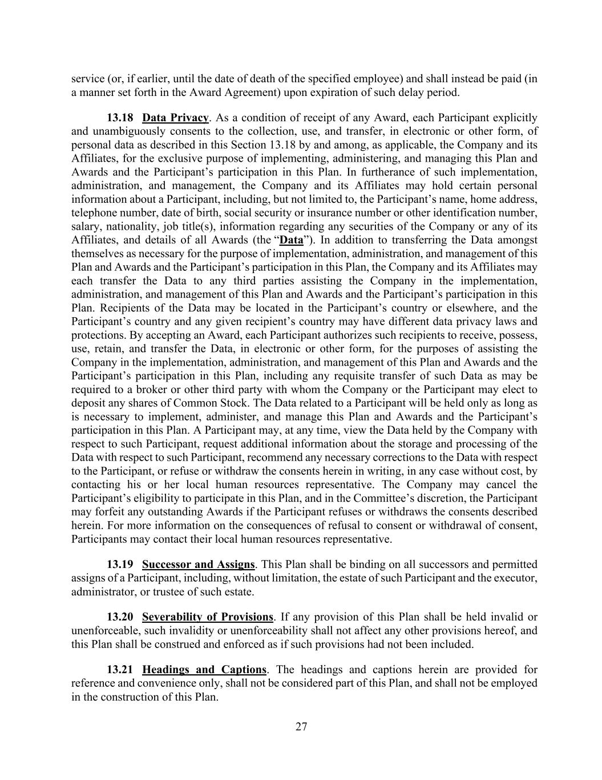
27 service (or, if earlier, until the date of death of the specified employee) and shall instead be paid (in a manner set forth in the Award Agreement) upon expiration of such delay period. 13.18 Data Privacy. As a condition of receipt of any Award, each Participant explicitly and unambiguously consents to the collection, use, and transfer, in electronic or other form, of personal data as described in this Section 13.18 by and among, as applicable, the Company and its Affiliates, for the exclusive purpose of implementing, administering, and managing this Plan and Awards and the Participant’s participation in this Plan. In furtherance of such implementation, administration, and management, the Company and its Affiliates may hold certain personal information about a Participant, including, but not limited to, the Participant’s name, home address, telephone number, date of birth, social security or insurance number or other identification number, salary, nationality, job title(s), information regarding any securities of the Company or any of its Affiliates, and details of all Awards (the “Data”). In addition to transferring the Data amongst themselves as necessary for the purpose of implementation, administration, and management of this Plan and Awards and the Participant’s participation in this Plan, the Company and its Affiliates may each transfer the Data to any third parties assisting the Company in the implementation, administration, and management of this Plan and Awards and the Participant’s participation in this Plan. Recipients of the Data may be located in the Participant’s country or elsewhere, and the Participant’s country and any given recipient’s country may have different data privacy laws and protections. By accepting an Award, each Participant authorizes such recipients to receive, possess, use, retain, and transfer the Data, in electronic or other form, for the purposes of assisting the Company in the implementation, administration, and management of this Plan and Awards and the Participant’s participation in this Plan, including any requisite transfer of such Data as may be required to a broker or other third party with whom the Company or the Participant may elect to deposit any shares of Common Stock. The Data related to a Participant will be held only as long as is necessary to implement, administer, and manage this Plan and Awards and the Participant’s participation in this Plan. A Participant may, at any time, view the Data held by the Company with respect to such Participant, request additional information about the storage and processing of the Data with respect to such Participant, recommend any necessary corrections to the Data with respect to the Participant, or refuse or withdraw the consents herein in writing, in any case without cost, by contacting his or her local human resources representative. The Company may cancel the Participant’s eligibility to participate in this Plan, and in the Committee’s discretion, the Participant may forfeit any outstanding Awards if the Participant refuses or withdraws the consents described herein. For more information on the consequences of refusal to consent or withdrawal of consent, Participants may contact their local human resources representative. 13.19 Successor and Assigns. This Plan shall be binding on all successors and permitted assigns of a Participant, including, without limitation, the estate of such Participant and the executor, administrator, or trustee of such estate. 13.20 Severability of Provisions. If any provision of this Plan shall be held invalid or unenforceable, such invalidity or unenforceability shall not affect any other provisions hereof, and this Plan shall be construed and enforced as if such provisions had not been included. 13.21 Headings and Captions. The headings and captions herein are provided for reference and convenience only, shall not be considered part of this Plan, and shall not be employed in the construction of this Plan.

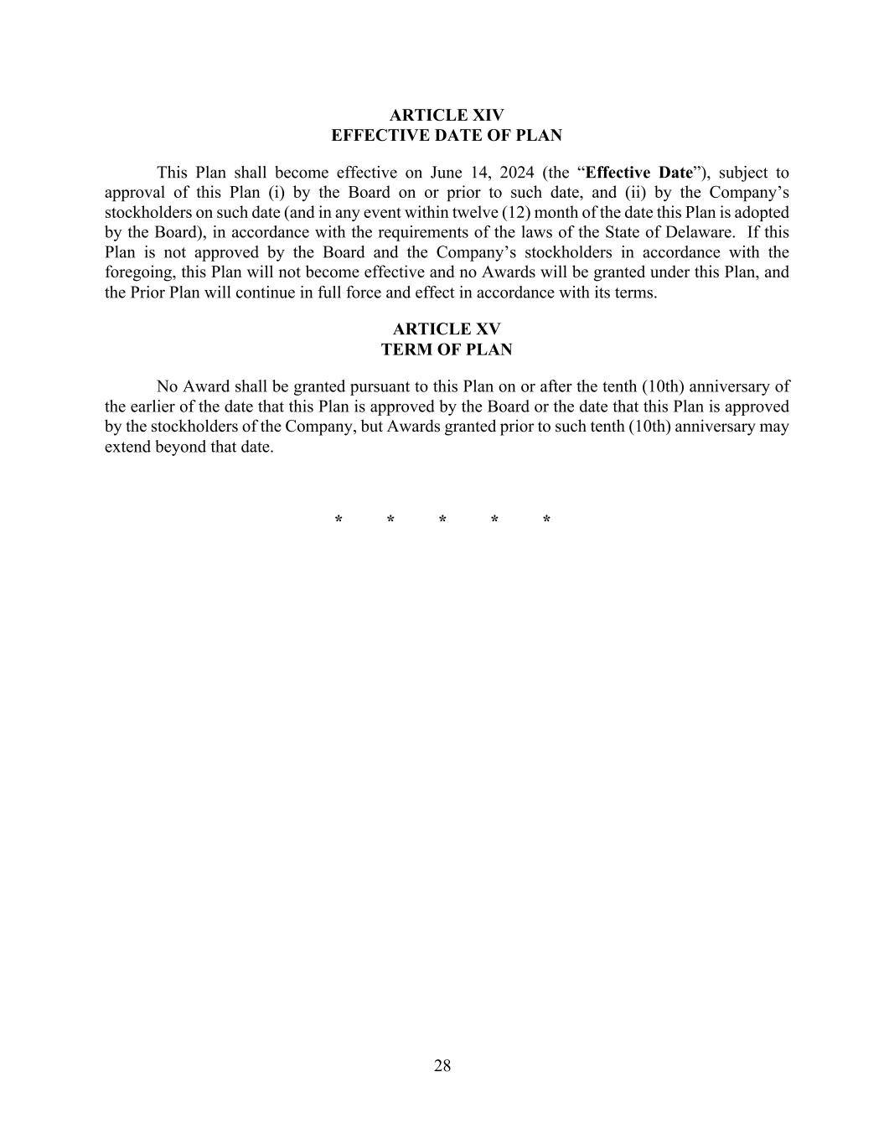
28 ARTICLE XIV EFFECTIVE DATE OF PLAN This Plan shall become effective on June 14, 2024 (the “Effective Date”), subject to approval of this Plan (i) by the Board on or prior to such date, and (ii) by the Company’s stockholders on such date (and in any event within twelve (12) month of the date this Plan is adopted by the Board), in accordance with the requirements of the laws of the State of Delaware. If this Plan is not approved by the Board and the Company’s stockholders in accordance with the foregoing, this Plan will not become effective and no Awards will be granted under this Plan, and the Prior Plan will continue in full force and effect in accordance with its terms. ARTICLE XV TERM OF PLAN No Award shall be granted pursuant to this Plan on or after the tenth (10th) anniversary of the earlier of the date that this Plan is approved by the Board or the date that this Plan is approved by the stockholders of the Company, but Awards granted prior to such tenth (10th) anniversary may extend beyond that date. * * * * *

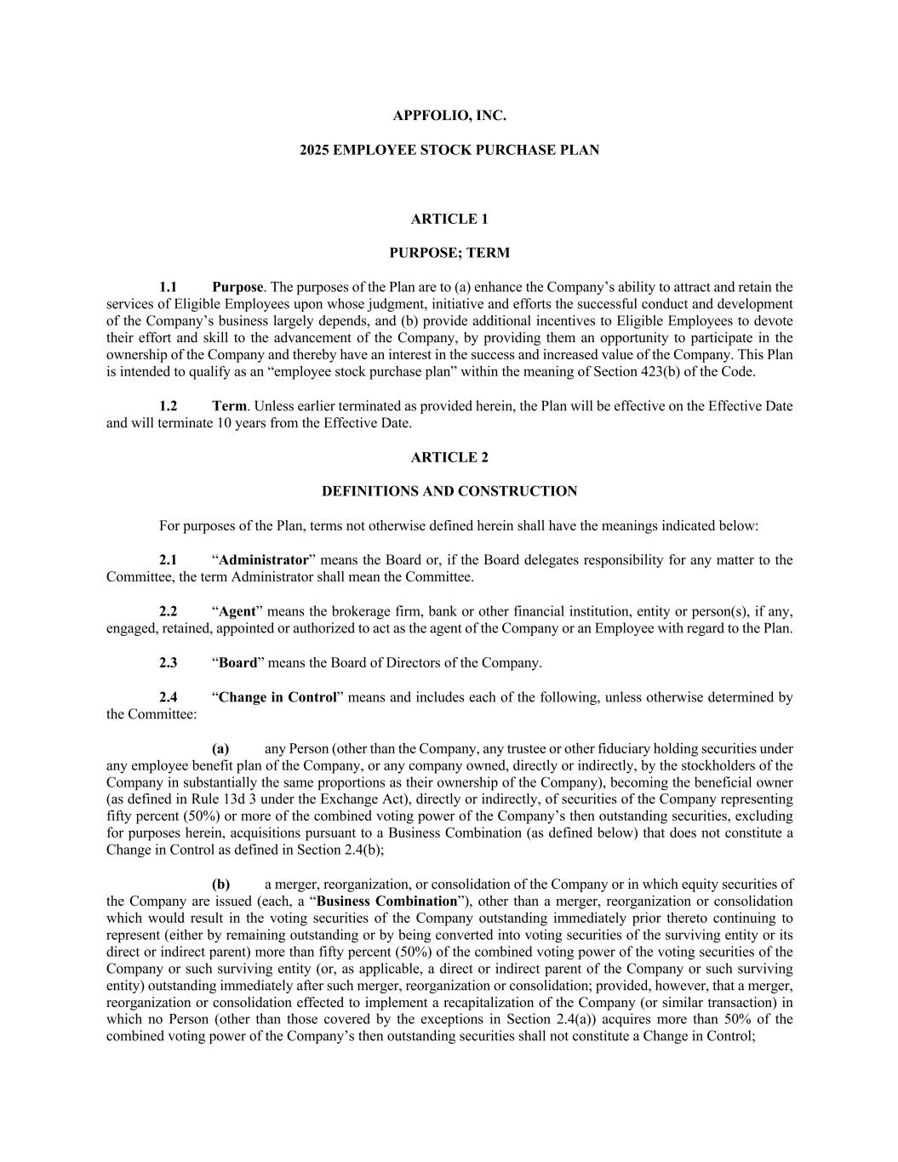
APPFOLIO, INC. 2025 EMPLOYEE STOCK PURCHASE PLAN ARTICLE 1 PURPOSE; TERM 1.1 Purpose. The purposes of the Plan are to (a) enhance the Company’s ability to attract and retain the services of Eligible Employees upon whose judgment, initiative and efforts the successful conduct and development of the Company’s business largely depends, and (b) provide additional incentives to Eligible Employees to devote their effort and skill to the advancement of the Company, by providing them an opportunity to participate in the ownership of the Company and thereby have an interest in the success and increased value of the Company. This Plan is intended to qualify as an “employee stock purchase plan” within the meaning of Section 423(b) of the Code. 1.2 Term. Unless earlier terminated as provided herein, the Plan will be effective on the Effective Date and will terminate 10 years from the Effective Date. ARTICLE 2 DEFINITIONS AND CONSTRUCTION For purposes of the Plan, terms not otherwise defined herein shall have the meanings indicated below: 2.1 “Administrator” means the Board or, if the Board delegates responsibility for any matter to the Committee, the term Administrator shall mean the Committee. 2.2 “Agent” means the brokerage firm, bank or other financial institution, entity or person(s), if any, engaged, retained, appointed or authorized to act as the agent of the Company or an Employee with regard to the Plan. 2.3 “Board” means the Board of Directors of the Company. 2.4 “Change in Control” means and includes each of the following, unless otherwise determined by the Committee: (a) any Person (other than the Company, any trustee or other fiduciary holding securities under any employee benefit plan of the Company, or any company owned, directly or indirectly, by the stockholders of the Company in substantially the same proportions as their ownership of the Company), becoming the beneficial owner (as defined in Rule 13d 3 under the Exchange Act), directly or indirectly, of securities of the Company representing fifty percent (50%) or more of the combined voting power of the Company’s then outstanding securities, excluding for purposes herein, acquisitions pursuant to a Business Combination (as defined below) that does not constitute a Change in Control as defined in Section 2.4(b); (b) a merger, reorganization, or consolidation of the Company or in which equity securities of the Company are issued (each, a “Business Combination”), other than a merger, reorganization or consolidation which would result in the voting securities of the Company outstanding immediately prior thereto continuing to represent (either by remaining outstanding or by being converted into voting securities of the surviving entity or its direct or indirect parent) more than fifty percent (50%) of the combined voting power of the voting securities of the Company or such surviving entity (or, as applicable, a direct or indirect parent of the Company or such surviving entity) outstanding immediately after such merger, reorganization or consolidation; provided, however, that a merger, reorganization or consolidation effected to implement a recapitalization of the Company (or similar transaction) in which no Person (other than those covered by the exceptions in Section 2.4(a)) acquires more than 50% of the combined voting power of the Company’s then outstanding securities shall not constitute a Change in Control;

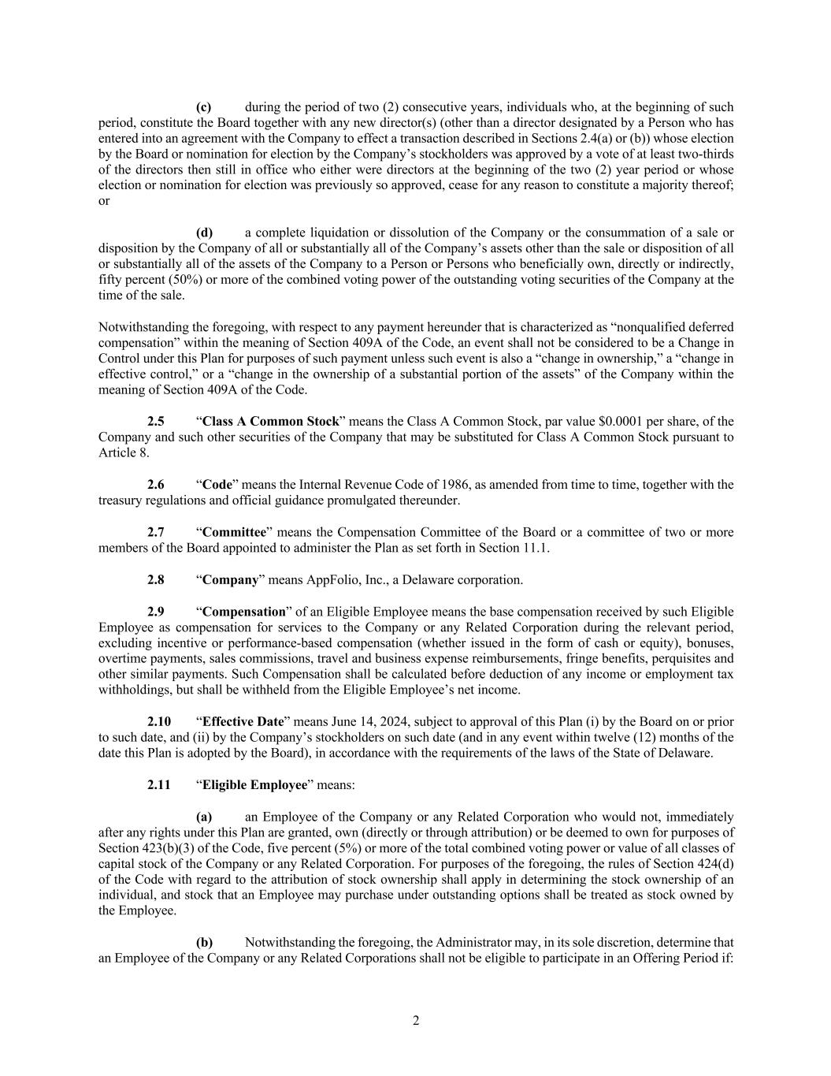
2 (c) during the period of two (2) consecutive years, individuals who, at the beginning of such period, constitute the Board together with any new director(s) (other than a director designated by a Person who has entered into an agreement with the Company to effect a transaction described in Sections 2.4(a) or (b)) whose election by the Board or nomination for election by the Company’s stockholders was approved by a vote of at least two-thirds of the directors then still in office who either were directors at the beginning of the two (2) year period or whose election or nomination for election was previously so approved, cease for any reason to constitute a majority thereof; or (d) a complete liquidation or dissolution of the Company or the consummation of a sale or disposition by the Company of all or substantially all of the Company’s assets other than the sale or disposition of all or substantially all of the assets of the Company to a Person or Persons who beneficially own, directly or indirectly, fifty percent (50%) or more of the combined voting power of the outstanding voting securities of the Company at the time of the sale. Notwithstanding the foregoing, with respect to any payment hereunder that is characterized as “nonqualified deferred compensation” within the meaning of Section 409A of the Code, an event shall not be considered to be a Change in Control under this Plan for purposes of such payment unless such event is also a “change in ownership,” a “change in effective control,” or a “change in the ownership of a substantial portion of the assets” of the Company within the meaning of Section 409A of the Code. 2.5 “Class A Common Stock” means the Class A Common Stock, par value $0.0001 per share, of the Company and such other securities of the Company that may be substituted for Class A Common Stock pursuant to Article 8. 2.6 “Code” means the Internal Revenue Code of 1986, as amended from time to time, together with the treasury regulations and official guidance promulgated thereunder. 2.7 “Committee” means the Compensation Committee of the Board or a committee of two or more members of the Board appointed to administer the Plan as set forth in Section 11.1. 2.8 “Company” means AppFolio, Inc., a Delaware corporation. 2.9 “Compensation” of an Eligible Employee means the base compensation received by such Eligible Employee as compensation for services to the Company or any Related Corporation during the relevant period, excluding incentive or performance-based compensation (whether issued in the form of cash or equity), bonuses, overtime payments, sales commissions, travel and business expense reimbursements, fringe benefits, perquisites and other similar payments. Such Compensation shall be calculated before deduction of any income or employment tax withholdings, but shall be withheld from the Eligible Employee’s net income. 2.10 “Effective Date” means June 14, 2024, subject to approval of this Plan (i) by the Board on or prior to such date, and (ii) by the Company’s stockholders on such date (and in any event within twelve (12) months of the date this Plan is adopted by the Board), in accordance with the requirements of the laws of the State of Delaware. 2.11 “Eligible Employee” means: (a) an Employee of the Company or any Related Corporation who would not, immediately after any rights under this Plan are granted, own (directly or through attribution) or be deemed to own for purposes of Section 423(b)(3) of the Code, five percent (5%) or more of the total combined voting power or value of all classes of capital stock of the Company or any Related Corporation. For purposes of the foregoing, the rules of Section 424(d) of the Code with regard to the attribution of stock ownership shall apply in determining the stock ownership of an individual, and stock that an Employee may purchase under outstanding options shall be treated as stock owned by the Employee. (b) Notwithstanding the foregoing, the Administrator may, in its sole discretion, determine that an Employee of the Company or any Related Corporations shall not be eligible to participate in an Offering Period if:

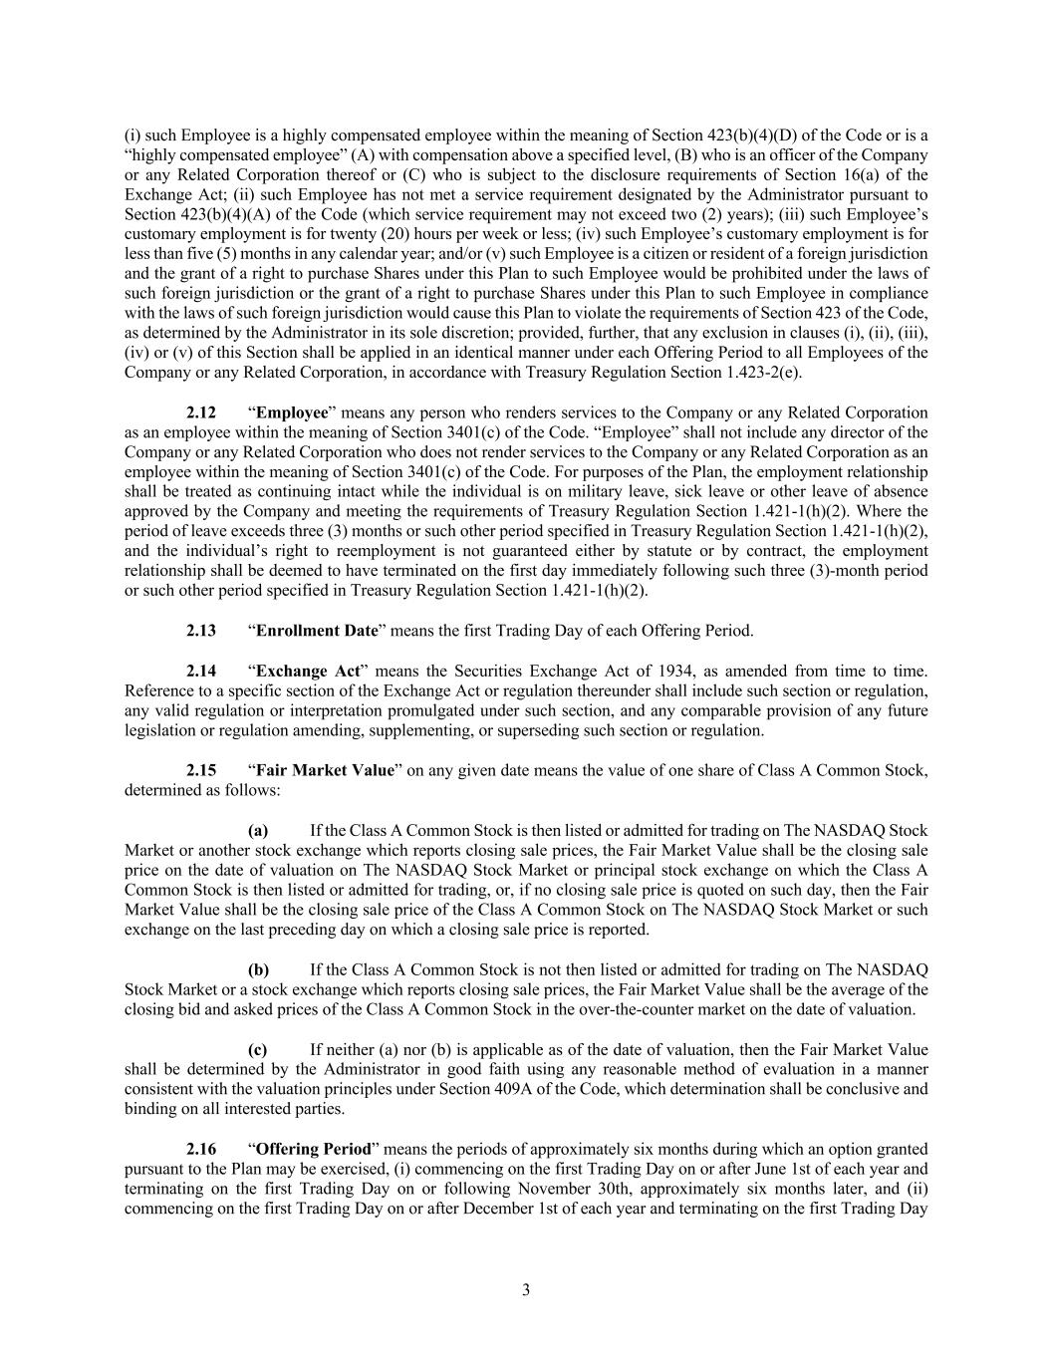
3 (i) such Employee is a highly compensated employee within the meaning of Section 423(b)(4)(D) of the Code or is a “highly compensated employee” (A) with compensation above a specified level, (B) who is an officer of the Company or any Related Corporation thereof or (C) who is subject to the disclosure requirements of Section 16(a) of the Exchange Act; (ii) such Employee has not met a service requirement designated by the Administrator pursuant to Section 423(b)(4)(A) of the Code (which service requirement may not exceed two (2) years); (iii) such Employee’s customary employment is for twenty (20) hours per week or less; (iv) such Employee’s customary employment is for less than five (5) months in any calendar year; and/or (v) such Employee is a citizen or resident of a foreign jurisdiction and the grant of a right to purchase Shares under this Plan to such Employee would be prohibited under the laws of such foreign jurisdiction or the grant of a right to purchase Shares under this Plan to such Employee in compliance with the laws of such foreign jurisdiction would cause this Plan to violate the requirements of Section 423 of the Code, as determined by the Administrator in its sole discretion; provided, further, that any exclusion in clauses (i), (ii), (iii), (iv) or (v) of this Section shall be applied in an identical manner under each Offering Period to all Employees of the Company or any Related Corporation, in accordance with Treasury Regulation Section 1.423-2(e). 2.12 “Employee” means any person who renders services to the Company or any Related Corporation as an employee within the meaning of Section 3401(c) of the Code. “Employee” shall not include any director of the Company or any Related Corporation who does not render services to the Company or any Related Corporation as an employee within the meaning of Section 3401(c) of the Code. For purposes of the Plan, the employment relationship shall be treated as continuing intact while the individual is on military leave, sick leave or other leave of absence approved by the Company and meeting the requirements of Treasury Regulation Section 1.421-1(h)(2). Where the period of leave exceeds three (3) months or such other period specified in Treasury Regulation Section 1.421-1(h)(2), and the individual’s right to reemployment is not guaranteed either by statute or by contract, the employment relationship shall be deemed to have terminated on the first day immediately following such three (3)-month period or such other period specified in Treasury Regulation Section 1.421-1(h)(2). 2.13 “Enrollment Date” means the first Trading Day of each Offering Period. 2.14 “Exchange Act” means the Securities Exchange Act of 1934, as amended from time to time. Reference to a specific section of the Exchange Act or regulation thereunder shall include such section or regulation, any valid regulation or interpretation promulgated under such section, and any comparable provision of any future legislation or regulation amending, supplementing, or superseding such section or regulation. 2.15 “Fair Market Value” on any given date means the value of one share of Class A Common Stock, determined as follows: (a) If the Class A Common Stock is then listed or admitted for trading on The NASDAQ Stock Market or another stock exchange which reports closing sale prices, the Fair Market Value shall be the closing sale price on the date of valuation on The NASDAQ Stock Market or principal stock exchange on which the Class A Common Stock is then listed or admitted for trading, or, if no closing sale price is quoted on such day, then the Fair Market Value shall be the closing sale price of the Class A Common Stock on The NASDAQ Stock Market or such exchange on the last preceding day on which a closing sale price is reported. (b) If the Class A Common Stock is not then listed or admitted for trading on The NASDAQ Stock Market or a stock exchange which reports closing sale prices, the Fair Market Value shall be the average of the closing bid and asked prices of the Class A Common Stock in the over-the-counter market on the date of valuation. (c) If neither (a) nor (b) is applicable as of the date of valuation, then the Fair Market Value shall be determined by the Administrator in good faith using any reasonable method of evaluation in a manner consistent with the valuation principles under Section 409A of the Code, which determination shall be conclusive and binding on all interested parties. 2.16 “Offering Period” means the periods of approximately six months during which an option granted pursuant to the Plan may be exercised, (i) commencing on the first Trading Day on or after June 1st of each year and terminating on the first Trading Day on or following November 30th, approximately six months later, and (ii) commencing on the first Trading Day on or after December 1st of each year and terminating on the first Trading Day

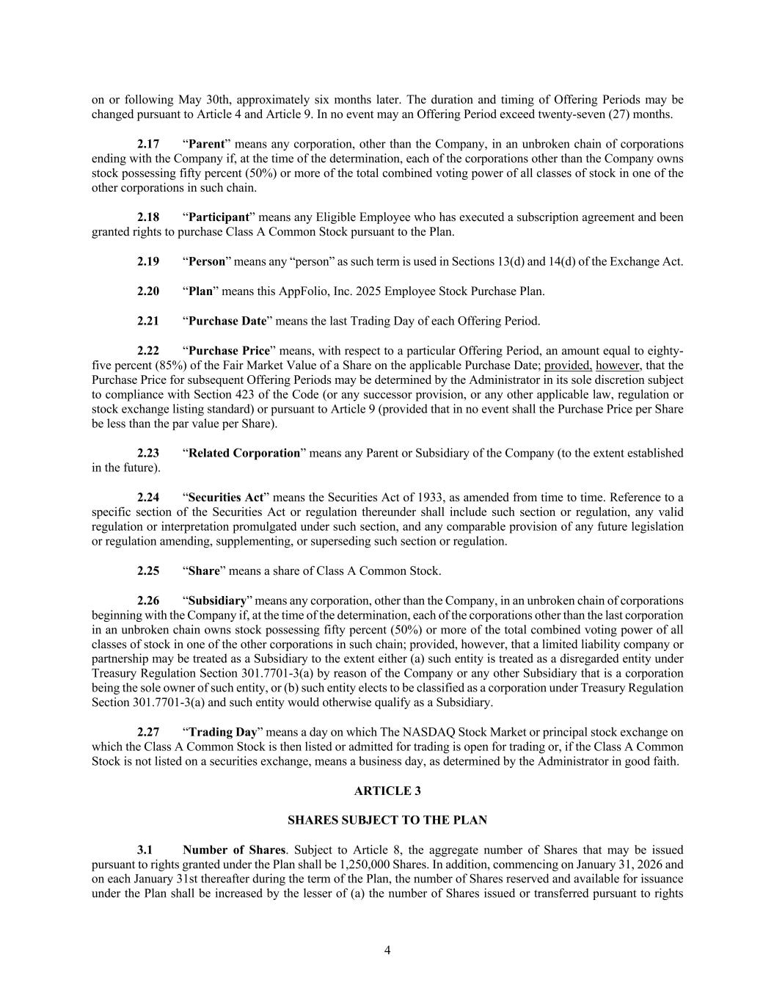
4 on or following May 30th, approximately six months later. The duration and timing of Offering Periods may be changed pursuant to Article 4 and Article 9. In no event may an Offering Period exceed twenty-seven (27) months. 2.17 “Parent” means any corporation, other than the Company, in an unbroken chain of corporations ending with the Company if, at the time of the determination, each of the corporations other than the Company owns stock possessing fifty percent (50%) or more of the total combined voting power of all classes of stock in one of the other corporations in such chain. 2.18 “Participant” means any Eligible Employee who has executed a subscription agreement and been granted rights to purchase Class A Common Stock pursuant to the Plan. 2.19 “Person” means any “person” as such term is used in Sections 13(d) and 14(d) of the Exchange Act. 2.20 “Plan” means this AppFolio, Inc. 2025 Employee Stock Purchase Plan. 2.21 “Purchase Date” means the last Trading Day of each Offering Period. 2.22 “Purchase Price” means, with respect to a particular Offering Period, an amount equal to eighty- five percent (85%) of the Fair Market Value of a Share on the applicable Purchase Date; provided, however, that the Purchase Price for subsequent Offering Periods may be determined by the Administrator in its sole discretion subject to compliance with Section 423 of the Code (or any successor provision, or any other applicable law, regulation or stock exchange listing standard) or pursuant to Article 9 (provided that in no event shall the Purchase Price per Share be less than the par value per Share). 2.23 “Related Corporation” means any Parent or Subsidiary of the Company (to the extent established in the future). 2.24 “Securities Act” means the Securities Act of 1933, as amended from time to time. Reference to a specific section of the Securities Act or regulation thereunder shall include such section or regulation, any valid regulation or interpretation promulgated under such section, and any comparable provision of any future legislation or regulation amending, supplementing, or superseding such section or regulation. 2.25 “Share” means a share of Class A Common Stock. 2.26 “Subsidiary” means any corporation, other than the Company, in an unbroken chain of corporations beginning with the Company if, at the time of the determination, each of the corporations other than the last corporation in an unbroken chain owns stock possessing fifty percent (50%) or more of the total combined voting power of all classes of stock in one of the other corporations in such chain; provided, however, that a limited liability company or partnership may be treated as a Subsidiary to the extent either (a) such entity is treated as a disregarded entity under Treasury Regulation Section 301.7701-3(a) by reason of the Company or any other Subsidiary that is a corporation being the sole owner of such entity, or (b) such entity elects to be classified as a corporation under Treasury Regulation Section 301.7701-3(a) and such entity would otherwise qualify as a Subsidiary. 2.27 “Trading Day” means a day on which The NASDAQ Stock Market or principal stock exchange on which the Class A Common Stock is then listed or admitted for trading is open for trading or, if the Class A Common Stock is not listed on a securities exchange, means a business day, as determined by the Administrator in good faith. ARTICLE 3 SHARES SUBJECT TO THE PLAN 3.1 Number of Shares. Subject to Article 8, the aggregate number of Shares that may be issued pursuant to rights granted under the Plan shall be 1,250,000 Shares. In addition, commencing on January 31, 2026 and on each January 31st thereafter during the term of the Plan, the number of Shares reserved and available for issuance under the Plan shall be increased by the lesser of (a) the number of Shares issued or transferred pursuant to rights

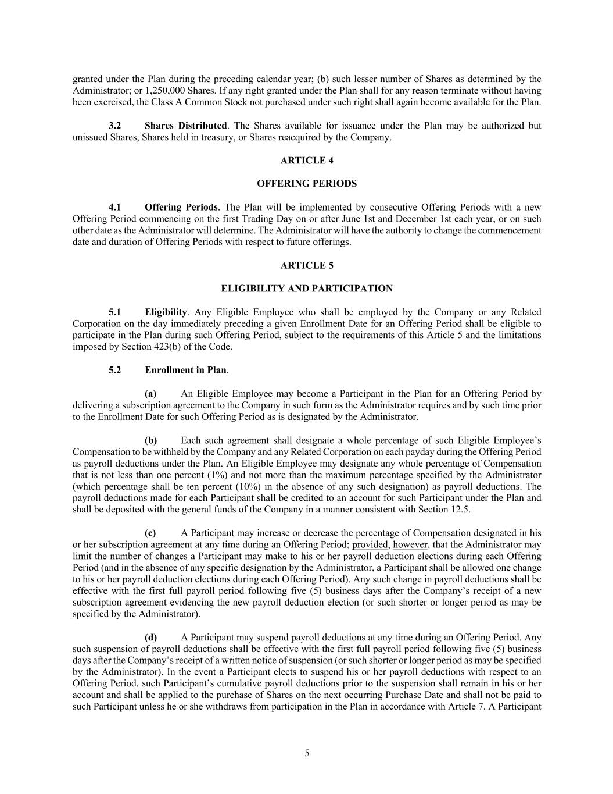
5 granted under the Plan during the preceding calendar year; (b) such lesser number of Shares as determined by the Administrator; or 1,250,000 Shares. If any right granted under the Plan shall for any reason terminate without having been exercised, the Class A Common Stock not purchased under such right shall again become available for the Plan. 3.2 Shares Distributed. The Shares available for issuance under the Plan may be authorized but unissued Shares, Shares held in treasury, or Shares reacquired by the Company. ARTICLE 4 OFFERING PERIODS 4.1 Offering Periods. The Plan will be implemented by consecutive Offering Periods with a new Offering Period commencing on the first Trading Day on or after June 1st and December 1st each year, or on such other date as the Administrator will determine. The Administrator will have the authority to change the commencement date and duration of Offering Periods with respect to future offerings. ARTICLE 5 ELIGIBILITY AND PARTICIPATION 5.1 Eligibility. Any Eligible Employee who shall be employed by the Company or any Related Corporation on the day immediately preceding a given Enrollment Date for an Offering Period shall be eligible to participate in the Plan during such Offering Period, subject to the requirements of this Article 5 and the limitations imposed by Section 423(b) of the Code. 5.2 Enrollment in Plan. (a) An Eligible Employee may become a Participant in the Plan for an Offering Period by delivering a subscription agreement to the Company in such form as the Administrator requires and by such time prior to the Enrollment Date for such Offering Period as is designated by the Administrator. (b) Each such agreement shall designate a whole percentage of such Eligible Employee’s Compensation to be withheld by the Company and any Related Corporation on each payday during the Offering Period as payroll deductions under the Plan. An Eligible Employee may designate any whole percentage of Compensation that is not less than one percent (1%) and not more than the maximum percentage specified by the Administrator (which percentage shall be ten percent (10%) in the absence of any such designation) as payroll deductions. The payroll deductions made for each Participant shall be credited to an account for such Participant under the Plan and shall be deposited with the general funds of the Company in a manner consistent with Section 12.5. (c) A Participant may increase or decrease the percentage of Compensation designated in his or her subscription agreement at any time during an Offering Period; provided, however, that the Administrator may limit the number of changes a Participant may make to his or her payroll deduction elections during each Offering Period (and in the absence of any specific designation by the Administrator, a Participant shall be allowed one change to his or her payroll deduction elections during each Offering Period). Any such change in payroll deductions shall be effective with the first full payroll period following five (5) business days after the Company’s receipt of a new subscription agreement evidencing the new payroll deduction election (or such shorter or longer period as may be specified by the Administrator). (d) A Participant may suspend payroll deductions at any time during an Offering Period. Any such suspension of payroll deductions shall be effective with the first full payroll period following five (5) business days after the Company’s receipt of a written notice of suspension (or such shorter or longer period as may be specified by the Administrator). In the event a Participant elects to suspend his or her payroll deductions with respect to an Offering Period, such Participant’s cumulative payroll deductions prior to the suspension shall remain in his or her account and shall be applied to the purchase of Shares on the next occurring Purchase Date and shall not be paid to such Participant unless he or she withdraws from participation in the Plan in accordance with Article 7. A Participant

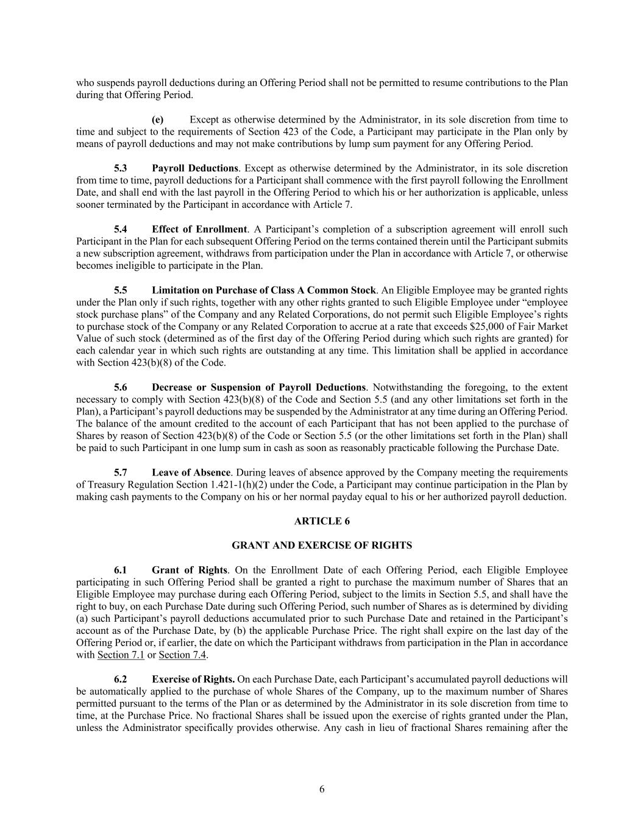
6 who suspends payroll deductions during an Offering Period shall not be permitted to resume contributions to the Plan during that Offering Period. (e) Except as otherwise determined by the Administrator, in its sole discretion from time to time and subject to the requirements of Section 423 of the Code, a Participant may participate in the Plan only by means of payroll deductions and may not make contributions by lump sum payment for any Offering Period. 5.3 Payroll Deductions. Except as otherwise determined by the Administrator, in its sole discretion from time to time, payroll deductions for a Participant shall commence with the first payroll following the Enrollment Date, and shall end with the last payroll in the Offering Period to which his or her authorization is applicable, unless sooner terminated by the Participant in accordance with Article 7. 5.4 Effect of Enrollment. A Participant’s completion of a subscription agreement will enroll such Participant in the Plan for each subsequent Offering Period on the terms contained therein until the Participant submits a new subscription agreement, withdraws from participation under the Plan in accordance with Article 7, or otherwise becomes ineligible to participate in the Plan. 5.5 Limitation on Purchase of Class A Common Stock. An Eligible Employee may be granted rights under the Plan only if such rights, together with any other rights granted to such Eligible Employee under “employee stock purchase plans” of the Company and any Related Corporations, do not permit such Eligible Employee’s rights to purchase stock of the Company or any Related Corporation to accrue at a rate that exceeds $25,000 of Fair Market Value of such stock (determined as of the first day of the Offering Period during which such rights are granted) for each calendar year in which such rights are outstanding at any time. This limitation shall be applied in accordance with Section 423(b)(8) of the Code. 5.6 Decrease or Suspension of Payroll Deductions. Notwithstanding the foregoing, to the extent necessary to comply with Section 423(b)(8) of the Code and Section 5.5 (and any other limitations set forth in the Plan), a Participant’s payroll deductions may be suspended by the Administrator at any time during an Offering Period. The balance of the amount credited to the account of each Participant that has not been applied to the purchase of Shares by reason of Section 423(b)(8) of the Code or Section 5.5 (or the other limitations set forth in the Plan) shall be paid to such Participant in one lump sum in cash as soon as reasonably practicable following the Purchase Date. 5.7 Leave of Absence. During leaves of absence approved by the Company meeting the requirements of Treasury Regulation Section 1.421-1(h)(2) under the Code, a Participant may continue participation in the Plan by making cash payments to the Company on his or her normal payday equal to his or her authorized payroll deduction. ARTICLE 6 GRANT AND EXERCISE OF RIGHTS 6.1 Grant of Rights. On the Enrollment Date of each Offering Period, each Eligible Employee participating in such Offering Period shall be granted a right to purchase the maximum number of Shares that an Eligible Employee may purchase during each Offering Period, subject to the limits in Section 5.5, and shall have the right to buy, on each Purchase Date during such Offering Period, such number of Shares as is determined by dividing (a) such Participant’s payroll deductions accumulated prior to such Purchase Date and retained in the Participant’s account as of the Purchase Date, by (b) the applicable Purchase Price. The right shall expire on the last day of the Offering Period or, if earlier, the date on which the Participant withdraws from participation in the Plan in accordance with Section 7.1 or Section 7.4. 6.2 Exercise of Rights. On each Purchase Date, each Participant’s accumulated payroll deductions will be automatically applied to the purchase of whole Shares of the Company, up to the maximum number of Shares permitted pursuant to the terms of the Plan or as determined by the Administrator in its sole discretion from time to time, at the Purchase Price. No fractional Shares shall be issued upon the exercise of rights granted under the Plan, unless the Administrator specifically provides otherwise. Any cash in lieu of fractional Shares remaining after the

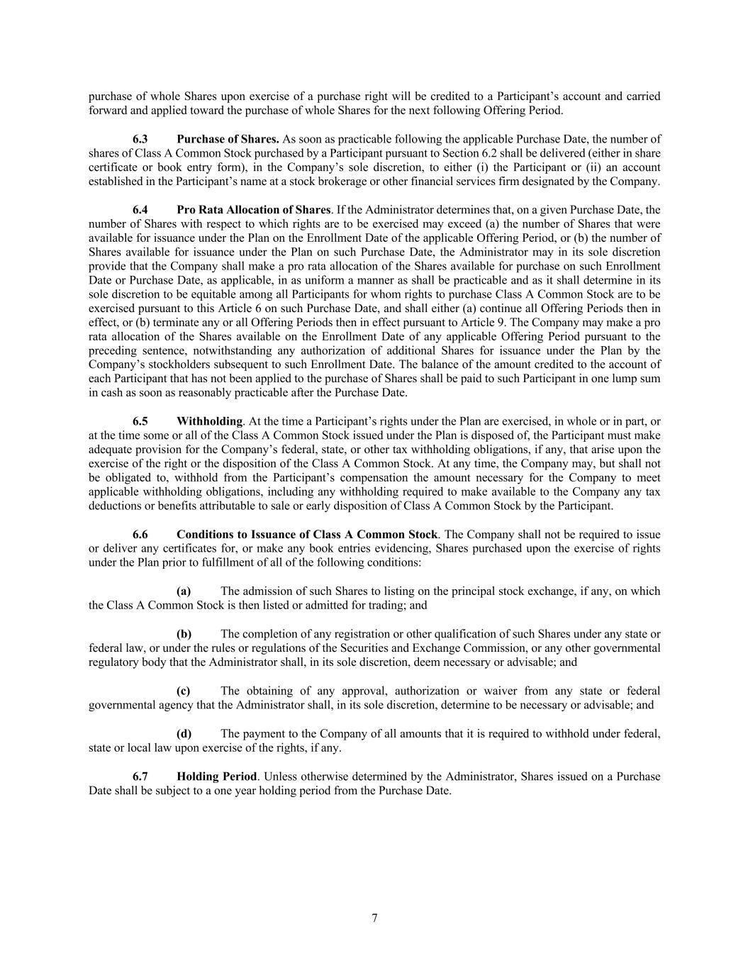
7 purchase of whole Shares upon exercise of a purchase right will be credited to a Participant’s account and carried forward and applied toward the purchase of whole Shares for the next following Offering Period. 6.3 Purchase of Shares. As soon as practicable following the applicable Purchase Date, the number of shares of Class A Common Stock purchased by a Participant pursuant to Section 6.2 shall be delivered (either in share certificate or book entry form), in the Company’s sole discretion, to either (i) the Participant or (ii) an account established in the Participant’s name at a stock brokerage or other financial services firm designated by the Company. 6.4 Pro Rata Allocation of Shares. If the Administrator determines that, on a given Purchase Date, the number of Shares with respect to which rights are to be exercised may exceed (a) the number of Shares that were available for issuance under the Plan on the Enrollment Date of the applicable Offering Period, or (b) the number of Shares available for issuance under the Plan on such Purchase Date, the Administrator may in its sole discretion provide that the Company shall make a pro rata allocation of the Shares available for purchase on such Enrollment Date or Purchase Date, as applicable, in as uniform a manner as shall be practicable and as it shall determine in its sole discretion to be equitable among all Participants for whom rights to purchase Class A Common Stock are to be exercised pursuant to this Article 6 on such Purchase Date, and shall either (a) continue all Offering Periods then in effect, or (b) terminate any or all Offering Periods then in effect pursuant to Article 9. The Company may make a pro rata allocation of the Shares available on the Enrollment Date of any applicable Offering Period pursuant to the preceding sentence, notwithstanding any authorization of additional Shares for issuance under the Plan by the Company’s stockholders subsequent to such Enrollment Date. The balance of the amount credited to the account of each Participant that has not been applied to the purchase of Shares shall be paid to such Participant in one lump sum in cash as soon as reasonably practicable after the Purchase Date. 6.5 Withholding. At the time a Participant’s rights under the Plan are exercised, in whole or in part, or at the time some or all of the Class A Common Stock issued under the Plan is disposed of, the Participant must make adequate provision for the Company’s federal, state, or other tax withholding obligations, if any, that arise upon the exercise of the right or the disposition of the Class A Common Stock. At any time, the Company may, but shall not be obligated to, withhold from the Participant’s compensation the amount necessary for the Company to meet applicable withholding obligations, including any withholding required to make available to the Company any tax deductions or benefits attributable to sale or early disposition of Class A Common Stock by the Participant. 6.6 Conditions to Issuance of Class A Common Stock. The Company shall not be required to issue or deliver any certificates for, or make any book entries evidencing, Shares purchased upon the exercise of rights under the Plan prior to fulfillment of all of the following conditions: (a) The admission of such Shares to listing on the principal stock exchange, if any, on which the Class A Common Stock is then listed or admitted for trading; and (b) The completion of any registration or other qualification of such Shares under any state or federal law, or under the rules or regulations of the Securities and Exchange Commission, or any other governmental regulatory body that the Administrator shall, in its sole discretion, deem necessary or advisable; and (c) The obtaining of any approval, authorization or waiver from any state or federal governmental agency that the Administrator shall, in its sole discretion, determine to be necessary or advisable; and (d) The payment to the Company of all amounts that it is required to withhold under federal, state or local law upon exercise of the rights, if any. 6.7 Holding Period. Unless otherwise determined by the Administrator, Shares issued on a Purchase Date shall be subject to a one year holding period from the Purchase Date.

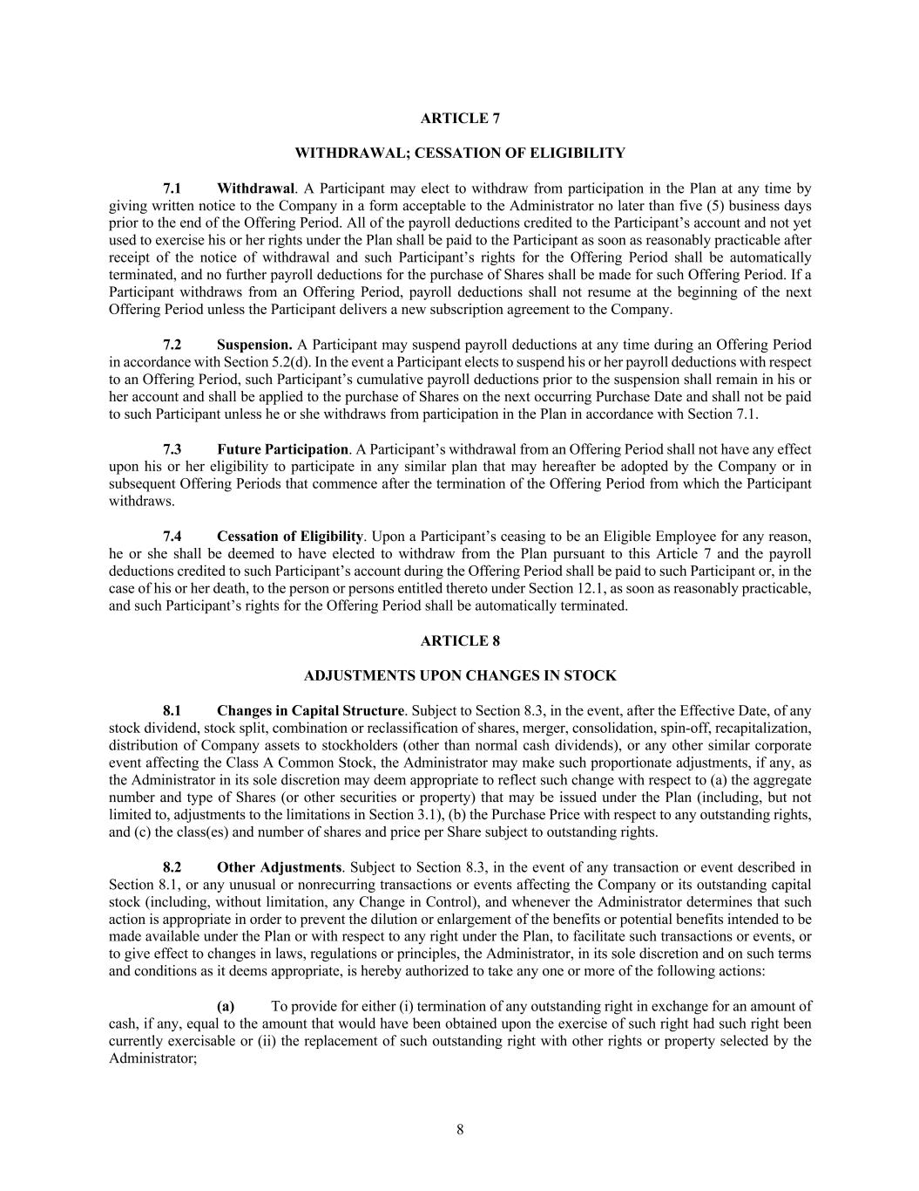
8 ARTICLE 7 WITHDRAWAL; CESSATION OF ELIGIBILITY 7.1 Withdrawal. A Participant may elect to withdraw from participation in the Plan at any time by giving written notice to the Company in a form acceptable to the Administrator no later than five (5) business days prior to the end of the Offering Period. All of the payroll deductions credited to the Participant’s account and not yet used to exercise his or her rights under the Plan shall be paid to the Participant as soon as reasonably practicable after receipt of the notice of withdrawal and such Participant’s rights for the Offering Period shall be automatically terminated, and no further payroll deductions for the purchase of Shares shall be made for such Offering Period. If a Participant withdraws from an Offering Period, payroll deductions shall not resume at the beginning of the next Offering Period unless the Participant delivers a new subscription agreement to the Company. 7.2 Suspension. A Participant may suspend payroll deductions at any time during an Offering Period in accordance with Section 5.2(d). In the event a Participant elects to suspend his or her payroll deductions with respect to an Offering Period, such Participant’s cumulative payroll deductions prior to the suspension shall remain in his or her account and shall be applied to the purchase of Shares on the next occurring Purchase Date and shall not be paid to such Participant unless he or she withdraws from participation in the Plan in accordance with Section 7.1. 7.3 Future Participation. A Participant’s withdrawal from an Offering Period shall not have any effect upon his or her eligibility to participate in any similar plan that may hereafter be adopted by the Company or in subsequent Offering Periods that commence after the termination of the Offering Period from which the Participant withdraws. 7.4 Cessation of Eligibility. Upon a Participant’s ceasing to be an Eligible Employee for any reason, he or she shall be deemed to have elected to withdraw from the Plan pursuant to this Article 7 and the payroll deductions credited to such Participant’s account during the Offering Period shall be paid to such Participant or, in the case of his or her death, to the person or persons entitled thereto under Section 12.1, as soon as reasonably practicable, and such Participant’s rights for the Offering Period shall be automatically terminated. ARTICLE 8 ADJUSTMENTS UPON CHANGES IN STOCK 8.1 Changes in Capital Structure. Subject to Section 8.3, in the event, after the Effective Date, of any stock dividend, stock split, combination or reclassification of shares, merger, consolidation, spin-off, recapitalization, distribution of Company assets to stockholders (other than normal cash dividends), or any other similar corporate event affecting the Class A Common Stock, the Administrator may make such proportionate adjustments, if any, as the Administrator in its sole discretion may deem appropriate to reflect such change with respect to (a) the aggregate number and type of Shares (or other securities or property) that may be issued under the Plan (including, but not limited to, adjustments to the limitations in Section 3.1), (b) the Purchase Price with respect to any outstanding rights, and (c) the class(es) and number of shares and price per Share subject to outstanding rights. 8.2 Other Adjustments. Subject to Section 8.3, in the event of any transaction or event described in Section 8.1, or any unusual or nonrecurring transactions or events affecting the Company or its outstanding capital stock (including, without limitation, any Change in Control), and whenever the Administrator determines that such action is appropriate in order to prevent the dilution or enlargement of the benefits or potential benefits intended to be made available under the Plan or with respect to any right under the Plan, to facilitate such transactions or events, or to give effect to changes in laws, regulations or principles, the Administrator, in its sole discretion and on such terms and conditions as it deems appropriate, is hereby authorized to take any one or more of the following actions: (a) To provide for either (i) termination of any outstanding right in exchange for an amount of cash, if any, equal to the amount that would have been obtained upon the exercise of such right had such right been currently exercisable or (ii) the replacement of such outstanding right with other rights or property selected by the Administrator;

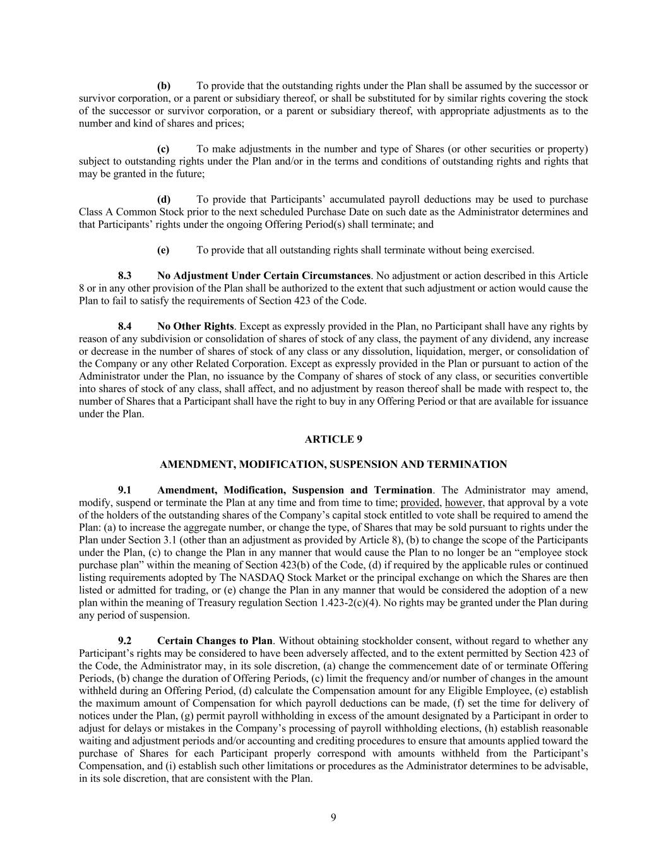
9 (b) To provide that the outstanding rights under the Plan shall be assumed by the successor or survivor corporation, or a parent or subsidiary thereof, or shall be substituted for by similar rights covering the stock of the successor or survivor corporation, or a parent or subsidiary thereof, with appropriate adjustments as to the number and kind of shares and prices; (c) To make adjustments in the number and type of Shares (or other securities or property) subject to outstanding rights under the Plan and/or in the terms and conditions of outstanding rights and rights that may be granted in the future; (d) To provide that Participants’ accumulated payroll deductions may be used to purchase Class A Common Stock prior to the next scheduled Purchase Date on such date as the Administrator determines and that Participants’ rights under the ongoing Offering Period(s) shall terminate; and (e) To provide that all outstanding rights shall terminate without being exercised. 8.3 No Adjustment Under Certain Circumstances. No adjustment or action described in this Article 8 or in any other provision of the Plan shall be authorized to the extent that such adjustment or action would cause the Plan to fail to satisfy the requirements of Section 423 of the Code. 8.4 No Other Rights. Except as expressly provided in the Plan, no Participant shall have any rights by reason of any subdivision or consolidation of shares of stock of any class, the payment of any dividend, any increase or decrease in the number of shares of stock of any class or any dissolution, liquidation, merger, or consolidation of the Company or any other Related Corporation. Except as expressly provided in the Plan or pursuant to action of the Administrator under the Plan, no issuance by the Company of shares of stock of any class, or securities convertible into shares of stock of any class, shall affect, and no adjustment by reason thereof shall be made with respect to, the number of Shares that a Participant shall have the right to buy in any Offering Period or that are available for issuance under the Plan. ARTICLE 9 AMENDMENT, MODIFICATION, SUSPENSION AND TERMINATION 9.1 Amendment, Modification, Suspension and Termination. The Administrator may amend, modify, suspend or terminate the Plan at any time and from time to time; provided, however, that approval by a vote of the holders of the outstanding shares of the Company’s capital stock entitled to vote shall be required to amend the Plan: (a) to increase the aggregate number, or change the type, of Shares that may be sold pursuant to rights under the Plan under Section 3.1 (other than an adjustment as provided by Article 8), (b) to change the scope of the Participants under the Plan, (c) to change the Plan in any manner that would cause the Plan to no longer be an “employee stock purchase plan” within the meaning of Section 423(b) of the Code, (d) if required by the applicable rules or continued listing requirements adopted by The NASDAQ Stock Market or the principal exchange on which the Shares are then listed or admitted for trading, or (e) change the Plan in any manner that would be considered the adoption of a new plan within the meaning of Treasury regulation Section 1.423-2(c)(4). No rights may be granted under the Plan during any period of suspension. 9.2 Certain Changes to Plan. Without obtaining stockholder consent, without regard to whether any Participant’s rights may be considered to have been adversely affected, and to the extent permitted by Section 423 of the Code, the Administrator may, in its sole discretion, (a) change the commencement date of or terminate Offering Periods, (b) change the duration of Offering Periods, (c) limit the frequency and/or number of changes in the amount withheld during an Offering Period, (d) calculate the Compensation amount for any Eligible Employee, (e) establish the maximum amount of Compensation for which payroll deductions can be made, (f) set the time for delivery of notices under the Plan, (g) permit payroll withholding in excess of the amount designated by a Participant in order to adjust for delays or mistakes in the Company’s processing of payroll withholding elections, (h) establish reasonable waiting and adjustment periods and/or accounting and crediting procedures to ensure that amounts applied toward the purchase of Shares for each Participant properly correspond with amounts withheld from the Participant’s Compensation, and (i) establish such other limitations or procedures as the Administrator determines to be advisable, in its sole discretion, that are consistent with the Plan.

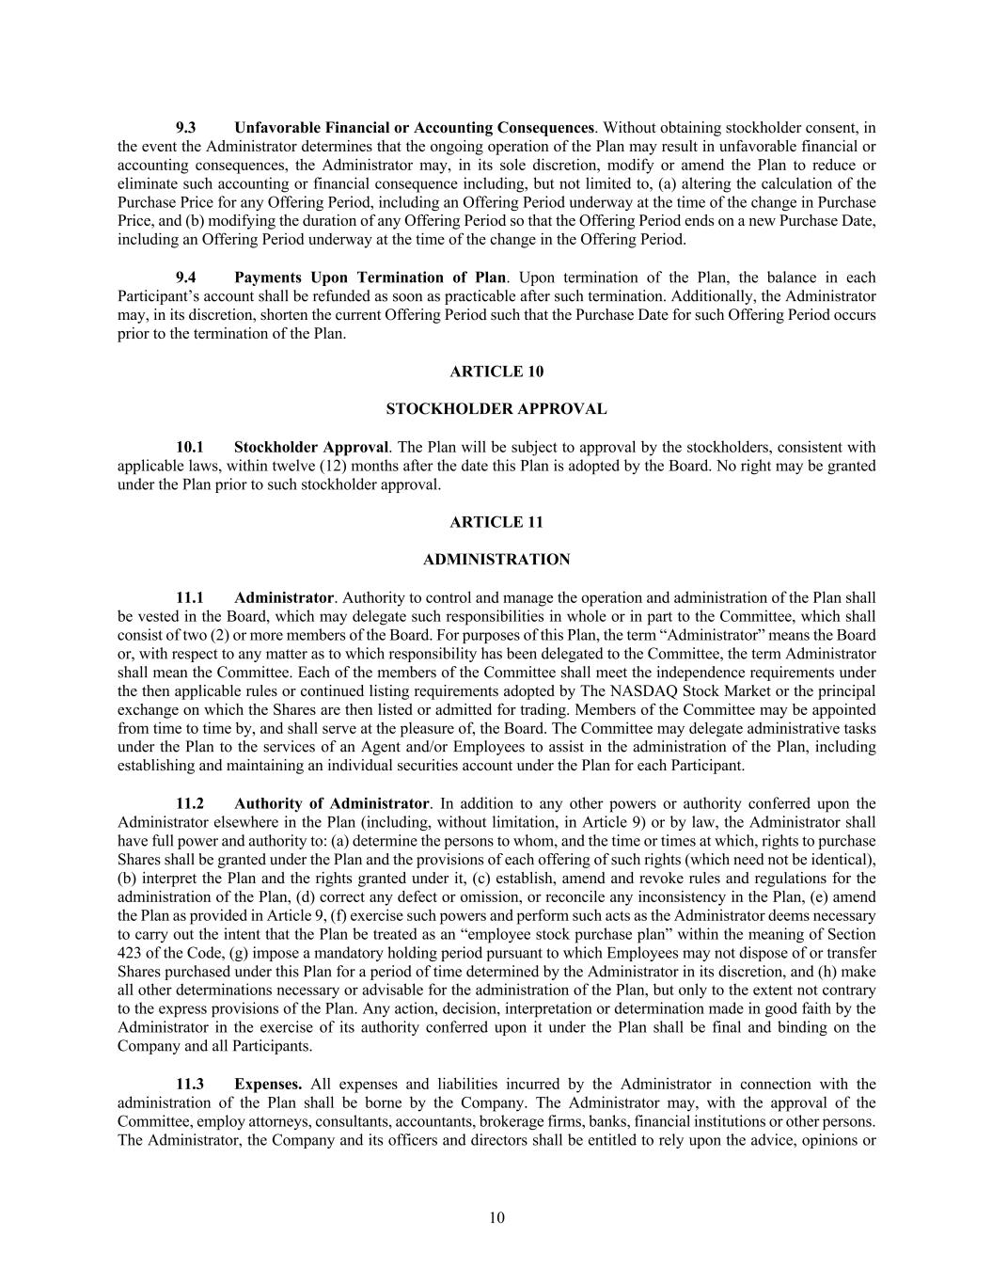
10 9.3 Unfavorable Financial or Accounting Consequences. Without obtaining stockholder consent, in the event the Administrator determines that the ongoing operation of the Plan may result in unfavorable financial or accounting consequences, the Administrator may, in its sole discretion, modify or amend the Plan to reduce or eliminate such accounting or financial consequence including, but not limited to, (a) altering the calculation of the Purchase Price for any Offering Period, including an Offering Period underway at the time of the change in Purchase Price, and (b) modifying the duration of any Offering Period so that the Offering Period ends on a new Purchase Date, including an Offering Period underway at the time of the change in the Offering Period. 9.4 Payments Upon Termination of Plan. Upon termination of the Plan, the balance in each Participant’s account shall be refunded as soon as practicable after such termination. Additionally, the Administrator may, in its discretion, shorten the current Offering Period such that the Purchase Date for such Offering Period occurs prior to the termination of the Plan. ARTICLE 10 STOCKHOLDER APPROVAL 10.1 Stockholder Approval. The Plan will be subject to approval by the stockholders, consistent with applicable laws, within twelve (12) months after the date this Plan is adopted by the Board. No right may be granted under the Plan prior to such stockholder approval. ARTICLE 11 ADMINISTRATION 11.1 Administrator. Authority to control and manage the operation and administration of the Plan shall be vested in the Board, which may delegate such responsibilities in whole or in part to the Committee, which shall consist of two (2) or more members of the Board. For purposes of this Plan, the term “Administrator” means the Board or, with respect to any matter as to which responsibility has been delegated to the Committee, the term Administrator shall mean the Committee. Each of the members of the Committee shall meet the independence requirements under the then applicable rules or continued listing requirements adopted by The NASDAQ Stock Market or the principal exchange on which the Shares are then listed or admitted for trading. Members of the Committee may be appointed from time to time by, and shall serve at the pleasure of, the Board. The Committee may delegate administrative tasks under the Plan to the services of an Agent and/or Employees to assist in the administration of the Plan, including establishing and maintaining an individual securities account under the Plan for each Participant. 11.2 Authority of Administrator. In addition to any other powers or authority conferred upon the Administrator elsewhere in the Plan (including, without limitation, in Article 9) or by law, the Administrator shall have full power and authority to: (a) determine the persons to whom, and the time or times at which, rights to purchase Shares shall be granted under the Plan and the provisions of each offering of such rights (which need not be identical), (b) interpret the Plan and the rights granted under it, (c) establish, amend and revoke rules and regulations for the administration of the Plan, (d) correct any defect or omission, or reconcile any inconsistency in the Plan, (e) amend the Plan as provided in Article 9, (f) exercise such powers and perform such acts as the Administrator deems necessary to carry out the intent that the Plan be treated as an “employee stock purchase plan” within the meaning of Section 423 of the Code, (g) impose a mandatory holding period pursuant to which Employees may not dispose of or transfer Shares purchased under this Plan for a period of time determined by the Administrator in its discretion, and (h) make all other determinations necessary or advisable for the administration of the Plan, but only to the extent not contrary to the express provisions of the Plan. Any action, decision, interpretation or determination made in good faith by the Administrator in the exercise of its authority conferred upon it under the Plan shall be final and binding on the Company and all Participants. 11.3 Expenses. All expenses and liabilities incurred by the Administrator in connection with the administration of the Plan shall be borne by the Company. The Administrator may, with the approval of the Committee, employ attorneys, consultants, accountants, brokerage firms, banks, financial institutions or other persons. The Administrator, the Company and its officers and directors shall be entitled to rely upon the advice, opinions or

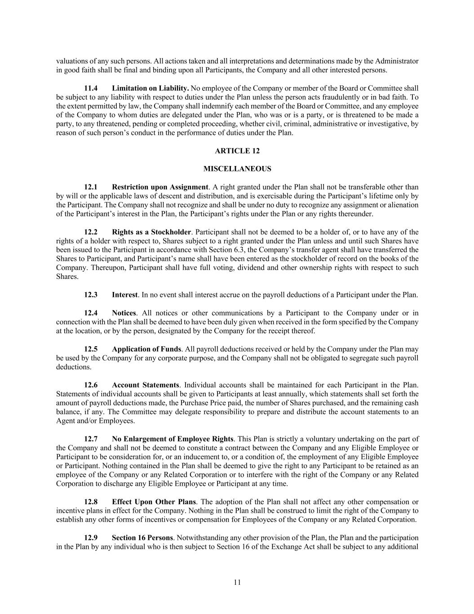
11 valuations of any such persons. All actions taken and all interpretations and determinations made by the Administrator in good faith shall be final and binding upon all Participants, the Company and all other interested persons. 11.4 Limitation on Liability. No employee of the Company or member of the Board or Committee shall be subject to any liability with respect to duties under the Plan unless the person acts fraudulently or in bad faith. To the extent permitted by law, the Company shall indemnify each member of the Board or Committee, and any employee of the Company to whom duties are delegated under the Plan, who was or is a party, or is threatened to be made a party, to any threatened, pending or completed proceeding, whether civil, criminal, administrative or investigative, by reason of such person’s conduct in the performance of duties under the Plan. ARTICLE 12 MISCELLANEOUS 12.1 Restriction upon Assignment. A right granted under the Plan shall not be transferable other than by will or the applicable laws of descent and distribution, and is exercisable during the Participant’s lifetime only by the Participant. The Company shall not recognize and shall be under no duty to recognize any assignment or alienation of the Participant’s interest in the Plan, the Participant’s rights under the Plan or any rights thereunder. 12.2 Rights as a Stockholder. Participant shall not be deemed to be a holder of, or to have any of the rights of a holder with respect to, Shares subject to a right granted under the Plan unless and until such Shares have been issued to the Participant in accordance with Section 6.3, the Company’s transfer agent shall have transferred the Shares to Participant, and Participant’s name shall have been entered as the stockholder of record on the books of the Company. Thereupon, Participant shall have full voting, dividend and other ownership rights with respect to such Shares. 12.3 Interest. In no event shall interest accrue on the payroll deductions of a Participant under the Plan. 12.4 Notices. All notices or other communications by a Participant to the Company under or in connection with the Plan shall be deemed to have been duly given when received in the form specified by the Company at the location, or by the person, designated by the Company for the receipt thereof. 12.5 Application of Funds. All payroll deductions received or held by the Company under the Plan may be used by the Company for any corporate purpose, and the Company shall not be obligated to segregate such payroll deductions. 12.6 Account Statements. Individual accounts shall be maintained for each Participant in the Plan. Statements of individual accounts shall be given to Participants at least annually, which statements shall set forth the amount of payroll deductions made, the Purchase Price paid, the number of Shares purchased, and the remaining cash balance, if any. The Committee may delegate responsibility to prepare and distribute the account statements to an Agent and/or Employees. 12.7 No Enlargement of Employee Rights. This Plan is strictly a voluntary undertaking on the part of the Company and shall not be deemed to constitute a contract between the Company and any Eligible Employee or Participant to be consideration for, or an inducement to, or a condition of, the employment of any Eligible Employee or Participant. Nothing contained in the Plan shall be deemed to give the right to any Participant to be retained as an employee of the Company or any Related Corporation or to interfere with the right of the Company or any Related Corporation to discharge any Eligible Employee or Participant at any time. 12.8 Effect Upon Other Plans. The adoption of the Plan shall not affect any other compensation or incentive plans in effect for the Company. Nothing in the Plan shall be construed to limit the right of the Company to establish any other forms of incentives or compensation for Employees of the Company or any Related Corporation. 12.9 Section 16 Persons. Notwithstanding any other provision of the Plan, the Plan and the participation in the Plan by any individual who is then subject to Section 16 of the Exchange Act shall be subject to any additional

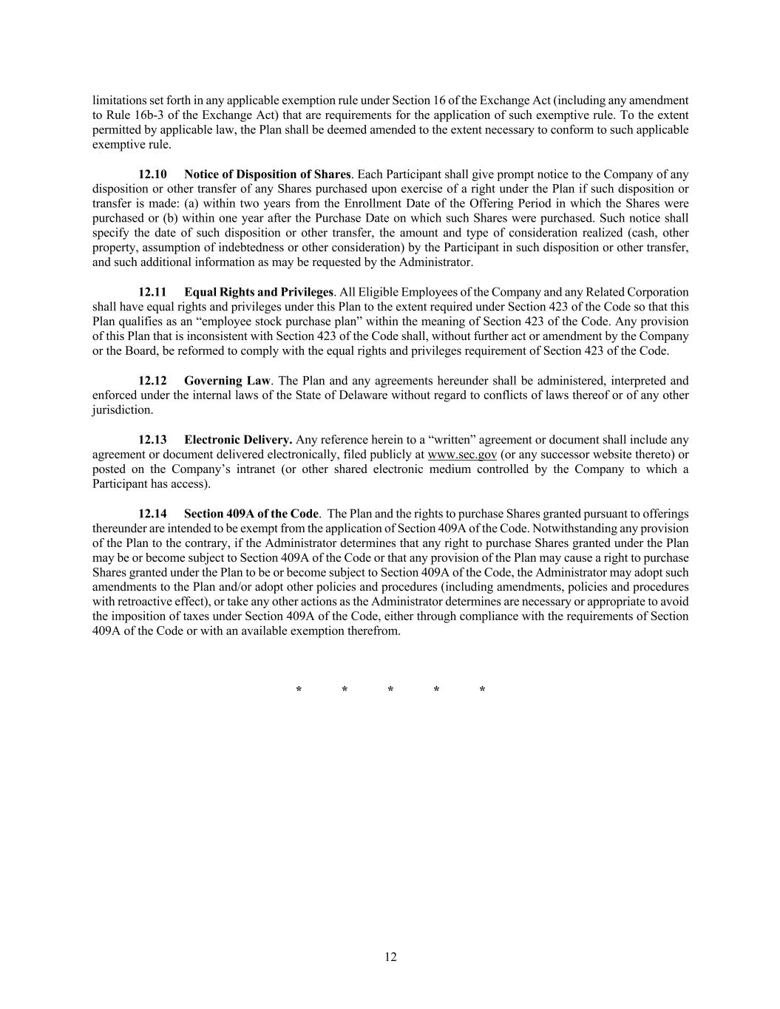
12 limitations set forth in any applicable exemption rule under Section 16 of the Exchange Act (including any amendment to Rule 16b-3 of the Exchange Act) that are requirements for the application of such exemptive rule. To the extent permitted by applicable law, the Plan shall be deemed amended to the extent necessary to conform to such applicable exemptive rule. 12.10 Notice of Disposition of Shares. Each Participant shall give prompt notice to the Company of any disposition or other transfer of any Shares purchased upon exercise of a right under the Plan if such disposition or transfer is made: (a) within two years from the Enrollment Date of the Offering Period in which the Shares were purchased or (b) within one year after the Purchase Date on which such Shares were purchased. Such notice shall specify the date of such disposition or other transfer, the amount and type of consideration realized (cash, other property, assumption of indebtedness or other consideration) by the Participant in such disposition or other transfer, and such additional information as may be requested by the Administrator. 12.11 Equal Rights and Privileges. All Eligible Employees of the Company and any Related Corporation shall have equal rights and privileges under this Plan to the extent required under Section 423 of the Code so that this Plan qualifies as an “employee stock purchase plan” within the meaning of Section 423 of the Code. Any provision of this Plan that is inconsistent with Section 423 of the Code shall, without further act or amendment by the Company or the Board, be reformed to comply with the equal rights and privileges requirement of Section 423 of the Code. 12.12 Governing Law. The Plan and any agreements hereunder shall be administered, interpreted and enforced under the internal laws of the State of Delaware without regard to conflicts of laws thereof or of any other jurisdiction. 12.13 Electronic Delivery. Any reference herein to a “written” agreement or document shall include any agreement or document delivered electronically, filed publicly at www.sec.gov (or any successor website thereto) or posted on the Company’s intranet (or other shared electronic medium controlled by the Company to which a Participant has access). 12.14 Section 409A of the Code. The Plan and the rights to purchase Shares granted pursuant to offerings thereunder are intended to be exempt from the application of Section 409A of the Code. Notwithstanding any provision of the Plan to the contrary, if the Administrator determines that any right to purchase Shares granted under the Plan may be or become subject to Section 409A of the Code or that any provision of the Plan may cause a right to purchase Shares granted under the Plan to be or become subject to Section 409A of the Code, the Administrator may adopt such amendments to the Plan and/or adopt other policies and procedures (including amendments, policies and procedures with retroactive effect), or take any other actions as the Administrator determines are necessary or appropriate to avoid the imposition of taxes under Section 409A of the Code, either through compliance with the requirements of Section 409A of the Code or with an available exemption therefrom. * * * * *

EXHIBIT 31.1

CERTIFICATION OF CHIEF EXECUTIVE OFFICER
PURSUANT TO SECTION 302 OF THE SARBANES-OXLEY ACT OF 2002

I, Shane Trigg, certify that:
1. |  |  | I have reviewed this Quarterly Report on Form 10-Q of AppFolio, Inc.;
2. |  |  | Based on my knowledge, this report does not contain any untrue statement of a material fact or omit to state a material fact necessary to make the statements made, in light of the circumstances under which such statements were made, not misleading with respect to the period covered by this report;
3. |  |  | Based on my knowledge, the financial statements, and other financial information included in this report, fairly present in all material respects the financial condition, results of operations and cash flows of the registrant as of, and for, the periods presented in this report;
4. |  |  | The registrant's other certifying officer and I are responsible for establishing and maintaining disclosure controls and procedures (as defined in Exchange Act Rules 13a-15(e) and 15d-15(e)) and internal control over financial reporting (as defined in Exchange Act Rules13a-15(f) and 15d-15(f)) for the registrant and have:
 |  |  | a. |  |  | Designed such disclosure controls and procedures, or caused such disclosure controls and procedures to be designed under our supervision, to ensure that material information relating to the registrant, including its consolidated subsidiaries, is made known to us by others within those entities, particularly during the period in which this report is being prepared;
 |  |  | b. |  |  | Designed such internal control over financial reporting, or caused such internal control over financial reporting to be designed under our supervision, to provide reasonable assurance regarding the reliability of financial reporting and the preparation of financial statements for external purposes in accordance with generally accepted accounting principles;
 |  |  | c. |  |  | Evaluated the effectiveness of the registrant’s disclosure controls and procedures and presented in this report our conclusions about the effectiveness of the disclosure controls and procedures, as of the end of the period covered by this report based on such evaluation; and
 |  |  | d. |  |  | Disclosed in this report any change in the registrant’s internal control over financial reporting that occurred during the registrant’s most recent fiscal quarter (the registrant’s fourth fiscal quarter in the case of an annual report) that has materially affected, or is reasonably likely to materially affect, the registrant’s internal control over financial reporting; and
5. |  |  | The registrant's other certifying officer and I have disclosed, based on our most recent evaluation of internal control over financial reporting, to the registrant’s auditors and the audit committee of the registrant’s board of directors (or persons performing the equivalent functions):
 |  |  | a. |  |  | All significant deficiencies and material weaknesses in the design or operation of internal control over financial reporting which are reasonably likely to adversely affect the registrant’s ability to record, process, summarize and report financial information; and
 |  |  | b. |  |  | Any fraud, whether or not material, that involves management or other employees who have a significant role in the registrant’s internal control over financial reporting.

Date: |  |  | July 26, 2024 |  |  |  |  |  | /s/ Shane Trigg
 |  |  |  |  |  |  |  |  | Shane Trigg
 |  |  |  |  |  |  |  |  | Chief Executive Officer

EXHIBIT 31.2

CERTIFICATION OF CHIEF FINANCIAL OFFICER
PURSUANT TO SECTION 302 OF THE SARBANES-OXLEY ACT OF 2002

I, Fay Sien Goon, certify that:
1. |  |  | I have reviewed this Quarterly Report on Form 10-Q of AppFolio, Inc.;
2. |  |  | Based on my knowledge, this report does not contain any untrue statement of a material fact or omit to state a material fact necessary to make the statements made, in light of the circumstances under which such statements were made, not misleading with respect to the period covered by this report;
3. |  |  | Based on my knowledge, the financial statements, and other financial information included in this report, fairly present in all material respects the financial condition, results of operations and cash flows of the registrant as of, and for, the periods presented in this report;
4. |  |  | The registrant's other certifying officer and I are responsible for establishing and maintaining disclosure controls and procedures (as defined in Exchange Act Rules 13a-15(e) and 15d-15(e)) and internal control over financial reporting (as defined in Exchange Act Rules13a-15(f) and 15d-15(f)) for the registrant and have:
 |  |  | a. |  |  | Designed such disclosure controls and procedures, or caused such disclosure controls and procedures to be designed under our supervision, to ensure that material information relating to the registrant, including its consolidated subsidiaries, is made known to us by others within those entities, particularly during the period in which this report is being prepared;
 |  |  | b. |  |  | Designed such internal control over financial reporting, or caused such internal control over financial reporting to be designed under our supervision, to provide reasonable assurance regarding the reliability of financial reporting and the preparation of financial statements for external purposes in accordance with generally accepted accounting principles;
 |  |  | c. |  |  | Evaluated the effectiveness of the registrant’s disclosure controls and procedures and presented in this report our conclusions about the effectiveness of the disclosure controls and procedures, as of the end of the period covered by this report based on such evaluation; and
 |  |  | d. |  |  | Disclosed in this report any change in the registrant’s internal control over financial reporting that occurred during the registrant’s most recent fiscal quarter (the registrant’s fourth fiscal quarter in the case of an annual report) that has materially affected, or is reasonably likely to materially affect, the registrant’s internal control over financial reporting; and
5. |  |  | The registrant's other certifying officer and I have disclosed, based on our most recent evaluation of internal control over financial reporting, to the registrant’s auditors and the audit committee of the registrant’s board of directors (or persons performing the equivalent functions):
 |  |  | a. |  |  | All significant deficiencies and material weaknesses in the design or operation of internal control over financial reporting which are reasonably likely to adversely affect the registrant’s ability to record, process, summarize and report financial information; and
 |  |  | b. |  |  | Any fraud, whether or not material, that involves management or other employees who have a significant role in the registrant’s internal control over financial reporting.
Date: |  |  | July 26, 2024 |  |  |  |  |  | /s/ Fay Sien Goon
 |  |  |  |  |  |  |  |  | Fay Sien Goon
 |  |  |  |  |  |  |  |  | Chief Financial Officer

EXHIBIT 32.1

CERTIFICATIONS OF CHIEF EXECUTIVE OFFICER AND CHIEF FINANCIAL OFFICER
PURSUANT TO 18 U.S.C. SECTION 1350,
AS ADOPTED PURSUANT TO SECTION 906 OF THE SARBANES-OXLEY ACT OF 2002

The following certifications are hereby made in connection with the Quarterly Report on Form 10-Q of AppFolio, Inc. (the “Company”) for the period ended June 30, 2024, as filed with the Securities and Exchange Commission on the date hereof (the “Report”):

I, Shane Trigg, President and Chief Executive Officer of the Company, hereby certify, pursuant to 18 U.S.C. Section 1350, as adopted pursuant to Section 906 of the Sarbanes-Oxley Act of 2002, that, to my knowledge, (i) the Report fully complies with the requirements of Section 13(a) or 15(d) of the Securities Exchange Act of 1934, as amended, and (ii) the information contained in the Report fairly presents, in all material respects, the financial condition and results of operations of the Company as of the dates and for the periods presented.
Date: |  |  | July 26, 2024 |  |  | By: |  |  | /s/ Shane Trigg
 |  |  |  |  |  |  |  |  | Shane Trigg
 |  |  |  |  |  |  |  |  | President and Chief Executive Officer

I, Fay Sien Goon, Chief Financial Officer of the Company, hereby certify, pursuant to 18 U.S.C. Section 1350, as adopted pursuant to Section 906 of the Sarbanes-Oxley Act of 2002, that, to my knowledge, (i) the Report fully complies with the requirements of Section 13(a) or 15(d) of the Securities Exchange Act of 1934, as amended, and (ii) the information contained in the Report fairly presents, in all material respects, the financial condition and results of operations of the Company as of the dates and for the periods presented.
Date: |  |  | July 26, 2024 |  |  | By: |  |  | /s/ Fay Sien Goon
 |  |  |  |  |  |  |  |  | Fay Sien Goon
 |  |  |  |  |  |  |  |  | Chief Financial Officer

